

PROJECT
ON
HUMAN RESOURCE MANAGEMENT IN WIPRO
TECHNOLOGY LTD.
SUBMITTED BY:-
POOJA SONI
MBA-1st year(PG 2)
CERTIFICATE
T h i s i s t o c e r t i f y t h a t t h e p r o je c t w o r k “ HUMAN RESOURCE
MANAGEMENT IN WIPRO TECHNOLOGY LTD.” i s a b o n a f i d e r e c o r d
o f wo r k d o n e b y Pooja Soni u n d e r g u i d a n c e o f M s . Av je e t
K a u r i n p a r t i a l f u l f i l l me n t o f t h e r e q u i r e me n t s f o r t h e
p r o je c t .
Ms. Avjeet Kaur
(Project Coordinator)
K. R.Mangalam

ACKNOWLEDGEMENTS
I take immense pleasure in thanking Ms. Avjeet Kaur our beloved Project
Coordinator for having permitted me to carry out this project work.
Pooja Soni
(MBA-1st year)

INDEX
SR.NO
1
2
3
4
5
6
7
8
9
10
11
12
13
14
15
16
17
18
19
CONTENT
Executive summary
History of Wipro
Vision & mission
Introduction to Wipro-BPO
HR practices in Wipro
Human resource planning
Six sigma methodology
Model of HRP system
Human resource outsourcing
Employee Retention ship Management
Recruitment & Selection
Training & Development
Performance Appraisal
Promotion
Compensation
Employee structure
Benefits given to employee at Wipro
Wipro consumer care strike work
Bibliography
PAGE NO.

EXECUTIVE SUMMARY
Wipro started as a vegetable oil company in 1947 from an old mill founded by Azim
Premji's father. When his father died in 1966, Azim, a graduate in Electrical Engineering
from Stanford University, took on the leadership of the company at the age 21. He
repositioned it and transformed Wipro (Western India Vegetable Products Ltd) into a
consumer goods company that produced hydrogenated cooking oils/fat company, laundry
soap, wax and tin containers and later set up Wipro Fluid Power to manufacture hydraulic
and pneumatic cylinders in 1975. At that time, it was valued at $2 million.
In 1977, when IBM was asked to leave India, Wipro entered the information technology
sector.
In 1979, Wipro began developing its own computers and in 1981, started selling
the finished product. This was the first in a string of products that would make Wipro one
of India's first computer makers. The company licensed technology from Sentinel
Computers in the United States and began building India's first mini-computers. Wipro
hired managers who were computer savvy, and strong on business experience. In 1980
Wipro moved in software development and started developing customized software
packages for their hardware customers. This expanded their IT business and subsequently
invented the first Indian 8086 chip.
Since 1992, Wipro began to grow its roots off shore in United States and by 2000
Wipro Ltd ADRs were listed on the New York Stock Exchange. With over 25 years in
the Information Technology business, Wipro Technologies is the largest outsourced R &
D Services provider and one of the pioneers in the remote delivery of IT services. Being a
global provider of consulting, IT Services, outsourced R&D, infrastructure outsourcing
and business process services, we deliver technology-driven business solutions that meet
the strategic objectives of our Global 2000 customers. Wipro today employs 96,000
people in over 50 countries. A career at Wipro means to learn and grow continuously,
opportunities to work on the latest technologies alongside the finest minds in the industry,
competitive salaries, stock options and excellent benefits.

HISTORY OF WIPRO
WIPRO is one of the largest IT services companies in India. Established in 1980 as
subsidiary of WIPRO limited listed on New York Stock Exchange. WIPRO was initially
set up in 1945 with main product of producing sunflower Vanaspati Oil and different
soaps. At that time Company was called Western India Vegetable Products limited with
representative offices in Maharashtra and Madhyapardhesh states of India. During 1970s
and 1980s it shifted its focus and begin to look into business opportunities in IT and
computing industry which was at nascent stages in India at that time. WIPRO was the
first company which marketed the first indigenous homemade PC from India in 1975.
In 1966 Azim Premji, still the majority shareholder in WIPRO, took over as the chairman
of the company at the age of 21 and with the passage of time transformed it into one of
the finest and largest IT outsourcing services provider of the world. It is now considered
the world's largest independent R&D service provider. It offers different technology
driven services all over the globe with 46 development centers. Azim Premji is still the
Chairman of the WIPRO along with other top class professionals heading different wings
of the business Wipro Tech is an information technology service company established in
India in 1980. It is the global IT services arm of Wipro Limited (in operation since 1945,
incorporated 1946). It is headquartered in Bangalore and is the third largest IT services
company in India. It has more than 78,000 employees as of September 2007, including its
business process outsourcing (BPO) arm which it acquired in 2002.
Wipro Technologies has over 300 customers across U.S., Europe and Japan including 50
of the Fortune 500 companies. Some of its customers are Nortel, Boeing, BP, Cisco,
Ericsson, IBM, Microsoft, Prudential, Seagate, Sony, Win driver and ToshibaIt is listed
on the New York Stock Exchange and is part of its TMT (technology media telecom)
index testing. With revenue in the excess of US $3 billion, Wipro is one of India's major
IT companies. It has dedicated development centers and offices across India, Europe,
North America, Latin America and Asia Pacific.
The current Chairman, Managing Director and majority stake owner is Azim Premji, who
has headed the software and hardware divisions since Wipro's inception. Examples of
Wipro's product design work include developing an Internet-browsing phone for a
Japanese telecom company in 1998, helping chipmaker Texas Instruments produce
digital signal processing software, and creating an automotive display unit for Italian
manufacturer Magneti Marelli that combined functions including cell phone capability,
global position system technology, a navigation system and a CD player.

Wipro was set up in 1945. Primarily an edible oil factory, the chief products were
Sunflower Vanaspati and 787 laundry soap (a by-product of the Vanaspati operations).
The company was called Western India Vegetable Products Limited; it had a minor
presence in Maharashtra and Madhya Pradesh. In the 1970s and 1980s, it began to
expand and made forays into computing.
TIMELINE: -
•
•
•
•
•
•
•
•
•
•
•
•
•
•
•
1945 - Incorporation as Western India Products Limited
1947 - Establishment of an oil mill at Amalner, Maharashtra, India
1960 - Manufacture of laundry soap 787 at Amalner
1970 - Manufacture of Bakery Shortening Vanaspati at Amalner
1975 - Diversification into engineering and manufacture of hydraulic cylinders as
WINTROL (now called Wipro Fluid Power) division in Bangalore.
1977 - Name of the Company changed to Wipro Products Limited
1980 - Diversification into Information Technology.
o This is the time the top IT Managers Sridhar Mitta, Dr. Laxman Rao,
Venkatesh, Sadasivam quit in one stoke from the IT division of giant
public sector ECIL, Hyderabad to join Wipro.
1988 - Crossed the $10 million mark in annualized revenues.
1990 - Incorporation of Wipro-GE medical systems
1992 - Going global with global IT services division
1993 - Busny to achieve the "TL9000 certification" for industry specific quality
standards.
o Wipro acquires American Management Systems’ global energy practice.
o Becomes world's first PCMM Level 5 company.
o Premji established Azim Premji Foundation, a not-for-profit organization
for elementary education.
o Wipro becomes only Indian company featured in Business Week’s 100
best-performing technology companies.
1995 - Established Wipro Academy of Software Excellence
2002
o Wipro acquires Spectramind.
o Ranked the 7th software services company in the world by Business Week
(Infotech 100, November 2002)
2003
o Wipro acquires Nerve wire.
o Wipro Technologies Wins Prestigious IEEE Award for Software Process
Excellence
o Wipro Technologies awarded prestigious ITSMA award for services
marketing excellence
o Wipro wins the 2003 Asian Most Admired Knowledge Enterprise Award.
2004
o Crossed the $1 Billion m
o IDC rates Wipro as the leader among worldwide offshore service
providers[5]

•
•
•
•
•
2005 - Wipro acquires mPower to enter payments space and also acquires
European System on Chip (SoC) design firm New Logic.
2006 - Wipro acquires Enabler to enter Niche Retail market
2007 - Wipro acquires US's Infocrossing for 600mn
2009 - Wipro acquires Gallagher Financial Systems to enter mortgage loan
origination space.
o Wipro stops Semiconductor IP Solutions and closes New Logic Sophia-
Antipolis R&D, France
- Wipro Launches ESS - Electronic Security Solutions with Products in CCTV
System, Access Control System and Building Management Systems.
MAJOR DIVISION OF WIPRO:-
•
IT Services: Wipro provides complete range of IT Services to the organization.
The range of services extends from Enterprise Application Services (CRM, ERP,
e-Procurement and SCM) to e-Business solutions. Wipro's enterprise solutions
serve a host of industries such as Energy and Utilities, Finance, Telecom, and
Media and Entertainment.
•
Product Engineering Solutions: Wipro is the largest independent provider of
R&D services in the world. Using "Extended Engineering" model for leveraging
R&D investment and accessing new knowledge and experience across the globe,
people and technical infrastructure, Wipro enables firms to introduce new
products rapidly.
•
Technology Infrastructure Service: Wipro's Technology Infrastructure Services
(TIS) is the largest Indian IT infrastructure service provider in terms of revenue,
people and customers with more than 200 customers in US, Europe, Japan and
over 650 customers in India.
•
Business Process Outsourcing: Wipro provides business process outsourcing
services in areas Finance & Accounting, Procurement, HR Services, Loyalty
Services and Knowledge Services. In 2002, Wipro acquiring Spectramind and
became one of the largest BPO service players.
•
Consulting Services: Wipro offers services in Business Consulting, Process
Consulting, Quality Consulting, and Technology Consulting.

VISION & MISSION OF WIPRO
VISION
Having already achieved the pinnacles of process and quality credentials (through SEI
CMM, PCMM and Six Sigma), Wipro's Vision is focused on attaining leadership in the
areas of business, customer and people.
Business Leadership: Among the top 10 Information Technology Services companies
globally and the No.1 Information Technology company in India.
Customer Leadership: The No.1 choice of customers through innovative solutions and
Six Sigma processes.
People Leadership: Among the top 10 most preferred employers globally by creating an
environment of empowerment, intellectual challenge and wealth sharing.
Brand Leadership: Wipro to be among the 5 most admired brand in India.
MISSION
Wipro’s mission is the quality which they have achieved through six sigma.

WIPRO – BPO (BUSINESS OUTSOURCING PROCESS)
What is BPO:-
Wipro BPO provides a broad range of services from customer relationship management,
back office transaction processing to industry-specific solutions. The key element of
services delivery is an integrated approach towards providing increasing value over the
entire course of our client relationships. This involves a phased approach towards process
standardization, process optimization and process re-engineering True value from
technology
requires
an
in-depth
understanding
of
business
strategy.
Today’s businesses need partners who can talk about strategy and technology in the same
conversation.
At Wipro, we believe true value from technology requires an in-depth understanding of
business strategy. Our cross-industry consulting services help you craft a vision for your
organization and then provide a specific, practical business and technology framework
that will make that vision a reality. Our consulting competencies spread across business,
process, quality and technology consulting. We've developed a model called "Extended
Engineering” that leverages synergies across the value chain.
As product manufacturers and platform vendors across the world strive to make better
products with shorter development cycles and reduced total cost of ownership, we at
Wipro Technologies partner with them to provide comprehensive solutions in product
lifecycle management and product realization.
At Wipro, we've developed a model called "Extended engineering" that allows you to
leverage synergies across the value chain and progress swiftly from concept to market.
We are now the world's largest contract R&D house for telecom, auto and electronics
HR PRACTICES IN WIPRO
HUMAN RESOURCE PLANNING
Planning is very important to our everyday activities. Several definitions have been given
by different writers what planning is all about and its importance to achieving our
objectives. It is amazing that this important part of HR is mostly ignored in HR in most
organizations because those at the top do not know the value of HR planning.
Organizations that do not plan for the future have fewer opportunities to survive the
competition ahead. This article will discuss the importance of HR planning; the six steps
of HR planning that is: Forecasting; inventory, audit, HR Resource Plan; Actioning of
Plan; Monitoring and Control.
DEFINITION OF HR PLANNING
Quoting Mondy et (1996) they define it as a systematic analysis of HR needs in order to
ensure that correct number of employees with the necessary skills are available when
they are required.
When we prepare our planning program, Practitioners should bear in mind that their staff
members have their objective they need to achieve. This is the reason why employees
seek employment. Neglecting these needs would result in poor motivation that may lead
to unnecessary poor performance and even Industrial actions.
HR Planning involves gathering of information, making objectives, and making decisions
to enable the organization achieve its objectives. Surprisingly, this aspect of HR is one of
the most neglected in the HR field. When HR Planning is applied properly in the field of
HR Management, it would assist to address the following questions:
1.
2.
3.
4.
How many staff does the Organization have?
What type of employees as far as skills and abilities does the Company have?
How should the Organization best utilize the available resources?
How can the Company keep its employees?
HR planning makes the organization move and succeed in the 21st Century that we are in.
Human Resources Practitioners who prepare the HR Planning program would assist the
Organization to manage its staff strategically. The program assists to direct the actions of
HR department.
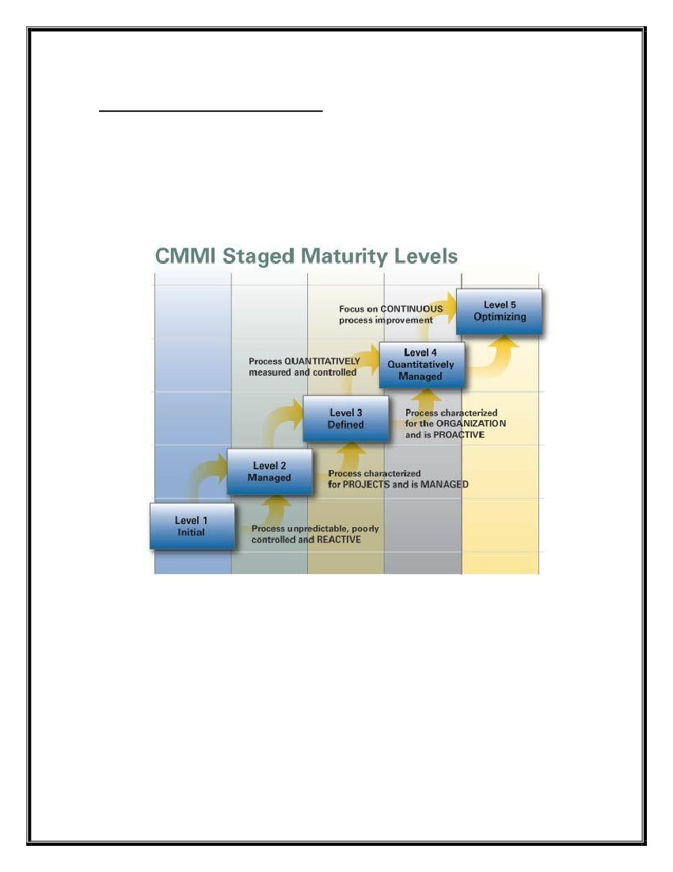
The programme does not assist the Organization only, but it will also facilitate the career
planning of the employees and assist them to achieve the objectives as well. This
augment motivation and the Organization would become a good place to work. HR
Planning forms an important part of Management information system.
HR have an enormous task keeping pace with the all the changes and ensuring that the
right people are available to the Organization at the right time. It is changes to the
composition of the workforce that force managers to pay attention to HR planning. The
changes in composition of workforce not only influence the appointment of staff, but also
the methods of selection, training, compensation and motivation. It becomes very critical
when Organizations merge, plants are relocated, and activities are scaled down due to
financial problems.
Human resources planning is an important component of securing future operations. For
sustainability, plans must be made to ensure that adequate resources are available and
trained for all levels of an organization. Although police organizations are stretched to
meet current service requirements, it is important that they also spend time to create plans
to ensure there will be officers to fill future positions. These plans must be prepared well
in advance, with targets set for the short, mid and long term. Not only must adequate
resourcing be considered for the bulk of the workforce but special consideration must be
given for the leadership of each organization. This requires developing specialized
succession plans for identifying and grooming potential future leaders. The leader
candidates must receive management, leadership, and all relevant knowledge and skills
training. Plans should also be created to leverage the knowledge of those leaving today’s
leadership roles so that future leaders are fully informed. Securing future policing
operations requires careful planning and a clear implementation strategy.
“When I look at where we have come, what gives me tremendous satisfaction is not so
much the success, but the fact that we achieved this success without compromising on the
value we defined for ourselves? Values combined with a powerful vision can turbo-
charge a company to scale new heights and make it succeed beyond one’s wildest
expectations.”
▪ Azim Premji
The basic purpose of having a manpower plan is to have accurate estimate of required
manpower with matching skills requirements. The main objectives are:
. Forecast manpower requirements.
. Cope with changes – environment, economic, organizational.
. Use existing manpower productively.
. Promote employees in a systematic way.
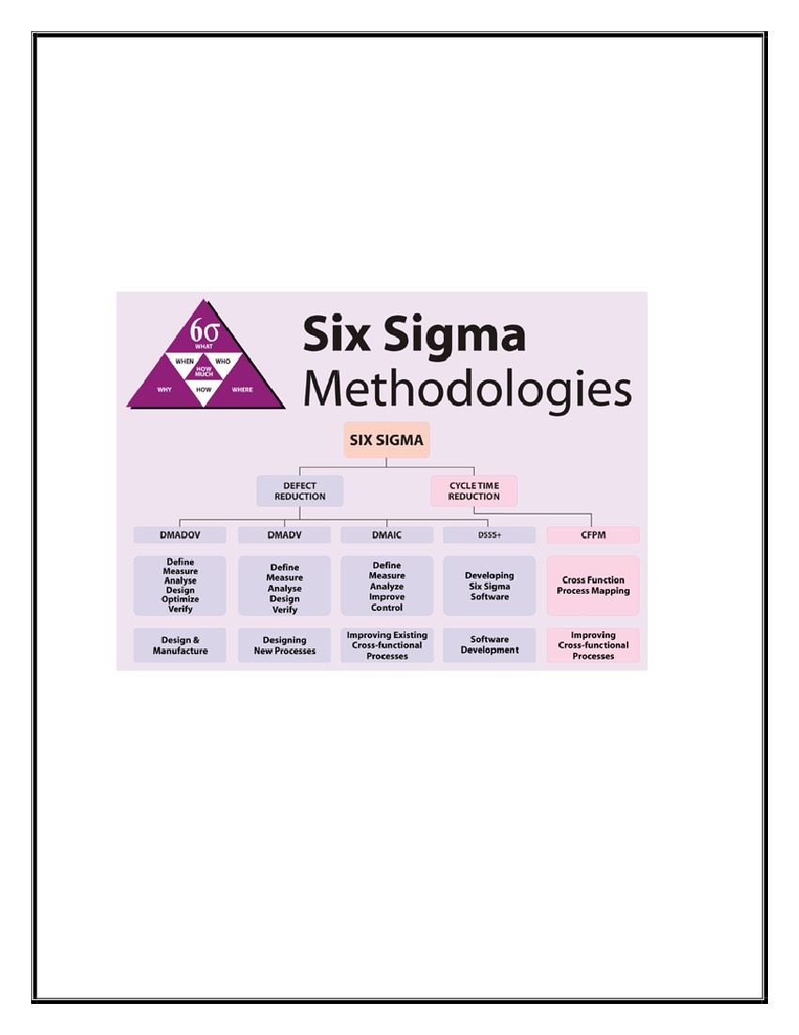
Human Resource Planning (HRP)
Wipro is the first People Capability Maturity Model (PCMM) Level 5, SEI
Capability Maturity Model (CMM) Level 5 and version 1.1 of CMMi certified IT
Services Company globally. Wipro’s people processes are based on the current best
practices in human resources, knowledge management and organization development,
giving a great focus to match changing business needs with development of employee
competencies.
Wipro has expertise in Six-Sigma methodologies, which have been put in use to
streamline and enhance existing people processes in organizations, enabling decision
making based on metrics and measurements.
❖ The central idea behind Six Sigma is that if you can measure how many “defects” you
have in a process, you can systematically figure out how to eliminate them and get as
close to “zero defects” as possible.
❖ Six Sigma starts with the application of statistical methods for translating information
from customers into specifications for products or services being developed or
produced. Six Sigma is the business strategy and a philosophy of one working smarter
not harder.
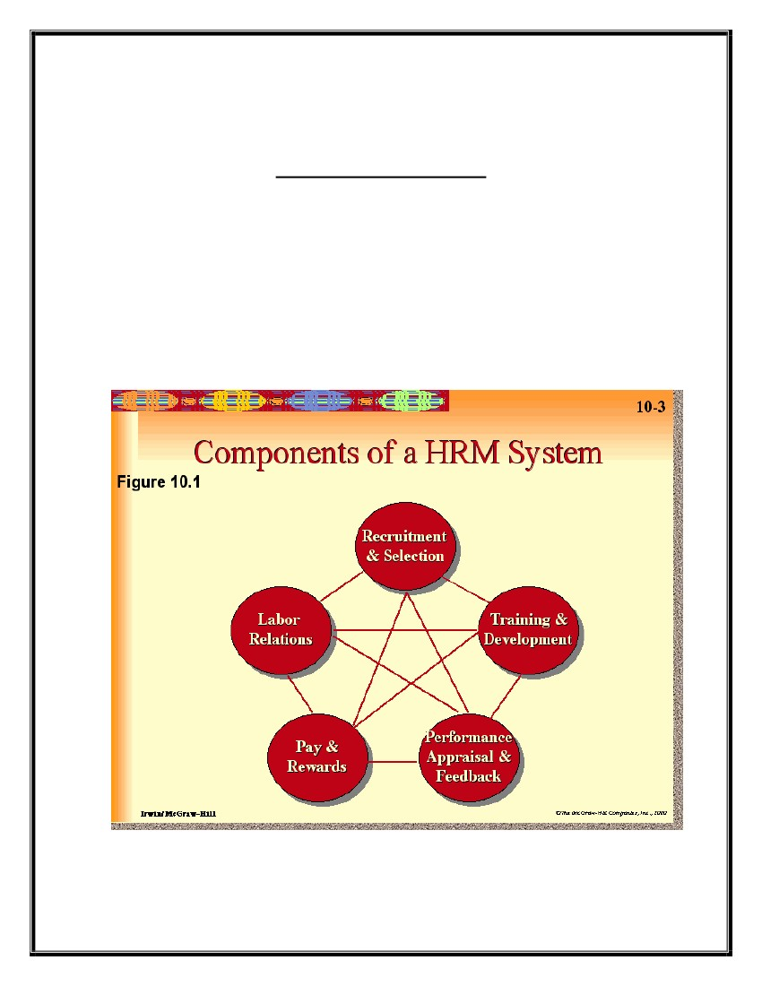
Wipro is the first Indian company to adopt Six Sigma. Today, Wipro has one of the
most mature Six Sigma programs in the industry ensuring that 91% of the projects are
completed on schedule, mush above the industry average of 55%. As the pioneers of Six
Sigma in India, Wipro has already put around ten years into process improvement
through Six Sigma. Along the way, it has scaled Six Sigma ladder, while helping to roll
out over 1000 projects. The Six Sigma program spreads right across verticals and impacts
multiple areas such as project management, market development and resource utilization.
Evolution of Six Sigma at Wipro:-
Six Sigma at Wipro simply means a measure of quality that strives for near perfection. It
is an umbrella initiative covering all business units and divisions so that it could
transform itself in a world class organization. At Wipro, it means:
(i) Have products and services meet global benchmarks
(ii) Ensure robust processes within the organization
(iii) Consistently meet and exceed customer expectations
(iv) Make Quality a culture within.
Process of human resource planning at Wipro is done by the top management
executives of HRD. They formulate the different polices in reference to the
Human Resource Planning.
MODEL OF HRP SYSTEM
❖ Human Resource Policies:-
✓
✓
✓
✓
✓
✓
✓
✓
✓
Manpower Planning
Recruitment & Selection
Training & Development
Performance Appraisal
Promotion, Transfer, & Demotion
Administration Section
Grievance Handling
Kaizen suggestion
Welfare Activities

Human Resources Outsourcing:
Services/products portfolio management has driven organizations globally to rethink their
service delivery strategy. They are looking at solutions to assist them in consolidating
segmented HR processes of various branches, maintaining quality and compliance.
Therefore, supplier consolidation/rationalization is being thoroughly analyzed as a means
to gain economies of scale, reduce overall cost and speedily implement new efforts to
meet shorter term business needs.
Wipro Human Resources Outsourcing (HRO) practice has substantial capability to
support the full spectrum of HR service offerings. These are delivered through a
combination of certified domain experts, proven transition methodology and quality
driven operational execution, which is integrated with apt technology enablers. Wipro
understands that our partners need a provider who can attain:
Lower operating cost
Speed to market
Scalable and sustainable services
Continuous improvement innovation
Wipro’s HR Business Process Outsourcing through leadership
Building transformation led and technology enabled Shared Service Centers
Promoting enhanced use of HR self-service in client organizations
Expanding the HR BPO portfolio, geographically and functionally
Engaging with more transformational engagements
Expanding language services (Wroclaw, Shanghai, Cebu, and Bucharest)
Continuously improving via Six-Sigma and Lean initiatives
Leveraging HR domain skills and process knowledge
HRO Services
Shared Services:
Our global service delivery model includes a mix of local, regional and offshore services
coupled with captive local and remote shared services centers.
HR Consulting Services:
We deliver business process efficiencies through a combination of process
transformation, outsourcing, and usage of technology platforms. These services include
Process HEAT MAPPING, Gap Analysis, Performance Metric Analysis &
Benchmarking, Process Controls Review and Risk Management, Improvement benefit
summary and Roadmap Design, Business Case Development, Process Consolidation,
Change Management, etc.
HR Transformation:
This is a planned execution of completely changing the way HR is organized and the way
services are delivered to HR customers. These changes include internal transformations,
Broad HR Outsourcing or Point Solution Outsourcing. This helps employers reduce
costs, free up resources to focus on strategy and business customers, and to improve
service.
Employee Relationship Management
Wipro has a well organized structure to deal with employee management. It has
developed few models to manage these processes, which include, EPM, BPO, SaaS,
Employee Contact Centre, etc.
Talent Management
Wipro typically offers flexible Employee Performance Management (EPM) solutions
delivered in either a Business Process Outsourcing (BPO) or Software as Service (SaaS)
model that makes assessment and development easy, more accurate and economical for
our client’s HR function. The EPM process includes goal management, performance
appraisals, multi-rater/360 feedback, workforce & succession planning, development
planning and training, etc.
Talent Management service spectrum covers the following aspects:
Learning Technology Solutions
Technology Consulting
Product Implementation and Development
Architecture
Integration, Maintenance and Production support services
Content Development
Product, Process, Domain and Technology Training Solutions
Behavioral, Soft Skills, Sales, Safety, Compliance
ERP and Non ERP Application Training Rollout
Rapid Content Development Solutions
Assessment and Certification
Consulting
Performance Consulting
Learning Interventions
Training Needs Analysis
Training Strategy Definition
Curriculum Design
Change Management
Documentation Services
Technical Writing
Technical Editing
Production
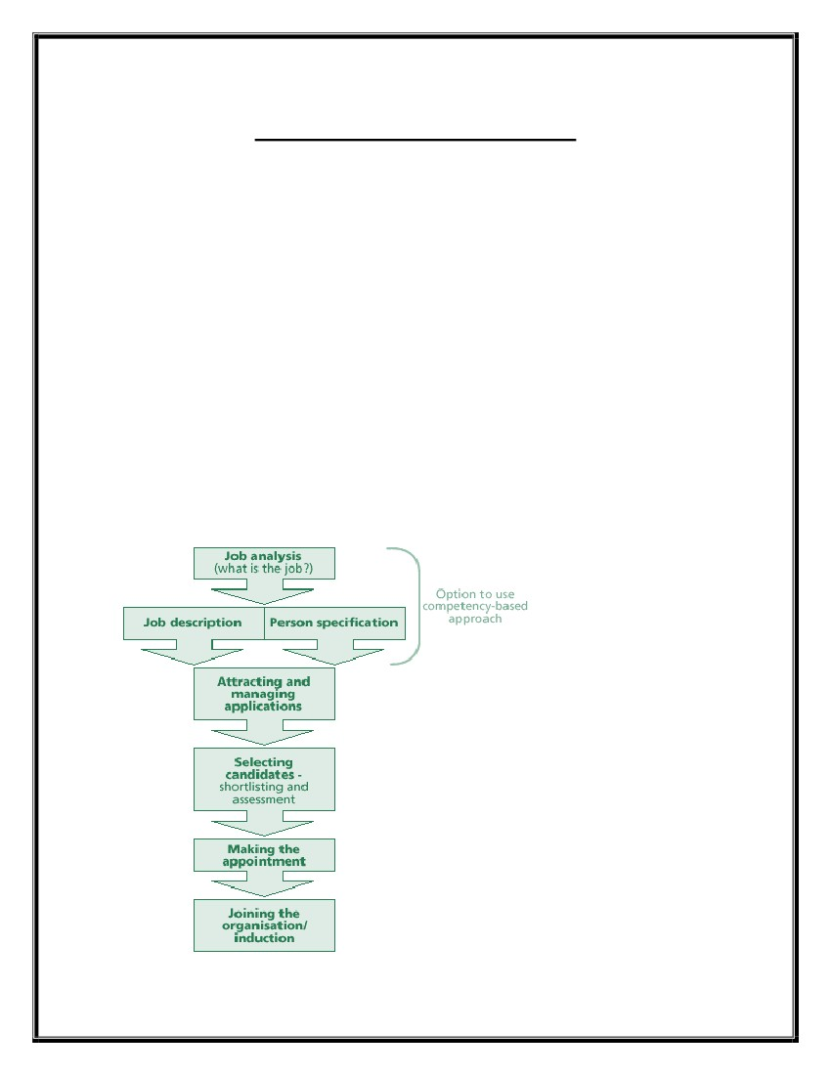
Publishing
End user documentation
Wipro’s Internal Talent Transformation Team
The “Training & Learning” arm of Wipro Technologies catering to learning needs of
over 63,000 employees
Winner of American Society for Training and Development BEST award for four
consecutive years – 2004, 2005, 2006 and 2007
Dale Carnegie Leadership Award in the year 2007
Payroll
Wipro’s HRO team understands that payroll is the key HR service, as it directly impacts
the employee and the organization and is one of the leading payroll administration
service providers. Currently, Wipro’s internal Shared Service Center (Wividus,)
established in 2003, services over 100,000 Wipro employees’ payroll.
Wipro supports ~350,000 employees across 51 states, for one of the largest retailers in
US. We process bonuses, commissions and payrolls on a weekly/biweekly basis, for
salaried/hourly employees i.e. ~1.2 million paychecks at 99.9% accuracy. The team also
handles salary queries, debt queries, final settlement checks, manual checks, stop
payments/recalls, payroll funding with the banking institutions and provides daily payroll
taxbalancingandcashfundinginformationtotheclient.
RECRUITMENT & SELECTION
Recruitment refers to the process of screening, and selecting qualified people for a job at
an organization or firm, or for a vacancy in a volunteer-based organization or community
group. While generalist managers or administrators can undertake some components of
the recruitment process, mid- and large-size organizations and companies often retain
professional recruiters or outsource some of the process to recruitment agencies. External
recruitment is the process of attracting and selecting employees from outside the
organization.
A. Internal
Sources:-
. Promotions and Transfer
. Job postings
. Employee Referrals
B. External Sources:-
. Advertisement
. Employment Agencies
. On campus Recruitment
. Employment exchanges
. Education and training institute
WIPRO recruitment process:-
Placement Tips
Three sections: you have to clear each section separately 15-verbal,15- apti,20-technical
time 50 minutes. Verbal type: word pair, analogy, fill in the blanks with appropriate
Words, Aptitude type: people, n chairs/chambers/parking etc all questions of this type
and also a paragraph was given and the logical deduction was to be done. 4 questions
were common from barons Tech type: general knowledge of computers (no programming
language questions) 4 options for each.
Interview was in 2 stages , technical was mainly concentrated on data structure and C ..
DBMS and CPP was also asked but stress was mainly upon the former, linux was asked
too if it was mentioned in the CV it was grilling and easy for some (there were 7 panels)
for the non -IT branch the interview was mainly on their project. HR was also an easy
cake, we had to prepare for 2 questions: What you know about Wipro and your strong
points, weak point, hobbies nothing else but the most surprising part was that they
eliminated more than 50 % of the candidates in the HR only whereas in others HR
eliminates only 5-10%.
There was 3 selection processes in WIPRO:-
1. APTITUDE TEST
2. TECHNICAL INTERVIEW
3. HR INTERVIEW
ABOUT APTITUDE TEST:-
Total no of question: 50
Marks: 50 (each question carrying 1 marks )
Time duration: 60 minutes
Section:
1) VERBAL (20 QUESTION)
2) QUANTITATIVE (20 QUESTION)
3) TECHNICAL (10 QUESTION)
There was sectional cut-off , question paper was not very much tough. There was no
negative marking.
VERBAL:-
You have to practice it from R S AGARWAL verbal & non verbal book & GRE barons. I
guessed the unknown answer. Synonyms, Antonyms, fill in the blanks, sentence
completion, punctuation, idioms, voice change, jumbled words, and analogies. You have
to practice it. Similar meaning of MAJESTIC etc.

QUANTITATIVE:-
This portion was easiest portion. If you practice it from R S AGARWAL- quantitative
aptitude book then you can find most of them are same type. Problem on ages,
permutation, combination, train, work & time, mixture & allegation, simple & compound
interest, probability, pipes & cistern, speed, problem on series (A.P., G.P.), profit & loss
etc are important for WIPRO.
TECHNICAL:-
You hav to brush up your C, C++, OS, Data structure thoroughly. ECE guys also will
give their importance on digital electronics & microprocessor. Some questions I
mentioned here-
1)binary digit of 172
2)excess 3 code of 32
3)Which is the volatile memory-a)RAM b)ROM c)Flash memory d)non of these
4)Marc Anderson is famous for which invention: a)Napster b)Netscape browser
c)Microsoft messenger d)Scur virus. Ans:-b)
5)’show the o/p’ related three problem.
165 students cleared apti test. After that they called us for technical interview & I’m 2nd
person in my panel.
Round 1: Written test
1. Verbal: This section will have 15 questions related to synonyms, antonyms,
Analogies, SC, Prepositions and reading comprehension.
2. Aptitude: This section will have 15 questions related to aptitude topics like Time &
Work, Time & Distance, Blood Relations, Series Completion, Puzzles, Calendars,
Clocks, Percentages, Ratio proportions, Ages, Pipes and Cisterns etc.
3. Technical: This section will have 20 questions related to basic technical concepts from
C, C++, Java, Linux, UNIX, DBMS, SQL, Programming fundamentals, Hardware,
Software Engineering, and Micro Processors etc. Candidates are informed to brush up
their technical skills which were covered in their regular academic curriculum.
Round 2: Technical Interview
This is a major elimination round. Candidates should be thorough with their basic
technical skills to clear this round. Candidates are here by informed to be prepared with
their core subjects. Technical test (networks, OS, basic computation) like:-
a. what is NIC?
b. define ping/ipconfig/dhcp etc. they can ask you to explain with a scenario.
c. Basic Computer knowledge (Like - how to locate LAN settings, how to get into
internet or hardware properties, how to check your domain and the computer name etc.)
d. Basic Internet knowledge.
e. How can you create a LAN?
f. Types of cables and which one is used where?
g. Network Layers/architecture. Types and related protocols (TCP/IP, FTP, SMTP..)
h. Basic file structure.
i. Win XP vs Win 98??
j. LAN / WAN / MAN.
k. Types of memory.
l. Router vs Hub vs Switch.
m. What is MODEM?
n. Types of movie file formats.
o. Broadband vs Baseband. etc.
Round 3: HR Interview
Candidates can expect basic HR interview questions like Tell me about your self, Why
should I hire you, Why only WIPRO, What is SIX sigma level.
Candidates will be tested in their communication and vocabulary during technical and
HR interviews.
These are the recently asked questions in HR round for Wipro non-voice process please
help me in answering this questions:
1. Tell me about yourself?
2. What do you know about our company?
3. What will you do in the lesure time?
4. Who is the person whom you are admired of?
5. What is investment banking?
6. What is the happiest movement in your life?
HR Interview Questions for Wipro
1. What
is the difference between PCR and CAP?
2. How do you run payroll?
3. How do you correct payroll?
4. If I want to include some more wage types, say bonus from today.
How should I do that?
5. What is meant by payroll area? What are the uses of payroll area?
6. What is meant by a control record?
7. What is meant by retroactive accounting?
8. How do you create customized ITs? What is the no. range for
customer specific ITs?
9. What are data types? How many data types exist? What are they? Where
do you configure them?
10. What is a counting rule?
11. What is absence type?
12. How do you configure absence? Give an example
13. What is absence quota type?
14. What are the features you used in benefits?
15. How many health plans have you configured, what are they?
16. What are the most important ITs in benefits?
17. List the applicant actions in recruitment.
18. What is the feature used for Personnel Administrator. What group
should you use in that?
19. What are the IT's used in NUMKR? (I said NUMKR is associated with
Org. Assgnmt.)
20. What is an applicant group?
21. What is an unsolicited applicant group?
22. What is the technical code for authorizations?
23. Differentiate between Payroll area and pay scale area?
Round 4: Placement
Upon Joining, the incumbent shall be given an employee code number by Manager(HR)
and he shall fill up the joining forms and shall submit the same to the Manager(HR) for
further course of action. Final HR - just a formality (They will explain you the salary structure
etc.) Wipro recruit 40% employees from campus recruitment. Another popular
source for Wipro’s Recruitment is the Online Placement through NSR (National
Skill Registry).
Selection is the process of putting right men on right job. It is a procedure of matching
organizational requirements with the skills and qualifications of people. Effective
selection can be done only when there is effective matching. By selecting best candidate
for the required job, the organization will get quality performance of employees.
Moreover, organization will face less of absenteeism and employee turnover problems.
By selecting right candidate for the required job, organization will also save time and
money. Proper screening of candidates takes place during selection procedure. All the
potential candidates who apply for the given job are tested.
But selection must be differentiated from recruitment, though these are two phases of
employment process. Recruitment is considered to be a positive process as it motivates
more of candidates to apply for the job. It creates a pool of applicants. It is just sourcing
of data. While selection is a negative process as the inappropriate candidates are rejected
here. Recruitment precedes selection in staffing process. Selection involves choosing the
best candidate with best abilities, skills and knowledge for the required job.
The Employee selection Process takes place in following order-
1. Preliminary Interviews- It is used to eliminate those candidates who do not meet
the minimum eligibility criteria laid down by the organization. The skills,
academic and family background, competencies and interests of the candidate are
examined during preliminary interview. Preliminary interviews are less
formalized and planned than the final interviews. The candidates are given a brief
up about the company and the job profile; and it is also examined how much the
candidate knows about the company. Preliminary interviews are also called
screening interviews.
2. Application blanks- The candidates who clear the preliminary interview are
required to fill application blank. It contains data record of the candidates such as
details about age, qualifications, reason for leaving previous job, experience, etc.
3. Written Tests- Various written tests conducted during selection procedure are
aptitude test, intelligence test, reasoning test, personality test, etc. These tests are
used to objectively assess the potential candidate. They should not be biased.
4. Employment Interviews- It is a one to one interaction between the interviewer
and the potential candidate. It is used to find whether the candidate is best suited
for the required job or not. But such interviews consume time and money both.
Moreover the competencies of the candidate cannot be judged. Such interviews
may be biased at times. Such interviews should be conducted properly. No
distractions should be there in room. There should be an honest communication
between candidate and interviewer.
5. Medical examination- Medical tests are conducted to ensure physical fitness of
the potential employee. It will decrease chances of employee absenteeism.
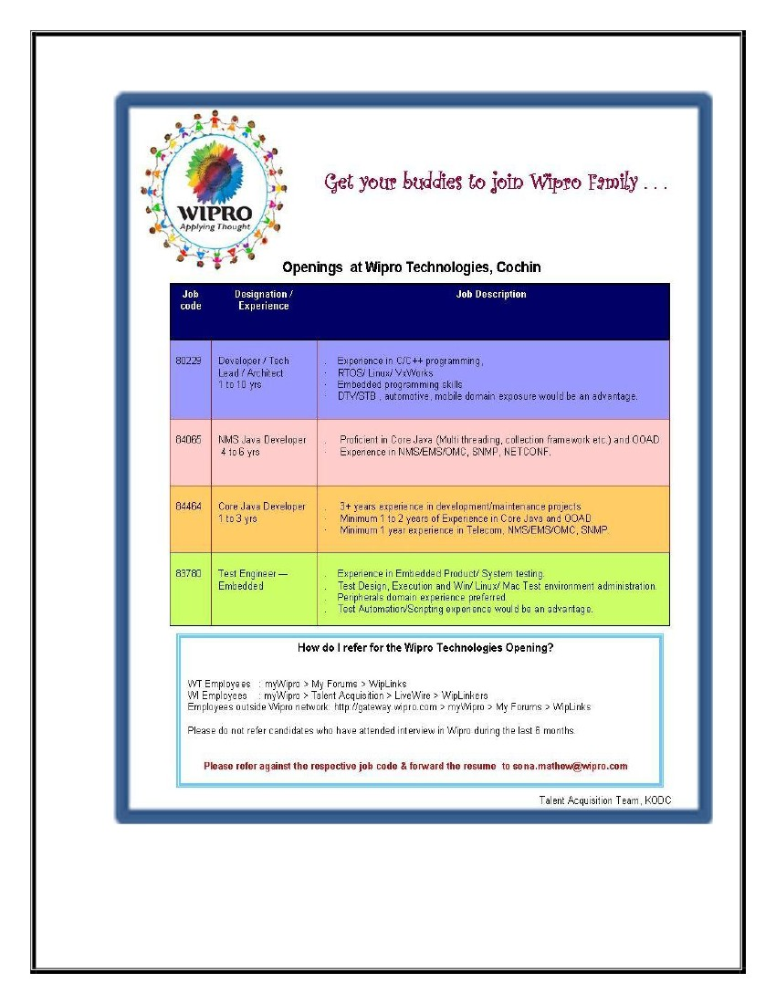
6. Appointment Letter- A reference check is made about the candidate selected and
then finally he is appointed by giving a formal appointment letter.
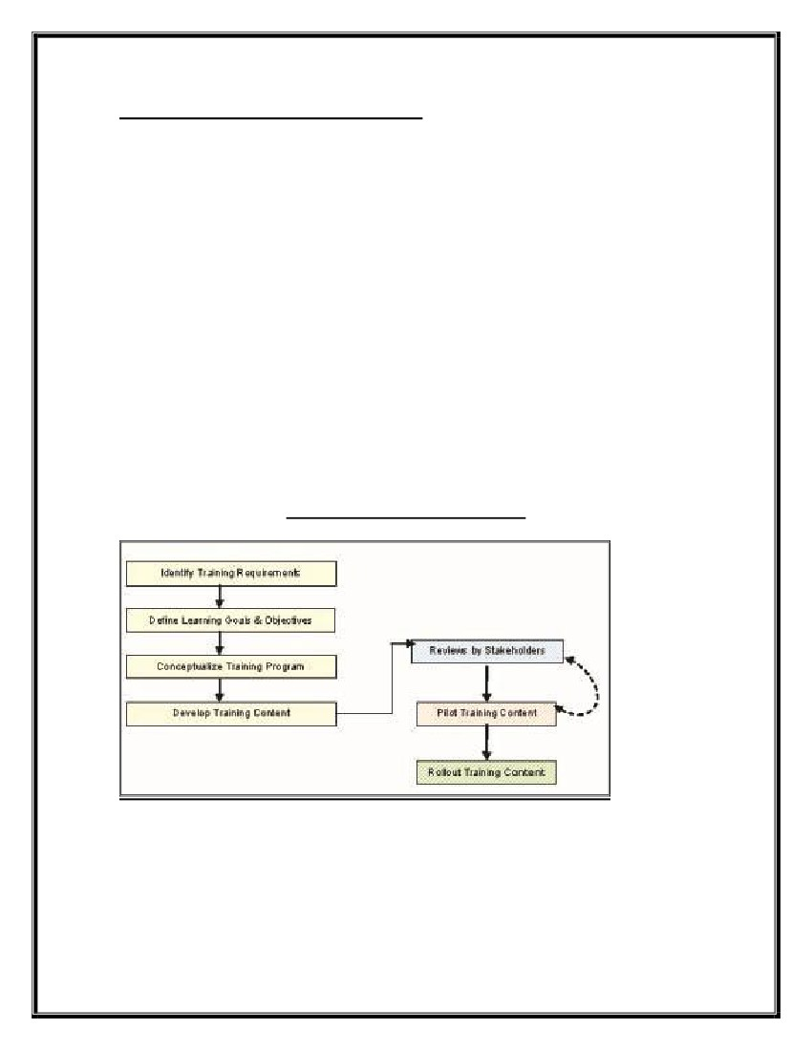
An Illustration for explaining the recruitment & Job Description of Wipro
TRAINING & DEVELOPMENT
The term training refers to the acquisition of knowledge, skills, and competencies as a result
of the teaching of vocational or practical skills and knowledge that relate to specific useful
competencies.
❖ Training & Development of individuals is a key focus area at Wipro. Our Talent
Transformation Division handles this. For those with less than one year of experience a
well-structured induction training program is conducted. This will cover all aspects of
software development skills that are required.
❖ As a PCMM Level 5 organization, there is also high focus on Competency Development.
Talent Transformation has a mandate to provide technical & business skill training based
on the departmental and divisional need. All employees are eligible to take training based
on the competency gap identified or Project need.
❖ In addition to class room training one can take e-Learning with out waiting for class room
training.
❖ Compliance and Regulatory training is an important aspect in today’s regulated
environment and is often implemented as part of corporate initiatives. All large companies
have mandatory trainings be it in the field of Environment, Health & Safety, Ethics, Risk-
Management, Finance, Law, etc.
WIPRO TRAINING MODEL
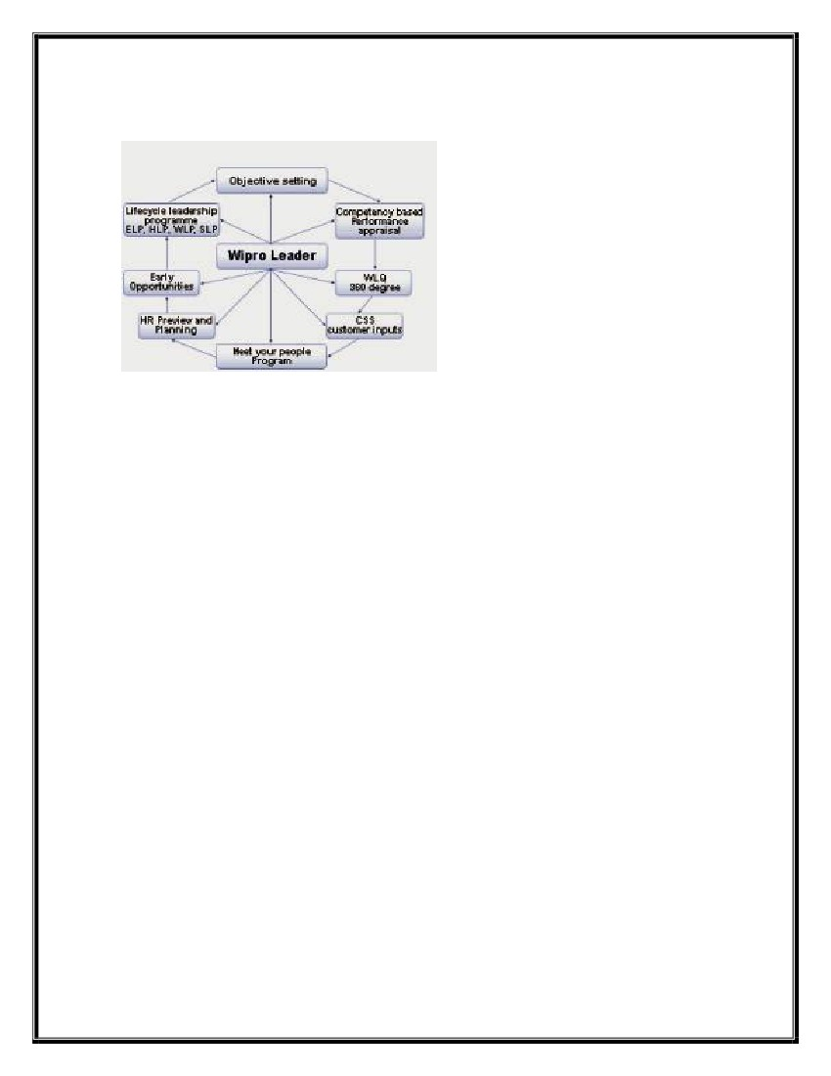
❖ Rapid Learning:-
At Wipro, we know how critical time is for fulfilling training needs and hence we have
developed competency in the area of Rapid Learning. An emerging form of content
development, Rapid Learning helps to develop content in a short span of time using
various tools; the content delivery can be both synchronous as well as asynchronous.
Wipro has strategic partnerships with leading technology providers to help you choose
the tool that suits your requirement best. Based on research conducted in this area, Rapid
Content Development can be used for any of the following content areas:
Critical Training – when the training requirement is critical and must be addressed
immediately.
Minor change – when the difference between what is known and what is new is minimal
Short shelf life – when the content in question has a very short shelf life
Frequent updates – when the content needs to be update frequently.
❖ Process Training :-
Large enterprises keep updating their processes to improve the efficacies of their systems.
Business process training is typically a part of any organization’s overall change
management plan. Wipro provides Process Training in several fields including HR,
Quality, Operation, Payroll, Recruitment, and more. For a meaningful transition of the
process, quality training is extremely critical. Understanding the complexities involved in
rolling out these process trainings, we bring you quick solutions that help deliver
effective training for your organization.
The components of process training are:
1. Analyze
2. Inform
3. Involve
4. Support
Development
Wipro Leaders’ Qualities Survey,which started in 1992, is one of our oldest leadership
development initiatives. It has successfully contributed in our endeavor to nurture top
class business leaders in Wipro. We have 8 Wipro Leadership Qualities, which are based
on Wipro vision, values and business strategy. In order to identify and help leaders
develop these competencies we adopt a 360-degree survey process. This is an end-to-end
program, which starts with the obtaining of feedback from relevant respondents and ends
with each leader drawing up a Personal Development Plan (PDP) based on the feedback
received. The PDP is developed through “Winds of Change” which is a seven-step
program that helps in identifying strengths and improvement areas, and determining the
action steps.
The Leadership Development Framework
Leadership Lifecycle Programs
Wipro has developed an approach for Life Cycle Stage Development Plan. Training and
development programs at various stages have been designed by mapping the
competencies to specific roles. Competencies specify the specific success behaviors at
every role.
· Entry-level program (ELP) - The program covers the junior management employees
with the objective of developing managerial qualities in the employee. The target group is
campus hires and lateral hires at junior level.
· New Leaders’ Program (NLP) - It is popularly known as NLP and aims at developing
potential people managers, who have taken such roles or are likely to get into those roles
in the near future.
· Wipro Leaders’ Program (WLP) - This program is for middle level leader with
people, process, business development and project management responsibilities. These
leaders are like the flag bearers of Wipro values and Wipro way of doing business.
· Business Leaders’ Program (BLP) - This is for senior leaders with business
responsibility. At this level, people are trained up for revenue generation; and Profit &
Loss responsibilities. The program covers commercial orientation, client relationship
development, and team building and performance management responsibilities among
other things.
· Strategic Leaders’ Program (SLP) - This program covers top management
employees. The focus is on Vision, Values, Strategy, Global Thinking and Acting,
Customer Focus and Building Star Performers. Wipro ties up with leading business
schools of international repute to conduct this program for Wipro leaders.
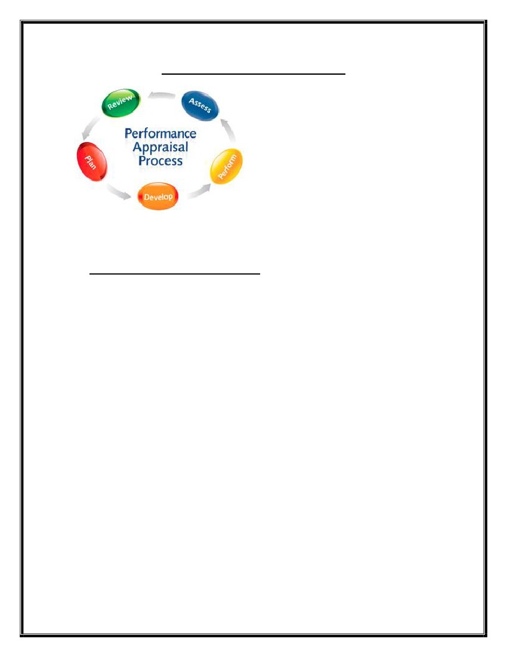
Custom Content Development
As a part of the Custom Content Development Service, Wipro provides innovative and
affordable learning content solutions. This service is customized specially to meet your
requirements and help you get a competitive edge. Wipro’s Custom Content
Development Service goes through a rigorous development cycle to ensure Quality and
Timely Delivery of the solution.
Custom Content Development Service includes:
· Application Training
· Process Training
· Compliance and Regulatory Training
· Product Training
· Rapid Training Solutions
Performance Appraisal
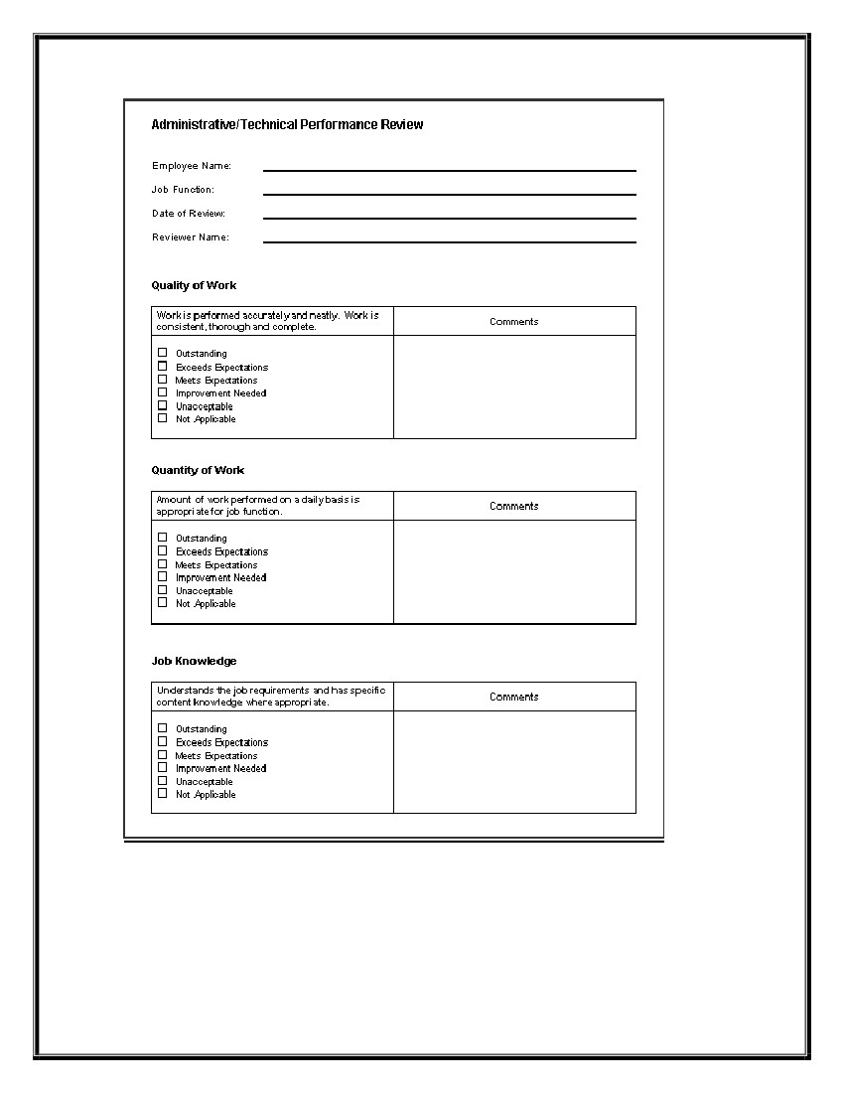
PERFORMANCE APPRAISAL
Performance appraisal is a method by which
the job performance of an employee is evaluated in terms of quality, quantity, cost and
time. Performance appraisals are regular reviews of employee performance within
organizations.
❖ Aims of a performance appraisal:-
Give feedback on performance to employees.
Identify employee training needs.
Document criteria used to allocate organizational rewards.
Form a basis for personnel decisions: salary increases, promotions,
disciplinary actions, etc.
➢ Provide the opportunity for organizational diagnosis and development.
➢ Facilitate communication between employee and administrator.
➢ Validate selection techniques and human resource policies to meet federal
Equal Employment Opportunity requirements.
➢ Wipro’s solution aims at strategic value delivery in the least possible time
incorporating rich functional features, aided by smooth workflow,
notification, authorization, etc.
Align employee objectives to the business goals. Enable strategic Performance
Management through Management by Objectives (MBO)
Measure and Assess employee performance periodically and provide feedback and
support to achieve quantitative, qualitative and process targets
Evaluate and track Hi-Performance and achievers based on Competency driven
practices.
Enable online Reward and Recognition Performance Appraisal.
➢
➢
➢
➢
➢
➢
➢
➢
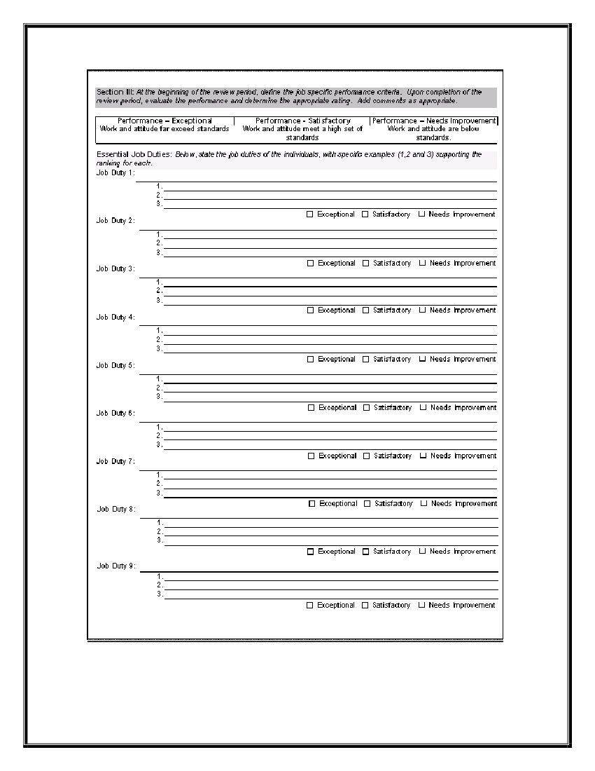


APPRAISAL SYSTEM :-
• Are your people developing and performing as fast as your business moves?
• Are you measuring the pace of your people and tracking it?
In order to answer your Performance related questions, Wipro offers an integrated end-to-
end Performance Management Solution. This solution is based on global people
processes drawn from best practices and helps organizations streamline their performance
evaluation processes.
Wipro’s e-Performance Management solution not only helps you establish the best
practices in Performance Management, like 360degree appraisal, MBO, etc, but enables
reduced Performance Management cycle time without compromising on the sub-
processes which are so critical to your HR values, like Work Planning Conference, Work
Plan establishment, Development plans and Objective setting, Interim Review, Overall
evaluation, detecting Performance deficiencies, Tracking, Documentation and Archiving.
Once reviewed by HR dept. Assistant (HR) updates the records for each employee’s
score in the database.

PROMOTION
“Higher you go. Heavier you get”
A promotion is the advancement of an employee's rank or position in an organizational
hierarchy system. Promotion may be an employee's reward for good performance i.e.
positive appraisal. Before a company promotes an employee to a particular position it
ensures that the person is able to handle the added responsibilities by screening the
employee with interviews and tests and giving them training or on-the-job experience. As
per Guidelines for supervisory employees’ promotion/up gradation, applicable to the
present year, Manager (HR) prepares the list of eligible employees. Simultaneously, V P
(HR) also asks for recommendations from HODs. A comprehensive list is then prepared
by Manager (HR) and submitted to the EPPP which is announced by the Site President,
for Executive and Manager family, and by the Group President (MSD), for Leader
Family.
• Bases Of Promotion :-
1. Seniority:-
Seniority simply depends upon how long the employees is doing job with the company.
The length of service and talent are both interrelated with each other. It is based on the
tradition of respect for older people. It creates a sense of security among employees and
avoids conflict arising from promotion decision.
2. Merit:-
Merit implies the knowledge, skill and performance records of an employee. It helps to
motivate competent employee to work hard and acquire new skills. It helps to attract and
retain young and promising employees in the organization.
On the above basis, promotion of employees is done in Wipro. Wipro also prompt
employee by conducting different case studies on different aspects of Information
Technology. Working at Wipro is very comparative & to get promotion required smart
work and projection.

COMPENSATION
Compensation is a systematic approach to providing monetary value to employees in
exchange for work performed. Compensation may achieve several purposes assisting in
recruitment, job performance, and job satisfaction.
Wages and salaries structure is very vital for the retention of the employees as due to stiff
competition, if proper salary is not given then the employees will go to those organization
offering higher salaries. Jivraj Tea Ltd is actively involved in retaining good manpower
in the organization by providing proper salary and incentive methods. Wipro runs 50
offices in India. It has a branch office in USA, Canada, Europe, Middle east, Africa etc.
PAY SCALE OF EMPLOYEE AT WIPRO
EMPLOYEE CLASS
A+ CLASS
A CLASS
B+ CLASS
B CLASS
TECHNICIAN
ZERO LEVEL
TOTAL
NO.OF EMPLOYEE
128
1240
33000
22000
4000
3440
SALARY PER MONTH
120000 US $
150000
60000
45000
35000
10000
EMPLOYEE WELFARE
According to the Oxford dictionary, employee welfare or labour welfare means “the
efforts to make life worth living for workmen.” Labour Welfare means anything done for
the comfort and improvement, intellectual or social, of the employees over and
governmental, which is not a necessity of the industry.
➢ Welfare Activities :-
▪ Education :-
Wipro has its own institute, where the education is given to the employees’ children
absolutely free. The school has classes from JR. kg to class-XII
In English medium. Free transportation facility is also provided to them.
▪ Medical –
Company’s philosophy is “Nobody should die without fund”. Company believes its
responsibility towards health services to provide to the employees go beyond the
statutory provision. Being the petrochemical industry and some of their process are
considered “Hazardous”. Company recognizes the importance of good occupational
health services. Therefore, at the manufacturing sites, they have well equipped, full
fledged medical centre, which are manned round the clock.
▪
Housing –
Company has it’s own township at different location in Bangalore. If house is
available, the new employees are allotted the house otherwise the company can also
hire house. All the maintenance in houses provided to employees by company is done
by the company.
▪ Canteen –
The company gives canteen facility under which food is provided to the employees
but it is not compulsory for them. They get the allowance in their salary. The Contract
Cell at Wipro invites tenders and the Contract cell signs detailed agreement with the
contractor. The operation of the canteen is given on the contract.

➢
Employee Welfare
▪ Sports -
To motivate the employees of the company organizes different sports tournaments i.e.
Cricket, Volleyball, Table Tennis, Badminton Etc.
▪ Recreation activities -
For the recreation of the employee, company organized gets to gather once in a year with
their family and also arranged short distance picnic. For picnic they get Rs. 100/- and free
transportation once in a year.
▪ Club membership -
The purpose of the club membership is to meet the other members of the industrial
community and interact with them for relation personnel leisure. This facility is provided
only to the SMC and above.
▪ Insurance Policy –
Wipro provides personal accident insurance policy of Rs 100000 for employees.
Premium of the company is half pay by employee and other will pay by Wipro.
❖
BENEFITS GIVEN TO THE EMPLOYEE IN WIPRO
Wings Within
You also have access to various job opportunities within Wipro itself. This would enable
you to pursue careers of your choice in the Organization. Your career at Wipro is what
you make of it. It is a tool that gives you flexibility to apply for the job of your choice
and map your own career. Very few organisations can match Wipro's capability to offer
the kind of flexibility and opportunity to pursue multiple careers and unhindered growth,
while you continue to work in the same organisation.
Wipro Leaders Program
We not only groom your technical talents but also bring out the leader in you. Our
Leadership Program gears you up to take on the challenge for successfully heading large
and strong teams. The program is designed to identify the specific actions and attitudes
that constitute the Wipro leader's qualities. It examines how each manager rates against
these qualities, provide an understanding of how the required skills and competencies can
be developed and plan what each individual can do to strengthen his or her leadership
qualities.
Recognition
Your hard work and contribution never go unnoticed at Wipro. The size we have grown
to and the diversity of people has given rise for a need to introduce awards. At every step
of success there is an award awaiting you. The challenges we encounter, motivates us to
accomplish greater feats and the comforts of rewards and recognition comes as a package
Long Services Award
We at Wipro take pride in our long serving colleagues. They are a major force behind our
success. We recognize their contribution through a comprehensive reward programme -
Schemes include holiday packages with special facilities.
Benefits
The governing theme in our organization is the well being of employees. The benefits we
offer them are on par with the best available.
Our Compensation package is among the best in the industry and it is aimed at retaining
existing talent. The package caters to all positions across Wipro. A reward for each
position is based on performance, potential, criticality and market value.
We have a comprehensive medical assistance program that covers the whole gamut of
medical expenses you and your family incur.
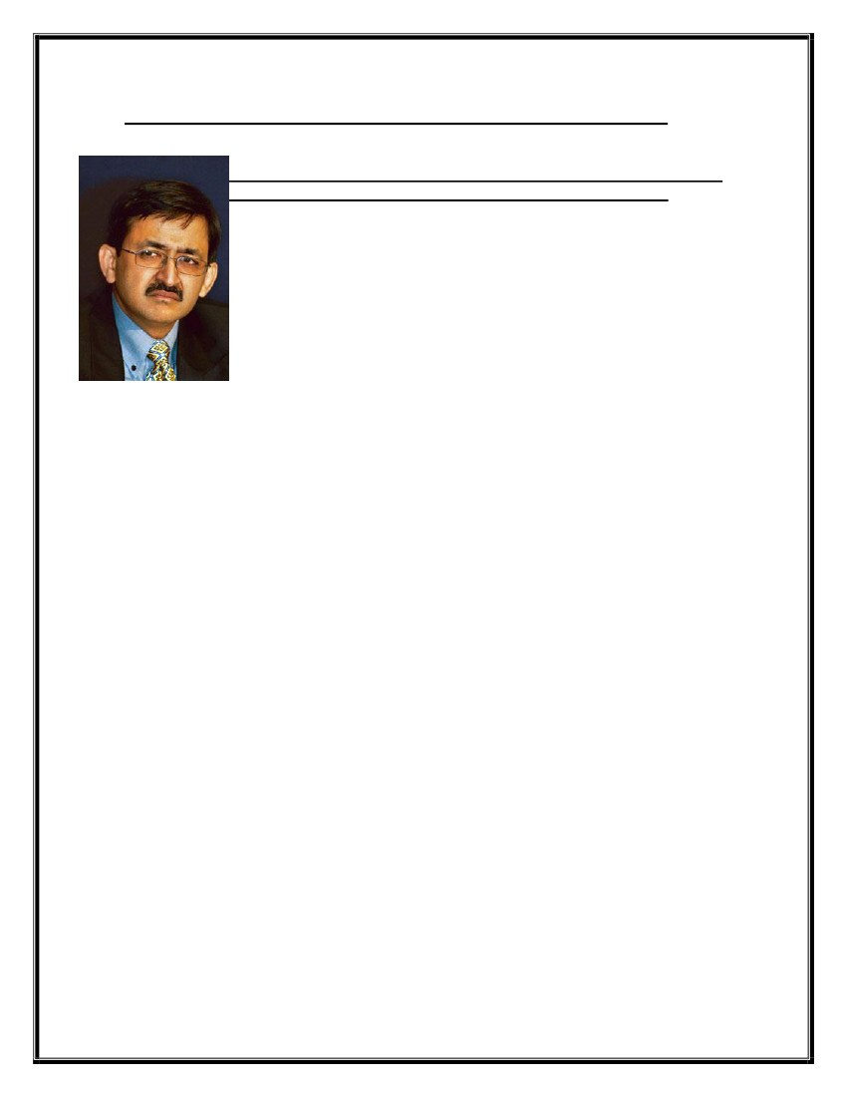
Our reimbursement scheme provides you tax shelter on quasi-official expenses.
Your growth in the company will be complemented by your own self-development. Our
educational assistance plan offers you all encouragement in pursuing the course of your
interest. Our leave policy also includes a sabbatical to pursue higher studies related to
your profession.
Our responsibility towards new employees doesn't stop at salaries and compensation
alone. We offer all possible help to facilitate their settling down. We provide interest-free
loan mainly intended to cover housing deposit or the purchase of a two wheeler. We also
provide contingency loans for your marriage, illness or death of a close family member.
As a part of employee empowerment, we offer stock options to deserving employees. The
Wipro Employee Stock Option Plan (WESOP) allows us to make employees share with
us the rewards of success.
Our other facilities include credit cards for all our employees as per the policy. Monetary
benefits apart, we take interest in the personal well being of our employees. We have a
facility wherein your domestic chores will be taken care of through an external agency,
ensuring that with us you don't need to worry about all those boring routines like payment
of bills, personal travel bookings etc. Not to forget shuttle services to our development
centers and canteen facility. (We also provide transport facilities to our development
centers and cafetaria at our facilities)
All these in addition to a host of deferred benefits like provident fund, gratuity and
pension plan.

Wipro Consumer Care and Lighting workers strike work
A Wipro statement said the firm was keen to sign a four-year wage
settlement and is open to discussions as soon as the strike ends
Bangalore: Workers at the Mysore factory of Wipro Consumer Care and
Lighting, a business division of Wipro Ltd, have struck work since
Tuesday over a wage dispute, halting the production of compact
fluorescent light bulbs and tubelights at the peak of the festive season.
On edge: Wipro Consumer Care and Lighting chief Vineet Agrawal.
Namas Bhojani / Bloomberg
The workers’ union, affiliated to the All India Trade Union Congress (Aituc), went on
strike over a wage settlement pending since February. The factory, located in the
Hootagalli industrial area on the outskirts of Mysore, employs nearly 250 workers.
The workers are demanding a wage hike of Rs5,000 a month and negotiations for pay
increases once in three years, effective May this year. The average monthly wage for
employees was Rs3,700, said H.R. Sheshadri, the local Aituc general secretary who also
heads the workers’ union. Unions at three of the seven Wipro factories across India are
affiliated to Aituc.
The eight-year-old Mysore plant is equipped to produce 37 million lamps of different
categories in a year.
A Wipro statement said the firm was keen to sign a four-year wage settlement and is open
to discussions as soon as the strike ends.
Wipro had offered a wage hike of Rs1,000 a month, said Seshadri, adding the union was
prepared to compromise on its demand and accept an increase of Rs2,500. The
management had refused to budge, he said. The union gave the mandatory 20 days’
notice before it went on strike, he said.
An official at the Karnataka labour department said it has called for tripartite talks on
Friday with the workers’ union and the management to settle the row.
The consumer care and lighting business posted revenues of Rs527 crore for the second
quarter ended September, less than one-tenth of the Rs6,507 crore Wipro earned during
the period. Wipro is also India’s third biggest computer services firm.
BIBLIOGRAPHY
➢ www.wipro.com
➢ www.wipro.in
➢ www.wipro.net
Book referred for the explanation of concept
➢ Human resource management \
Author- V.S.P.Rao
Edition – II

