Road Network Shortest Path Analysis
Using SNAP Dataset
Analytical Report
CS5329 Algorithm Design & Analysis
Team Members
Raja Brahmendra
Varshith Gandra

Executive Summary
This project analyzes shortest-path search on a real-world road network using the SNAP roadNet-CA dataset. The dataset represents road intersections or endpoints as nodes and road connections as edges. Because the dataset does not include distance, speed, or travel time, it is treated as an unweighted graph.
The project compares two approaches for shortest-path search: a baseline edge-list BFS and an optimized adjacency-list BFS. Both approaches use BFS and return the same shortest path length, but they differ in how they find neighbors. The baseline scans the full edge list repeatedly, while the optimized version builds an adjacency list for direct neighbor lookup.
The benchmark tested five input sizes from 10,000 to 1,000,000 edges. At 1,000,000 edges, the optimized BFS was about 17.93 times faster than the baseline while still producing correct output. The optimized version used more memory because it stores the adjacency list, which shows a clear time-memory tradeoff.

1. Dataset Description
The dataset used in this project is the SNAP roadNet-CA dataset. It represents the California road network as a graph. Each row in the file is an edge between two node IDs.
In this project:
- Node: a road intersection or road endpoint.
- Edge: a road connection between two intersections or endpoints.
- Graph type: unweighted graph for this project, because distance and travel time are not included.
Example dataset rows:
0 1
0 2
1 385

This means node 0 is connected to node 1, node 0 is connected to node 2, and node 1 is connected to node 385.

2. Problem Statement
The problem is to find the shortest path between two road intersections in a large road network. Since the graph is unweighted, the shortest path is measured by the number of road segments, not by miles or travel time.
Breadth-First Search is appropriate because BFS finds the shortest path by number of edges in an unweighted graph. This project is not a full GPS system because the dataset does not include road names, distances, coordinates, speed limits, or traffic conditions.

3. Code Structure and Modularity
The project is split into separate files so each part has one clear responsibility.
File | Purpose
data_loader.py | Loads and parses the SNAP road network dataset.
algorithms.py | Contains baseline BFS, optimized BFS, adjacency-list construction, and verification helpers.
test_algorithms.py | Runs a small correctness test before benchmarking.
main.py | Main project demo and entry point.
benchmark.py | Measures runtime, memory, speedup, and correctness across input sizes.
road_closure_analysis.py | Extra feature that simulates blocked intersections or road segments.

4. Algorithmic Comparison

4.1 Baseline Approach: Edge-List BFS
The baseline approach uses BFS directly on the edge list. Every time the algorithm visits a node, it scans the entire edge list to find outgoing neighbors from that node.
This approach is simple and easy to implement, but it is inefficient on large graphs because the full edge list is scanned many times.
Baseline time complexity: O(V * E), where V is the number of visited nodes and E is the number of edges.
Baseline memory usage is low because it does not build an extra adjacency structure. Most extra memory is used by the BFS queue, visited set, and path tracking.

4.2 Optimized Approach: Adjacency-List BFS
The optimized approach first builds an adjacency list. In an adjacency list, each node stores its direct neighbors. This makes neighbor lookup fast.
Example adjacency list:
0: [1, 2, 469]
1: [0, 6, 385]
Building the adjacency list costs O(E). Running BFS using the adjacency list costs O(V + E). The total simplified complexity is O(V + E).
The optimized approach uses more memory because it stores the adjacency list, but it avoids repeated full-edge scans and is much faster in practice.

4.3 Key Difference
Both approaches use BFS. The improvement is not from changing BFS into a different algorithm. The improvement comes from using a better data structure for neighbor lookup.
Baseline: scan the full edge list to find neighbors. Optimized: use direct adjacency-list lookup.

5. Correctness Verification
Before benchmarking, both algorithms were tested using the same start and goal nodes. The test confirmed that both algorithms returned the same shortest path length.
Start node: 0
Goal node: 385
Baseline path: [0, 1, 385]
Optimized path: [0, 1, 385]
Path length: 2
Same shortest path length: True
The exact node sequence is not always required to match because a graph may contain multiple valid shortest paths with the same length. Therefore, the project verifies correctness by comparing shortest path length.

6. Benchmark Methodology
The benchmark compares the baseline and optimized approaches across five input sizes. Each input size runs 100 route queries.
- Input sizes: 10K, 50K, 100K, 500K, and 1M edges.
- Runtime measurement: time.perf_counter().
- Memory measurement: tracemalloc.
- Correctness check: shortest path length comparison.
- Output file: results/benchmark_results.csv.

7. Benchmark Results
Edges | Nodes | Queries | Baseline Time (ms) | Optimized Time (ms) | Speedup | Correct
10,000 | 4,478 | 100 | 27.10 | 2.43 | 11.14x | True
50,000 | 17,572 | 100 | 116.57 | 5.78 | 20.18x | True
100,000 | 35,539 | 100 | 223.26 | 11.87 | 18.82x | True
500,000 | 183,395 | 100 | 1116.88 | 82.62 | 13.52x | True
1,000,000 | 361,835 | 100 | 2383.67 | 132.91 | 17.93x | True

At 1,000,000 edges, the baseline took 2383.67 ms and the optimized approach took 132.91 ms. This means the optimized approach was about 17.93 times faster while still producing correct output.

8. Empirical Charts
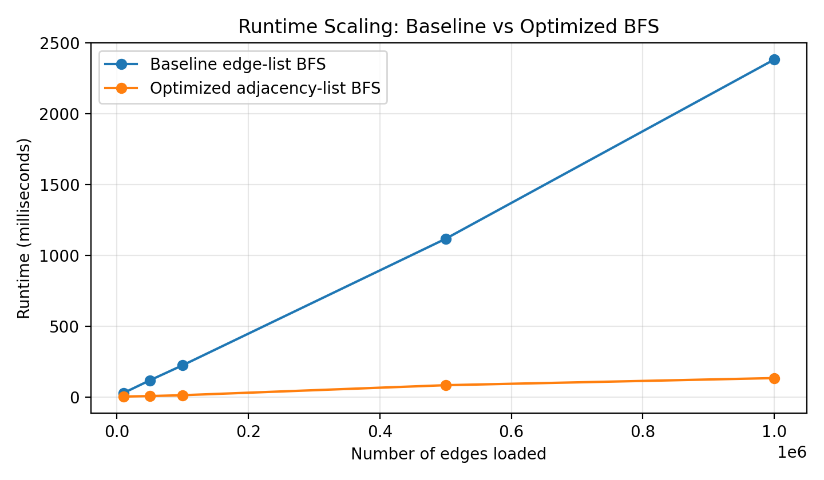
Figure 1. Runtime scaling for baseline and optimized BFS.
Figure 1 shows that the optimized approach has much lower runtime than the baseline at every input size. The difference is caused by faster neighbor lookup after building the adjacency list.
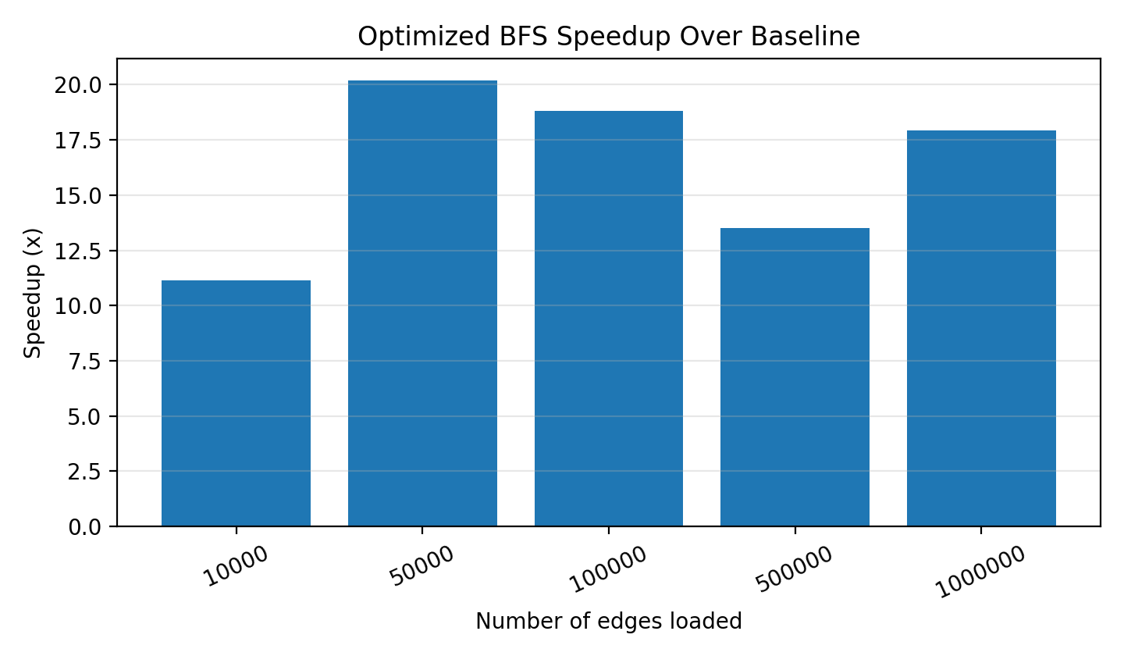
Figure 2. Speedup of optimized BFS over baseline BFS.
Figure 2 shows the optimized approach consistently gives a strong speedup. The speedup is 17.93x at 1,000,000 edges.
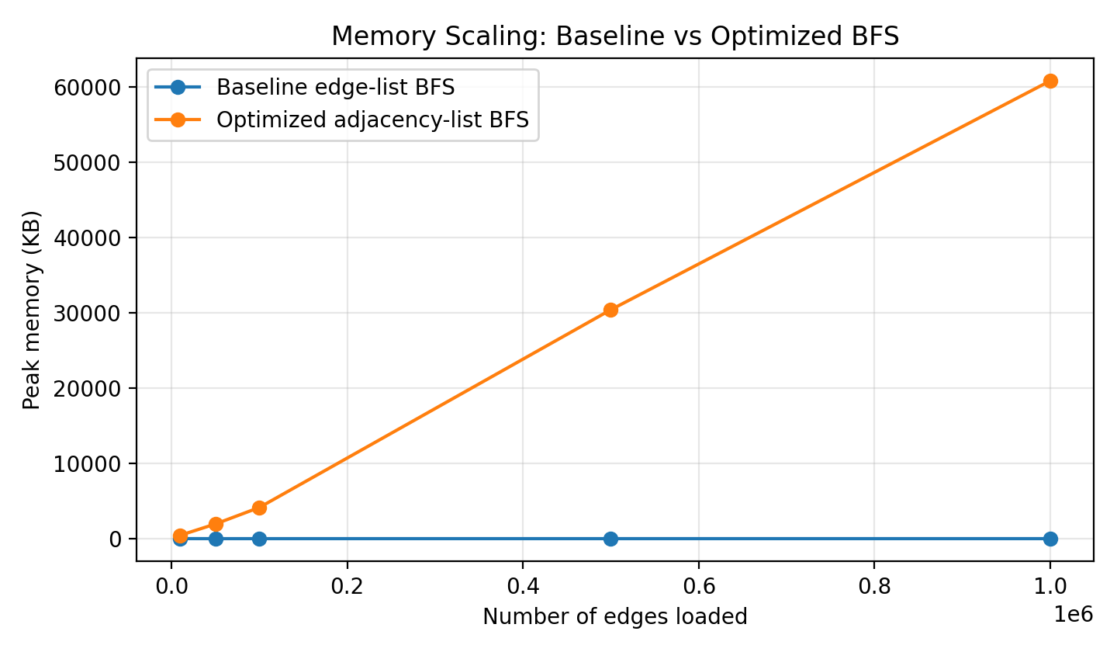
Figure 3. Memory usage for baseline and optimized BFS.
Figure 3 shows that optimized BFS uses more memory because it stores the adjacency list. This is expected and represents a time-memory tradeoff.

9. Theory vs Practice
The empirical results match the theoretical analysis. The baseline approach has time complexity O(V * E) because it repeatedly scans the entire edge list to find neighbors. This repeated scanning causes runtime to grow as the number of edges increases.
The optimized approach has time complexity O(V + E) after building the adjacency list. In practice, it was faster at every tested input size. The benchmark showed a 17.93x speedup at 1,000,000 edges.
The memory results also match expectations. The optimized approach uses more memory because it stores neighbors directly in an adjacency list. However, this memory cost gives a large runtime improvement.

10. Memory Tradeoff
The baseline approach uses less memory because it does not create an additional graph structure. It only uses memory for the queue, visited set, and path tracking.
The optimized approach uses more memory because it stores an adjacency list. At 1,000,000 edges, the optimized version used about 60,829 KB of peak memory, while the baseline used about 5.44 KB during the measured search portion.
This tradeoff is worth it for large road networks because real systems usually answer many route queries. Faster query time is more important than saving a small amount of memory during traversal.

11. Amortized Cost Analysis
The optimized approach has an upfront preprocessing cost. It must build the adjacency list before running BFS. This build step costs O(E).
However, once the adjacency list is built, each route query becomes much faster because neighbor lookup is direct. In a road network system, the graph is usually loaded once and queried many times.
This is the amortized benefit: build once, query many times. The one-time cost of building the adjacency list is spread across many route searches, making the optimized approach better for repeated queries.

12. Extra Feature: Road Closure Analysis
The project includes an extra road closure analysis feature. This feature simulates a blocked intersection or blocked road segment. After blocking part of the graph, the program reruns BFS while avoiding the blocked node or edge.
This feature can represent real-world situations such as road construction, accidents, flooding, or emergency detours. It shows how graph traversal can support rerouting decisions in a road network.

13. Challenges Faced
The first challenge was understanding the dataset format. The SNAP file only contains node pairs, not road names, distances, coordinates, or travel times. Because of this, BFS was selected instead of Dijkstra for the main shortest-path algorithm.
The second challenge was designing a fair baseline. If both approaches used an adjacency list, the comparison would not clearly show the advantage of the optimized data structure. Therefore, the baseline scans the edge list while the optimized approach uses adjacency-list lookup.
The third challenge was correctness verification. A graph may have multiple shortest paths with the same length, so the project compares shortest path length instead of exact path sequence.

14. Reflection Questions

14.1 Most difficult bug or conceptual hurdle
The most difficult conceptual hurdle was understanding that the optimization was not changing BFS itself. Both approaches use BFS. The difference is how neighbors are found. The baseline scans the full edge list, while the optimized version uses an adjacency list for direct neighbor lookup.
We overcame this by separating the algorithm logic into its own file and testing both algorithms with the same start and goal nodes. This confirmed that both approaches were correct while still having different performance.

14.2 What we would add with four more weeks
If we had four more weeks, we would add weighted shortest-path search. The current dataset is unweighted, so BFS is suitable. If road distance or estimated travel time were added as edge weights, Dijkstra's algorithm or A* Search would be more appropriate.
We would also add route visualization and test the full roadNet-CA dataset beyond 1,000,000 edges.

14.3 Difference between expectations and empirical results
Before running the benchmark, we expected the optimized approach to be faster. The results confirmed this, and the speedup was clear at every input size. At 1,000,000 edges, optimized BFS was about 17.93 times faster than the baseline.
One result that stood out was memory usage. The optimized version used more memory because it stores the adjacency list. This showed a clear time-memory tradeoff: more memory is used to get much faster runtime.

15. Future Improvements
- Add edge weights such as road distance or estimated travel time.
- Implement Dijkstra's algorithm for weighted shortest paths.
- Implement A* Search if coordinates are available.
- Compare BFS, Dijkstra, and A* on the same dataset.
- Visualize routes on a map.
- Run benchmarks on the full roadNet-CA dataset beyond 1,000,000 edges.
- Add more realistic road closure and traffic simulations.

16. Conclusion
This project demonstrates how graph algorithms behave at scale using a real-world road network dataset. The baseline edge-list BFS is simple but inefficient because it repeatedly scans the full edge list. The optimized adjacency-list BFS is much faster because it stores neighbors directly.
The benchmark results show that the optimized approach provides a clear performance improvement while still producing the correct shortest path length. At 1,000,000 edges, the optimized approach was about 17.93 times faster than the baseline.
The main lesson is that the algorithm matters, but the data structure used with the algorithm matters just as much.

