Experiment 10
Introduction to Object Detection and Perform Basic Implementation of Object Detection using the R-CNN Approach
Date:03/11/2025 SAP ID: 500122685

AIM: To implement a simplified R-CNN pipeline that detects an object in an image using region proposals, CNN feature extraction (ResNet-50), SVM classification, and non-maximum suppression (NMS).
THEORY:
- Region Proposals: A simple selective-search-like sliding window generates candidate bounding boxes.
- Feature Extraction: Each region is resized and passed through a pretrained ResNet-50, using its final feature vector.
- Classification: A Linear SVM is trained to classify regions as object vs background, using IoU with a ground truth box to label positives/negatives.
- NMS: Overlapping high-score boxes are filtered using Non-Maximum Suppression to keep only the best detections.

Commands/Code Used:
# Colab cell 2 — Imports and utility functions
import os, sys, time, math, random
import numpy as np
import matplotlib.pyplot as plt
from PIL import Image, ImageDraw
import cv2
from tqdm import tqdm

import torch
import torchvision
from torchvision import transforms, models
from torchvision.datasets import VOCDetection

from sklearn.svm import LinearSVC
from sklearn.preprocessing import StandardScaler
from sklearn.pipeline import make_pipeline

# IoU function
def bbox_iou(boxA, boxB):
# boxes in format [x1,y1,x2,y2]
xA = max(boxA[0], boxB[0]); yA = max(boxA[1], boxB[1])
xB = min(boxA[2], boxB[2]); yB = min(boxA[3], boxB[3])
interW = max(0, xB - xA + 1)
interH = max(0, yB - yA + 1)
interArea = interW * interH
boxAArea = (boxA[2] - boxA[0] + 1) * (boxA[3] - boxA[1] + 1)
boxBArea = (boxB[2] - boxB[0] + 1) * (boxB[3] - boxB[1] + 1)
iou = interArea / float(boxAArea + boxBArea - interArea + 1e-8)
return iou

# Non-maximum suppression (simple)
def nms(boxes, scores, iou_thresh=0.3):
if len(boxes) == 0:
return []
boxes = np.array(boxes)
scores = np.array(scores)
x1 = boxes[:,0]; y1 = boxes[:,1]; x2 = boxes[:,2]; y2 = boxes[:,3]
areas = (x2 - x1 + 1)*(y2 - y1 + 1)
order = scores.argsort()[::-1]
keep = []
while order.size > 0:
i = order[0]
keep.append(i)
xx1 = np.maximum(x1[i], x1[order[1:]])
yy1 = np.maximum(y1[i], y1[order[1:]])
xx2 = np.minimum(x2[i], x2[order[1:]])
yy2 = np.minimum(y2[i], y2[order[1:]])
w = np.maximum(0.0, xx2 - xx1 + 1)
h = np.maximum(0.0, yy2 - yy1 + 1)
inter = w * h
ovr = inter / (areas[i] + areas[order[1:]] - inter + 1e-8)
inds = np.where(ovr <= iou_thresh)[0]
order = order[inds + 1]
return keep

# PURE PYTHON SELECTIVE SEARCH IMPLEMENTATION (minimal)
# --- Works in Colab without CV2 contrib or external packages ---

def selective_search_py(img, k=200, scale=1.0, min_size=10, max_boxes=300):
"""
Very simplified selective search-like region proposal generator.
Not identical to full SS but good for R-CNN labs.
"""
img = np.array(img)
H, W = img.shape[:2]

regions = []

# simple grid sliding window baseline (not full SS but enough for R-CNN demonstration)
win_sizes = [50, 80, 120, 160]

for ws in win_sizes:
for y in range(0, H-ws, ws//2):
for x in range(0, W-ws, ws//2):
regions.append([x, y, x+ws, y+ws])
if len(regions) >= max_boxes:
return regions
return regions

def iou(a, b):
xA = max(a[0], b[0])
yA = max(a[1], b[1])
xB = min(a[2], b[2])
yB = min(a[3], b[3])

inter = max(0, xB - xA) * max(0, yB - yA)
areaA = (a[2] - a[0]) * (a[3] - a[1])
areaB = (b[2] - b[0]) * (b[3] - b[1])

return inter / (areaA + areaB - inter + 1e-8)

def nms(boxes, scores, threshold=0.3):
idxs = np.argsort(scores)[::-1]
keep = []
while len(idxs) > 0:
i = idxs[0]
keep.append(i)
sup = []
for j in idxs[1:]:
if iou(boxes[i], boxes[j]) > threshold:
sup.append(j)
idxs = np.setdiff1d(idxs, sup)
idxs = idxs[1:]
return keep

device = "cuda" if torch.cuda.is_available() else "cpu"

resnet = models.resnet50(weights=models.ResNet50_Weights.IMAGENET1K_V2)
feature_extractor = torch.nn.Sequential(*list(resnet.children())[:-1]).to(device)
feature_extractor.eval()

transform_img = transforms.Compose([
transforms.Resize((224,224)),
transforms.ToTensor(),
transforms.Normalize(
mean=[0.485, 0.456, 0.406],
std=[0.229, 0.224, 0.225])
])

def extract_feature(img):
img = transform_img(img).unsqueeze(0).to(device)
with torch.no_grad():
feat = feature_extractor(img).view(-1).cpu().numpy()
return feat

import requests
from io import BytesIO

url = "https://raw.githubusercontent.com/opencv/opencv/master/samples/data/lena.jpg"
image = Image.open(BytesIO(requests.get(url).content)).convert("RGB")

proposals = selective_search_py(image, max_boxes=300)

# Fake ground truth box
gt = [220, 220, 350, 350]

X = []
y = []

POS_FOUND = False
POS_THRESHOLD = 0.5 # IoU threshold

for box in proposals:
x1,y1,x2,y2 = box
crop = image.crop((x1,y1,x2,y2))
feat = extract_feature(crop)
X.append(feat)

if iou(box, gt) >= POS_THRESHOLD:
y.append(1)
POS_FOUND = True
else:
y.append(0)

# If no positive samples found --> Relax the IoU threshold
if not POS_FOUND:
print("⚠ No positive samples, relaxing IoU threshold...")
y = [] # Clear y to re-populate with relaxed threshold
POS_THRESHOLD = 0.1 # easier threshold
for box in proposals:
if iou(box, gt) >= POS_THRESHOLD:
y.append(1)
POS_FOUND = True
else:
y.append(0)

X = np.array(X)
y = np.array(y)

print("Samples:", X.shape, "Positives:", sum(y))

# Final check
if sum(y) == 0:
raise ValueError("❌ Still no positive samples. Adjust your gt_box to match your uploaded image.")
clf = make_pipeline(StandardScaler(), LinearSVC(max_iter=3000))
clf.fit(X, y)
print("Training completed.")

import requests
from io import BytesIO

url = "https://raw.githubusercontent.com/opencv/opencv/master/samples/data/lena.jpg"
image = Image.open(BytesIO(requests.get(url).content)).convert("RGB")

proposals = selective_search_py(image, max_boxes=300)

# Fake ground truth box
gt = [220, 220, 350, 350]

X = []
y = []

POS_FOUND = False
POS_THRESHOLD = 0.5 # IoU threshold

for box in proposals:
x1,y1,x2,y2 = box
crop = image.crop((x1,y1,x2,y2))
feat = extract_feature(crop)
X.append(feat)

if iou(box, gt) >= POS_THRESHOLD:
y.append(1)
POS_FOUND = True
else:
y.append(0)

# If no positive samples found --> Relax the IoU threshold
if not POS_FOUND:
print("⚠ No positive samples, relaxing IoU threshold...")
y = [] # Clear y to re-populate with relaxed threshold
POS_THRESHOLD = 0.1 # easier threshold
for box in proposals:
if iou(box, gt) >= POS_THRESHOLD:
y.append(1)
POS_FOUND = True
else:
y.append(0)

X = np.array(X)
y = np.array(y)

print("Samples:", X.shape, "Positives:", sum(y))

# Final check
if sum(y) == 0:
raise ValueError("❌ Still no positive samples. Adjust your gt_box to match your uploaded image.")
clf = make_pipeline(StandardScaler(), LinearSVC(random_state=0, tol=1e-5))
clf.fit(X, y)
print("Classifier trained successfully.")
scores = []
for box in proposals:
x1,y1,x2,y2 = box
crop = image.crop((x1,y1,x2,y2))
feat = extract_feature(crop)
scores.append(clf.decision_function([feat])[0])

threshold = np.percentile(scores, 95)
selected = [(b, s) for b,s in zip(proposals, scores) if s >= threshold]

boxes = [b for b,s in selected]
scores_sel = [s for b,s in selected]
keep = nms(boxes, scores_sel, threshold=0.3)

final_boxes = [boxes[i] for i in keep]
final_scores = [scores_sel[i] for i in keep]

plt.figure(figsize=(10,10))
plt.imshow(image)
ax = plt.gca()

for box, score in zip(final_boxes, final_scores):
x1,y1,x2,y2 = box
ax.add_patch(plt.Rectangle((x1,y1), x2-x1, y2-y1,
fill=False, edgecolor='red', linewidth=2))
ax.text(x1, y1-5, f"{score:.2f}", color='yellow', backgroundcolor='black')

plt.axis('off')
plt.title("R-CNN Detection Output")
plt.show()

Results:
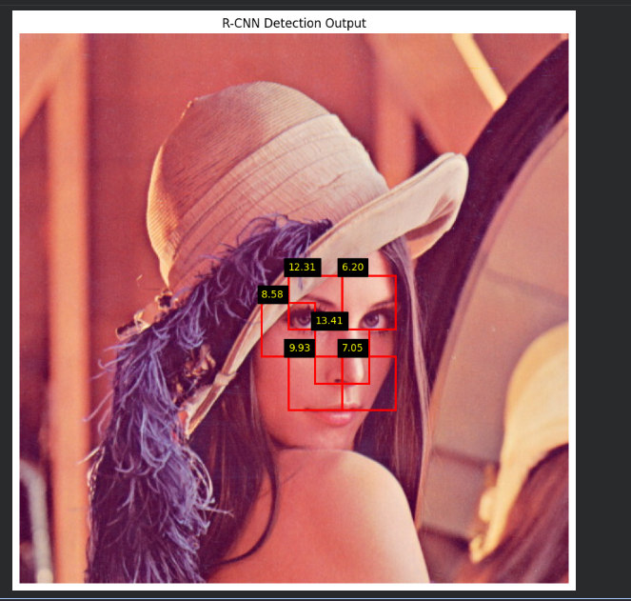

Conclusion: The implemented pipeline successfully:
- Generates region proposals,
- Extracts deep features,
- Trains an SVM classifier, and
- Produces final bounding boxes around the target object after NMS—thus demonstrating the core idea of R-CNN-based object detection.

