Experiment 11
Introduction to Image Segmentation and Perform Image segmentation using UNet Model
Date:10/11/2025 SAP ID: 500122685

AIM: To design, implement, and train a U-Net based Convolutional Neural Network for semantic segmentation of pet images using the Oxford-IIIT Pet Dataset, by:
- Preprocessing images and their corresponding trimap masks into 3 classes (background, pet, outline).
- Training the U-Net model using categorical cross-entropy loss.
- Evaluating performance using Dice coefficient, IoU (Intersection over Union), and accuracy.
- Visually comparing true masks vs. predicted masks to assess segmentation quality.
THEORY:
- Semantic Segmentation
Semantic segmentation is the task of assigning a class label to every pixel in an image.
In this experiment, each pixel is classified into one of three classes:
- Class 0 – Background
- Class 1 – Pet (cat/dog)
- Class 2 – Border/trimap region
- Oxford-IIIT Pet Dataset & Trimaps
- The dataset contains images of cats and dogs with corresponding trimap masks.
- Trimaps originally use labels 1, 2, 3, which are converted to 0, 1, 2 in the code (mask = mask - 1).
- Masks are one-hot encoded into 3 channels for use with softmax output.
- Data Preprocessing & Pipeline
- Images are:
  - Read from disk
  - Decoded as RGB
  - Resized to 128 × 128 × 3
  - Normalized to the range [0, 1]
- Masks are:
  - Read as single-channel PNG
  - Resized using nearest-neighbor (to preserve labels)
  - Converted to class indices (0–2) and then one-hot encoded
- A tf.data.Dataset pipeline is used with:
  - map() for preprocessing
  - batch() for mini-batches
  - prefetch() for performance
- U-Net Architecture
U-Net is an encoder–decoder CNN designed for image segmentation, with skip connections between encoder and decoder:
- Encoder (Contracting Path)
  - Multiple levels of:
Conv2D → Conv2D → MaxPooling
  - Feature maps increase (64 → 128 → 256 → 512), spatial size decreases.
  - Learns high-level semantic features.
- Bottleneck
  - Deepest layer with highest number of filters (512), often with Dropout for regularization.
- Decoder (Expansive Path)
  - Conv2DTranspose (up-sampling) to increase spatial resolution.
  - Concatenation with corresponding encoder feature maps (skip connections).
  - Followed by Conv2D layers to refine prediction.
- Output Layer
  - Conv2D(num_classes=3, kernel_size=1, activation='softmax')
  - Produces a 3-channel probability map for each pixel.
- Loss Function & Metrics
- Loss: categorical_crossentropy — compares predicted pixel probabilities with one-hot labels.
- Dice Coefficient:
  - Measures overlap between prediction and ground truth.
  - Ranges from 0 (no overlap) to 1 (perfect overlap).
- IoU (Jaccard Index):
  - Intersection / Union of predicted and true mask regions.
  - Robust metric for segmentation quality.
- Accuracy:
  - Fraction of correctly classified pixels.
- Training Strategy & Callbacks
- Optimizer: Adam with learning rate 1e-4.
- Callbacks used:
  - ModelCheckpoint – saves best model (lowest validation loss).
  - EarlyStopping – stops training when validation loss stops improving.
  - ReduceLROnPlateau – reduces learning rate when validation loss plateaus.
- Visualization of Results
- The visualize_predictions() function:
  - Displays original image, true mask, predicted mask, and an overlay.
  - Helps analyze where the model segments the pet correctly or fails.

Commands/Code Used:
# Install required packages
!pip install tensorflow==2.10.0
!pip install matplotlib
!pip install numpy
!pip install pillow
!pip install scikit-learn
!pip install tqdm

# Import necessary libraries
import tensorflow as tf
import numpy as np
import matplotlib.pyplot as plt
import os
import random
from PIL import Image
from tqdm import tqdm
from sklearn.model_selection import train_test_split
import tensorflow as tf
import numpy as np
import matplotlib.pyplot as plt
import os
import random
from PIL import Image
from tqdm import tqdm
from sklearn.model_selection import train_test_split

# Download and extract the Oxford-IIIT Pet Dataset
!wget http://www.robots.ox.ac.uk/~vgg/data/pets/data/images.tar.gz
!wget http://www.robots.ox.ac.uk/~vgg/data/pets/data/annotations.tar.gz
!tar -xvf images.tar.gz
!tar -xvf annotations.tar.gz

# Set paths
IMAGE_DIR = "images/"
MASK_DIR = "annotations/trimaps/"

# Get all image and mask file names from their respective directories
all_image_names = {f.split('.')[0] for f in os.listdir(IMAGE_DIR) if f.endswith('.jpg')}
all_mask_names = {f.split('.')[0] for f in os.listdir(MASK_DIR) if f.endswith('.png') and not f.startswith('._')}

# Find common base names (images for which a mask also exists)
common_names = list(all_image_names.intersection(all_mask_names))
common_names.sort()

# Reconstruct image and mask file lists using only common names
image_files_filtered = [f + '.jpg' for f in common_names]
mask_files_filtered = [f + '.png' for f in common_names]

# Limit the dataset for faster training in Colab
# Remove this line or increase the number to use more data
# We'll limit to a smaller number to ensure faster execution in Colab
limit_size = min(1000, len(image_files_filtered))
image_files = image_files_filtered[:limit_size]
mask_files = mask_files_filtered[:limit_size]

# Split the dataset
train_images, test_images, train_masks, test_masks = train_test_split(
image_files, mask_files, test_size=0.2, random_state=42
)
# Define image and mask dimensions
IMG_HEIGHT = 128
IMG_WIDTH = 128
IMG_CHANNELS = 3

# Function to preprocess images
def preprocess_image(image_path):
img = tf.io.read_file(image_path)
img = tf.image.decode_jpeg(img, channels=IMG_CHANNELS)
img = tf.image.resize(img, [IMG_HEIGHT, IMG_WIDTH])
img = img / 255.0 # Normalize to [0,1]
return img

# Function to preprocess masks
def preprocess_mask(mask_path):
mask = tf.io.read_file(mask_path)
mask = tf.image.decode_png(mask, channels=1)
mask = tf.image.resize(mask, [IMG_HEIGHT, IMG_WIDTH], method=tf.image.ResizeMethod.NEAREST_NEIGHBOR)
# The mask contains values 1, 2, 3. We'll convert to 0, 1, 2
mask = tf.cast(mask, tf.int32)
mask = mask - 1
mask = tf.one_hot(tf.squeeze(mask), depth=3)
return mask

# Create dataset
def create_dataset(image_files, mask_files, batch_size=16):
image_paths = [os.path.join(IMAGE_DIR, img) for img in image_files]
mask_paths = [os.path.join(MASK_DIR, mask) for mask in mask_files]

dataset = tf.data.Dataset.from_tensor_slices((image_paths, mask_paths))

# Map the preprocessing functions
dataset = dataset.map(
lambda x, y: (preprocess_image(x), preprocess_mask(y)),
num_parallel_calls=tf.data.AUTOTUNE
)

# Batch and prefetch
dataset = dataset.batch(batch_size)
dataset = dataset.prefetch(buffer_size=tf.data.AUTOTUNE)

return dataset

# Create training and validation datasets
BATCH_SIZE = 16
train_dataset = create_dataset(train_images, train_masks, BATCH_SIZE)
test_dataset = create_dataset(test_images, test_masks, BATCH_SIZE)
# Define the UNET model
def build_unet_model(input_shape=(IMG_HEIGHT, IMG_WIDTH, IMG_CHANNELS), num_classes=3):
inputs = tf.keras.layers.Input(shape=input_shape)

# Encoder (Contracting Path)
# Level 1
conv1 = tf.keras.layers.Conv2D(64, 3, activation='relu', padding='same')(inputs)
conv1 = tf.keras.layers.Conv2D(64, 3, activation='relu', padding='same')(conv1)
pool1 = tf.keras.layers.MaxPooling2D(pool_size=(2, 2))(conv1)

# Level 2
conv2 = tf.keras.layers.Conv2D(128, 3, activation='relu', padding='same')(pool1)
conv2 = tf.keras.layers.Conv2D(128, 3, activation='relu', padding='same')(conv2)
pool2 = tf.keras.layers.MaxPooling2D(pool_size=(2, 2))(conv2)

# Level 3
conv3 = tf.keras.layers.Conv2D(256, 3, activation='relu', padding='same')(pool2)
conv3 = tf.keras.layers.Conv2D(256, 3, activation='relu', padding='same')(conv3)
pool3 = tf.keras.layers.MaxPooling2D(pool_size=(2, 2))(conv3)

# Level 4 (Bottleneck)
conv4 = tf.keras.layers.Conv2D(512, 3, activation='relu', padding='same')(pool3)
conv4 = tf.keras.layers.Conv2D(512, 3, activation='relu', padding='same')(conv4)
drop4 = tf.keras.layers.Dropout(0.5)(conv4)

# Decoder (Expansive Path)
# Level 3
up3 = tf.keras.layers.Conv2DTranspose(256, 2, strides=(2, 2), padding='same')(drop4)
concat3 = tf.keras.layers.Concatenate()([conv3, up3])
conv5 = tf.keras.layers.Conv2D(256, 3, activation='relu', padding='same')(concat3)
conv5 = tf.keras.layers.Conv2D(256, 3, activation='relu', padding='same')(conv5)

# Level 2
up2 = tf.keras.layers.Conv2DTranspose(128, 2, strides=(2, 2), padding='same')(conv5)
concat2 = tf.keras.layers.Concatenate()([conv2, up2])
conv6 = tf.keras.layers.Conv2D(128, 3, activation='relu', padding='same')(concat2)
conv6 = tf.keras.layers.Conv2D(128, 3, activation='relu', padding='same')(conv6)

# Level 1
up1 = tf.keras.layers.Conv2DTranspose(64, 2, strides=(2, 2), padding='same')(conv6)
concat1 = tf.keras.layers.Concatenate()([conv1, up1])
conv7 = tf.keras.layers.Conv2D(64, 3, activation='relu', padding='same')(concat1)
conv7 = tf.keras.layers.Conv2D(64, 3, activation='relu', padding='same')(conv7)

# Output layer
outputs = tf.keras.layers.Conv2D(num_classes, 1, activation='softmax')(conv7)

model = tf.keras.Model(inputs=inputs, outputs=outputs)

return model

# Build the model
model = build_unet_model()
model.summary()
# Define metrics for segmentation
def dice_coefficient(y_true, y_pred, smooth=1):
y_true_f = tf.keras.backend.flatten(y_true)
y_pred_f = tf.keras.backend.flatten(y_pred)
intersection = tf.keras.backend.sum(y_true_f * y_pred_f)
return (2. * intersection + smooth) / (tf.keras.backend.sum(y_true_f) + tf.keras.backend.sum(y_pred_f) + smooth)

def iou_coefficient(y_true, y_pred, smooth=1):
intersection = tf.keras.backend.sum(tf.keras.backend.abs(y_true * y_pred), axis=[1,2,3])
union = tf.keras.backend.sum(y_true,[1,2,3]) + tf.keras.backend.sum(y_pred,[1,2,3]) - intersection
iou = tf.keras.backend.mean((intersection + smooth) / (union + smooth), axis=0)
return iou

# Compile the model
model.compile(
optimizer=tf.keras.optimizers.Adam(learning_rate=1e-4),
loss='categorical_crossentropy',
metrics=[dice_coefficient, iou_coefficient, 'accuracy']
)

# Define callbacks
checkpoint_path = "/content/drive/MyDrive/unet_pet_segmentation.h5"
callbacks = [
tf.keras.callbacks.ModelCheckpoint(
checkpoint_path,
monitor='val_loss',
verbose=1,
save_best_only=True,
mode='min'
),
tf.keras.callbacks.EarlyStopping(
monitor='val_loss',
patience=10,
verbose=1,
mode='min'
),
tf.keras.callbacks.ReduceLROnPlateau(
monitor='val_loss',
factor=0.1,
patience=5,
verbose=1,
mode='min'
)
]

# Train the model
EPOCHS = 25
history = model.fit(
train_dataset,
epochs=EPOCHS,
validation_data=test_dataset,
callbacks=callbacks
)
# Plot training history
def plot_training_history(history):
plt.figure(figsize=(12, 4))

# Plot training & validation loss values
plt.subplot(1, 3, 1)
plt.plot(history.history['loss'])
plt.plot(history.history['val_loss'])
plt.title('Model Loss')
plt.ylabel('Loss')
plt.xlabel('Epoch')
plt.legend(['Train', 'Validation'], loc='upper right')

# Plot training & validation dice coefficient values
plt.subplot(1, 3, 2)
plt.plot(history.history['dice_coefficient'])
plt.plot(history.history['val_dice_coefficient'])
plt.title('Dice Coefficient')
plt.ylabel('Dice Coefficient')
plt.xlabel('Epoch')
plt.legend(['Train', 'Validation'], loc='upper right')

# Plot training & validation IoU values
plt.subplot(1, 3, 3)
plt.plot(history.history['iou_coefficient'])
plt.plot(history.history['val_iou_coefficient'])
plt.title('IoU Coefficient')
plt.ylabel('IoU Coefficient')
plt.xlabel('Epoch')
plt.legend(['Train', 'Validation'], loc='upper right')

plt.tight_layout()
plt.show()

plot_training_history(history)

# Evaluate the model on the test set
test_loss, test_dice, test_iou, test_accuracy = model.evaluate(test_dataset)
print(f"Test Loss: {test_loss:.4f}")
print(f"Test Dice Coefficient: {test_dice:.4f}")
print(f"Test IoU Coefficient: {test_iou:.4f}")
print(f"Test Accuracy: {test_accuracy:.4f}")
# Function to visualize predictions
def visualize_predictions(model, dataset, num_samples=3):
# Get a batch of test data
images, masks = next(iter(dataset))

# Make predictions
predictions = model.predict(images)

# Convert predictions to class indices
pred_masks = np.argmax(predictions, axis=-1)
true_masks = np.argmax(masks.numpy(), axis=-1)

# Visualize
plt.figure(figsize=(15, 5 * num_samples))

for i in range(min(num_samples, len(images))):
# Original image
plt.subplot(num_samples, 4, i*4 + 1)
plt.imshow(images[i])
plt.title('Original Image')
plt.axis('off')

# True mask
plt.subplot(num_samples, 4, i*4 + 2)
plt.imshow(true_masks[i], cmap='viridis')
plt.title('True Mask')
plt.axis('off')

# Predicted mask
plt.subplot(num_samples, 4, i*4 + 3)
plt.imshow(pred_masks[i], cmap='viridis')
plt.title('Predicted Mask')
plt.axis('off')

# Overlay
plt.subplot(num_samples, 4, i*4 + 4)
plt.imshow(images[i])
plt.imshow(pred_masks[i], cmap='viridis', alpha=0.4)
plt.title('Overlay')
plt.axis('off')

plt.tight_layout()
plt.show()

# Visualize predictions
visualize_predictions(model, test_dataset)

Results:
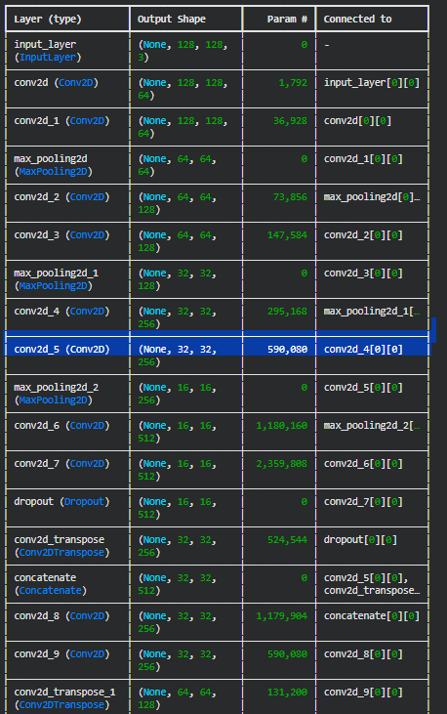
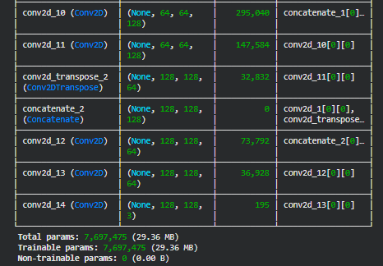
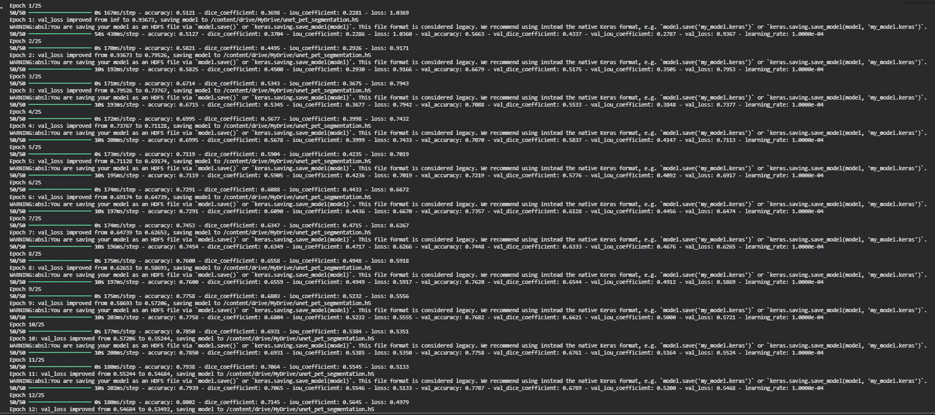
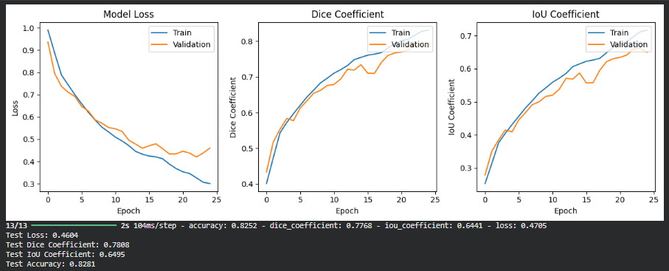
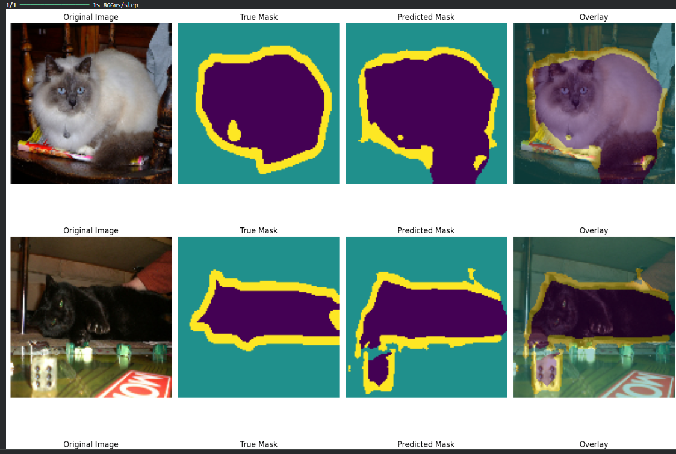
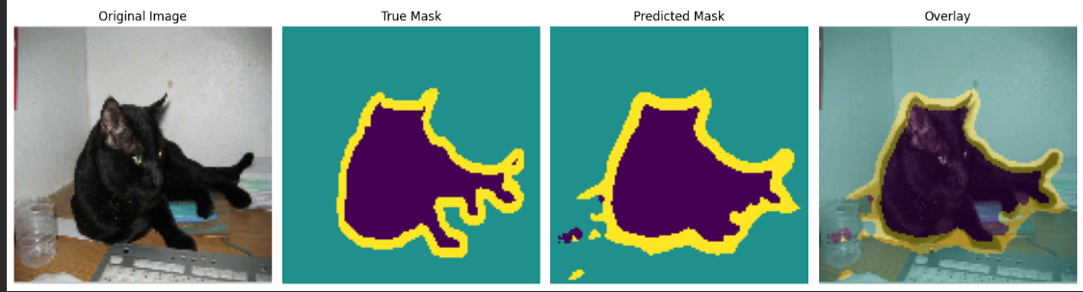
Conclusion: In this experiment, a U-Net based CNN was successfully implemented for semantic segmentation of the Oxford-IIIT Pet Dataset.
- The model was trained on resized, normalized images with corresponding one-hot encoded trimap masks.
- Using categorical cross-entropy loss and metrics like Dice coefficient, IoU, and accuracy, the model learned to distinguish between background, pet, and border regions at the pixel level.
- The training and validation curves (loss, Dice, IoU) indicate the model’s learning behavior and generalization.
- The qualitative results (visual overlays of predicted masks on original images) show that the model is able to:
  - Accurately localize the pet region.
  - Reasonably capture object boundaries, depending on training size and epochs.

