Experiment 12
Image Reconstruction and Feature Compression Using Autoencoders
Date:17/11/2025 SAP ID: 500122685

AIM: To design and train a convolutional autoencoder on the MNIST dataset to learn a compact latent representation, reconstruct input images, and evaluate the quality of reconstructions and learned features using image quality metrics and a simple classifier.
THEORY:
- An autoencoder is an unsupervised neural network that learns to encode input data into a low-dimensional latent vector and then decode it back to reconstruct the input.
- The encoder (Conv + Strided Conv + Dense) compresses the image into a LATENT_DIM-dimensional feature vector.
- The decoder (Dense + Conv2DTranspose) upsamples the latent vector back to the original image size.
- The model is trained using MSE loss between original and reconstructed images.
- Image quality is measured with MSE, MAE, PSNR, SSIM.
- PCA and t-SNE are applied to latent vectors to visualize class separation, and Logistic Regression on latent features evaluates how discriminative the learned representation is.

Commands/Code Used:
import os
import numpy as np
import matplotlib.pyplot as plt
from datetime import datetime

import tensorflow as tf
from tensorflow.keras import layers, models, callbacks, optimizers
from tensorflow.keras.datasets import mnist

from sklearn.decomposition import PCA
from sklearn.manifold import TSNE
from sklearn.linear_model import LogisticRegression
from sklearn.metrics import accuracy_score

# For SSIM
!pip -q install scikit-image >/dev/null 2>&1
from skimage.metrics import structural_similarity as ssim

# Fix random seeds for reproducibility (optional)
import random
SEED = 42
np.random.seed(SEED)
tf.random.set_seed(SEED)
random.seed(SEED)

print("TensorFlow version:", tf.__version__)

# --- 1. Configurable parameters ---
DATASET = "MNIST" # "MNIST" or "CIFAR10"
BATCH_SIZE = 128
EPOCHS = 30
LATENT_DIM = 64 # change to compress more/less
IMG_RESCALE = True # scale images to [0,1]
USE_GPU = tf.config.list_physical_devices('GPU') != []

print("Using GPU:", USE_GPU)
if DATASET == "MNIST":
(x_train, y_train), (x_test, y_test) = mnist.load_data()
# MNIST shape: (N, 28, 28), grayscale
x_train = np.expand_dims(x_train, -1)
x_test = np.expand_dims(x_test, -1)
input_shape = x_train.shape[1:] # (28,28,1)
else:
# CIFAR-10 branch (uncomment import at top if switching)
from tensorflow.keras.datasets import cifar10
(x_train, y_train), (x_test, y_test) = cifar10.load_data()
y_train = y_train.flatten(); y_test = y_test.flatten()
input_shape = x_train.shape[1:] # (32,32,3)

print("Dataset:", DATASET, "| input shape:", input_shape)
print("Train / Test sizes:", x_train.shape[0], x_test.shape[0])

if IMG_RESCALE:
x_train = x_train.astype("float32") / 255.
x_test = x_test.astype("float32") / 255.
else:
x_train = x_train.astype("float32")
x_test = x_test.astype("float32")

def build_conv_autoencoder(input_shape, latent_dim):
inp = layers.Input(shape=input_shape)
x = inp
# Encoder
x = layers.Conv2D(32, 3, strides=2, padding='same', activation='relu')(x) # /2
x = layers.Conv2D(64, 3, strides=2, padding='same', activation='relu')(x) # /4
# If input is 28x28 -> after two strided convs: 7x7 (approx)
shape_before_flatten = tf.keras.backend.int_shape(x)[1:] # (h,w,channels)
x = layers.Flatten()(x)
latent = layers.Dense(latent_dim, name='latent_vector')(x)

# Decoder
x = layers.Dense(np.prod(shape_before_flatten), activation='relu')(latent)
x = layers.Reshape(shape_before_flatten)(x)
x = layers.Conv2DTranspose(64, 3, strides=2, padding='same', activation='relu')(x) # *2
x = layers.Conv2DTranspose(32, 3, strides=2, padding='same', activation='relu')(x) # *4
# final conv to get original channels
channels = input_shape[-1]
x = layers.Conv2D(channels, 3, padding='same', activation='sigmoid')(x)

encoder = models.Model(inp, latent, name="encoder")
autoencoder = models.Model(inp, x, name="autoencoder")
return encoder, autoencoder

encoder, autoencoder = build_conv_autoencoder(input_shape, LATENT_DIM)
autoencoder.summary()
encoder.summary()
autoencoder.compile(optimizer=optimizers.Adam(1e-3), loss='mse', metrics=['mae'])
log_dir = f"/tmp/ae_logs_{datetime.now().strftime('%Y%m%d_%H%M%S')}"
os.makedirs(log_dir, exist_ok=True)
cb = [
callbacks.EarlyStopping(monitor='val_loss', patience=6, restore_best_weights=True),
callbacks.ModelCheckpoint(os.path.join(log_dir, 'autoencoder_best.h5'), save_best_only=True, monitor='val_loss'),
callbacks.ReduceLROnPlateau(monitor='val_loss', factor=0.5, patience=3, min_lr=1e-6)
]
history = autoencoder.fit(
x_train, x_train,
epochs=EPOCHS,
batch_size=BATCH_SIZE,
shuffle=True,
validation_split=0.1,
callbacks=cb
)
x_test_pred = autoencoder.predict(x_test, batch_size=BATCH_SIZE)

# Metrics functions
def compute_mse(true, recon):
return np.mean(np.square(true - recon), axis=(1,2,3))

def compute_mae(true, recon):
return np.mean(np.abs(true - recon), axis=(1,2,3))

def compute_psnr_batch(true, recon, data_range=1.0):
# data_range = 1.0 if inputs in [0,1]
mse_vals = compute_mse(true, recon)
# avoid divide by zero
psnr_vals = 20 * np.log10(data_range) - 10 * np.log10(np.maximum(mse_vals, 1e-12))
return psnr_vals

def compute_ssim_batch(true, recon):
# skimage ssim expects 2D or multichannel images. Compute per-sample.
ssim_vals = []
for i in range(true.shape[0]):
if true.shape[-1] == 1:
# squeeze last channel
t = np.squeeze(true[i], axis=-1)
r = np.squeeze(recon[i], axis=-1)
val = ssim(t, r, data_range=1.0)
else:
val = ssim(true[i], recon[i], multichannel=True, data_range=1.0)
ssim_vals.append(val)
return np.array(ssim_vals)

mse_vals = compute_mse(x_test, x_test_pred)
mae_vals = compute_mae(x_test, x_test_pred)
psnr_vals = compute_psnr_batch(x_test, x_test_pred, data_range=1.0)
ssim_vals = compute_ssim_batch(x_test, x_test_pred)

# Aggregate metrics
metrics_summary = {
'MSE_mean': float(np.mean(mse_vals)),
'MSE_std' : float(np.std(mse_vals)),
'MAE_mean': float(np.mean(mae_vals)),
'PSNR_mean': float(np.mean(psnr_vals)),
'SSIM_mean': float(np.mean(ssim_vals))
}
print("=== Test set metrics summary ===")
for k,v in metrics_summary.items():
print(f"{k}: {v:.6f}")

# 8.1 Training curves
plt.figure(figsize=(10,4))
plt.subplot(1,2,1)
plt.plot(history.history['loss'], label='train_loss')
plt.plot(history.history['val_loss'], label='val_loss')
plt.title('Loss (MSE)'); plt.xlabel('Epoch'); plt.ylabel('MSE'); plt.legend()

plt.subplot(1,2,2)
plt.plot(history.history['mae'], label='train_mae')
plt.plot(history.history['val_mae'], label='val_mae')
plt.title('MAE'); plt.xlabel('Epoch'); plt.ylabel('MAE'); plt.legend()
plt.tight_layout()
plt.show()
def plot_reconstructions(orig, recon, n=10):
plt.figure(figsize=(2*n,4))
for i in range(n):
# original
ax = plt.subplot(2, n, i+1)
img = orig[i]
if img.shape[-1] == 1:
plt.imshow(img.squeeze(), cmap='gray')
else:
plt.imshow(img)
ax.axis('off')
if i == 0: ax.set_title("Original")

# reconstruction
ax = plt.subplot(2, n, n+i+1)
imgr = recon[i]
if img.shape[-1] == 1:
plt.imshow(imgr.squeeze(), cmap='gray')
else:
plt.imshow(imgr)
ax.axis('off')
if i == 0: ax.set_title("Reconstructed")
plt.show()

# pick random sample indices to show
idxs = np.random.choice(len(x_test), size=10, replace=False)
plot_reconstructions(x_test[idxs], x_test_pred[idxs], n=10)
plt.figure(figsize=(10,4))
plt.subplot(1,2,1)
plt.hist(psnr_vals, bins=50)
plt.title("PSNR distribution (dB)")
plt.xlabel("PSNR (dB)"); plt.ylabel("Count")

plt.subplot(1,2,2)
plt.hist(ssim_vals, bins=50)
plt.title("SSIM distribution")
plt.xlabel("SSIM"); plt.ylabel("Count")
plt.tight_layout()
plt.show()
# Extract latent vectors for test set
latent_test = encoder.predict(x_test, batch_size=BATCH_SIZE)

# PCA to 2D
pca = PCA(n_components=2, random_state=SEED)
z_pca = pca.fit_transform(latent_test)

plt.figure(figsize=(6,5))
scatter = plt.scatter(z_pca[:,0], z_pca[:,1], c=y_test, s=8, cmap='tab10')
plt.title('PCA of latent vectors')
plt.colorbar(scatter, ticks=np.unique(y_test))
plt.xlabel('PC1'); plt.ylabel('PC2')
plt.show()

# t-SNE (slower) - run on subset for speed if dataset large
subset = 2000
sel_idx = np.random.choice(len(latent_test), subset, replace=False)
tsne = TSNE(n_components=2, perplexity=30, learning_rate=200, n_iter=1000, random_state=SEED, init='pca')
z_tsne = tsne.fit_transform(latent_test[sel_idx])

plt.figure(figsize=(6,5))
plt.scatter(z_tsne[:,0], z_tsne[:,1], c=y_test[sel_idx], s=6, cmap='tab10')
plt.title(f't-SNE of latent vectors (n={subset})')
plt.colorbar()
plt.show()
# --- 10. Representation evaluation: train simple classifier on latent vectors ---
# Train logistic regression on latent space: use a subset to train
# We will use training partition latent vectors:
latent_train = encoder.predict(x_train, batch_size=BATCH_SIZE)

# Use a simple Logistic Regression (scikit-learn)
clf = LogisticRegression(max_iter=1000, multi_class='multinomial', solver='saga')
# Random subsample for speed
sub_n = 5000 if latent_train.shape[0] > 5000 else latent_train.shape[0]
train_idx = np.random.choice(latent_train.shape[0], sub_n, replace=False)
clf.fit(latent_train[train_idx], y_train[train_idx])

# Evaluate on test latent vectors
y_pred = clf.predict(latent_test)
acc = accuracy_score(y_test, y_pred)
print(f"Logistic Regression on latent vectors - Accuracy: {acc*100:.2f}%")

Results:
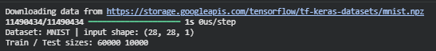
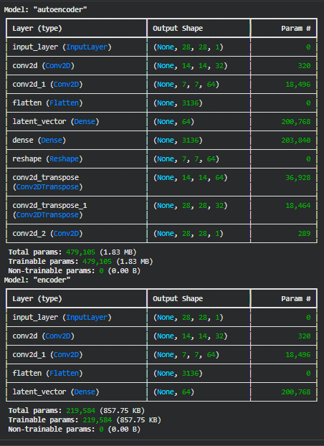
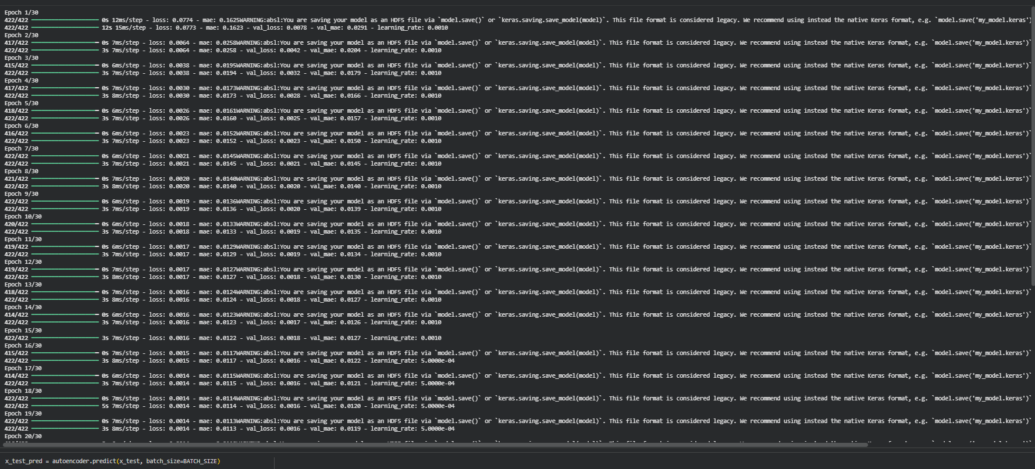
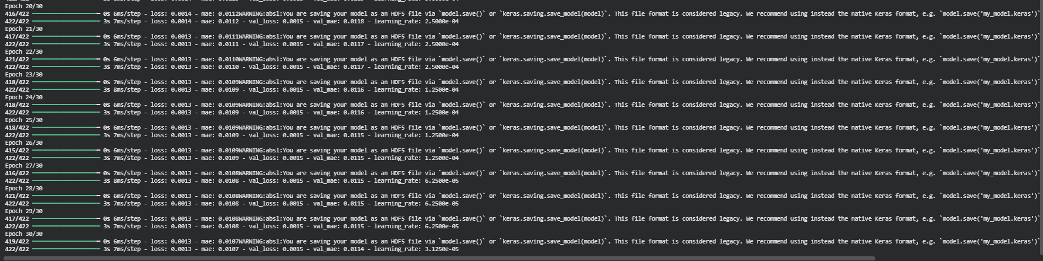
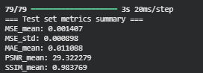
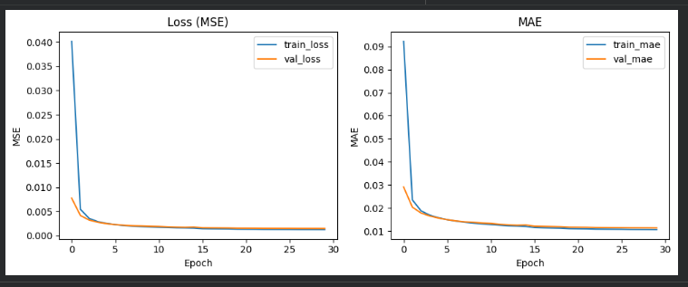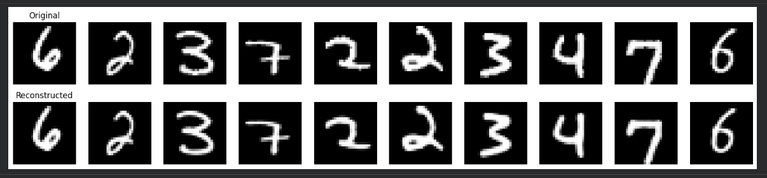
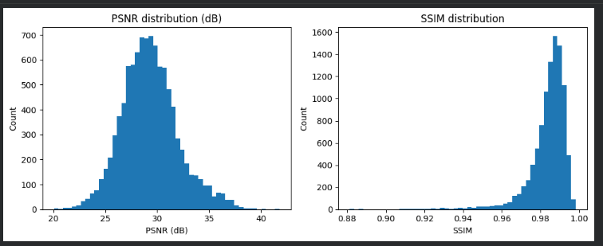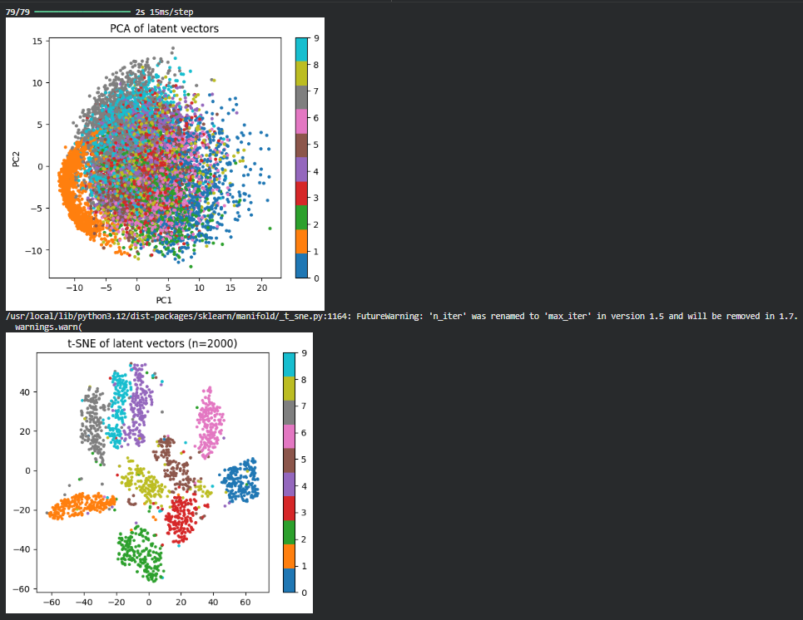
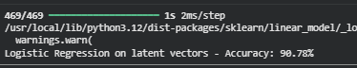
Conclusion: The convolutional autoencoder successfully reconstructed MNIST digits with low reconstruction error and reasonable PSNR/SSIM values.
The latent space showed clear structure and class separation in PCA/t-SNE plots, and a simple logistic regression classifier achieved good accuracy on latent vectors, proving that the autoencoder learned meaningful and compact feature representations of the digit images.

