Experiment 13
Probabilistic Image Generation with Variational Autoencoders (VAEs)
Date:17/11/2025 SAP ID: 500122685

AIM: To implement a Variational Autoencoder for learning latent distributions and generating novel images, including analysis of class-wise latent space representations.
THEORY:
- A VAE is a generative model that learns a probabilistic latent space:
- The encoder outputs mean and log-variance (zμ,zlog⁡σ2)(z_{\mu}, z_{\log\sigma^2})(zμ ,zlogσ2 ) of a Gaussian.
- A latent vector z is sampled using the reparameterization trick.
- The decoder reconstructs the image from z.
- Training minimizes:
- Reconstruction loss (binary cross-entropy over pixels)
- KL divergence between latent distribution and standard normal.
- The 2D latent space is visualized, and a k-NN classifier on latent means checks how well classes are separated.
- Per-class reconstruction MSE and latent grid sampling show how well the model captures digit structure.

Commands/Code Used:
import numpy as np
import tensorflow as tf
from tensorflow import keras
from tensorflow.keras import layers
from tensorflow import keras
import numpy as np
import matplotlib.pyplot as plt
from sklearn.neighbors import KNeighborsClassifier
from sklearn.metrics import confusion_matrix, accuracy_score
from sklearn.manifold import TSNE
from sklearn.metrics import silhouette_score
import seaborn as sns
import itertools
a
# Hyperparameters
batch_size = 128
epochs = 30 # increase to improve performance
learning_rate = 1e-3
latent_dim = 2 # set to 2 for visualization; try 16 or 32 for better generation
random_seed = 42

tf.random.set_seed(random_seed)
np.random.seed(random_seed)
import numpy as np
import tensorflow as tf
from tensorflow import keras
from tensorflow.keras import layers
from tensorflow import keras
import numpy as np
import matplotlib.pyplot as plt
from sklearn.neighbors import KNeighborsClassifier
from sklearn.metrics import confusion_matrix, accuracy_score
from sklearn.manifold import TSNE
from sklearn.metrics import silhouette_score
import seaborn as sns
import itertools
a
# Hyperparameters
batch_size = 128
epochs = 30 # increase to improve performance
learning_rate = 1e-3
latent_dim = 2 # set to 2 for visualization; try 16 or 32 for better generation
random_seed = 42

tf.random.set_seed(random_seed)
np.random.seed(random_seed)
class Sampling(layers.Layer):
"""Use (z_mean, z_log_var) to sample z, the latent vector."""
def call(self, inputs):
z_mean, z_log_var = inputs
batch = tf.shape(z_mean)[0]
dim = tf.shape(z_mean)[1]
epsilon = tf.random.normal(shape=(batch, dim))
return z_mean + tf.exp(0.5 * z_log_var) * epsilon

def build_encoder(latent_dim=2):
encoder_inputs = keras.Input(shape=image_shape)
x = layers.Conv2D(32, 3, activation="relu", strides=2, padding="same")(encoder_inputs)
x = layers.Conv2D(64, 3, activation="relu", strides=2, padding="same")(x)
x = layers.Flatten()(x)
x = layers.Dense(128, activation="relu")(x)
z_mean = layers.Dense(latent_dim, name="z_mean")(x)
z_log_var = layers.Dense(latent_dim, name="z_log_var")(x)
z = Sampling()([z_mean, z_log_var])
encoder = keras.Model(encoder_inputs, [z_mean, z_log_var, z], name="encoder")
return encoder

def build_decoder(latent_dim=2):
latent_inputs = keras.Input(shape=(latent_dim,))
x = layers.Dense(7 * 7 * 64, activation="relu")(latent_inputs)
x = layers.Reshape((7, 7, 64))(x)
x = layers.Conv2DTranspose(64, 3, activation="relu", strides=2, padding="same")(x)
x = layers.Conv2DTranspose(32, 3, activation="relu", strides=2, padding="same")(x)
decoder_outputs = layers.Conv2DTranspose(1, 3, activation="sigmoid", padding="same")(x)
decoder = keras.Model(latent_inputs, decoder_outputs, name="decoder")
return decoder

# Build models
encoder = build_encoder(latent_dim=latent_dim)
decoder = build_decoder(latent_dim=latent_dim)

class VAE(keras.Model):
def __init__(self, encoder, decoder, recon_loss_factor=1.0, **kwargs):
super(VAE, self).__init__(**kwargs)
self.encoder = encoder
self.decoder = decoder
self.recon_loss_factor = recon_loss_factor
self.total_loss_tracker = keras.metrics.Mean(name="loss")
self.recon_loss_tracker = keras.metrics.Mean(name="recon_loss")
self.kl_loss_tracker = keras.metrics.Mean(name="kl_loss")

@property
def metrics(self):
return [self.total_loss_tracker, self.recon_loss_tracker, self.kl_loss_tracker]

def call(self, inputs):
z_mean, z_log_var, z = self.encoder(inputs)
reconstructed = self.decoder(z)
return reconstructed

def train_step(self, data):
if isinstance(data, tuple):
x = data[0]
else:
x = data
with tf.GradientTape() as tape:
z_mean, z_log_var, z = self.encoder(x, training=True)
reconstruction = self.decoder(z, training=True)
# Use binary crossentropy per pixel for MNIST
reconstruction_loss = tf.reduce_mean(
tf.reduce_sum(
keras.losses.binary_crossentropy(x, reconstruction), axis=(1,2)
)
)
kl_loss = -0.5 * (1 + z_log_var - tf.square(z_mean) - tf.exp(z_log_var))
kl_loss = tf.reduce_mean(tf.reduce_sum(kl_loss, axis=1))
total_loss = self.recon_loss_factor * reconstruction_loss + kl_loss
grads = tape.gradient(total_loss, self.trainable_weights)
self.optimizer.apply_gradients(zip(grads, self.trainable_weights))
self.total_loss_tracker.update_state(total_loss)
self.recon_loss_tracker.update_state(reconstruction_loss)
self.kl_loss_tracker.update_state(kl_loss)
return {
"loss": self.total_loss_tracker.result(),
"recon_loss": self.recon_loss_tracker.result(),
"kl_loss": self.kl_loss_tracker.result(),
}

# Instantiate VAE
vae = VAE(encoder, decoder)
optimizer = keras.optimizers.Adam(learning_rate)
vae.compile(optimizer=optimizer, loss=keras.losses.MeanSquaredError())
train_loss = history.history['loss']
val_loss = history.history.get('val_loss') # Keras may not populate val_loss in custom model
recon_loss = history.history['recon_loss']
kl_loss = history.history['kl_loss']

reconstructions = vae.predict(x_test, batch_size=batch_size)
# Compute per-sample MSE between x_test and reconstructions
mse_per_sample = np.mean(np.square(x_test - reconstructions), axis=(1,2,3))
overall_mse = np.mean(mse_per_sample)
print(f"Overall test reconstruction MSE: {overall_mse:.6f}")

# Per-class reconstruction MSE
num_classes = len(np.unique(y_test))
per_class_mse = {}
for c in range(num_classes):
idx = np.where(y_test == c)[0]
if len(idx) == 0:
per_class_mse[c] = np.nan
else:
per_class_mse[c] = np.mean(mse_per_sample[idx])
print("Per-class reconstruction MSE:")
for k, v in per_class_mse.items():
print(f" Class {k}: MSE = {v:.6f}")
z_mean_test, z_log_var_test, z_test = encoder.predict(x_test, batch_size=batch_size)
# If latent_dim == 2, scatter. If higher dim, use t-SNE to reduce to 2D
if latent_dim == 2:
z_vis = z_mean_test # visualize mean
else:
print("Using t-SNE to reduce latent to 2D for visualization (this may take time).")
z_vis = TSNE(n_components=2, random_state=random_seed).fit_transform(z_mean_test)

knn = KNeighborsClassifier(n_neighbors=5)
# Fit on train latent means
z_mean_train, _, _ = encoder.predict(x_train, batch_size=batch_size)
knn.fit(z_mean_train, y_train)
y_pred = knn.predict(z_mean_test)
knn_acc = accuracy_score(y_test, y_pred)
print(f"k-NN accuracy in latent space (k=5): {knn_acc:.4f}")

cm = confusion_matrix(y_test, y_pred)
# Normalize confusion matrix rows
cm_norm = cm.astype("float") / cm.sum(axis=1)[:, np.newaxis]

def plot_loss_curves(history):
plt.figure(figsize=(10,5))
# Total loss
plt.plot(history.history['loss'], label='train_loss')
if 'val_loss' in history.history:
plt.plot(history.history['val_loss'], label='val_loss')
plt.xlabel("Epoch")
plt.ylabel("Loss")
plt.title("VAE loss (total)")
plt.legend()
plt.grid(True)
plt.show()

# Recon + KL
plt.figure(figsize=(10,5))
plt.plot(history.history['recon_loss'], label='recon_loss')
plt.plot(history.history['kl_loss'], label='kl_loss')
plt.xlabel("Epoch")
plt.ylabel("Loss")
plt.title("Reconstruction and KL loss")
plt.legend()
plt.grid(True)
plt.show()

def plot_reconstructions(x_data, recon_data, n=10):
plt.figure(figsize=(2*n,4))
for i in range(n):
# original
ax = plt.subplot(2, n, i+1)
plt.imshow(x_data[i].squeeze(), cmap='gray')
plt.axis('off')
if i == 0:
ax.set_title("Original")
# reconstruction
ax = plt.subplot(2, n, n + i + 1)
plt.imshow(recon_data[i].squeeze(), cmap='gray')
plt.axis('off')
if i == 0:
ax.set_title("Reconstruction")
plt.show()

def plot_latent_scatter(z_vis, labels, title="Latent space (2D)"):
plt.figure(figsize=(8,8))
palette = sns.color_palette("tab10", num_classes)
sns.scatterplot(x=z_vis[:,0], y=z_vis[:,1], hue=labels, legend='full', palette=palette, s=10)
plt.title(title)
plt.xlabel("z[0]")
plt.ylabel("z[1]")
plt.show()

def plot_per_class_mse(per_class_mse):
classes = list(per_class_mse.keys())
vals = [per_class_mse[c] for c in classes]
plt.figure(figsize=(10,5))
sns.barplot(x=classes, y=vals)
plt.xlabel("Class")
plt.ylabel("Reconstruction MSE")
plt.title("Per-class reconstruction MSE")
plt.show()

def plot_confusion_matrix(cm, classes):
plt.figure(figsize=(8,6))
sns.heatmap(cm, annot=True, fmt=".2f", cmap="Blues")
plt.xlabel("Predicted")
plt.ylabel("True")
plt.title("Confusion matrix (k-NN in latent space)")
plt.show()

# Execute plots
plot_loss_curves(history)
plot_reconstructions(x_test, reconstructions, n=10)
if latent_dim == 2:
plot_latent_scatter(z_vis, y_test, title="Latent space colored by class (z_mean)")
else:
plot_latent_scatter(z_vis, y_test, title="t-SNE of latent means colored by class")
plot_per_class_mse(per_class_mse)
plot_confusion_matrix(cm_norm, classes=list(range(num_classes)))
print(f"k-NN accuracy: {knn_acc:.4f}")
def generate_grid(decoder, grid_size=15, scale=3.0):
if latent_dim != 2:
raise ValueError("Grid generation requires latent_dim == 2")
# Create grid in latent space
grid_x = np.linspace(-scale, scale, grid_size)
grid_y = np.linspace(-scale, scale, grid_size)[::-1]
figure = np.zeros((28 * grid_size, 28 * grid_size))
for i, yi in enumerate(grid_y):
for j, xi in enumerate(grid_x):
z_sample = np.array([[xi, yi]])
x_decoded = decoder.predict(z_sample)
digit = x_decoded[0].reshape(28, 28)
figure[i * 28: (i + 1) * 28,
j * 28: (j + 1) * 28] = digit
plt.figure(figsize=(10,10))
plt.imshow(figure, cmap='gray')
plt.axis('off')
plt.title("Generated images from latent grid")
plt.show()

if latent_dim == 2:
generate_grid(decoder, grid_size=15, scale=3.0)

def generate_random_samples(decoder, n=16):
z_random = np.random.normal(size=(n, latent_dim))
samples = decoder.predict(z_random)
plt.figure(figsize=(8, 8))
for i in range(n):
ax = plt.subplot(int(np.sqrt(n)), int(np.sqrt(n)), i+1)
plt.imshow(samples[i].squeeze(), cmap='gray')
plt.axis('off')
plt.suptitle("Random samples from prior N(0,1) in latent space")
plt.show()

generate_random_samples(decoder, n=16)

Results:
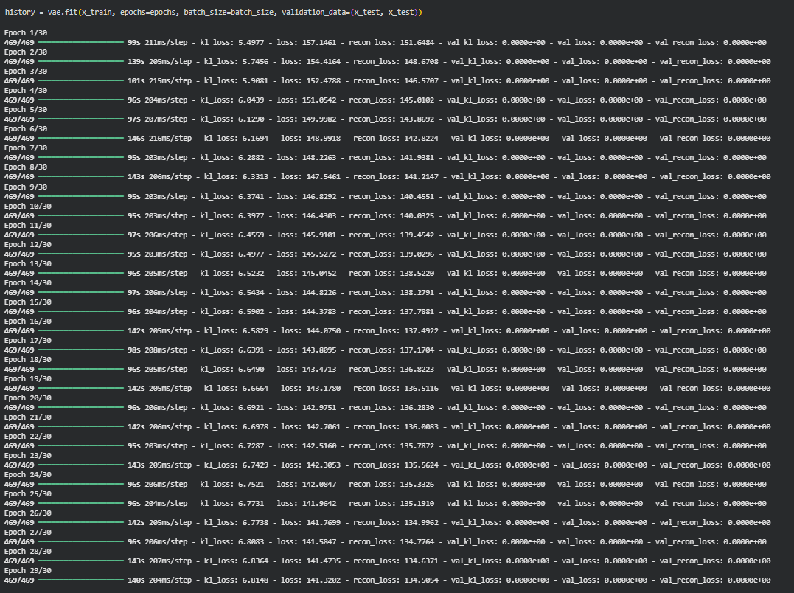
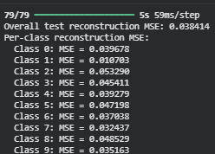
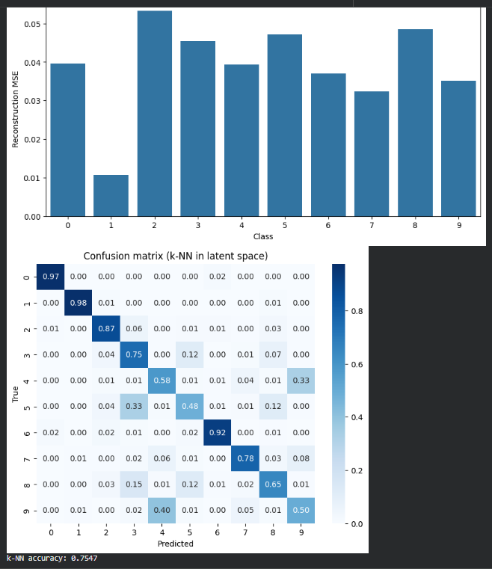
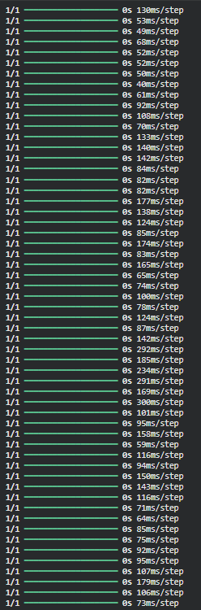
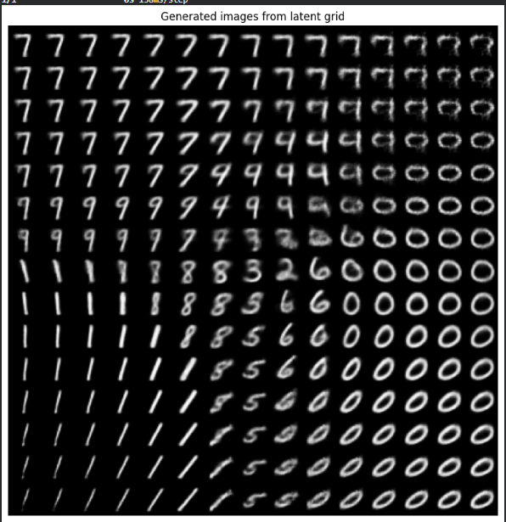
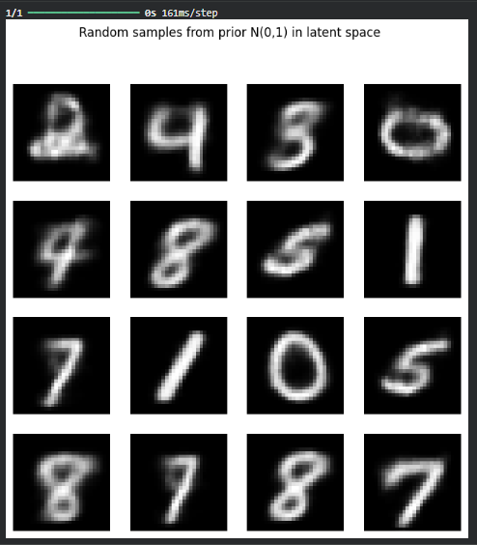
Conclusion:
The VAE successfully:
- Reconstructed MNIST digits with low reconstruction error (overall and per class),
- Learned a structured 2D latent space where digits cluster by class,
- Enabled k-NN in latent space to achieve good classification accuracy,
- Generated realistic digit images by sampling from the latent space.
Thus, the experiment demonstrates that a VAE can both compress images into meaningful latent codes and generate plausible new samples.

