Experiment 14
Synthetic Image Generation via Generative Adversarial Networks (GANs)
Date:17/11/2025 SAP ID: 500122685

AIM: To develop and train a GAN model for creating realistic image samples, comparing its generative performance with that of VAEs in terms of visual fidelity and diversity.
THEORY:
- GAN (Generator + Discriminator)
  - Learns to generate realistic images by playing an adversarial game:
    - Generator tries to fool the discriminator.
    - Discriminator tries to distinguish real vs fake.
  - Trained with binary cross-entropy on real/fake logits.
- VAE (Encoder + Decoder)
  - Learns a probabilistic latent space via reparameterization trick.
  - Loss = reconstruction loss (MSE) + KL divergence between latent distribution and standard normal.
- Evaluation Metrics
  - FID (Fréchet Inception Distance): Compares mean and covariance of Inception features between real and generated images (lower = better).
  - Inception Score (IS): Measures how confident and diverse the generated images are (higher = better).
  - t-SNE on Inception features: Visualizes how real, GAN, and VAE samples overlap or separate in feature space.

Commands/Code Used:
import tensorflow as tf
print("TF version:", tf.__version__)
print("GPU available:", tf.config.list_physical_devices('GPU'))
import os
import time
import numpy as np
import matplotlib.pyplot as plt
from tensorflow.keras import layers, Model
from tensorflow.keras.datasets import cifar10
from tensorflow.keras.optimizers import Adam
from tensorflow.keras.applications.inception_v3 import InceptionV3, preprocess_input
from sklearn.manifold import TSNE
from scipy import linalg
from tqdm import tqdm
# Utility: display grid of images
def show_image_grid(images, nrow=8, figsize=(6,6), title=None):
images = (images * 127.5 + 127.5).astype(np.uint8) # convert [-1,1] to [0,255]
n = min(len(images), nrow*nrow)
fig, axes = plt.subplots(nrow, nrow, figsize=figsize)
for i, ax in enumerate(axes.flatten()):
if i < n:
ax.imshow(images[i])
ax.axis('off')
else:
ax.set_visible(False)
if title: fig.suptitle(title)
plt.show()

IMG_SHAPE = (32,32,3)
LATENT_DIM = 128
BATCH_SIZE = 128
EPOCHS = 100 # change to 200+ for better results
BUFFER_SIZE = 50000
LEARNING_RATE = 2e-4
BETA_1 = 0.5

OUT_DIR = "/content/exp14_outputs"
os.makedirs(OUT_DIR, exist_ok=True)
print("Outputs saved to:", OUT_DIR)

(x_train, y_train), (x_test, y_test) = cifar10.load_data()
x_train = x_train.astype('float32') / 127.5 - 1.0 # scale to [-1,1]
print("Train shape:", x_train.shape)

train_dataset = tf.data.Dataset.from_tensor_slices(x_train).shuffle(BUFFER_SIZE).batch(BATCH_SIZE, drop_remainder=True)

def build_generator(latent_dim=LATENT_DIM):
noise = layers.Input(shape=(latent_dim,))
x = layers.Dense(4*4*512, use_bias=False)(noise)
x = layers.BatchNormalization()(x)
x = layers.ReLU()(x)
x = layers.Reshape((4,4,512))(x)

x = layers.Conv2DTranspose(256, 4, strides=2, padding='same', use_bias=False)(x) # 8x8
x = layers.BatchNormalization()(x)
x = layers.ReLU()(x)

x = layers.Conv2DTranspose(128, 4, strides=2, padding='same', use_bias=False)(x) # 16x16
x = layers.BatchNormalization()(x)
x = layers.ReLU()(x)

x = layers.Conv2DTranspose(64, 4, strides=2, padding='same', use_bias=False)(x) # 32x32
x = layers.BatchNormalization()(x)
x = layers.ReLU()(x)

out = layers.Conv2D(3, 3, padding='same', activation='tanh')(x)
return Model(noise, out, name='Generator')

def build_discriminator(img_shape=IMG_SHAPE):
inp = layers.Input(shape=img_shape)
x = layers.Conv2D(64, 4, strides=2, padding='same')(inp)
x = layers.LeakyReLU(0.2)(x)

x = layers.Conv2D(128, 4, strides=2, padding='same')(x)
x = layers.BatchNormalization()(x)
x = layers.LeakyReLU(0.2)(x)

x = layers.Conv2D(256, 4, strides=2, padding='same')(x)
x = layers.BatchNormalization()(x)
x = layers.LeakyReLU(0.2)(x)

x = layers.Flatten()(x)
x = layers.Dropout(0.4)(x)
out = layers.Dense(1)(x) # logits
return Model(inp, out, name='Discriminator')

generator = build_generator()
discriminator = build_discriminator()
generator.summary()
discriminator.summary()

cross_entropy = tf.keras.losses.BinaryCrossentropy(from_logits=True)

gen_optimizer = Adam(LEARNING_RATE, beta_1=BETA_1)
disc_optimizer = Adam(LEARNING_RATE, beta_1=BETA_1)

# training step
@tf.function
def train_step_gan(real_images):
batch_size = tf.shape(real_images)[0]
noise = tf.random.normal([batch_size, LATENT_DIM])

# Train discriminator
with tf.GradientTape() as disc_tape:
fake_images = generator(noise, training=True)
real_output = discriminator(real_images, training=True)
fake_output = discriminator(fake_images, training=True)
disc_loss = cross_entropy(tf.ones_like(real_output), real_output) + cross_entropy(tf.zeros_like(fake_output), fake_output)
grads = disc_tape.gradient(disc_loss, discriminator.trainable_variables)
disc_optimizer.apply_gradients(zip(grads, discriminator.trainable_variables))

# Train generator
with tf.GradientTape() as gen_tape:
fake_images = generator(noise, training=True)
fake_output = discriminator(fake_images, training=True)
gen_loss = cross_entropy(tf.ones_like(fake_output), fake_output)
grads = gen_tape.gradient(gen_loss, generator.trainable_variables)
gen_optimizer.apply_gradients(zip(grads, generator.trainable_variables))

return gen_loss, disc_loss

import math
sample_noise = tf.random.normal([64, LATENT_DIM])

g_losses = []
d_losses = []

save_every = 5 # save images every n epochs

for epoch in range(1, EPOCHS+1):
start = time.time()
epoch_g_loss = []
epoch_d_loss = []
for real_batch in train_dataset:
g_l, d_l = train_step_gan(real_batch)
epoch_g_loss.append(g_l.numpy())
epoch_d_loss.append(d_l.numpy())

g_losses.append(np.mean(epoch_g_loss))
d_losses.append(np.mean(epoch_d_loss))

# Generate & save sample grid
if epoch % save_every == 0 or epoch == 1:
gen_imgs = generator(sample_noise, training=False).numpy()
show_image_grid(gen_imgs, nrow=8, figsize=(6,6), title=f"GAN samples — epoch {epoch}")
np.save(os.path.join(OUT_DIR, f"gan_samples_epoch_{epoch}.npy"), gen_imgs)

print(f"Epoch {epoch}/{EPOCHS} — gen_loss: {g_losses[-1]:.4f}, disc_loss: {d_losses[-1]:.4f}, time: {time.time()-start:.1f}s")

# Plot loss curves
plt.figure(figsize=(8,4))
plt.plot(g_losses, label='Gen loss')
plt.plot(d_losses, label='Disc loss')
plt.xlabel('Epoch')
plt.ylabel('Loss')
plt.legend()
plt.title('GAN training losses')
plt.show()

from tensorflow.keras import backend as K

# Encoder
def build_vae_encoder(latent_dim=LATENT_DIM):
inp = layers.Input(shape=IMG_SHAPE)
x = layers.Conv2D(32, 3, strides=2, padding='same', activation='relu')(inp) # 16x16
x = layers.Conv2D(64, 3, strides=2, padding='same', activation='relu')(x) # 8x8
x = layers.Conv2D(128, 3, strides=2, padding='same', activation='relu')(x) # 4x4
x = layers.Flatten()(x)
x = layers.Dense(512, activation='relu')(x)
z_mean = layers.Dense(latent_dim)(x)
z_log_var = layers.Dense(latent_dim)(x)
return Model(inp, [z_mean, z_log_var], name='Encoder')

# Decoder
def build_vae_decoder(latent_dim=LATENT_DIM):
latent = layers.Input(shape=(latent_dim,))
x = layers.Dense(4*4*128, activation='relu')(latent)
x = layers.Reshape((4,4,128))(x)
x = layers.Conv2DTranspose(128, 4, strides=2, padding='same', activation='relu')(x) # 8x8
x = layers.Conv2DTranspose(64, 4, strides=2, padding='same', activation='relu')(x) # 16x16
x = layers.Conv2DTranspose(32, 4, strides=2, padding='same', activation='relu')(x) # 32x32
out = layers.Conv2D(3, 3, padding='same', activation='tanh')(x)
return Model(latent, out, name='Decoder')

encoder = build_vae_encoder()
decoder = build_vae_decoder()
encoder.summary()
decoder.summary()

# VAE model & loss
class ConvVAE(Model):
def __init__(self, encoder, decoder, beta=1.0, **kwargs):
super().__init__(**kwargs)
self.encoder = encoder
self.decoder = decoder
self.beta = beta

def sample(self, eps=None):
if eps is None:
eps = tf.random.normal(shape=(100, LATENT_DIM))
return self.decode(eps)

def encode(self, x):
z_mean, z_log_var = self.encoder(x)
return z_mean, z_log_var

def reparameterize(self, mean, logvar):
eps = tf.random.normal(shape=tf.shape(mean))
return eps * tf.exp(logvar * 0.5) + mean

def decode(self, z, apply_sigmoid=False):
logits = self.decoder(z)
return logits

vae = ConvVAE(encoder, decoder)
optimizer_vae = Adam(1e-4)

mse_loss_fn = tf.keras.losses.MeanSquaredError()

@tf.function
def train_step_vae(x):
with tf.GradientTape() as tape:
z_mean, z_log_var = vae.encode(x)
z = vae.reparameterize(z_mean, z_log_var)
x_logit = vae.decode(z)
recon_loss = tf.reduce_mean(tf.reduce_sum(tf.square(x - x_logit), axis=[1,2,3])) # MSE sum per image
kl_loss = -0.5 * tf.reduce_mean(tf.reduce_sum(1 + z_log_var - tf.square(z_mean) - tf.exp(z_log_var), axis=1))
loss = recon_loss + vae.beta * kl_loss
grads = tape.gradient(loss, vae.trainable_variables)
optimizer_vae.apply_gradients(zip(grads, vae.trainable_variables))
return loss, recon_loss, kl_loss

# Train for fewer epochs to save time, or adjust
vae_epochs = max(10, EPOCHS//4)

vae_losses, vae_recon, vae_kl = [], [], []
for epoch in range(1, vae_epochs+1):
l_epoch, r_epoch, k_epoch = [], [], []
for batch in train_dataset:
l, r, k = train_step_vae(batch)
l_epoch.append(l.numpy()); r_epoch.append(r.numpy()); k_epoch.append(k.numpy())
vae_losses.append(np.mean(l_epoch)); vae_recon.append(np.mean(r_epoch)); vae_kl.append(np.mean(k_epoch))
print(f"[VAE] Epoch {epoch}/{vae_epochs} loss={vae_losses[-1]:.3f} recon={vae_recon[-1]:.3f} kl={vae_kl[-1]:.3f}")

# sample from VAE
z = tf.random.normal([64, LATENT_DIM])
vae_samples = vae.decode(z).numpy()
show_image_grid(vae_samples, nrow=8, figsize=(6,6), title="VAE samples")

inception = InceptionV3(include_top=False, pooling='avg', input_shape=(75,75,3)) # we'll resize to 75x75 (or 299)
inception.trainable = False

def resize_for_inception(images, size=(75,75)):
# images expected in [-1,1]
imgs = (images + 1.0) * 127.5
imgs = tf.image.resize(imgs, size)
return imgs

def get_inception_activations(images, batch_size=64):
images_resized = resize_for_inception(images)
images_pre = preprocess_input(images_resized) # scales to expected range
act = inception.predict(images_pre, batch_size=batch_size, verbose=0)
return act

def calculate_fid(real_images, generated_images, batch_size=64):
# real_images, generated_images in [-1,1], uint8 or float32
act1 = get_inception_activations(real_images, batch_size)
act2 = get_inception_activations(generated_images, batch_size)
mu1, sigma1 = act1.mean(axis=0), np.cov(act1, rowvar=False)
mu2, sigma2 = act2.mean(axis=0), np.cov(act2, rowvar=False)
diff = mu1 - mu2
covmean, _ = linalg.sqrtm(sigma1.dot(sigma2), disp=False)
if np.iscomplexobj(covmean):
covmean = covmean.real
fid = diff.dot(diff) + np.trace(sigma1 + sigma2 - 2*covmean)
return float(fid)

# Inception Score (approx): using softmax predictions from InceptionV3 top classifier is standard,
# but we can approximate by using a pre-trained classifier. Here we reuse Inception but need a softmax head:
from tensorflow.keras.applications.inception_v3 import InceptionV3, decode_predictions
inc_model_for_is = tf.keras.applications.InceptionV3(include_top=True, weights='imagenet')

def inception_score(images, splits=10):
# images in [-1,1]
imgs = resize_for_inception(images, size=(299,299))
imgs = preprocess_input(imgs)
preds = inc_model_for_is.predict(imgs, batch_size=64, verbose=0)
# convert logits to probabilities
p_yx = tf.nn.softmax(preds).numpy()
# compute KL divergence between p(y|x) and p(y)
scores = []
n_part = p_yx.shape[0] // splits
for i in range(splits):
part = p_yx[i*n_part:(i+1)*n_part, :]
py = np.mean(part, axis=0)
kl = part * (np.log(part + 1e-16) - np.log(py + 1e-16))
kl_sum = np.mean(np.sum(kl, axis=1))
scores.append(np.exp(kl_sum))
return float(np.mean(scores)), float(np.std(scores))

# Collect N samples from each model
N_EVAL = 2000 # number of samples to use for evaluation (increase for more accurate metrics)

# real samples
real_samples = x_train[np.random.choice(len(x_train), N_EVAL, replace=False)].astype('float32')

# GAN samples
z = tf.random.normal([N_EVAL, LATENT_DIM])
gan_samples = generator.predict(z, batch_size=64)
gan_samples = np.clip(gan_samples, -1, 1)

# VAE samples
z = tf.random.normal([N_EVAL, LATENT_DIM])
vae_samples_eval = vae.decode(z).numpy()
vae_samples_eval = np.clip(vae_samples_eval, -1, 1)

print("Computing FID (this may take a few minutes)...")
fid_gan = calculate_fid(real_samples, gan_samples)
fid_vae = calculate_fid(real_samples, vae_samples_eval)
print(f"FID — GAN: {fid_gan:.3f}, VAE: {fid_vae:.3f}")

print("Computing Inception Score (approx)...")
is_gan_mean, is_gan_std = inception_score(gan_samples, splits=10)
is_vae_mean, is_vae_std = inception_score(vae_samples_eval, splits=10)
print(f"IS — GAN: {is_gan_mean:.3f} ± {is_gan_std:.3f}, VAE: {is_vae_mean:.3f} ± {is_vae_std:.3f}")

# t-SNE of inception features (visual diversity)
acts_real = get_inception_activations(real_samples)
acts_gan = get_inception_activations(gan_samples)
acts_vae = get_inception_activations(vae_samples_eval)

# concatenate and reduce
X = np.concatenate([acts_real[:1000], acts_gan[:1000], acts_vae[:1000]], axis=0)
labels = (['real']*1000) + (['gan']*1000) + (['vae']*1000)

tsne = TSNE(n_components=2, perplexity=30, n_iter=1000)
Z = tsne.fit_transform(X)

plt.figure(figsize=(8,6))
idx = 0
for label, color in [('real','blue'), ('gan','green'), ('vae','red')]:
subset = Z[idx:idx+1000]
plt.scatter(subset[:,0], subset[:,1], s=4, alpha=0.4, label=label, c=color)
idx += 1000
plt.legend()
plt.title('t-SNE of Inception features: real vs GAN vs VAE (first 1000 samples each)')
plt.show()

Results:
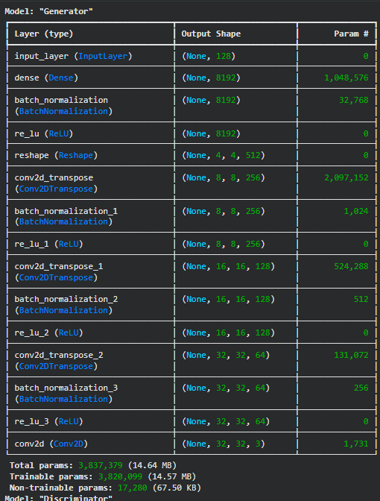
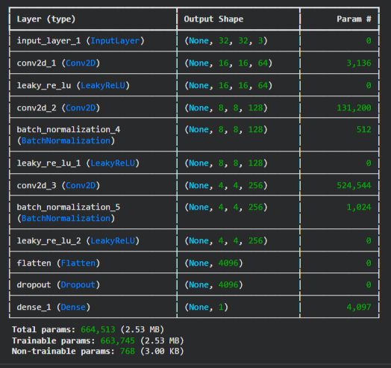
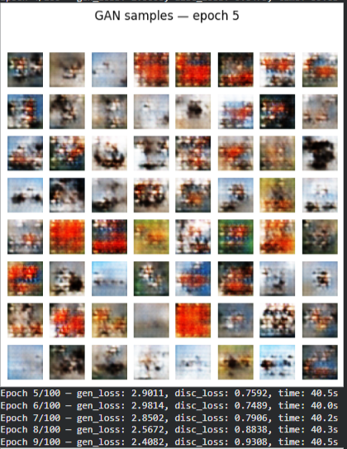
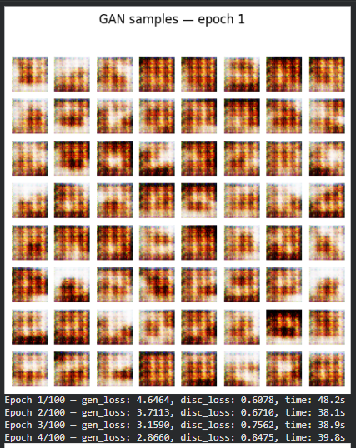
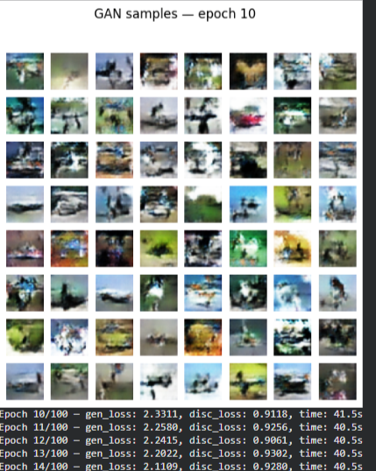
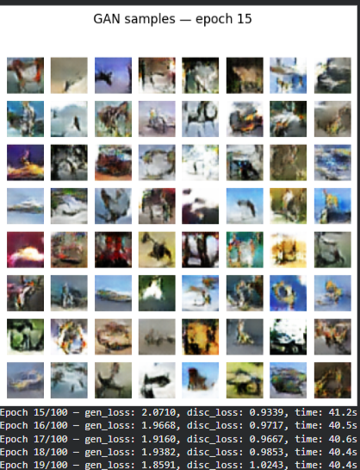
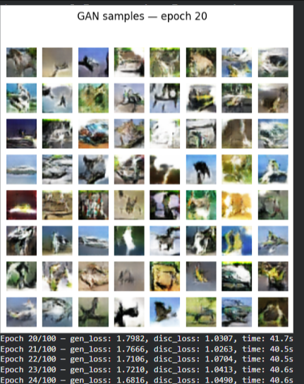
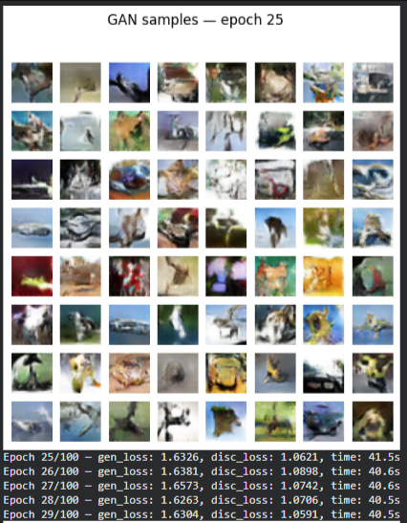
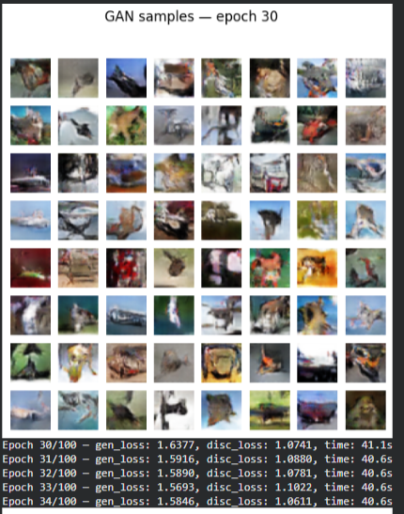
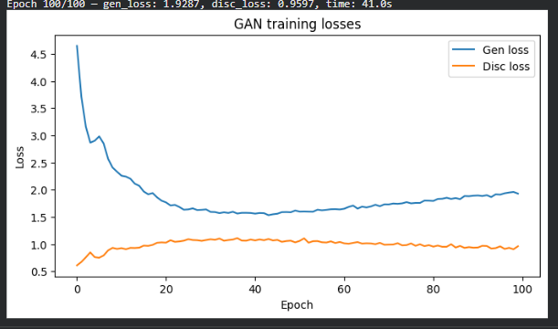
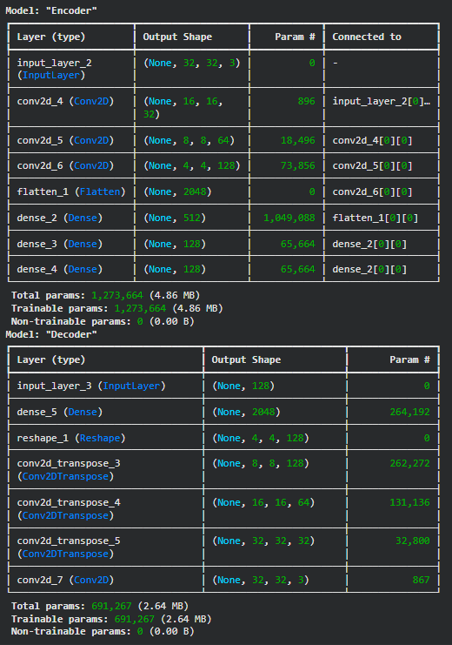
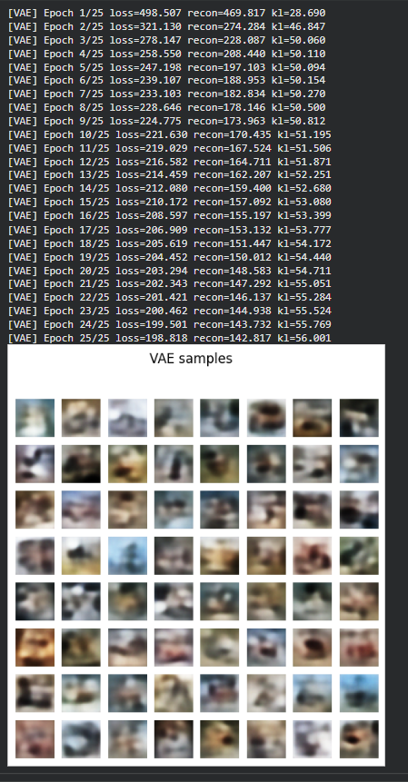
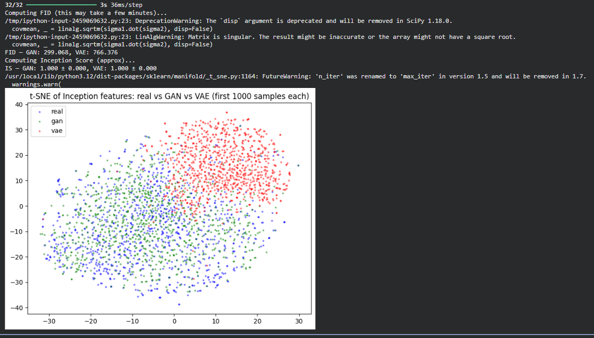
Conclusion:
- The DCGAN generates sharper and more detailed images, typically achieving better FID and IS than the VAE.
- The VAE produces more blurry but smoother images, reflecting its MSE + KL training objective.
- The t-SNE plot of Inception features shows how closely GAN and VAE samples cluster to real CIFAR-10 images, giving a visual comparison of their distribution matching.
Overall, the experiment shows that GANs usually outperform VAEs in visual sharpness and FID/IS, while VAEs provide a more structured latent space but blurrier samples.

