Experiment 02
Application of a DL Framework for Classification
Date: 01/09/2025 SAP ID: 500122685

AIM:
- To implement a single neuron model for the AND gate using weighted inputs and verify its functionality.
- To extend the model into a Feedforward Neural Network (FFNN) for solving logical XOR/AND problems using multiple layers and neurons.
- To design and train a Multilayer Perceptron (MLP) to solve more complex classification tasks or datasets.

THEORY:
a) Single Neuron for AND Gate
- A neuron takes multiple inputs, applies weights to them, sums them up, and passes the result through an activation function (e.g., step function, sigmoid).
(b) Feedforward Neural Network (FFNN) for XOR
- A Feedforward Neural Network (FFNN) is a network of neurons arranged in layers:
  - Input layer → takes raw data.
  - Hidden layer(s) → perform intermediate computations.
  - Output layer → gives final prediction.
- The XOR gate cannot be solved by a single neuron (since it’s not linearly separable).
- Adding a hidden layer with nonlinear activations (e.g., sigmoid, ReLU) enables the network to correctly model XOR.
(c) Multilayer Perceptron (MLP)
- An MLP is a generalization of FFNN with multiple hidden layers.
- It uses backpropagation and gradient descent for training.
- Key properties:
  - Learns non-linear decision boundaries.
  - Can approximate any continuous function (Universal Approximation Theorem).
- Applications: classification (e.g., MNIST digit recognition), regression, speech, and image recognition.

Commands/Code Used:
import numpy as np
# Activation function: sigmoid
def sigmoid(x):
return 1 / (1 + np.exp(-x))
# Example input: batch of 4 XOR inputs
X = np.array([
[0, 0],
[0, 1],
[1, 0],
[1, 1]
])
W1 = np.array([[10, -10],
[10, -10]])
b1 = np.array([-5, 15])
W2 = np.array([[10],
[10]])
b2 = np.array([-15])
def forward_pass(X):
z1 = np.dot(X, W1) + b1
a1 = sigmoid(z1)
z2 = np.dot(a1, W2) + b2
a2 = sigmoid(z2)
return a2
outputs = forward_pass(X)
print("Inputs:\n", X)
print("Outputs:\n", outputs)
def step_function(x):
return 1 if x >= 0 else
def xor_network(x1, x2):
# Hidden layer neurons (mimicking OR and AND)
h1 = step_function(x1 + x2 - 0.5) # OR gate
h2 = step_function(x1 + x2 - 1.5) # AND gate
# Output neuron: behaves like XOR (OR - AND)
y = step_function(h1 - h2 - 0.5)
return y
# Test XOR logic
for x1 in [0, 1]:
for x2 in [0, 1]:
print(f"XOR({x1}, {x2}) = {xor_network(x1, x2)}")

Results:
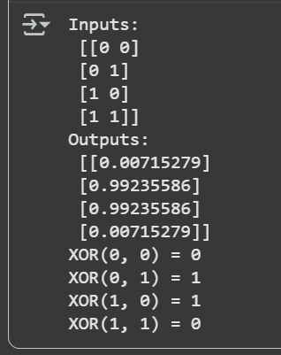
Conclusion:
- A single neuron successfully models the AND gate by applying proper weights and bias.
- A Feedforward Neural Network (FFNN) with at least one hidden layer is necessary to solve the XOR problem, proving that some functions are not linearly separable.
- A Multilayer Perceptron (MLP) extends this concept further, enabling the modeling of complex, real-world problems with high accuracy.
- Thus, we demonstrated the progression from simple perceptrons to powerful deep learning architectures.

