Experiment 6
Implementation of Multi-Layer Perceptron (MLP) with Activation and Loss Functions Visualization

Date: 15/09/25 SAP ID: 500122685

AIM:

- To design, train, and evaluate a feed-forward Multi-Layer Perceptron (MLP) on the MNIST handwritten digit dataset using PyTorch.
- To measure performance via cross-entropy (NLL with log-softmax) loss and classification accuracy, and to visualize learning curves and sample predictions.
- To demonstrate the effect of ReLU activations, Adam optimizer, and Dropout regularization on generalization.

THEORY:
1. What is MNIST?
- The MNIST dataset contains images of handwritten digits (0–9). Each image is 28×28 pixels, and the goal is to make a model that can correctly recognize which digit the image shows.
It is a classification problem with 10 output classes.

2. What is an MLP (Multi-Layer Perceptron)?
- An MLP is a type of Artificial Neural Network (ANN) that consists of multiple fully connected (dense) layers.
Each layer learns different features of the data.
- The input layer takes the image pixels (784 values).
- The hidden layers process and learn features using mathematical functions.
- The output layer gives the probability for each digit (0–9).

3. Activation Function (ReLU)
- After each layer, we apply an activation function to make the model learn complex patterns.
We use ReLU (Rectified Linear Unit) because it is simple and helps the model train faster by avoiding vanishing gradients.

4. Dropout Layer
- Dropout helps to prevent overfitting.
During training, it randomly turns off (drops) some neurons, so the model doesn’t depend too much on specific connections.
It improves generalization on new (test) data.

5. Loss Function (NLLLoss)
- The loss function tells the model how wrong its predictions are.
Here, we use Negative Log-Likelihood Loss (NLLLoss) with Log Softmax.
It is commonly used for multi-class classification problems.

6. Optimizer (Adam)
- The Adam optimizer is used to update the weights of the network efficiently.
It automatically adjusts the learning rate for each parameter and helps the model reach the best result faster.

7. Training Process
- The model learns by comparing predictions with actual labels.
- It adjusts its weights using backpropagation.
- This process repeats for many epochs until accuracy improves.

8. Evaluation Metrics
- We measure how well the model performs using:
- Loss – smaller is better.
- Accuracy (%) – higher is better.
- We also check both training and testing accuracy to see if the model generalizes well.

9. Visualization
- Graphs of accuracy and loss vs. epochs help to see if learning is stable.
- Predicted images show whether the model correctly identifies digits.

Commands/Code Used:
# Import necessary libraries
import torch
import torch.nn as nn
import torch.optim as optim
import torch.nn.functional as F
from torchvision import datasets, transforms
from torch.utils.data import DataLoader
import matplotlib.pyplot as plt
import numpy as np
# Set random seed for reproducibility
torch.manual_seed(42)
# Define device
device = torch.device('cuda' if torch.cuda.is_available() else 'cpu')
print(f"Using device: {device}")
# Define data transformations
transform = transforms.Compose([
transforms.ToTensor(),
transforms.Normalize((0.1307,), (0.3081,)) # MNIST dataset mean and std
])
# Load MNIST dataset
train_dataset = datasets.MNIST(root='./data', train=True, download=True, transform=transform)
test_dataset = datasets.MNIST(root='./data', train=False, download=True, transform=transform)
# Create data loaders
batch_size = 64
train_loader = DataLoader(train_dataset, batch_size=batch_size, shuffle=True)
test_loader = DataLoader(test_dataset, batch_size=batch_size, shuffle=False)
# Define the MLP model
class MLP(nn.Module):
def __init__(self, input_size=784, hidden_size1=256, hidden_size2=128, output_size=10):
super(MLP, self).__init__()
self.fc1 = nn.Linear(input_size, hidden_size1)
self.fc2 = nn.Linear(hidden_size1, hidden_size2)
self.fc3 = nn.Linear(hidden_size2, output_size)
self.dropout = nn.Dropout(0.2) # Dropout for regularization
def forward(self, x):
# Flatten the input
x = x.view(-1, 784)
# First hidden layer with ReLU activation
x = F.relu(self.fc1(x))
x = self.dropout(x)
# Second hidden layer with ReLU activation
x = F.relu(self.fc2(x))
x = self.dropout(x)
# Output layer
x = self.fc3(x)
# Apply log softmax for numerical stability
output = F.log_softmax(x, dim=1)
return output
# Initialize the model
model = MLP().to(device)
# Define loss function and optimizer
criterion = nn.NLLLoss() # Negative Log Likelihood Loss
optimizer = optim.Adam(model.parameters(), lr=0.001)
# Training function
def train(model, device, train_loader, optimizer, epoch):
model.train()
train_loss = 0
correct = 0
total = 0
for batch_idx, (data, target) in enumerate(train_loader):
# Move data to device
data, target = data.to(device), target.to(device)
# Zero the gradients
optimizer.zero_grad()
# Forward pass
output = model(data)
# Calculate loss
loss = criterion(output, target)
# Backward pass
loss.backward()
# Update weights
optimizer.step()
# Update statistics
train_loss += loss.item()
_, predicted = output.max(1)
total += target.size(0)
correct += predicted.eq(target).sum().item()
# Print progress
if (batch_idx + 1) % 100 == 0:
print(f'Epoch: {epoch}, Batch: {batch_idx+1}/{len(train_loader)}, Loss: {loss.item():.4f}')
# Calculate epoch statistics
train_loss /= len(train_loader)
train_accuracy = 100. * correct / total
return train_loss, train_accuracy
# Testing function
def test(model, device, test_loader):
model.eval()
test_loss = 0
correct = 0
total = 0
with torch.no_grad():
for data, target in test_loader:
# Move data to device
data, target = data.to(device), target.to(device)
# Forward pass
output = model(data)
# Calculate loss
test_loss += criterion(output, target).item()
# Get predictions
_, predicted = output.max(1)
total += target.size(0)
correct += predicted.eq(target).sum().item()
# Calculate test statistics
test_loss /= len(test_loader)
test_accuracy = 100. * correct / total
return test_loss, test_accuracy
# Train the model
epochs = 10
train_losses = []
train_accuracies = []
test_losses = []
test_accuracies = []
for epoch in range(1, epochs + 1):
train_loss, train_accuracy = train(model, device, train_loader, optimizer, epoch)
test_loss, test_accuracy = test(model, device, test_loader)
# Store statistics
train_losses.append(train_loss)
train_accuracies.append(train_accuracy)
test_losses.append(test_loss)
test_accuracies.append(test_accuracy)
# Print epoch statistics
print(f'Epoch: {epoch}/{epochs}')
print(f'Train Loss: {train_loss:.4f}, Train Accuracy: {train_accuracy:.2f}%')
print(f'Test Loss: {test_loss:.4f}, Test Accuracy: {test_accuracy:.2f}%')
print('-' * 60)
# Plot training and test loss
plt.figure(figsize=(12, 4))
plt.subplot(1, 2, 1)
plt.plot(train_losses, label='Train Loss')
plt.plot(test_losses, label='Test Loss')
plt.title('Loss vs. Epochs')
plt.xlabel('Epochs')
plt.ylabel('Loss')
plt.legend()
# Plot training and test accuracy
plt.subplot(1, 2, 2)
plt.plot(train_accuracies, label='Train Accuracy')
plt.plot(test_accuracies, label='Test Accuracy')
plt.title('Accuracy vs. Epochs')
plt.xlabel('Epochs')
plt.ylabel('Accuracy (%)')
plt.legend()
plt.tight_layout()
plt.show()
# Visualize some predictions
def visualize_predictions(model, device, test_loader, num_samples=10):
model.eval()
# Get a batch of test data
dataiter = iter(test_loader)
images, labels = next(dataiter)
# Move to device
images, labels = images.to(device), labels.to(device)
# Get predictions
with torch.no_grad():
outputs = model(images)
_, predicted = torch.max(outputs, 1)
# Move back to CPU for visualization
images = images.cpu().numpy()
labels = labels.cpu().numpy()
predicted = predicted.cpu().numpy()
# Plot the images with predictions
plt.figure(figsize=(15, 4))
for i in range(num_samples):
plt.subplot(1, num_samples, i+1)
plt.imshow(images[i].squeeze(), cmap='gray')
plt.title(f'Pred: {predicted[i]}\nTrue: {labels[i]}')
plt.axis('off')
plt.tight_layout()
plt.show()
# Visualize predictions
visualize_predictions(model, device, test_loader)
# Save the model
torch.save(model.state_dict(), 'mlp_mnist.pth')
print("Model saved as 'mlp_mnist.pth'")

Results:

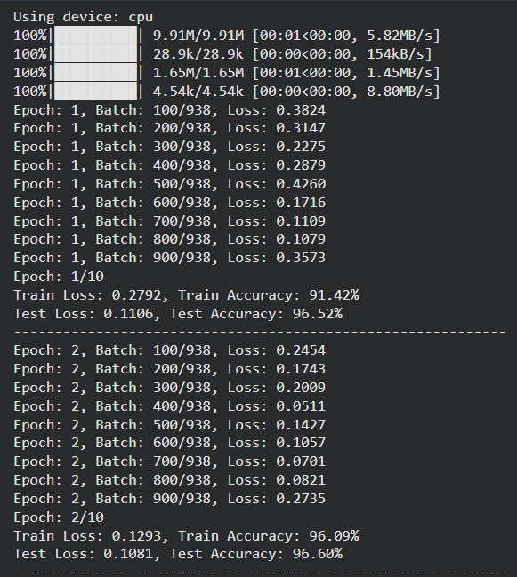
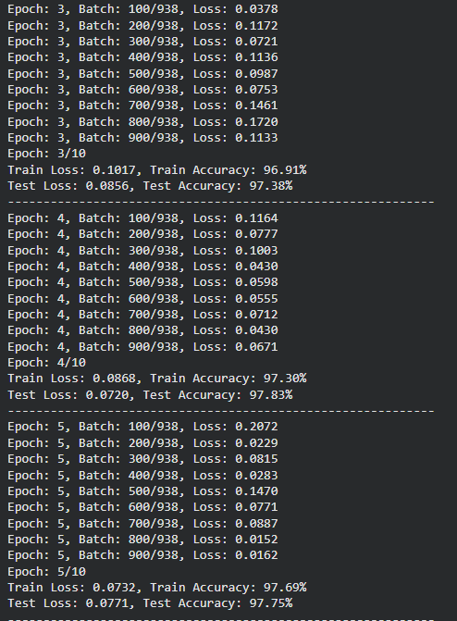
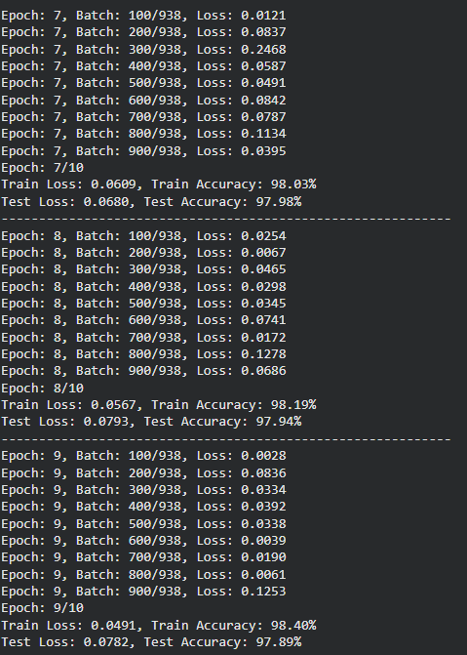

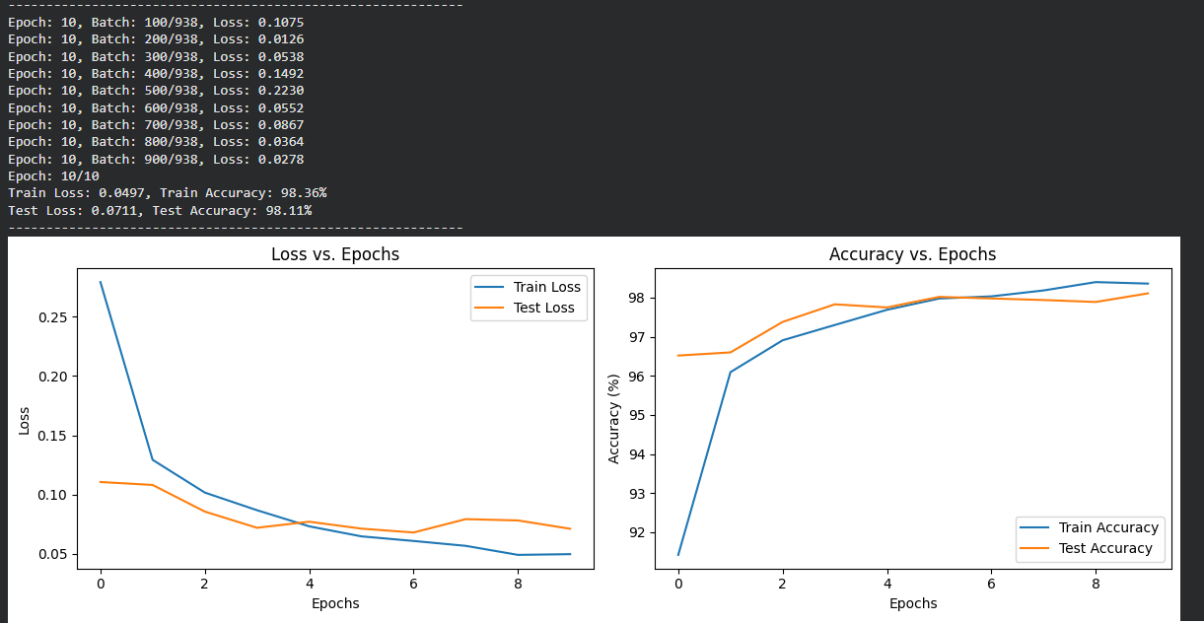

Conclusion:
- A relatively shallow MLP with ReLU + Dropout + Adam achieves high accuracy on MNIST with stable learning dynamics.
- Normalization and Dropout notably improve generalization, while Adam accelerates convergence with minimal tuning.
- The learning curves and prediction grids confirm that the model fits the training data and transfers well to unseen test images.
- For further gains (especially robustness), consider batch normalization, learning-rate scheduling, early stopping, or switching to a CNN (e.g., LeNet) which leverages spatial structure and typically surpasses MLPs on image data.

(Optional) Limitations & Future Work
- Limitations: MLP ignores image locality; more parameters than necessary for 28×28 images; less robust to translation/rotation.
- Future work: Use a small CNN, data augmentation (random shifts/rotations), LR schedulers (e.g., ReduceLROnPlateau), and calibration checks (ECE).

