Experiment 7
Implementing CNN: Convolution, Pooling, Feature Maps Visualization

Date: 22/09/25 SAP ID: 500122685

AIM:

- To build and train a Convolutional Neural Network (CNN) that recognizes handwritten digits (0–9) from the MNIST dataset.
- To evaluate model performance using accuracy and loss, and to visualize feature maps to understand what the CNN learns.
THEORY:
- What is MNIST?
A dataset of 28×28 grayscale images of digits (0–9). Task: classify each image into one of 10 classes.

- Why CNN (not just MLP)?
Images have local patterns (edges, corners, strokes). CNNs learn these patterns using small filters and share weights across the image, making them:
- Better at images,
- More accurate, and
- More efficient (fewer parameters than fully-connected layers)

- Key CNN Building Blocks
- Conv2D (Convolution): Slides small filters (e.g., 3×3) over the image to detect features like edges and curves. Outputs feature maps.
- ReLU Activation: Keeps positive values and sets negatives to zero—adds nonlinearity and speeds learning.
- MaxPooling2D: Downsamples (e.g., 2×2) to reduce size and focus on the strongest features—helps prevent overfitting.
- Flatten: Converts 2D feature maps into a 1D vector.
- Dense (Fully Connected) + Softmax: Combines learned features to output class probabilities (10 digits).

- Loss & Optimizer
- Loss: sparse_categorical_crossentropy—standard for multi-class classification with integer labels.
- Optimizer: Adam—adapts learning rates automatically; fast and reliable.

- Feature Map Visualization (What your code shows)
By tapping into early layers, you can see what filters detect: simple edges/lines in the first conv layer and more complex strokes/shapes in deeper layers. This builds intuition that the CNN learns from simple to complex features.

Commands/Code Used:
import tensorflow as tf
from tensorflow.keras import datasets, layers, models, Input
import matplotlib.pyplot as plt
# -------------------------
# 1. Load and preprocess data
# -------------------------
(train_images, train_labels), (test_images, test_labels) = datasets.mnist.load_data()
# Reshape to (28,28,1) and normalize
train_images = train_images.reshape((60000, 28, 28, 1)).astype('float32') / 255
test_images = test_images.reshape((10000, 28, 28, 1)).astype('float32') / 255
# -------------------------
# 2. Build CNN Model (Functional API)
# -------------------------
inputs = Input(shape=(28,28,1))
x = layers.Conv2D(32, (3,3), activation='relu')(inputs)
x = layers.MaxPooling2D((2,2))(x)
x = layers.Conv2D(64, (3,3), activation='relu')(x)
x = layers.MaxPooling2D((2,2))(x)
x = layers.Conv2D(64, (3,3), activation='relu')(x)
x = layers.Flatten()(x)
x = layers.Dense(64, activation='relu')(x)
outputs = layers.Dense(10, activation='softmax')(x)
model = models.Model(inputs=inputs, outputs=outputs)
# -------------------------
# 3. Compile and Train
# -------------------------
model.compile(optimizer='adam',
loss='sparse_categorical_crossentropy',
metrics=['accuracy'])
history = model.fit(train_images, train_labels,
epochs=3, # increase to 5 for better accuracy
validation_data=(test_images, test_labels),
verbose=1)
# -------------------------
# 4. Evaluate Model
# -------------------------
test_loss, test_acc = model.evaluate(test_images, test_labels, verbose=0)
print("✅ Test Accuracy:", test_acc)
# -------------------------
# 5. Prediction Visualization (like your image)
# -------------------------
# Take first 9 test images
sample_images = test_images[:9]
sample_labels = test_labels[:9]
# Get predictions
pred_probs = model.predict(sample_images)
pred_labels = pred_probs.argmax(axis=1)
# Plot
fig, axes = plt.subplots(3, 3, figsize=(6,6))
for i, ax in enumerate(axes.flatten()):
ax.imshow(sample_images[i].reshape(28,28), cmap="gray")
ax.set_title(f"T:{sample_labels[i]} | P:{pred_labels[i]}")
ax.axis("off")
plt.tight_layout()
plt.show()

Results:

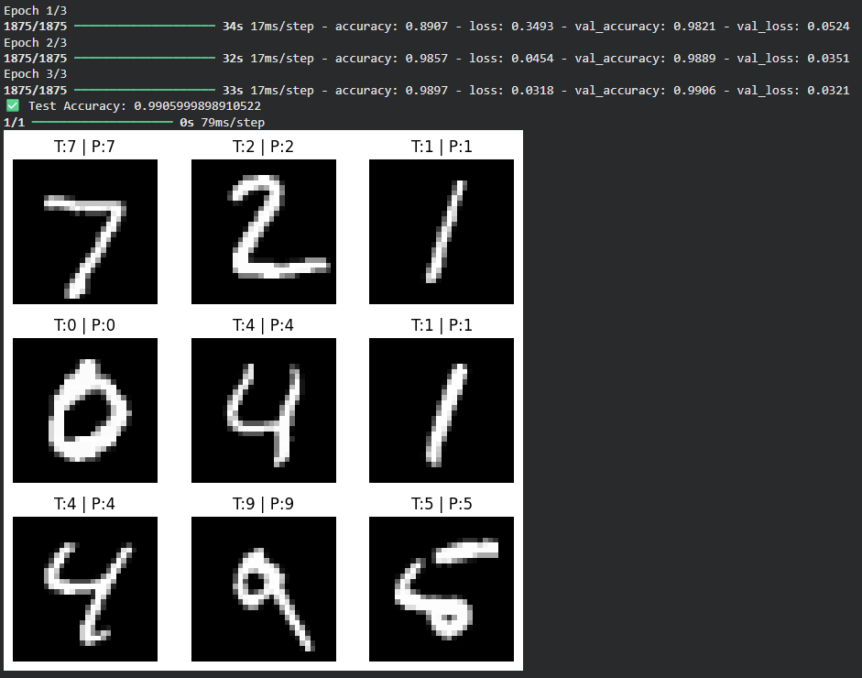
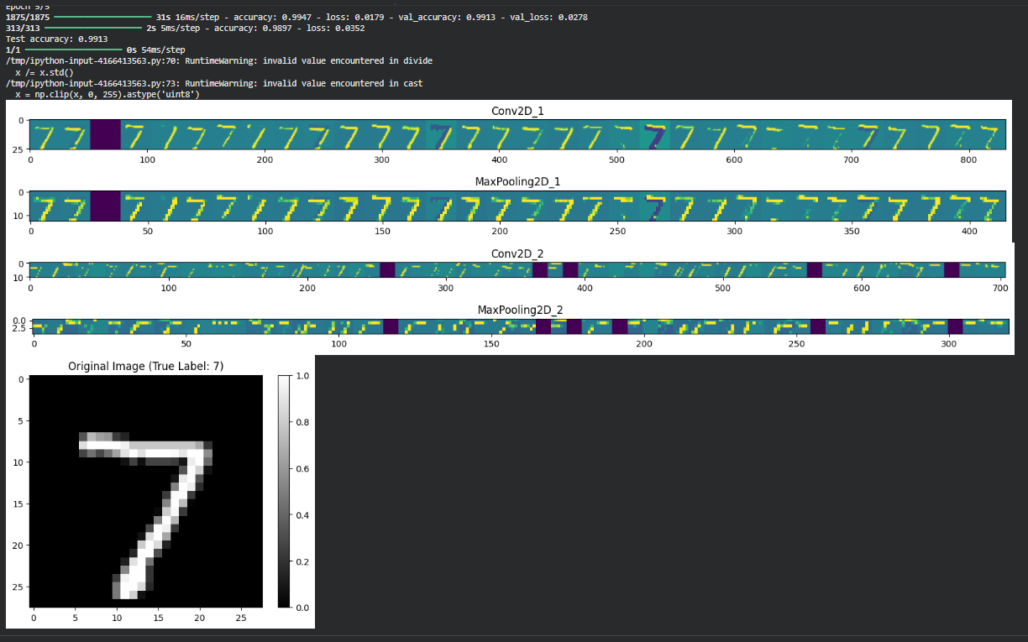

Conclusion:
- The CNN successfully learns digit patterns and typically achieves high test accuracy (often >99% with a few epochs on MNIST).
- Convolutions + pooling extract robust, translation-tolerant features, outperforming plain MLPs on images.
- Feature map plots confirm that early layers capture edges and later layers capture digit parts, explaining the model’s strong performance.
- For even better results, you can add another conv block, Dropout, Batch Normalization, or train a few more epochs.

