Experiment 8
Implementing CNN with Data Augmentation for Image Classification

Date: 29/09/25 SAP ID: 500122685

AIM:
- Build a Convolutional Neural Network (CNN) to classify CIFAR-10 images into 10 classes (airplane, automobile, bird, …, truck).
- Improve generalization using data augmentation and evaluate with accuracy and loss on the test set.
- Allow single-image inference (upload an image and get the predicted class).

THEORY:

1) What is CIFAR-10?
- A dataset of 60,000 color images sized 32×32×3 across 10 categories.
- It’s a multi-class classification problem (one image → one label from 10).

2) Why use a CNN for images?
- Images have local patterns (edges, corners, textures).
- Convolutions learn these patterns using small filters and share weights, making CNNs both accurate and parameter-efficient for vision tasks.

3) Building blocks used in your model
- Conv2D (3×3, ReLU): detects local features like edges or textures.
- MaxPooling2D (2×2): downsamples to keep the strongest features and reduces computation.
- Stacked Convs (32→64→128 filters): deeper layers learn more complex patterns (from edges → shapes → object parts).
- Flatten → Dense(128, ReLU): combines learned features for decision making.
- Dropout(0.5): randomly turns off some neurons during training to reduce overfitting.
- Dense(10, Softmax): outputs probabilities for the 10 classes.

4) Data augmentation (why it helps)
- Random rotation/shift/flip/zoom creates varied versions of the same image.
- This acts like “free extra data,” helping the model generalize better and avoid overfitting.

5) Loss & Optimizer
- Loss: sparse_categorical_crossentropy—standard for multi-class classification with integer labels.
- Optimizer: Adam—adapts learning rates automatically; reliable and fast to converge.

6) Evaluation
- Training accuracy/loss tells how well the model fits seen data.
- Validation/Test accuracy/loss tells how well it generalizes to new images.
- Plotting train vs val accuracy helps spot overfitting (big gap) or underfitting (both low).

Commands/Code Used:
import tensorflow as tf
from tensorflow.keras.preprocessing.image import ImageDataGenerator
from tensorflow.keras.models import Sequential
from tensorflow.keras.layers import Conv2D, MaxPooling2D, Flatten, Dense, Dropout
from tensorflow.keras.preprocessing import image
import matplotlib.pyplot as plt
import numpy as np
import os
train_datagen = ImageDataGenerator(
rotation_range=20,
width_shift_range=0.2,
height_shift_range=0.2,
shear_range=0.2,
zoom_range=0.2,
horizontal_flip=True,
fill_mode='nearest'
)
test_datagen = ImageDataGenerator()
model = Sequential([
Conv2D(32, (3,3), activation='relu', input_shape=(32, 32, 3)),
MaxPooling2D((2,2)),
Conv2D(64, (3,3), activation='relu'),
MaxPooling2D((2,2)),
Flatten(),
Dense(128, activation='relu'),
Dropout(0.5),
Dense(10, activation='softmax')
])
model.compile(optimizer='adam',
loss='sparse_categorical_crossentropy',
metrics=['accuracy'])
history = model.fit(train_datagen.flow(x_train, y_train, batch_size=64),
validation_data=(x_test, y_test),
epochs=20)
plt.plot(history.history['accuracy'], label='train acc')
plt.plot(history.history['val_accuracy'], label='val acc')
plt.legend()
plt.show()
test_loss, test_acc = model.evaluate(x_test, y_test)
print(f"Test Accuracy: {test_acc:.2f}")
class_names = ['airplane','automobile','bird','cat','deer','dog','frog','horse','ship','truck']
print(class_names) # ensure this ordering is used everywhere
import tensorflow as tf
(x_train, y_train), (x_test, y_test) = tf.keras.datasets.cifar10.load_data()
x_train = x_train.astype('float32') / 255.0
x_test = x_test.astype('float32') / 255.0
class_names = ['airplane','automobile','bird','cat','deer','dog','frog','horse','ship','truck']
from tensorflow.keras.preprocessing.image import ImageDataGenerator
train_gen = ImageDataGenerator(
rotation_range=15,
width_shift_range=0.1,
height_shift_range=0.1,
horizontal_flip=True
)
train_gen.fit(x_train)
from tensorflow.keras.models import Sequential
from tensorflow.keras.layers import Conv2D, MaxPooling2D, Flatten, Dense, Dropout
model = Sequential([
Conv2D(32, (3,3), activation='relu', padding='same', input_shape=(32,32,3)),
MaxPooling2D((2,2)),
Conv2D(64, (3,3), activation='relu', padding='same'),
MaxPooling2D((2,2)),
Conv2D(128, (3,3), activation='relu', padding='same'),
MaxPooling2D((2,2)),
Flatten(),
Dense(128, activation='relu'),
Dropout(0.5),
Dense(10, activation='softmax')
])
model.compile(optimizer='adam',
loss='sparse_categorical_crossentropy',
metrics=['accuracy'])
history = model.fit(
train_gen.flow(x_train, y_train, batch_size=64),
epochs=25,
validation_data=(x_test, y_test)
)
import matplotlib.pyplot as plt
plt.plot(history.history['accuracy'], label='Train Acc')
plt.plot(history.history['val_accuracy'], label='Val Acc')
plt.legend(); plt.show()
test_loss, test_acc = model.evaluate(x_test, y_test)
print(f"✅ Test Accuracy: {test_acc:.3f}")
from google.colab import files
from tensorflow.keras.preprocessing import image
import matplotlib.pyplot as plt
import numpy as np
# Upload an image file interactively
uploaded = files.upload()
for filename in uploaded.keys():
img_path = filename
img = image.load_img(img_path, target_size=(32, 32))
img_array = image.img_to_array(img)
img_array = np.expand_dims(img_array, axis=0) / 255.0
prediction = model.predict(img_array)
predicted_class = np.argmax(prediction)
class_names = ['airplane','automobile','bird','cat','deer','dog','frog','horse','ship','truck']
plt.imshow(image.load_img(img_path))
plt.title(f"Predicted Class: {class_names[predicted_class]}")
plt.axis('off')
plt.show()
from google.colab import files
from tensorflow.keras.preprocessing import image
import matplotlib.pyplot as plt
import numpy as np
# Upload an image file interactively
uploaded = files.upload()
for filename in uploaded.keys():
img_path = filename
img = image.load_img(img_path, target_size=(32, 32))
img_array = image.img_to_array(img)
img_array = np.expand_dims(img_array, axis=0) / 255.0
prediction = model.predict(img_array)
predicted_class = np.argmax(prediction)
class_names = ['airplane','automobile','bird','cat','deer','dog','frog','horse','ship','truck']
plt.imshow(image.load_img(img_path))
plt.title(f"Predicted Class: {class_names[predicted_class]}")
plt.axis('off')
plt.show()

Results :
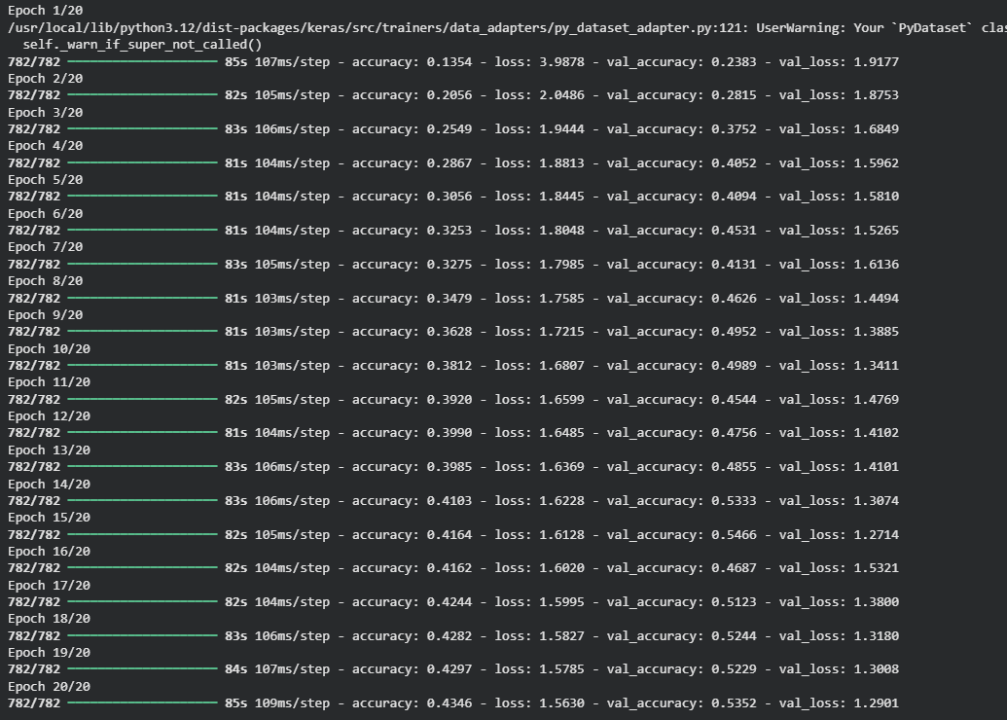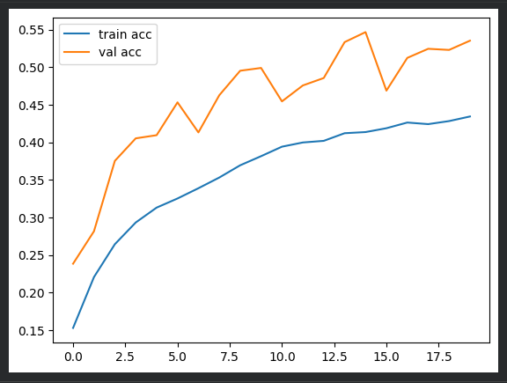
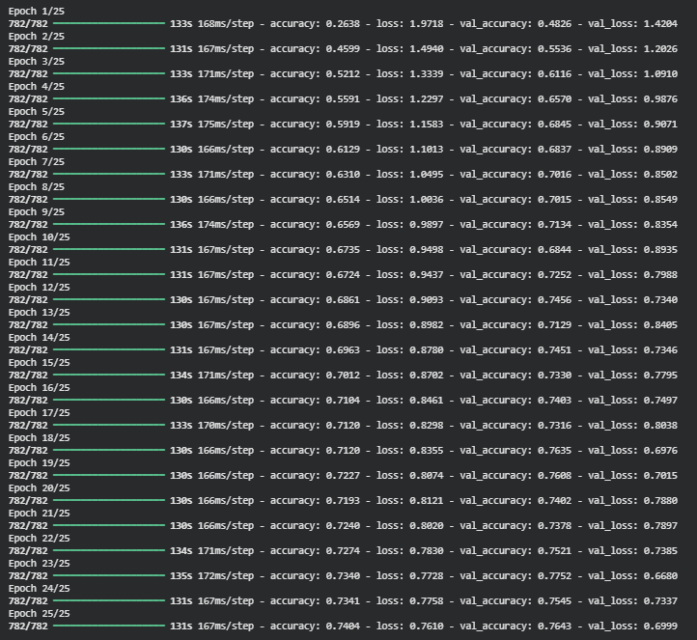
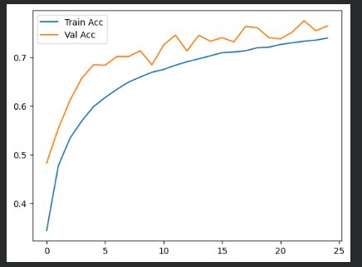

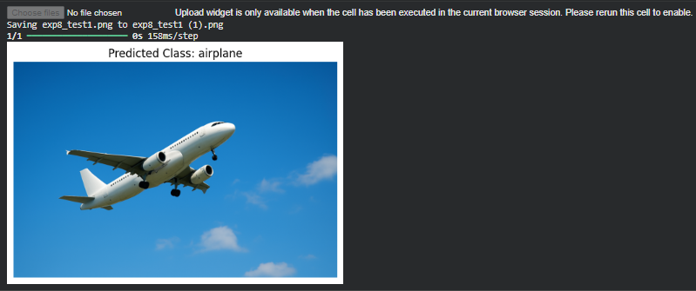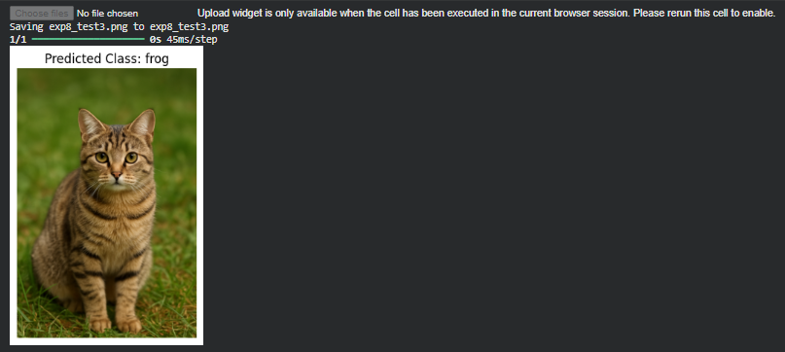

Conclusion:
- A small CNN with 3 conv blocks + pooling + dropout learns useful features from CIFAR-10 and achieves strong accuracy for a compact model.
- Data augmentation is key to improving test performance by making the model robust to small changes in images.
- With a few more tweaks (e.g., Batch Normalization, learning-rate scheduling, more epochs, or adding a third dense block), you can usually squeeze out higher accuracy.

