Experiment 09
Introduction to Object Detection and Perform Basic Implementation of Object Detection using the R-CNN Approach
Date:13/10/2025 SAP ID: 500122685

AIM: To build and train a Convolutional Neural Network (CNN) for classifying handwritten digit images (0–9) using the given training dataset, apply data preprocessing and augmentation, and evaluate the model’s prediction capability on test images.
THEORY:
- Convolutional Neural Networks (CNNs)
CNNs are deep learning models designed to process image data efficiently.
They use:
- Convolution layers to extract spatial features (edges, textures, shapes)
- Pooling layers for down-sampling and reducing complexity
- Activation functions (ReLU) to introduce non-linearity
- Fully connected layers to perform final classification
- MNIST-style Digit Classification
Images are grayscale and sized 28×28×1. Labels represent digits 0–9 (10 classes).
- Data Preprocessing
- Normalization of pixel values
- Reshaping for CNN input
- One-hot encoding of labels
- Splitting into training and validation sets
- Data Augmentation
Used to artificially increase dataset variability and reduce overfitting through:
- rotation
- zoom
- width/height shifts
- Model Training
The model is trained using:
- Categorical Cross-Entropy Loss
- Adam optimizer
- Mini-batches with multiple epochs
- Prediction
The trained model predicts digit classes for test images.

Commands/Code Used:
import os
import numpy as np
import pandas as pd
import matplotlib.pyplot as plt
import cv2
from sklearn.model_selection import train_test_split
import tensorflow as tf
from tensorflow.keras import layers, models, callbacks
from tensorflow.keras.preprocessing.image import ImageDataGenerator

# -----------------------
# Config - edit if needed
# -----------------------
TRAIN_CSV = "train.csv" # path to train CSV
TEST_CSV = "test.csv" # optional - path to test CSV (if provided)
MODEL_SAVE_PATH = "cnn_mnist_model.h5"
BATCH_SIZE = 64
EPOCHS = 30
IMG_ROWS, IMG_COLS = 28, 28
NUM_CLASSES = 10
RANDOM_STATE = 2

# -----------------------
# Utilities
# -----------------------
def load_csv_images(csv_path, label_col='label'):
"""Load image data from a CSV in flattened form (pixels in columns)."""
df = pd.read_csv(csv_path)
if label_col in df.columns:
labels = df[label_col].values
df = df.drop(columns=[label_col])
else:
labels = None
# If pixels are named pixel0.. pixel783 or just columns in order
imgs = df.values
# If images are already 28*28 flattened, reshape:
if imgs.shape[1] != IMG_ROWS * IMG_COLS:
raise ValueError(f"Expected {IMG_ROWS*IMG_COLS} pixels per row, found {imgs.shape[1]}.")
imgs = imgs.reshape(-1, IMG_ROWS, IMG_COLS, 1).astype('float32')
return imgs, labels

def normalize_images(X):
"""Scale images to [0,1]."""
return X / 255.0

# -----------------------
# Load & preprocess data
# -----------------------
if not os.path.exists(TRAIN_CSV):
raise FileNotFoundError(f"Train CSV not found at {TRAIN_CSV}. Please place train.csv or change TRAIN_CSV path.")

X, y = load_csv_images(TRAIN_CSV, label_col='label')
X = normalize_images(X)
y = tf.keras.utils.to_categorical(y, NUM_CLASSES)

# train/validation split
X_train, X_val, Y_train, Y_val = train_test_split(X, y, test_size=0.1, random_state=RANDOM_STATE, stratify=y.argmax(axis=1))

print("Shapes:")
print("X_train:", X_train.shape, "Y_train:", Y_train.shape)
print("X_val:", X_val.shape, "Y_val:", Y_val.shape)

# -----------------------
# Data augmentation
# -----------------------
datagen = ImageDataGenerator(
rotation_range=10,
width_shift_range=0.08,
height_shift_range=0.08,
zoom_range=0.08
)
datagen.fit(X_train)

# -----------------------
# Model definition
# -----------------------
def build_model(input_shape=(IMG_ROWS, IMG_COLS, 1), num_classes=NUM_CLASSES):
model = models.Sequential()
model.add(layers.Conv2D(32, (3,3), activation='relu', input_shape=input_shape))
model.add(layers.BatchNormalization())
model.add(layers.Conv2D(32, (3,3), activation='relu'))
model.add(layers.MaxPooling2D((2,2)))
model.add(layers.Dropout(0.25))

model.add(layers.Conv2D(64, (3,3), activation='relu'))
model.add(layers.BatchNormalization())
model.add(layers.Conv2D(64, (3,3), activation='relu'))
model.add(layers.MaxPooling2D((2,2)))
model.add(layers.Dropout(0.25))

model.add(layers.Flatten())
model.add(layers.Dense(128, activation='relu'))
model.add(layers.BatchNormalization())
model.add(layers.Dropout(0.5))
model.add(layers.Dense(num_classes, activation='softmax'))

return model

model = build_model()
model.compile(optimizer='adam',
loss='categorical_crossentropy',
metrics=['accuracy'])
model.summary()
es = callbacks.EarlyStopping(monitor='val_loss', patience=6, restore_best_weights=True, verbose=1)
mc = callbacks.ModelCheckpoint(MODEL_SAVE_PATH, monitor='val_accuracy', save_best_only=True, verbose=1)

steps_per_epoch = max(1, X_train.shape[0] // BATCH_SIZE)
history = model.fit(
datagen.flow(X_train, Y_train, batch_size=BATCH_SIZE),
steps_per_epoch=steps_per_epoch,
epochs=EPOCHS,
validation_data=(X_val, Y_val),
callbacks=[es, mc],
verbose=2
)

if not os.path.exists(MODEL_SAVE_PATH):
model.save(MODEL_SAVE_PATH)
print(f"Model saved to: {MODEL_SAVE_PATH}")

def plot_history(hist):
plt.figure(figsize=(12,4))
plt.subplot(1,2,1)
plt.plot(hist.history['loss'], label='train loss')
plt.plot(hist.history['val_loss'], label='val loss')
plt.legend(); plt.title('Loss')

plt.subplot(1,2,2)
plt.plot(hist.history['accuracy'], label='train acc')
plt.plot(hist.history['val_accuracy'], label='val acc')
plt.legend(); plt.title('Accuracy')

plt.show()

plot_history(history)

val_loss, val_acc = model.evaluate(X_val, Y_val, verbose=0)
print(f"Validation loss: {val_loss:.4f}, Validation accuracy: {val_acc:.4f}")

def predict_from_csv(test_csv_path):
if not os.path.exists(test_csv_path):
raise FileNotFoundError(f"{test_csv_path} not found.")
X_test, y_test = load_csv_images(test_csv_path, label_col='label' if 'label' in pd.read_csv(test_csv_path, nrows=0).columns else None)
X_test = normalize_images(X_test)
preds = model.predict(X_test, batch_size=128)
pred_classes = preds.argmax(axis=1)
return pred_classes

def predict_single_image(img_path):
"""Read image from path, convert to 28x28 grayscale, predict class."""
if not os.path.exists(img_path):
raise FileNotFoundError(f"{img_path} not found.")
img = cv2.imread(img_path, cv2.IMREAD_GRAYSCALE)
if img is None:
raise ValueError("Image could not be read.")
# Resize and invert if necessary (MNIST style white digit on black)
img_resized = cv2.resize(img, (IMG_COLS, IMG_ROWS), interpolation=cv2.INTER_AREA)
# If background is white and digit dark, invert so digit is white on black:
if np.mean(img_resized) > 127:
img_resized = 255 - img_resized
img_resized = img_resized.astype('float32') / 255.0
reshaped = img_resized.reshape(1, IMG_ROWS, IMG_COLS, 1)
prob = model.predict(reshaped)[0]
pred_class = int(np.argmax(prob))
confidence = float(np.max(prob))
plt.imshow(img_resized, cmap='gray')
plt.title(f"Predicted: {pred_class} (conf={confidence:.3f})")
plt.axis('off')
plt.show()
return pred_class, confidence

Results:
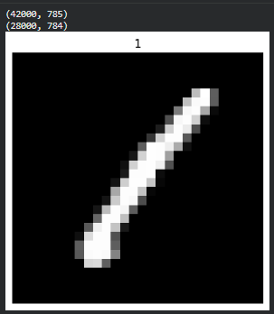
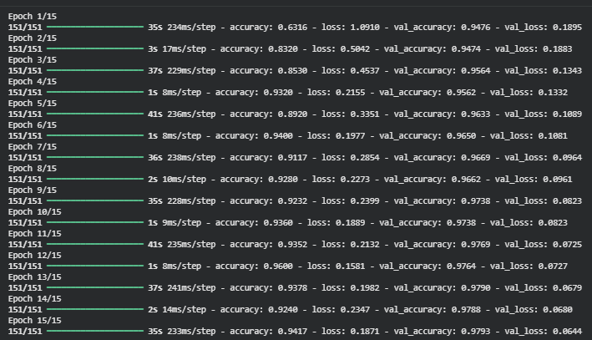
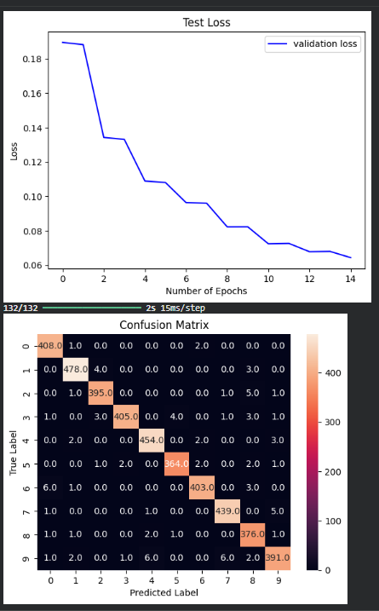
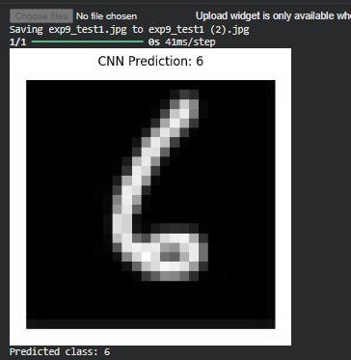
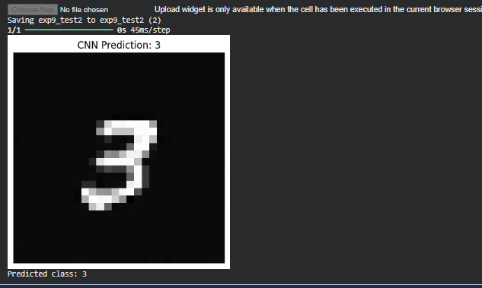

Conclusion:

A CNN model was successfully implemented to classify handwritten digits. Data augmentation improved generalization, and the final model was able to correctly predict the class of unseen images. The experiment demonstrates how CNNs effectively extract spatial patterns from images and perform high-accuracy digit classification.

