|  |
| --- |
| **NATIONAL INSTITUTE OF TECHNOLOGY, DELHI**  Department of Computer Science and Engineering  **CSB353: Compiler Design**  Project synopsis  **Project name: C ladder**  **Submitted to:**  **Dr. Shelly Sachdeva**  Department of Computer Science and Engineering  **Submitted by:**  Gourav Bansal (191220020)  Kishan Srivastava (191220030)  Vardan Agarwal (191220051) |

**INDEX**

|  |  |
| --- | --- |
| **TOPIC** | **Page No.** |
| Aim and introduction | 3 |
| Problem Statement and Domain of our compiler | 4 |
| Test Case | 5 |
| Design Idea | 6 |
| Hardware & Software requirements | 8 |

**C Ladder**

**INTRODUCTION:**  
A compiler is a translating program that translates the instructions of high-level language to machine level language. A program which is input to the compiler is called a **Source program**. This program is now converted to a machine level language by a compiler is known as the **Object code.**

Following students of CSE 3rd year are the part of a team working on this project:

1. **Gourav Bansal – 191220020**
2. **Kishan Srivastava – 191220030**
3. **Vardan Agarwal – 191220051**

**PROBLEM STATEMENT:**

To build a complete compiler that accepts a high-level language as input and produces working assembly code as output.

**DOMAIN:**

For now, we have thought of building a compiler that can accept a basic C program with limited keywords, conditional statements and loops.

Our compiler will specify productions for the following:

* **Arithmetic operators**
* **Relational operators**
* **Conditional constructs**: if, else if and else.
* **Loop constructs**: for, while.
* **Keywords of C (necessary ones)**
* **Single and multi-line Comments**
* **Data types:** int/float

**TEST CASE:**

#include<stdio.h>

int main()

{

    int n=5;

    int flag=1;

    if(flag==1)

    {

        // first n positive odd numbers

        int j = 0;

        for(int i=1; j<n; i+=2,j+=1)

            printf("%d",i);

    }

    else

    {

        // first n positive even numbers

        int j = 0;

        for(int i=2; j<n; i+=2,j+=1)

            printf("%d",i);

    }

}

**DESIGN IDEA:**

The compilation process is a sequence of various phases. Each phase takes input from its previous stage, has its own representation of source program, and feeds its output to the next phase of the compiler.

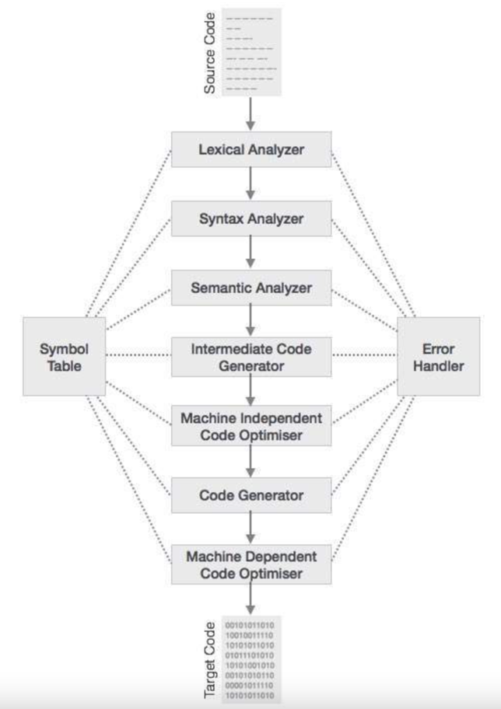

**Lexical Analysis**

The first phase of scanner works as a text scanner. This phase scans the source code as a stream of characters and converts it into meaningful lexemes.

Implementation planned using a lex program.

### Syntax Analysis

The next phase is called the syntax analysis or **parsing**. It takes the token produced by lexical analysis as input and generates a parse tree (or syntax tree).

Implementation of parser planned using lex and yacc programs.

### Semantic Analysis

Semantic analysis checks whether the parse tree constructed follows the rules of language.

Implementation of parser planned using lex and yacc programs.

### Intermediate Code Generation

After semantic analysis the compiler generates an intermediate code of the source code for the target machine.

Implementation planned using lex and yacc programs.

*Test cases will be .c type files.

### Code Optimization

The next phase does code optimization of the intermediate code.

### Code Generation

In this phase, the code generator takes the optimized representation of the intermediate code and maps it to the target machine language.

**FURTHER ADD-ONs**

We will also display the symbol Table, Constant table and intermediately generated code

**HARDWARE REQUIREMENTS**

Assuming, that we are designing a very basic C compiler, it will have to take very few information as input as far as memory is concerned. Further the whole information has to be processed. So, there is no need for a high specs system for running this.

All this suggest that the minimum hardware requirements should be: -

• Memory (RAM): 512 MB of RAM required.

• Hard Disk Space: 100 MB of free space required.

• Processor: Intel Pentium 4 or later.

• Cache: 512KB

**SOFTWARE REQUIRMENTS**

Following software should be installed for smooth functioning:

* Operating System: Windows 7/8/8.1/10/11/MacOs/LINUX
* FLEX
* BISON (yacc)
* gcc compiler
* Code editor for editing files