STARTING WITH OPENCV
with eclipse on ubuntu in java

Installing Opencv:

Install the required packages from https://docs.opencv.org/3.4/d7/d9f/tutorial_linux_install.html
For example for installing git write: sudo apt-get install git on the terminal. Similarly install all the required packages.

The files of opencv can be downloaded from https://github.com/opencv/opencv
Unpack or extract the files. I placed the file in Documents.

To install JDK 10 write on terminal
- sudo add-apt-repository ppa:linuxuprising/java
- sudo apt-get update
- sudo apt-get install oracle-java10-installer

Now to set it as default
- sudo apt-get install oracle-java10-set-default

Open the terminal and enter the opencv file using the cd command. Then creater a folder build in the file using mkdir and then enter it.

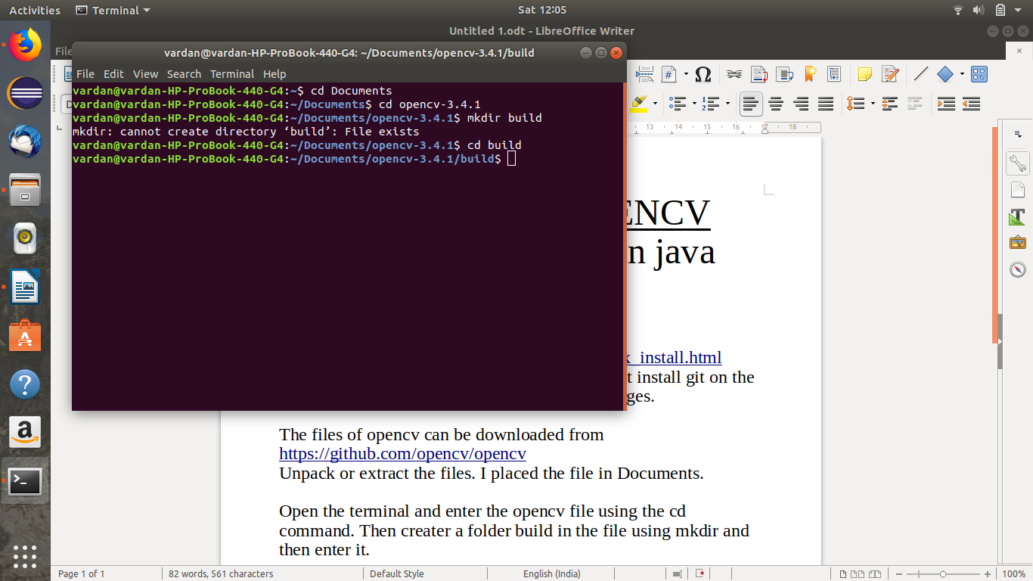

In my case I had already built the build folder.

After this write on the terminal

- cmake -DCMAKE_BUILD_TYPE=Release -DCMAKE_INSTALL_PREFIX=/usr/local ..
- make -j8

Here -j8 represents the number of cores to be simulatenously used and it speeds up the process. Normal ‘make’ can also be used.

Now check in Java there will be an option called ant. If it is no then write:
- sudo apt-get remove ant
- sudo apt-get install ant
if the make stops stating that JAVA_HOME does not point to the JDK or ant remains no then write:
- Locate jni.h
- Then see the path of jvm and write as follows:
- export JAVA_HOME=/usr/lib/jvm/java-1.11.0-openjdk-amd64
(in this case the java home was /usr/lib/jvm/java-1.11.0-openjdk-amd64/include/jni.h)
- export PATH=$JAVA_HOME/bin:$PATH
Now write make again.
To avoid setting path of java_home every time you login you can:
Open a seperate terminal
- sudo vim .bashrc
- vim .bashrc
- now write those two lines in it
- export JAVA_HOME=/usr/lib/jvm/java-1.11.0-openjdk-amd64
- export PATH=$JAVA_HOME/bin:$PATH
Close the terminal
All the processes in vim .bashrc are executed every time a terminal is opened and so the path of java_home will also be set.

If while opening vim .bashrc an error occurs saying that a bashrc.swp file exists then abort it and write:
rm .bashrc.swp
The error occured as a version of vim .bashrc was already running.
Make any changes as required.
To exit vim .bashrc
- Press escape
- Press :
- write w to save
- write q to quit

Now you can open your opencv folder and in it build and it will be something like this-:
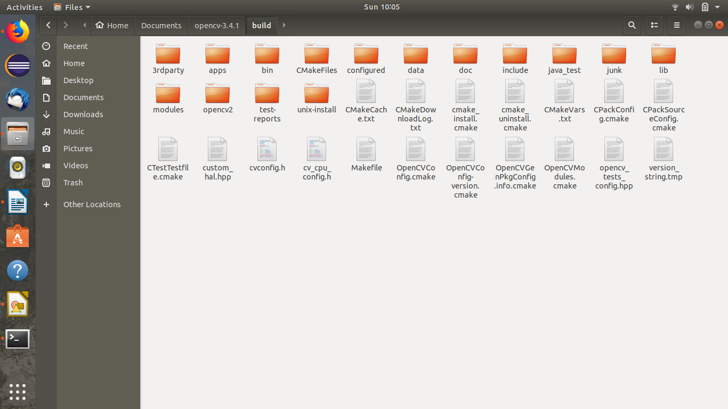
We are done with the installation of opencv.

Installing Eclipse:
Just search on the store eclipse and download the one that is one for java ide the one with the blue circle with three white lines.

Integrating opencv with eclipse:
- Click on file and create a new java project.
- Enter its name and click next and then click on Libraries.
- There click on Add External JARs
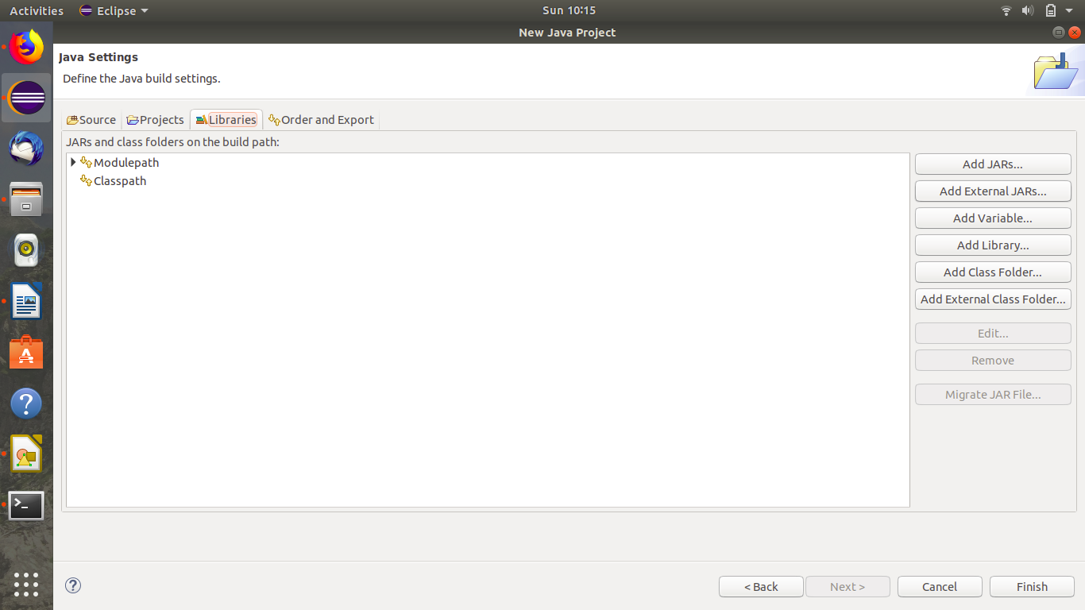

- Then go to build folder and in it bin. There will be a jar file (in my case opencv-341.jar) and then click ok.
- Then expand opencv and there will be an option of Native library location. Set it to path till build/build/lib
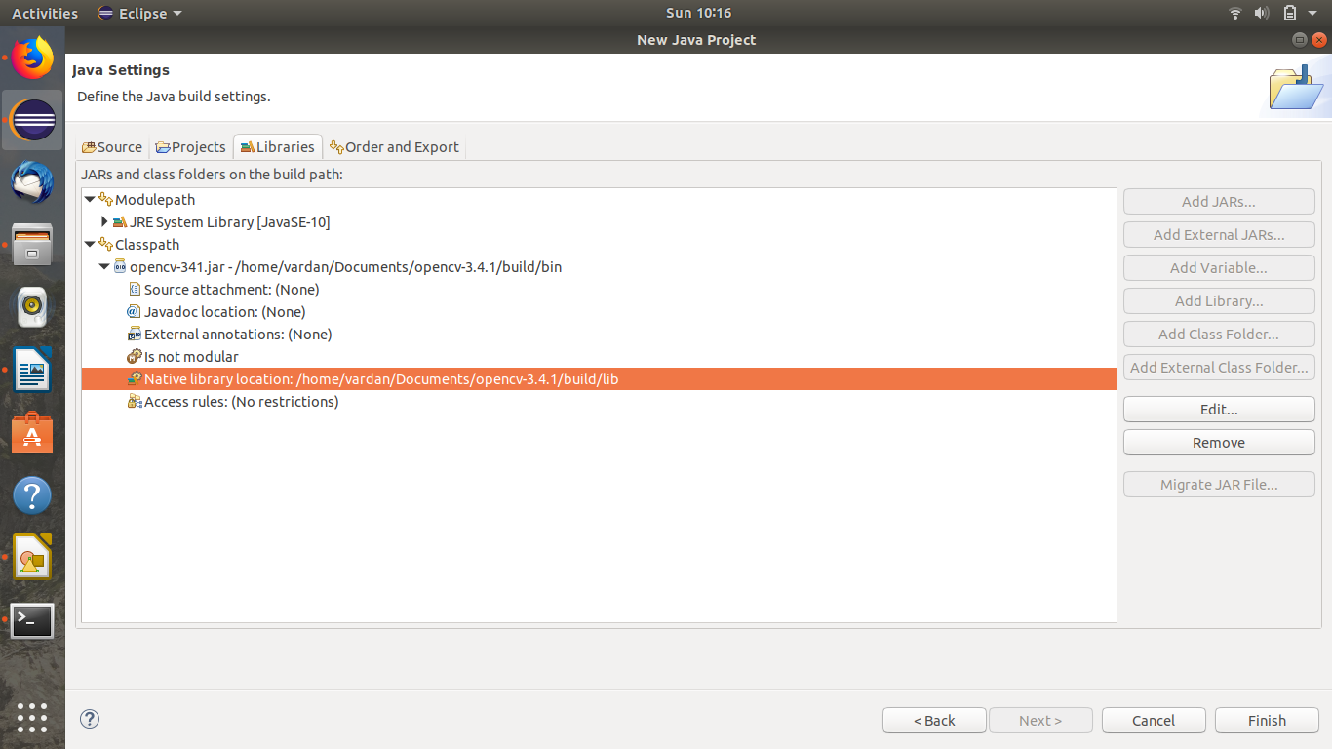
Then click on Finish.

This program can be run to tested whether it is done properly or-:
package va;
import org.opencv.core.Core;
import org.opencv.core.CvType;
import org.opencv.core.Mat;
public class testing {
public static void main( String[] args )
{
System.loadLibrary( Core.NATIVE_LIBRARY_NAME );
Mat mat = Mat.eye( 3, 3, CvType.CV_8UC1);
System.out.println( mat.dump() );
}
}

The output should be an identity matrix.

To check documentation of any keyword press F3.

Core: Core package includes having basic data structures, including multi dimensional array Mat and basic function used by modules.
System.loadLibrary(Core.NATIVE_LIBRARY_NAME)
:we need to load the native library. This command must be executed once per Java process to using native OpenCV methods. If it does not get used, it throws an exception like "UnsatisfiedLink errors."
mat.eye represents identity matrix. Similarly mat.ones and mat.zeroes is used for matrix with only 1s and 0s respectively.
Mat.dump is used to print the matrix.

Cascade classifiers used in opencv
Cascade classifiers are used to determine objects during video stream.
There are two types of cascade classifiers-:
- Haar classifier
- lbp classifier
Haar classifier is more accurate than lbp classifier but lbp is faster in working as well as training.
There is a third classifier as well called HOG but it is discontinued in Opencv-3.

Opencv program examples
Blending two images:
package va;
import org.opencv.core.*;
import org.opencv.highgui.HighGui;
import org.opencv.imgcodecs.Imgcodecs;
import java.io.*;
class blendingrun {
public void run()throws IOException
{
BufferedReader buf=new BufferedReader(new InputStreamReader(System.in));
double alpha=0.5,beta,input;
Mat src1,src2,dst=new Mat();
input=Double.parseDouble(buf.readLine());
if(input>=0.0 && input<=1.0)
alpha=input;
beta=1-alpha;
src1=Imgcodecs.imread("/home/vardan/Pictures/test2.png");
src2=Imgcodecs.imread("/home/vardan/Pictures/test3.png");
if(src1.empty()==true)
{
System.out.println("error loading image");
return;
}
if(src2.empty()==true)
{
System.out.println("error loading image");
return;
}
Core.addWeighted(src1,alpha,src2,beta,0.0,dst);
HighGui.imshow("Linear blend",dst);
HighGui.waitKey(0);
System.exit(0);
}
}
public class blending
{
public static void main(String args[])throws IOException
{
System.loadLibrary(Core.NATIVE_LIBRARY_NAME);
new blendingrun().run();
}
}

import org.opencv.highgui.HighGui: is for high level GUI and media
import org.opencv.imgcodecs.Imgcodecs: is for image input and output
src=Imgcodecs.imread(“path”): used for storing image.
HighGui.imshow(“__message__”,dst): used for displaying images.
The final image is alpha*src1 + beta*src2.
Alpha lies between 0 and 1.

Smoothing images:

package va;
import org.opencv.core.*;
import org.opencv.highgui.HighGui;
import org.opencv.imgcodecs.Imgcodecs;
import org.opencv.imgproc.Imgproc;
class SmoothingRun {
int DELAY_CAPTION = 1500;
int DELAY_BLUR = 100;
int MAX_KERNEL_LENGTH = 31;
Mat src = new Mat(), dst = new Mat();
String windowName = "Filter Demo 1";
public void run(String[] args) {
src=Imgcodecs.imread("/home/vardan/Pictures/test2.png");
if( src.empty() ) {
System.out.println("Error opening image");
System.out.println("Usage: ./Smoothing [image_name __/Pictures/test2.png] \n");
System.exit(-1);
}
if( displayCaption( "Original Image" ) != 0 ) { System.exit(0); }
dst = src.clone();
if( displayDst( DELAY_CAPTION ) != 0 ) { System.exit(0); }
if( displayCaption( "Homogeneous Blur" ) != 0 ) { System.exit(0); }
for (int i = 1; i < MAX_KERNEL_LENGTH; i = i + 2) {
Imgproc.blur(src, dst, new Size(i, i), new Point(-1, -1));
displayDst(DELAY_BLUR);
}
if( displayCaption( "Gaussian Blur" ) != 0 ) { System.exit(0); }
for (int i = 1; i < MAX_KERNEL_LENGTH; i = i + 2) {
Imgproc.GaussianBlur(src, dst, new Size(i, i), 0, 0);
displayDst(DELAY_BLUR);
}
if( displayCaption( "Median Blur" ) != 0 ) { System.exit(0); }
for (int i = 1; i < MAX_KERNEL_LENGTH; i = i + 2) {
Imgproc.medianBlur(src, dst, i);
displayDst(DELAY_BLUR);
}
if( displayCaption( "Bilateral Blur" ) != 0 ) { System.exit(0); }
for (int i = 1; i < MAX_KERNEL_LENGTH; i = i + 2) {
Imgproc.bilateralFilter(src, dst, i, i * 2, i / 2);
displayDst(DELAY_BLUR);
}
displayCaption( "Done!" );
System.exit(0);
}
int displayCaption(String caption) {
dst = Mat.zeros(src.size(), src.type());
Imgproc.putText(dst, caption,
new Point(src.cols() / 4, src.rows() / 2),
Core.FONT_HERSHEY_COMPLEX, 1, new Scalar(255, 255, 255));
return displayDst(DELAY_CAPTION);
}
int displayDst(int delay) {
HighGui.imshow( windowName, dst );
int c = HighGui.waitKey( delay );
if (c >= 0) { return -1; }
return 0;
}
}
public class Smoothing {
public static void main(String[] args) {
// Load the native library.
System.loadLibrary(Core.NATIVE_LIBRARY_NAME);
new SmoothingRun().run(args);
}
}

Explanation:
This program displays all image after using four different blurring techniques.
import org.opencv.imgproc.Imgproc: is used for image processing.

Training your own classifier
We use opencv train_cascade. It is a new version than opencv haar_cascade and it supports lbp classifier as well.

- Place all the positive and negative images in seperate folders(eg-pos and negatives).
- Open terminal and write after entering the directory these files are stored in e.g.Desktop in my case.
- ls pos>cars.info
- ls negatives>bg.txt

An info file and a text file will be created containing the names of all the images.
- Open the files and edit the contents to thier absolute paths. In the cars.info file write: a b c d e
where-
a is the number of times the positive object is appearing.
b and c are what part of image to be taken. If full image then 0 and 0.
d and e are the size of image in pixels represnting width and height respectively.
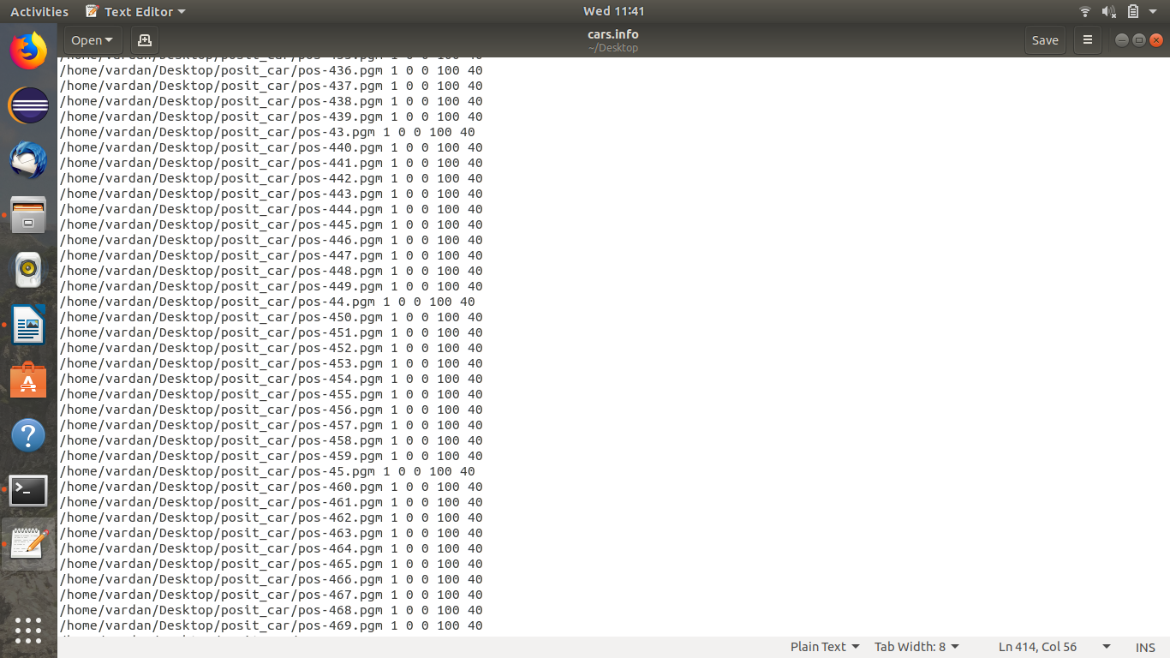

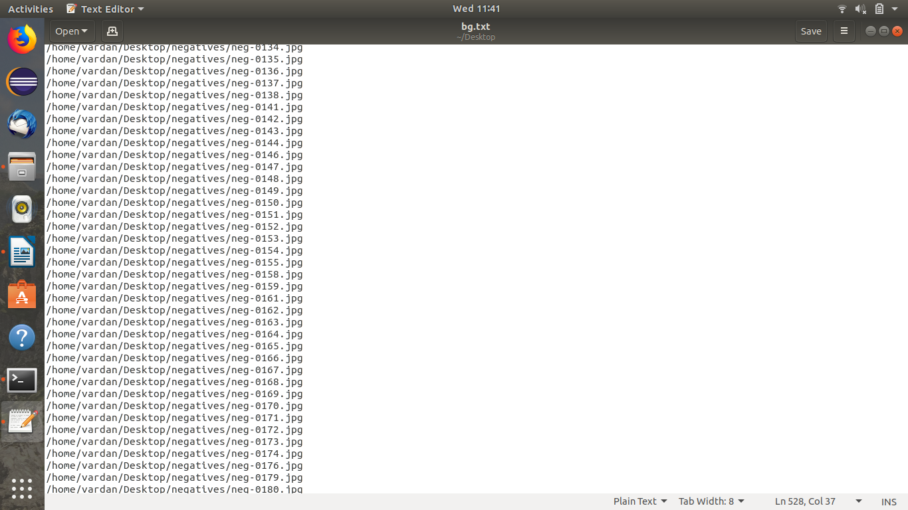
- To create a .vec file of the positive images write
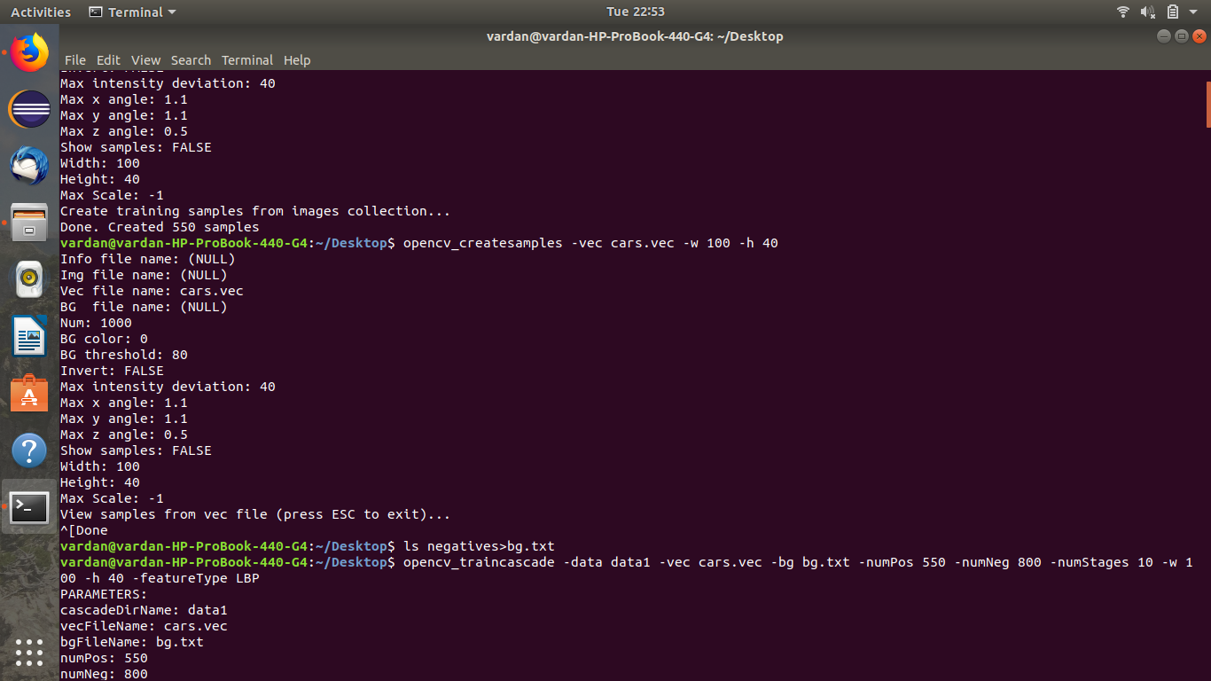
opencv_createsamples -info cars.info -num 550 -w 100 -h 40 -vec cars.vec
where num represents the number of positive images and a vec file, cars.vec, will be created.

- The vec file can be viewed as
opencv_createsamples -vec cars.vec -w 100 -h 40
- Create a folder where you want to store the xml files. eg(carhaardata)
- Now to train write
opencv_traincascade -data carhaardata -vec cars.vec -bg bg.txt -numPos 500 -numNeg 800 -numStages 10 -w 100 -h 40 -featureType HAAR

The number of positive images should be kept lower than than the total images.
NumStages represents the total number of training stages.
FeatureType can be set to HAAR or LBP based on which classifier needs to be used for trianing.
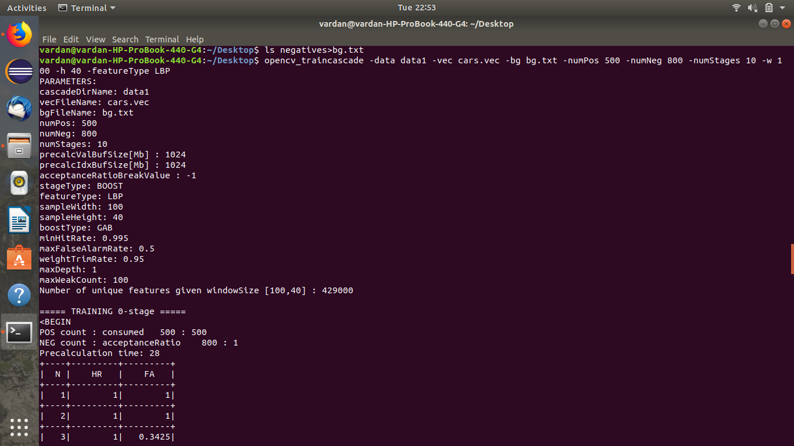

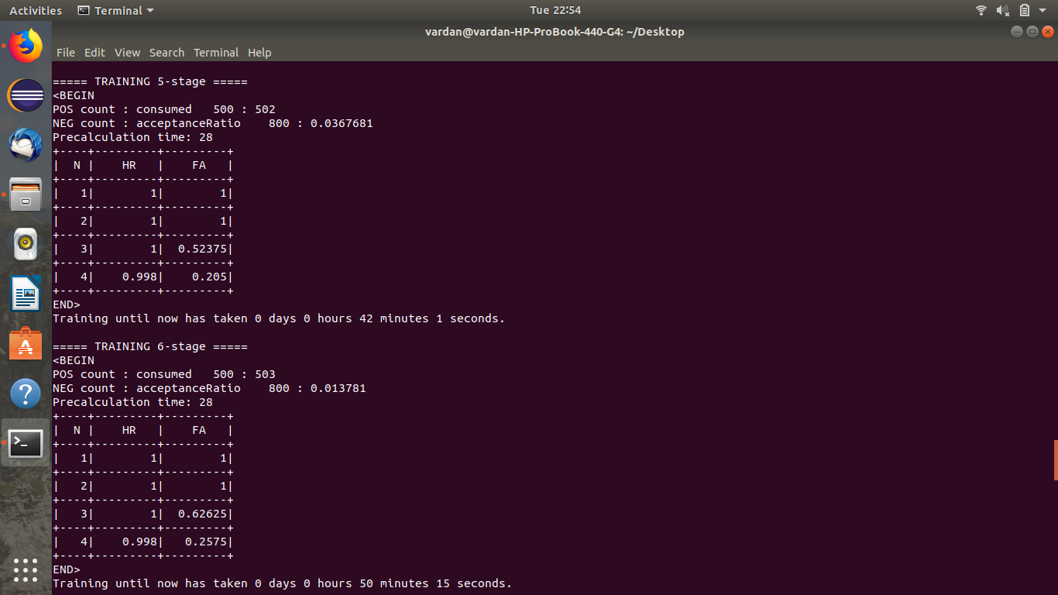
Here HR denotes Hit Rate i.e. % of positive samples correctly classified and FA denotes False Alarm i.e % of negative samples incorrectly classified as positive.
Code for face and eye detection from webcam:
package va;
import java.util.List;
import org.opencv.core.Core;
import org.opencv.core.Mat;
import org.opencv.core.MatOfRect;
import org.opencv.core.Point;
import org.opencv.core.Rect;
import org.opencv.core.Scalar;
import org.opencv.core.Size;
import org.opencv.highgui.HighGui;
import org.opencv.imgproc.Imgproc;
import org.opencv.objdetect.CascadeClassifier;
import org.opencv.videoio.VideoCapture;
class ObjectDetection {
public void detectAndDisplay(Mat frame, CascadeClassifier faceCascade, CascadeClassifier eyesCascade) {
Mat frameGray = new Mat();
Imgproc.cvtColor(frame, frameGray, Imgproc.COLOR_BGR2GRAY);
Imgproc.equalizeHist(frameGray, frameGray);
// -- Detect faces
MatOfRect faces = new MatOfRect();
faceCascade.detectMultiScale(frameGray, faces);
//faces detected

List<Rect> listOfFaces = faces.toList();
for (Rect face : listOfFaces) {
Point center = new Point(face.x + face.width / 2, face.y + face.height / 2);//centre point of ellipse to be drawn
Imgproc.ellipse(frame, center, new Size(face.width / 2, face.height / 2), 0, 0, 360,
new Scalar(255, 0, 255));//ellipse drawn
Mat faceROI = frameGray.submat(face);
//eyes will only be checked for in the region of face
// -- In each face, detect eyes
MatOfRect eyes = new MatOfRect();
eyesCascade.detectMultiScale(faceROI, eyes);
List<Rect> listOfEyes = eyes.toList();
for (Rect eye : listOfEyes) {
Point eyeCenter = new Point(face.x + eye.x + eye.width / 2, face.y + eye.y + eye.height / 2);
int radius = (int) Math.round((eye.width + eye.height) * 0.25);
Imgproc.circle(frame, eyeCenter, radius, new Scalar(255, 0, 0), 4);
}
}
//-- Show what you got
HighGui.imshow("Capture - Face detection", frame );
}
public void run(String[] args) {
String filenameFaceCascade = args.length > 2 ? args[0] : "/home/vardan/Documents/opencv-3.4.1/data/haarcascades/haarcascade_frontalface_alt.xml";//file containing face detecter
String filenameEyesCascade = args.length > 2 ? args[1] : "/home/vardan/Documents/opencv-3.4.1/data/haarcascades/haarcascade_eye_tree_eyeglasses.xml";// file containing eyes detecter
int cameraDevice = args.length > 2 ? Integer.parseInt(args[2]) : 0;
CascadeClassifier faceCascade = new CascadeClassifier();
CascadeClassifier eyesCascade = new CascadeClassifier();
if (!faceCascade.load(filenameFaceCascade)) {
System.err.println("--(!)Error loading face cascade: " + filenameFaceCascade);
System.exit(0);
}
if (!eyesCascade.load(filenameEyesCascade)) {
System.err.println("--(!)Error loading eyes cascade: " + filenameEyesCascade);
System.exit(0);
}
VideoCapture capture = new VideoCapture(cameraDevice);
//for webcam
if (!capture.isOpened()) {
System.err.println("--(!)Error opening video capture");
System.exit(0);
}
Mat frame = new Mat();
while (capture.read(frame)) {
if (frame.empty()) {
System.err.println("--(!) No captured frame -- Break!");
break;
}
//-- 3. Apply the classifier to the frame
detectAndDisplay(frame, faceCascade, eyesCascade);
if (HighGui.waitKey(10) == 27) {
break;// escape
}
}
System.exit(0);
}
}
public class ObjectDetectionDemo {
public static void main(String[] args) {
// Load the native OpenCV library
System.loadLibrary(Core.NATIVE_LIBRARY_NAME); elif [ -f /etc/bash_completion ]; then
. /etc/bash_completion
new ObjectDetection().run(args);
}
}
Explanation:
import org.opencv.objdetect.CascadeClassifier:Used for importing cascade classifier which is going to be used to recognize the face and eyes.
import org.opencv.videoio.VideoCapture: Used for video capturing from the webcam.
Imgproc.cvtColor(frame, frameGray, Imgproc.COLOR_BGR2GRAY): Used for converting color image to greyscale. Opencv uses BGR format instead of RGB format therefore it is BGR2GRAY.
Imgproc.equalizeHist(frameGray, frameGray): Used for evening the intensity of the image.

Code for car detection on an image using the classifier trained:
package va;
import org.opencv.core.*;
import org.opencv.highgui.HighGui;
import org.opencv.imgcodecs.Imgcodecs;
import org.opencv.imgproc.Imgproc;
import org.opencv.objdetect.CascadeClassifier;
import java.io.*;
import java.util.List;
class cardetectionrun {
public void detectAndDisplay(Mat src, CascadeClassifier carCascade)throws IOException
{
Mat frameGray = new Mat();
Imgproc.cvtColor(src, frameGray, Imgproc.COLOR_BGR2GRAY);
Imgproc.equalizeHist(frameGray, frameGray);
MatOfRect cars = new MatOfRect();
carCascade.detectMultiScale(frameGray, cars);
List<Rect> listOfCars = cars.toList();
for (Rect car : listOfCars) {
Imgproc.rectangle(src, new Point(car.x,car.y),new Point(car.x+car.width,car.y+car.height),new Scalar(0, 0, 255));
}
HighGui.imshow("car",src);
HighGui.waitKey(0);
System.exit(0);
}
public void run()throws IOException
{
Mat src=new Mat();
String cardetecter="/home/vardan/Desktop/carhaardata/cascade.xml";
CascadeClassifier carCascade = new CascadeClassifier();
if (!carCascade.load(cardetecter)) {
System.err.println("--(!)Error loading car cascade: " + cardetecter);
System.exit(0);
}
src=Imgcodecs.imread("/home/vardan/Downloads/CarData/TestImages_Scale/test-9.pgm");//test image
if(src.empty()==true)
{
System.out.println("error loading image");
return;
}
detectAndDisplay(src, carCascade);

}
}
public class cardetection {
public static void main(String args[])throws IOException {
// Load the native OpenCV library
System.loadLibrary(Core.NATIVE_LIBRARY_NAME);
new cardetectionrun().run();
}
}

Explanation:
Creates a rectngle over cars detected by using the classifier trained.
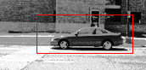

Code for using multiple trained classifiers at once:
package va;
import org.opencv.core.*;
import org.opencv.highgui.HighGui;
import org.opencv.imgcodecs.Imgcodecs;
import org.opencv.imgproc.Imgproc;
import org.opencv.objdetect.CascadeClassifier;
import java.io.*;
import java.util.List;
class multirun {
public void detectAndDisplay(Mat src, CascadeClassifier carCascade, CascadeClassifier carCascade2)
{
Mat frameGray = new Mat();
Imgproc.cvtColor(src, frameGray, Imgproc.COLOR_BGR2GRAY);
Imgproc.equalizeHist(frameGray, frameGray);
MatOfRect cars = new MatOfRect();
carCascade.detectMultiScale(frameGray, cars);
List<Rect> listOfCars = cars.toList();
for (Rect car : listOfCars) {
Point center = new Point(car.x + car.width / 2, car.y + car.height / 2);
Imgproc.ellipse(src, center, new Size(car.width / 2, car.height / 2), 0, 0, 360,
new Scalar(0, 0, 255));
}
carCascade2.detectMultiScale(frameGray, cars);
List<Rect> listOfCars2 = cars.toList();
for (Rect car : listOfCars2) {
Point center2 = new Point(car.x + car.width / 2, car.y + car.height / 2);
Imgproc.ellipse(src, center2, new Size(car.width / 2, car.height / 2), 0, 0, 360,
new Scalar(0, 255, 0));
}
HighGui.imshow("car",src);
HighGui.waitKey(0);
System.exit(0);
}
public void run()
{
Mat src=new Mat();
String cardetecter="/home/vardan/Desktop/carlbpdata/cascade.xml";
CascadeClassifier carCascade = new CascadeClassifier();
if (!carCascade.load(cardetecter)) {
System.err.println("--(!)Error loading car cascade: " + cardetecter);
System.exit(0);
}
String cardetecter2="/home/vardan/Desktop/carhaardata/cascade.xml";
CascadeClassifier carCascade2 = new CascadeClassifier();
if (!carCascade2.load(cardetecter2)) {
System.err.println("--(!)Error loading car cascade: " + cardetecter);
System.exit(0);
}
src=Imgcodecs.imread("/home/vardan/Pictures/test4.png");
if(src.empty()==true)
{
System.out.println("error loading image");
return;
}
detectAndDisplay(src, carCascade,carCascade2);

}
}
public class Multicardetection {
public static void main(String args[])throws IOException {
// Load the native OpenCV library
System.loadLibrary(Core.NATIVE_LIBRARY_NAME);
new multirun().run();
}
}
To count and print the number of cars detected in an image we can write:
System.out.println(cars.toArray().length);

For working with videos in place of images write:
- VideoCapture capture = new VideoCapture("/home/vardan/Pictures/video1.mkv");
- Mat frame = new Mat();
- while (capture.read(frame)) {
- if (frame.empty()) {
- System.err.println("--(!) No captured frame -- Break!");
- break;
- }

How to convert a all the frames of a video to images:
- Download ffmpeg from the store
- Reach the directory where the video is saved using cd.
- Write in the terminal:
ffmpeg -i video1.mkv img%d.png
All the frames will be stored as png images.

To invert the colors of an image or produce the negative of a black and white image write:
Core.bitwise_not(src,dst);

Background Subtaction
It is useful for subtracting the moving forground mask from a background.
To implement it write:
1. BackgroundSubtractorMOG2 bg = Video.createBackgroundSubtractorMOG2(500, 16, true);
It has three parameters:
- History: Default value is 500. It denotes the length of history.
- VarThreshold: Its default value is 16. Threshold on the squared distance between the pixel and the sample to decide whether a pixel is close to that sample. This parameter does not affect the background update.
- DcetectShadows: Its default value is true. If true, the algorithm will detect sahdows and mark them. It decreses the speed a bit. So if you do not need this feature, set the parameter to false.
2. bg.apply(frame, fgmask,-1);
It also has three parameters:
- image: Next video frame. Floating point frame will be used without scaling and should be in range[0,255].
- Fgmask: The output foreground mask as an 8-bit binary image.
- Learning rate: The value between 0 and 1 indicates how fast the background model is learnt. Negative parameter valur makes the algorithm to use some automatically chosen learning rate. 0 means that the background model is not updated at all, 1 means that the background model is completely reinitialized from the last frame.

An example code of background subtraction:
package va;
import org.opencv.core.Core;
import org.opencv.core.CvType;
import org.opencv.core.Mat;
import org.opencv.highgui.HighGui;
import org.opencv.video.BackgroundSubtractorMOG2;
import org.opencv.video.Video;
import org.opencv.videoio.VideoCapture;

class DoBackground {

public void TryBackground() throws InterruptedException {
VideoCapture capture = new VideoCapture("/home/vardan/Pictures/video1.mkv");
Mat frame = new Mat(1500, 1000, CvType.CV_8UC4);
BackgroundSubtractorMOG2 bg = Video.createBackgroundSubtractorMOG2(500, 16, true);
Mat fgmask = new Mat(1500, 1000, CvType.CV_8UC1);
if (!capture.isOpened()) {
System.err.println("video capture not opened");
System.exit(0);
}
while (capture.read(frame)) {
if (frame.empty()) {
System.err.println("frame is empty");
System.exit(0);
}
bg.apply(frame, fgmask);

HighGui.imshow("try Background subtraction", fgmask);
if (HighGui.waitKey(30) == 27)
break;

}
System.exit(0);
}
}

public class Background {
public static void main(String args[]) throws InterruptedException {
System.loadLibrary(Core.NATIVE_LIBRARY_NAME);
new DoBackground().TryBackground();
}
}

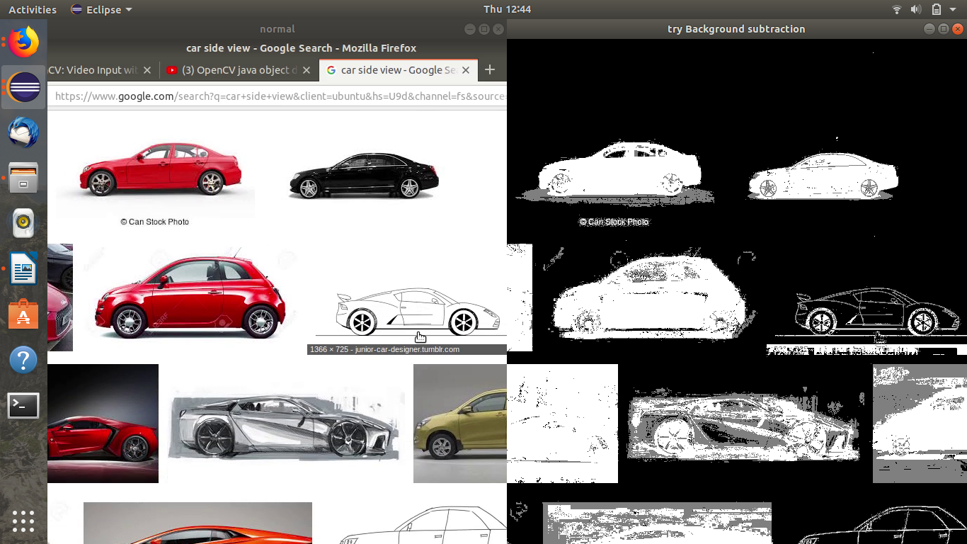
On the left side is the normal video and the left side has the foreground mask obtained by background subtraction.

How to install opencv_contrib
Opencv_contrib contains extra modules which are not included in the official opencv distribution as they do not have a stable API and are not quite well tested so they need to be installed seprately.
Download the zip file from https://github.com/opencv/opencv_contrib
Download the same version as your main opencv (go in releases and check it).
To install:
- Enter the build folder of your original opencv document in the terminal.
- Then write:
cmake -DOPENCV_EXTRA_MODULES_PATH=/home/vardan/Documents/opencv_contrib-3.4.1/modules /home/vardan/Documents/opencv-3.4.1
(i.e. cmake -DOPENCV_EXTRA_MODULES_PATH=<opencv_contrib>/modules <opencv_source_directory>)
- Then write make -j8

Tracking in opencv(part of opencv_contrib)
Opencv has many tracking algorithms available but the best ones are tracker kcf and tracker mil. Others also have some specific uses. These are all for a single detection. For multitracking multi tracker is available. Tracker has a benefit over constant object detection that it is fast and it works even under occlusion where the object detector completely fails.
Tracker can be implemented by:
- TrackerKCF track=TrackerKCF.create();
- track.init(frame,roi);
- track.update(frame, roi);
For creating a tracker there are three steps. In the first we create the tracker, in the second we initialize it and the parameters are of the frame of video and the region of interest of rect2d type i.e. the area what the tracker is going to monitor. In the last one we update the tracker over new frames of video.
Source code example:
package va;
import java.util.List;
import org.opencv.core.*;
import org.opencv.highgui.HighGui;
import org.opencv.imgproc.Imgproc;
import org.opencv.objdetect.CascadeClassifier;
import org.opencv.videoio.VideoCapture;
import org.opencv.tracking.*;
class DoTrytracking {
public void run(String args[])
{
String filenameFaceCascade = args.length > 2 ? args[0] : "/home/vardan/Documents/opencv-3.4.1/data/haarcascades/haarcascade_frontalface_alt.xml";
CascadeClassifier faceCascade = new CascadeClassifier();
if (!faceCascade.load(filenameFaceCascade)) {
System.err.println("--(!)Error loading face cascade: " + filenameFaceCascade);
System.exit(0);
}
trackit(faceCascade,args);
}
public void trackit(CascadeClassifier faceCascade,String args[])
{
boolean flag=false;
int cameraDevice = args.length > 2 ? Integer.parseInt(args[2]) : 0;
VideoCapture capture = new VideoCapture(cameraDevice);
if (!capture.isOpened()) {
System.err.println("--(!)Error opening video capture");
System.exit(0);
}
Mat frame = new Mat();
Rect2d roi=new Rect2d(0,0,0,0);

TrackerKCF track=TrackerKCF.create();
while (capture.read(frame)) {
if (frame.empty()) {
System.err.println("--(!) No captured frame -- Break!");
break;
}
MatOfRect faces = new MatOfRect();
faceCascade.detectMultiScale(frame, faces);
List<Rect> listOfFaces = faces.toList();

for (Rect face : listOfFaces) {
roi=new Rect2d(face.x,face.y,face.width,face.height);
flag=true;
if(roi.width==0 || roi.height==0)
{ System.out.println("roi empty");
System.exit(0);
}
}
if(flag)
break;
}
track.init(frame,roi);
for(;;)
{

while (capture.read(frame)) {
if (frame.empty()) {
System.err.println("--(!) No captured frame -- Break!");
break;
}
track.update(frame, roi);

Imgproc.rectangle(frame,new Point(roi.x,roi.y),new Point(roi.x+roi.width,roi.y+roi.height), new Scalar(0,0,255));
HighGui.imshow("tracker", frame);
if(HighGui.waitKey(1)==27)
System.exit(0);
}
}
}

}
public class Trytracking{
public static void main(String args[])
{
System.loadLibrary(Core.NATIVE_LIBRARY_NAME);
new DoTrytracking().run(args);
}
}

Explanation:

In this program I have made a face tracker which tracks a face from the webcam. On detection of a face the tracker is intialized with its coordinates as the region of interest and then the webcam feed is displayed which tracks the face by displaying a red rectangle over the face.

Another example:
package va;

import java.util.ArrayList;
import java.util.List;

import org.opencv.core.Core;
import org.opencv.core.Mat;
import org.opencv.core.MatOfRect;
import org.opencv.core.MatOfRect2d;
import org.opencv.core.Point;
import org.opencv.core.Rect;
import org.opencv.core.Rect2d;
import org.opencv.core.Scalar;
import org.opencv.highgui.HighGui;
import org.opencv.imgproc.Imgproc;
import org.opencv.objdetect.CascadeClassifier;
import org.opencv.tracking.MultiTracker;
import org.opencv.tracking.TrackerKCF;
import org.opencv.videoio.VideoCapture;

class DTrytracking {
public void run(String args[]) {
String filenameFaceCascade = args.length > 2 ? args[0] : "/home/vardan/Desktop/carlbpnewdata/cascade.xml";
CascadeClassifier faceCascade = new CascadeClassifier();
if (!faceCascade.load(filenameFaceCascade)) {
System.err.println("--(!)Error loading face cascade: " + filenameFaceCascade);
System.exit(0);
}
trackit(faceCascade);
}

public void trackit(CascadeClassifier faceCascade) {
Rect2d roi = new Rect2d(0, 0, 0, 0);
boolean flag = false;
MatOfRect2d rect2d = new MatOfRect2d();
int l = 0, i = 0;
Rect2d a[] = null;
VideoCapture capture = new VideoCapture("/home/vardan/Pictures/video1.mkv");
VideoCapture capture2 = new VideoCapture("/home/vardan/Pictures/video1.mkv");
if (!capture.isOpened()) {
System.err.println("--(!)Error opening video capture");
System.exit(0);
}
Mat frame = new Mat();
MultiTracker track = MultiTracker.create();
ArrayList<MultiTracker> track2 = new ArrayList<MultiTracker>();
while (capture.read(frame)) {
if (frame.empty()) {
System.err.println("--(!) No captured frame -- Break!");
break;
}
MatOfRect faces = new MatOfRect();
faceCascade.detectMultiScale(frame, faces);
List<Rect> listOfFaces = faces.toList();
l = faces.toArray().length;
a = new Rect2d[l];
for (Rect face : listOfFaces) {
roi = new Rect2d(face.x, face.y, face.width, face.height);
flag = true;
a[i] = roi;
i++;
if (roi.width == 0 || roi.height == 0) {
System.out.println("roi empty");
System.exit(0);
}
track.add(TrackerKCF.create(), frame, roi);
}
if (flag)
break;
}
Mat frame2 = new Mat();
int l2, i2 = 0, c = 0, nof = 0, z = 0;
while (capture2.read(frame2))
nof++;
nof = nof / 100;
flag = false;
Rect2d a2[][] = new Rect2d[nof][];
for (int k = 1; k > 0; k++) {
if (k % 100 == 0) {
while (capture.read(frame)) {
MatOfRect faces2 = new MatOfRect();
faceCascade.detectMultiScale(frame, faces2);
List<Rect> listOfFaces2 = faces2.toList();
for (Rect face : listOfFaces2)
if (face.y > 550)
z++;
a2[c] = new Rect2d[z];
z = 0;
i2 = 0;
for (Rect face : listOfFaces2) {
if (face.y > 550) {
flag = true;
roi = new Rect2d(face.x, face.y, face.width, face.height);
a2[c][i2] = roi;
i2++;
if (roi.width == 0 || roi.height == 0) {
System.out.println("roi empty");
System.exit(0);
}
track2.add(MultiTracker.create());
track2.get(c).add(TrackerKCF.create(), frame, roi);

}
}
c++;
break;
}
}
for (;;) {

while (capture.read(frame)) {
if (frame.empty()) {
System.err.println("--(!) No captured frame -- Break!");
System.exit(0);
}
rect2d.fromArray(a);
track.update(frame, rect2d);
a = rect2d.toArray();
l = a.length;
for (i = 0; i < l; i++) {

if (a[i].y + a[i].height / 2 > 140)
Imgproc.rectangle(frame, new Point(a[i].x, a[i].y),
new Point(a[i].x + a[i].width, a[i].y + a[i].height), new Scalar(0, 0, 255));

}
if (flag) {

for (int cIndex = 0; cIndex < c; cIndex++) {
rect2d.fromArray(a2[cIndex]);
MultiTracker t2 = track2.get(cIndex);
if (t2 != null)
t2.update(frame, rect2d);

a2[cIndex] = rect2d.toArray();
l2 = a2[cIndex].length;
for (i2 = 0; i2 < l2; i2++) {

if (a2[cIndex][i2].y + a2[cIndex][i2].height / 2 > 140)
Imgproc.rectangle(frame, new Point(a2[cIndex][i2].x, a2[cIndex][i2].y),
new Point(a2[cIndex][i2].x + a2[cIndex][i2].width,
a2[cIndex][i2].y + a2[cIndex][i2].height),
new Scalar(0, 0, 0));

}
}
}
HighGui.imshow("tracker", frame);
if (HighGui.waitKey(1) == 27)
System.exit(0);
break;
}
break;
}
}
}

}

public class TryMultiTracking {
public static void main(String args[]) {
System.loadLibrary(Core.NATIVE_LIBRARY_NAME);
new DTrytracking().run(args);
}
}

Explanation:
In this program multi tracker is used to track cars in video feed. In the first frame the detected cars are assigned to a multi tracker. Even if the cars exit the frame the multi tracker displays the rectangle so an if condition is applied to check that. For the cars coming from down an array list of multi trackers is made. The total number of frames in the video have been counted and the new multi tracker is applied once every 100 frames on the cars that are below a certain limit. The array list has a size of total number of frames/100. Their roi are stored in a rect2d array having total number of rows as the number of new trackers in the array list and the number of columns as the numbers of cars detected which lie in the limit.
In update step of multi tracker mat of rect2d variable is required which stores all the rois of the tracked cars in this case. To make a mat of rect2d object we can create an array of rect2d type and store the rois in it. Then rect2d.fromArray(a); can be used to convert the array to mat of rect2d.

