Microservices Assignment: Module 1
Monolithic vs Microservices Architecture

Question 1
Draw a diagram (hand-drawn or digital) showing the architecture of a food delivery app (like Zomato) as a monolithic application, labeling at least 3 core features such as user login, restaurant listing, and order management.
Answer
In a monolithic architecture, all features are built in one codebase, deployed as a single unit, and share one database. The diagram below shows a food delivery app with four core modules: User login, Restaurant listing, Order management, and Payment and delivery.
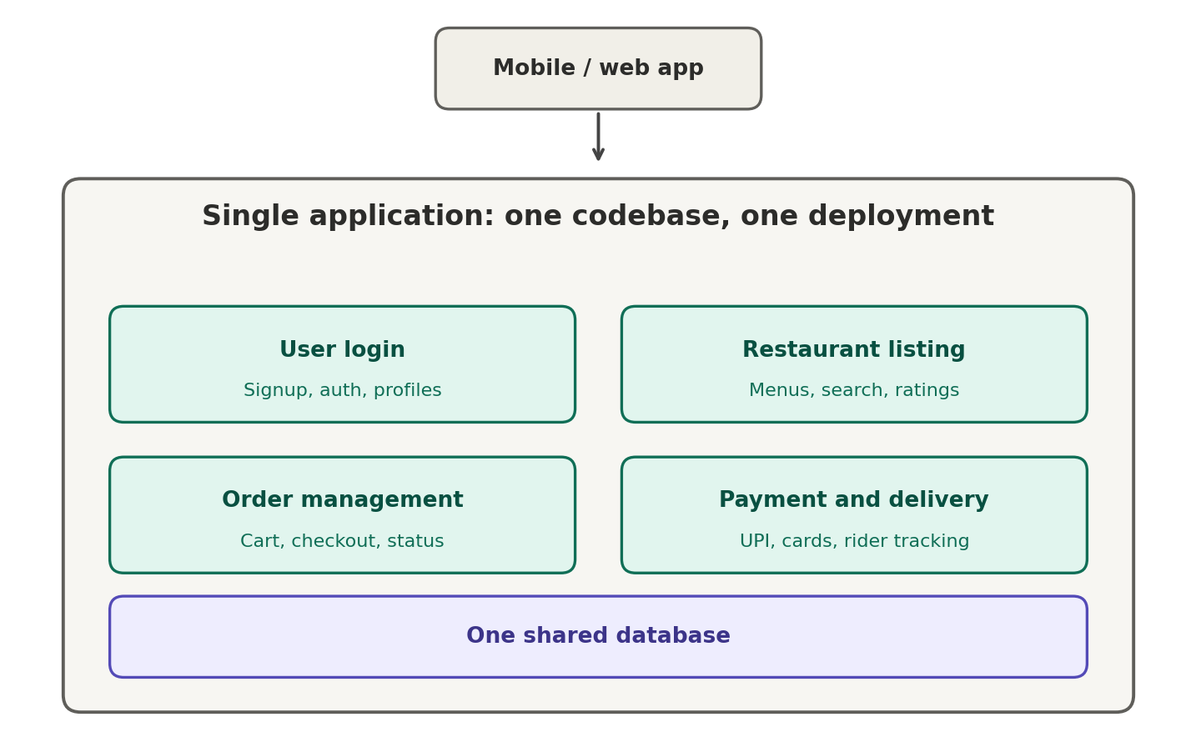
Figure 1: Food delivery app as a monolithic application

Question 2
Now, redraw the same food delivery app architecture as a microservices system, splitting it into at least 3 separate services (for example: User Service, Restaurant Service, Order Service) and show how they interact.
Answer
In the microservices version, the app is split into small independent services. Requests from the client go through an API gateway, which routes each request to the right service. Each service owns its own database, and services communicate with each other through an event bus or REST calls (for example, the Order service asks the Payment service to charge the customer).
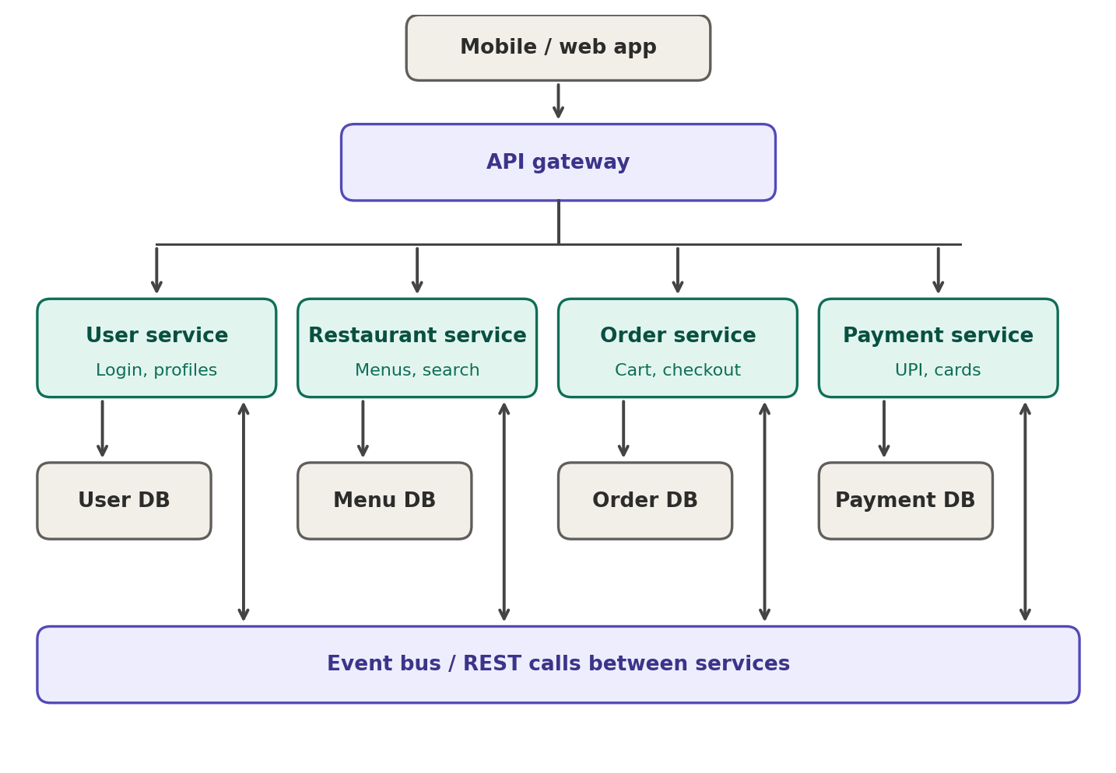
Figure 2: Food delivery app as a microservices system

Question 3
List 4 advantages of using microservices over a monolithic architecture for a movie ticket booking app (like BookMyShow), and give a one-line example for each advantage.
Answer
- Independent scaling: Only the busy part needs more servers. Example: during a big Friday release, only the Seat Booking service scales up while the Reviews service stays small.
- Fault isolation: One failing part does not take everything down. Example: if the Recommendations service crashes, people can still search shows and book tickets.
- Faster, independent deployments: Teams release their own service without redeploying the whole app. Example: the Offers team ships a new coupon rule without waiting for the Booking team.
- Technology freedom: Each service can use the language or database that suits it best. Example: Search can use Elasticsearch, while Payments uses a relational database for transactions.

Question 4
Imagine you're updating the payment feature in a monolithic shopping app. Describe in 3-4 sentences how this update could impact other features, compared to making the same update in a microservices-based app like Flipkart.
Answer
In a monolithic shopping app, payment code lives in the same codebase and deployment as every other feature, so even a small payment change means rebuilding and redeploying the whole app. That causes downtime for unrelated features like browsing, cart and login. A bug in the update can also break those features, since they share code and a database. In a microservices app like Flipkart, only the Payment service is redeployed, and it can be rolled out gradually or rolled back on its own. Browsing, cart and login keep running, so the risk stays limited to payments.

Quick comparison
- Monolith: one deployment, one database, changes affect the whole app, scales as a whole.
- Microservices: many small deployments, a database per service, changes stay local, each service scales on its own.

