**PADILLA, JHOANALYN D. SCORE: __________**

**12 ICT CHARLES BABBAGE DATE: 11/29/2023**

**QUARTER II**

**ACTIVITY 1**

**HTML CODE:**

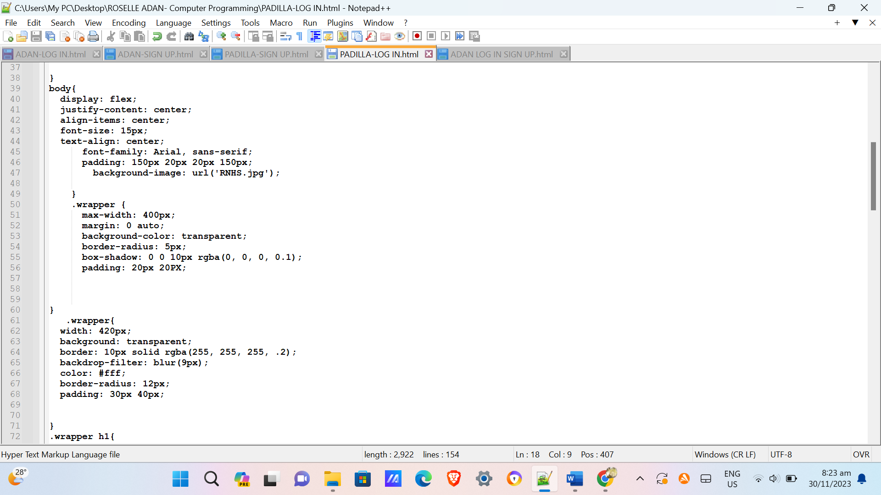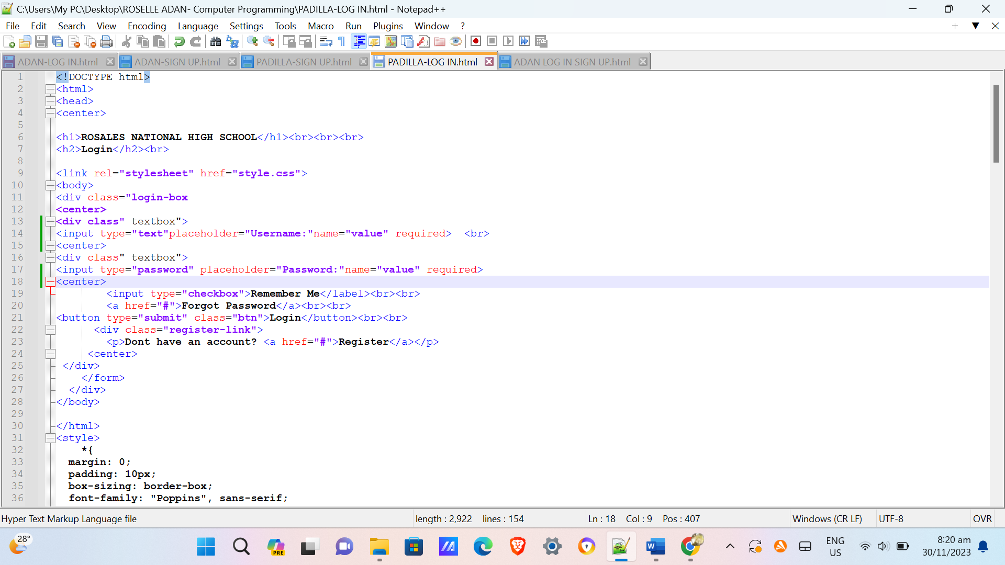

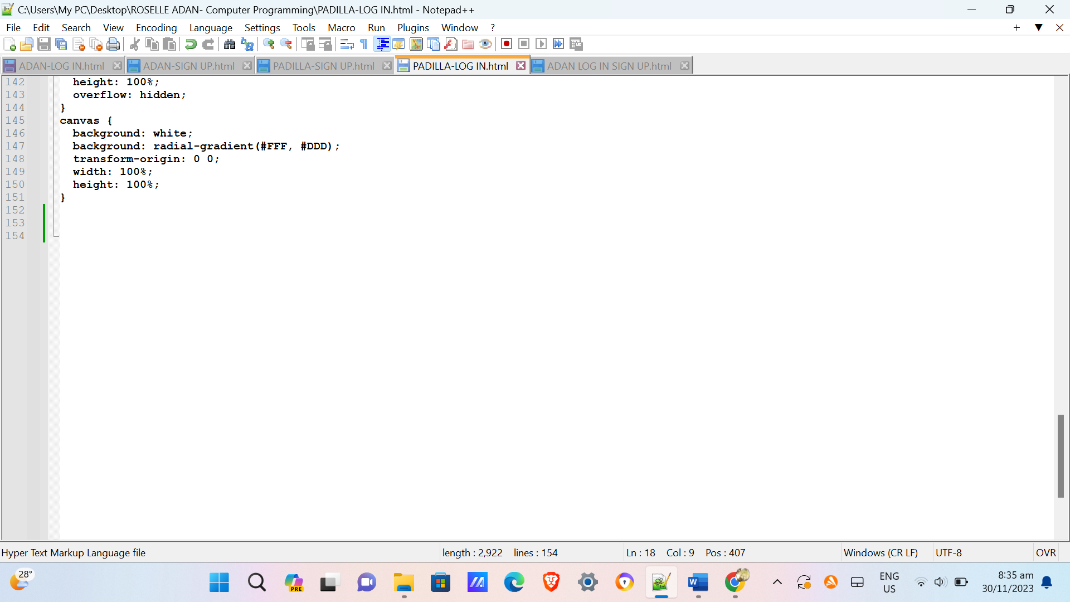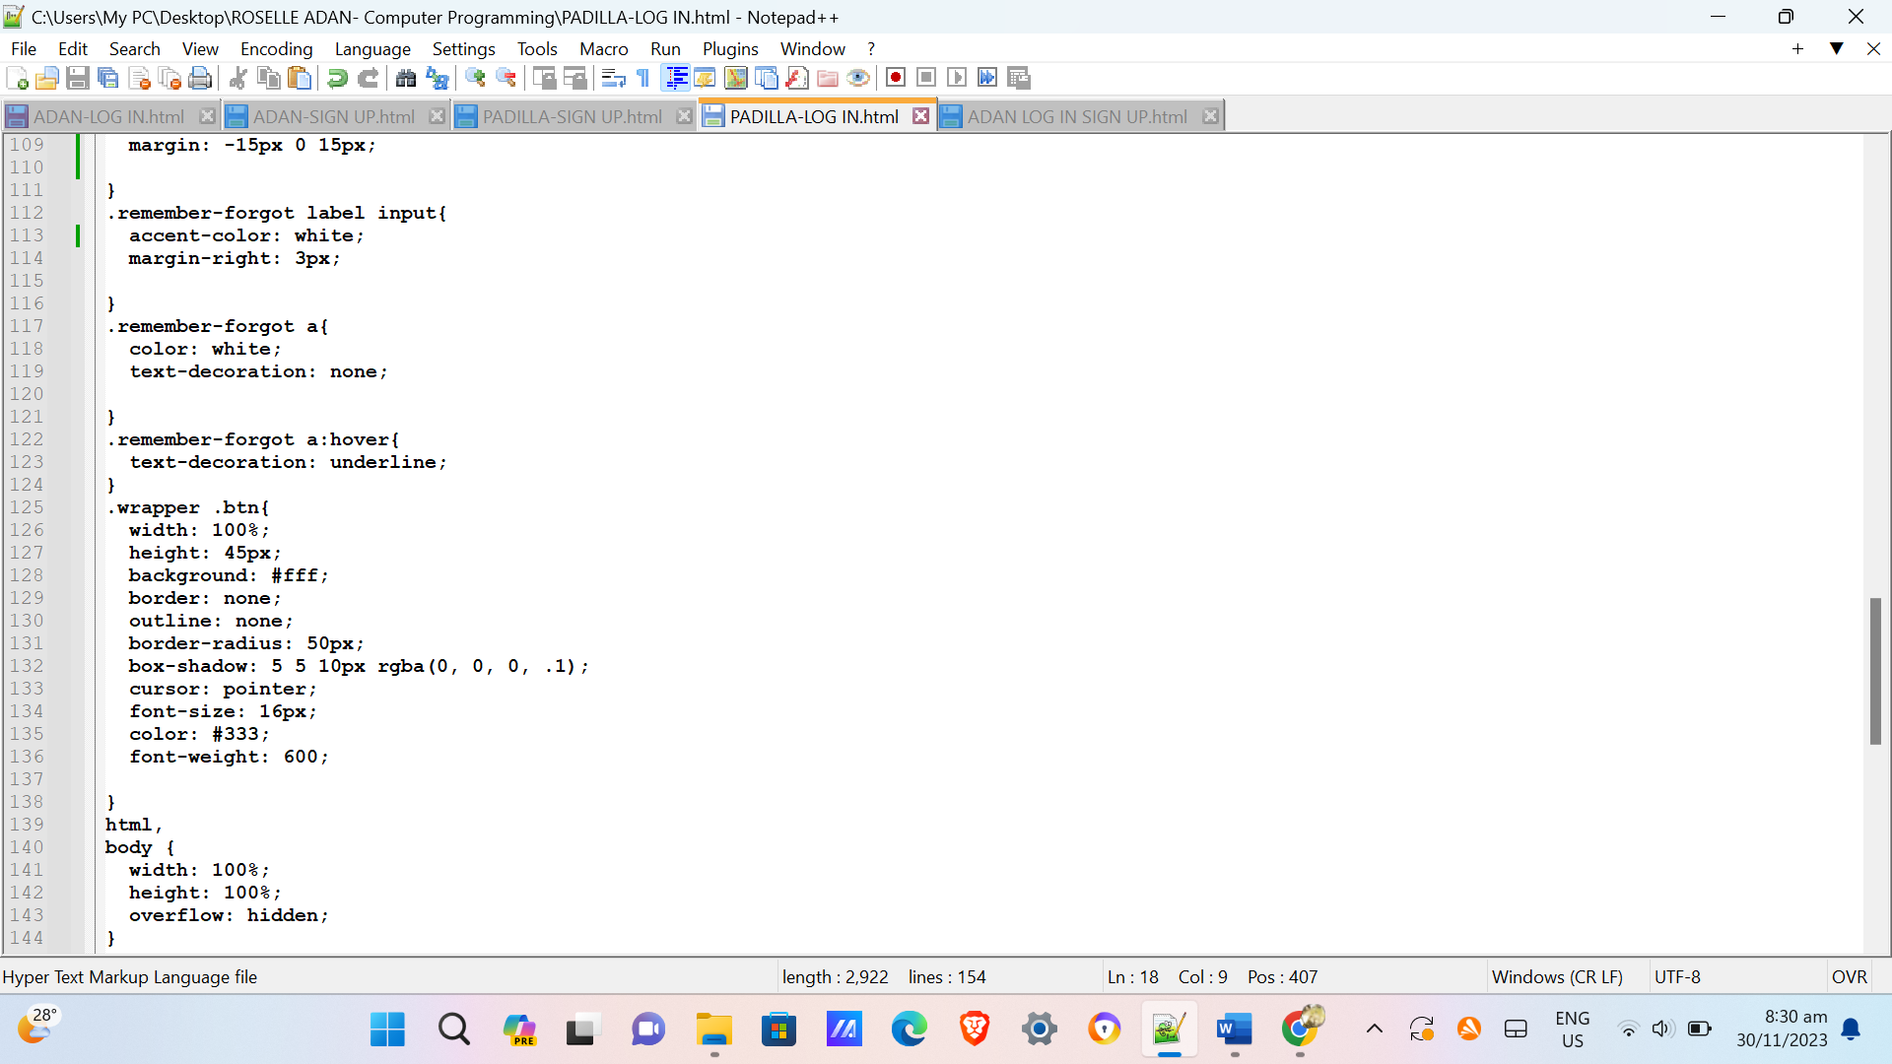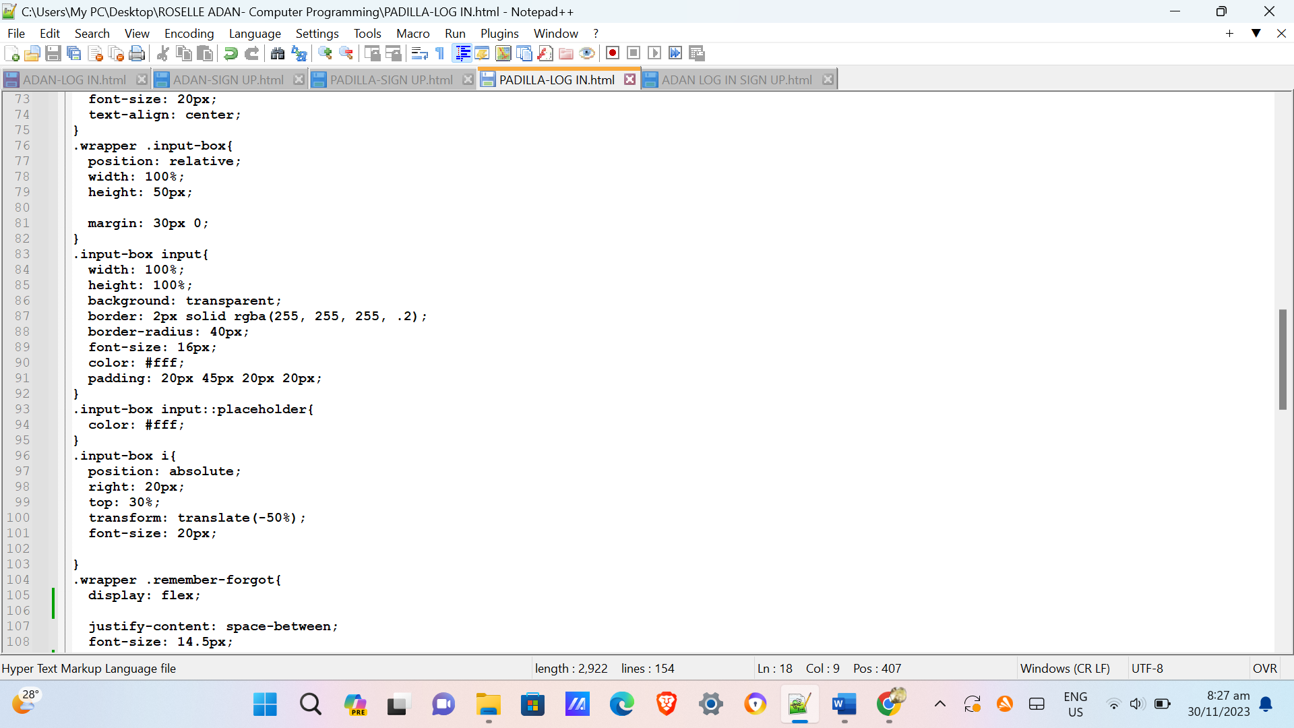

**OUTPUT:**

