**PADILLA, JHOANALYN D. SCORE: __________**

**12 ICT CHARLES BABBAGE DATE: 11/30/2023**

**QUARTER II**

**ACTIVITY 2**

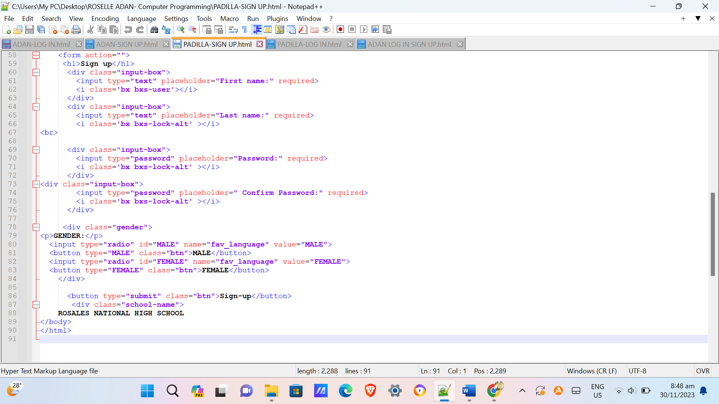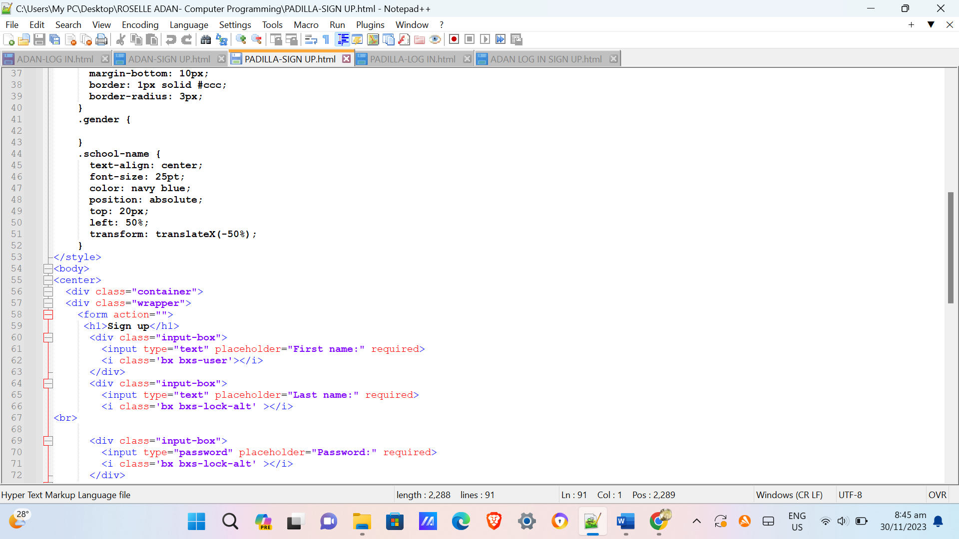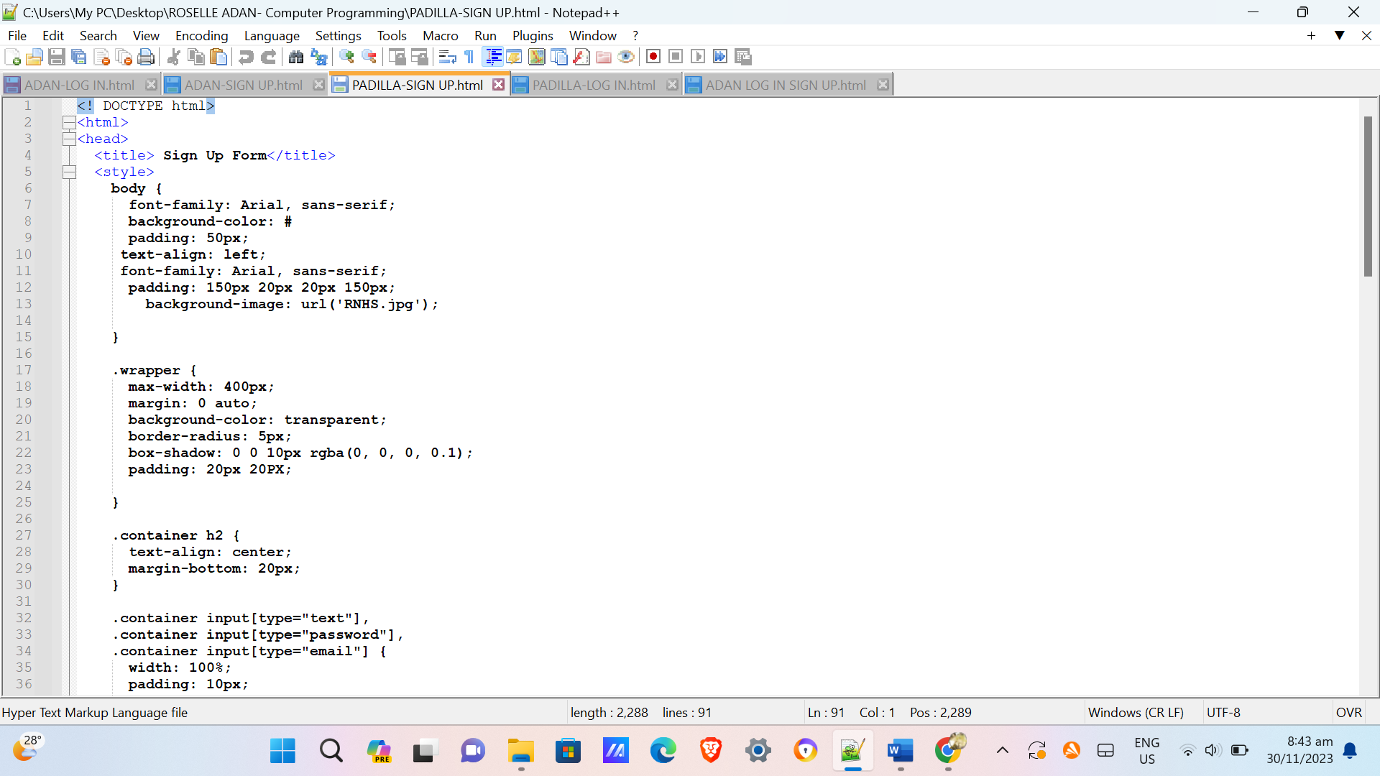**HTML CODE:**

**OUTPUT:**

