**Seri Pacific Hotel Kuala Lumpur**

**Rs 3469**

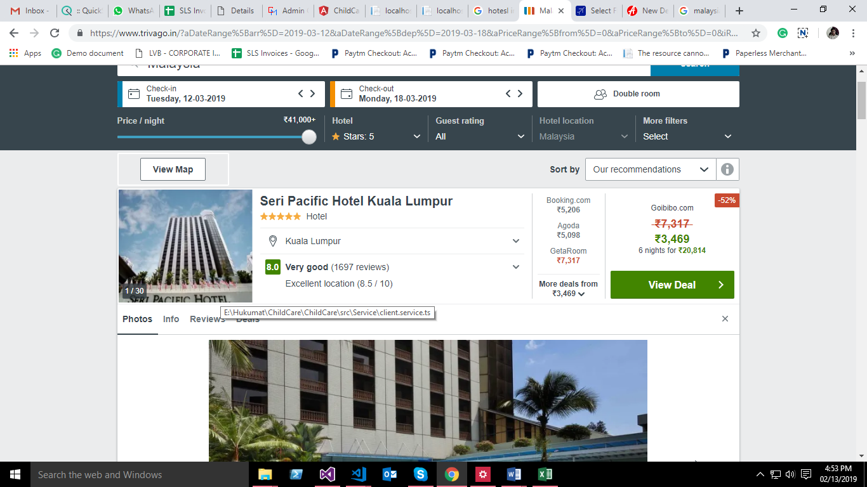

**Hotel Palace Of The Golden Horses**

Rs 2392

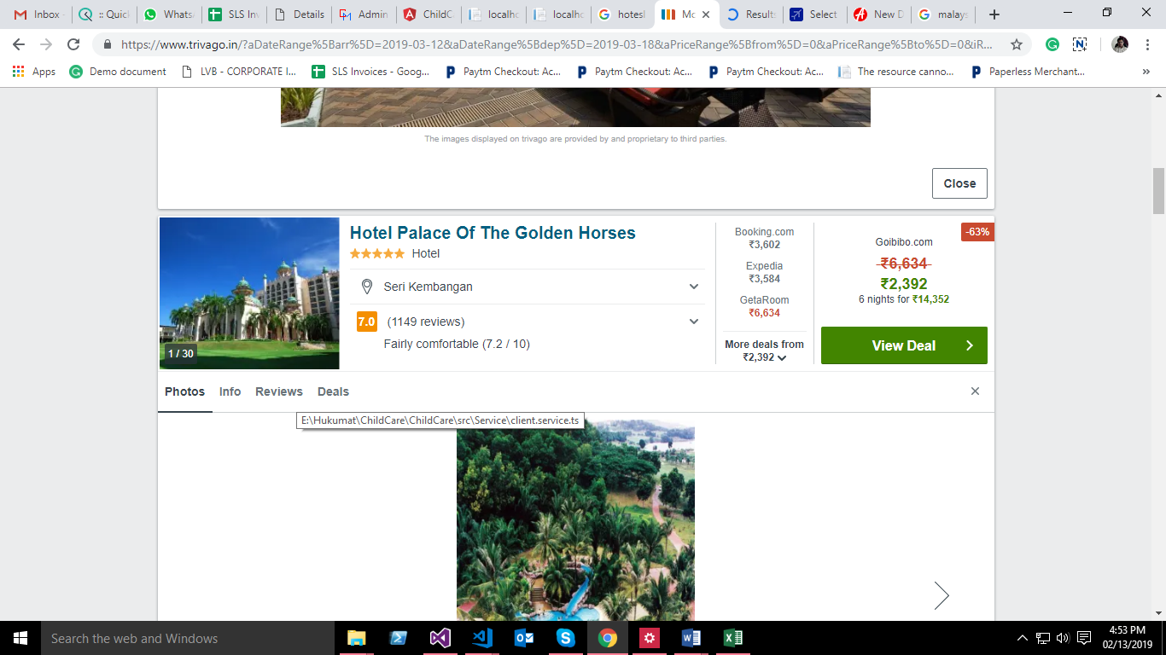

**GTower Hotel**

Rs 4447

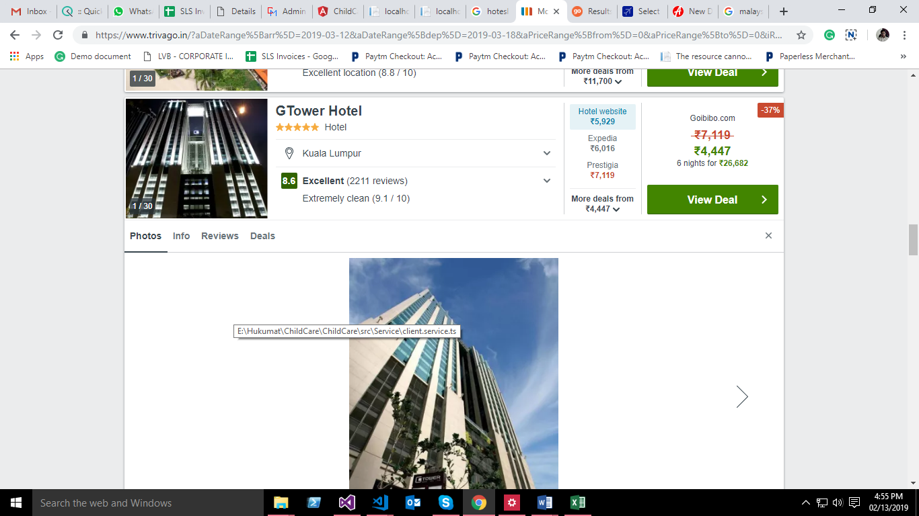

**Hotel Hilton Petaling Jaya**

**Rs 5954**

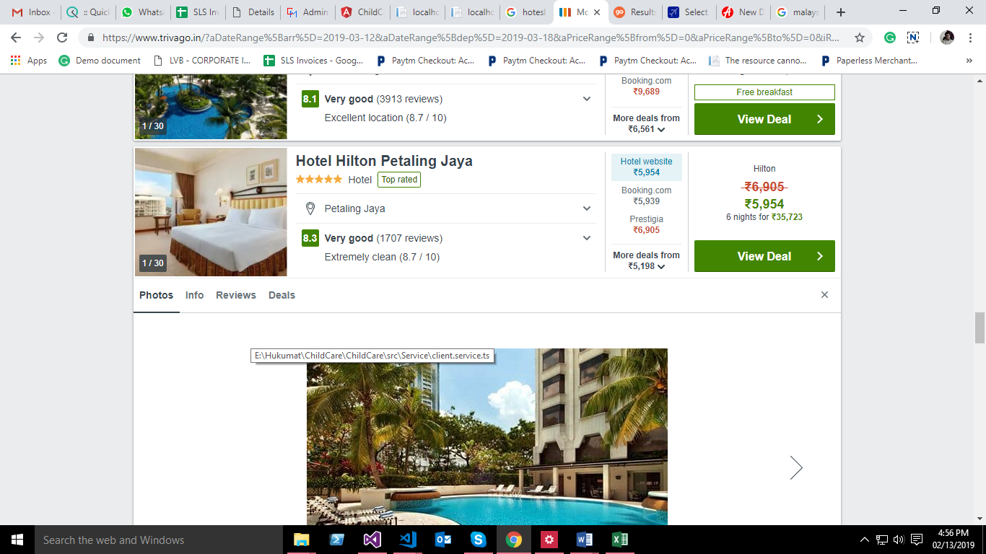

Singapore