Q1
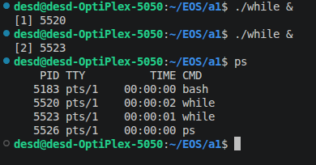
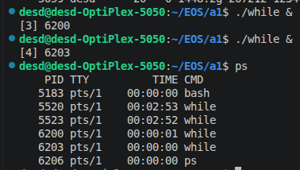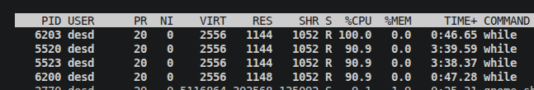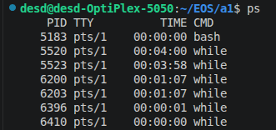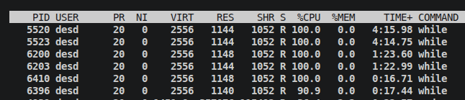
Q2
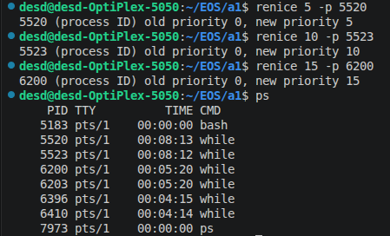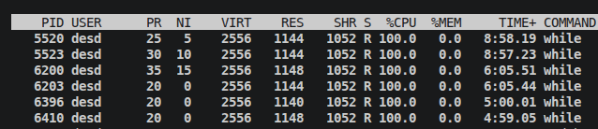
Observation: NICE values are reflected in top. Since it is a multicore system, all processes get 100% CPU Time.
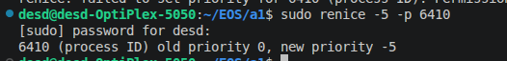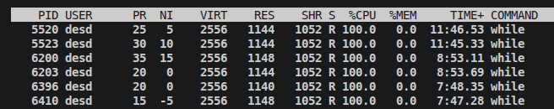
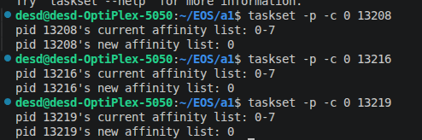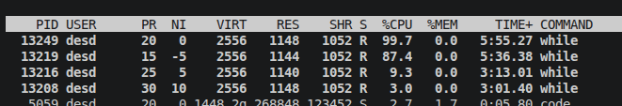
Observation: After limiting the processes to one core, their CPU time distribution changes according to nice value. Lower the nice value, higher the CPU Time.

Q3
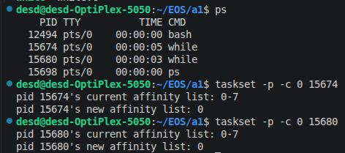
Time sharing
Observation: CPU Time is split equally

Round Robin
Observation: With same priority, equal CPU time

Observation: higher priority gets all CPU Time

FIFO
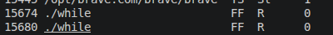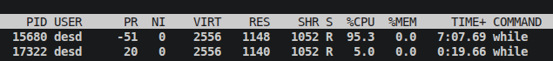
Observation: Lower priority gets more CPU time

With sched_yield()
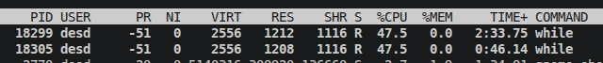
Observation: both processes get equal time

