Q1
ASLR = 2 (Fully enabled)
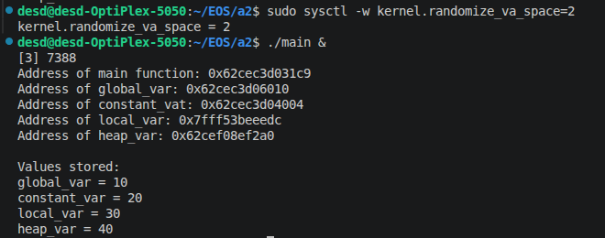
ASLR = 1(Partial)
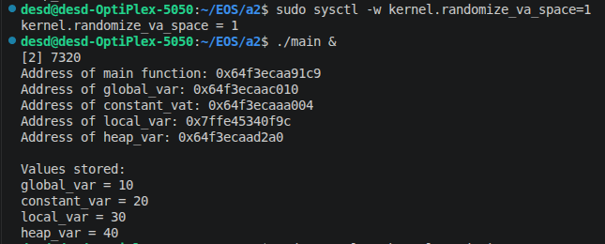
ASLR = 0 (Disabled)
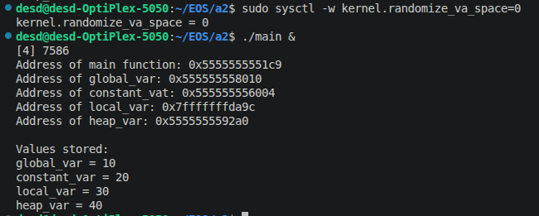

Multiple instances of same program
ASLR = 0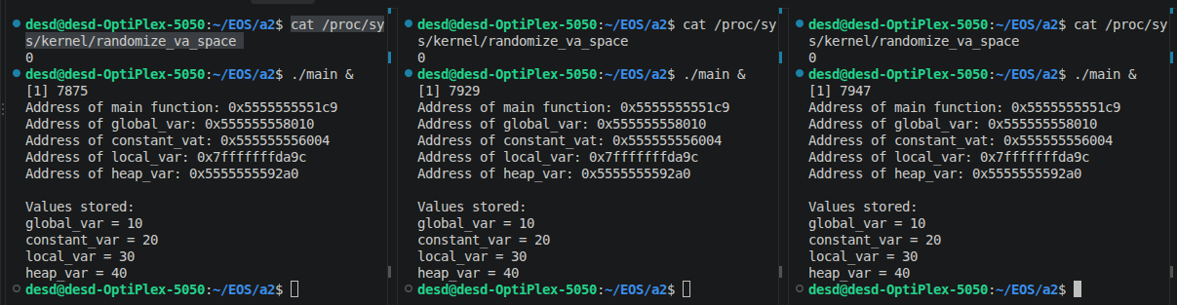
ASLR = 1
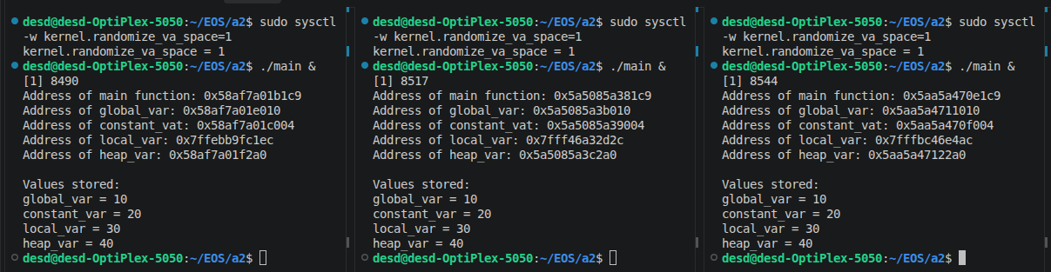
ASLR = 2
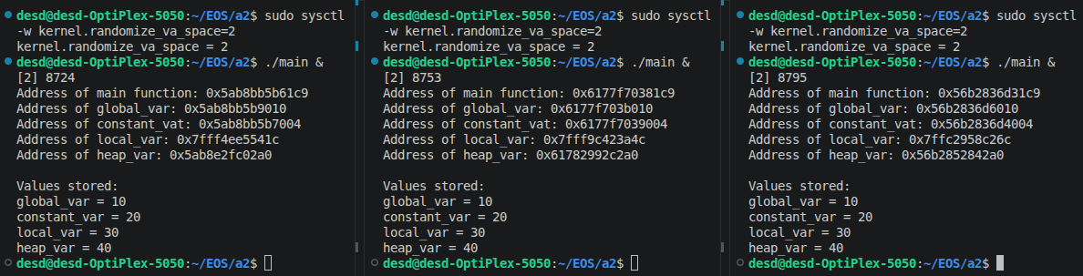

MEMORY MAPS
ASLR = 2
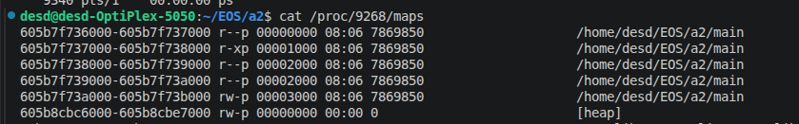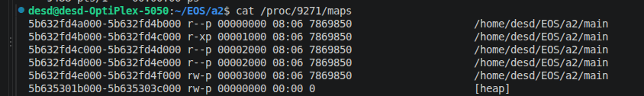
Observation: Random address spaces

ASLR = 1
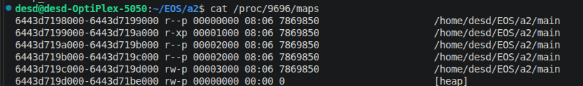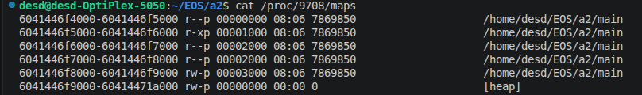
Observation: Partial random address spaces

ASLR = 0
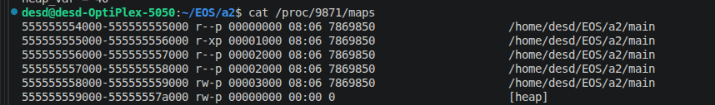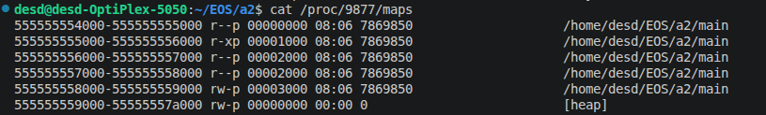
Observation: Sequential address spaces

Accessing Global Variable
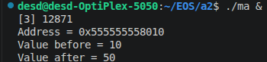

Accessing global const variable
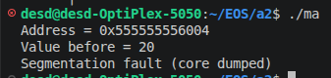
Accessing local variable
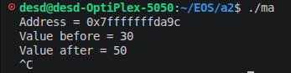

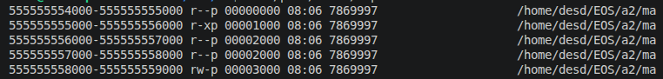
Accessing Read only segment from memory map
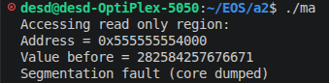

Accessing Read-Write segment from memory map
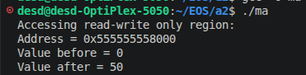

Accessing Read-Execute segment from memory map
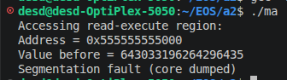

Accessing invalid region
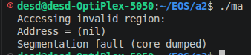

Q2
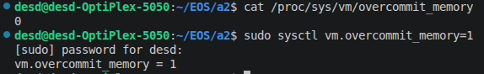
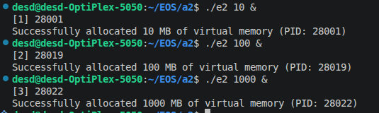
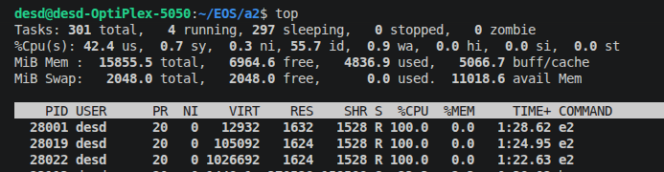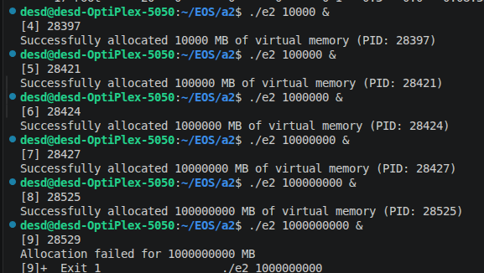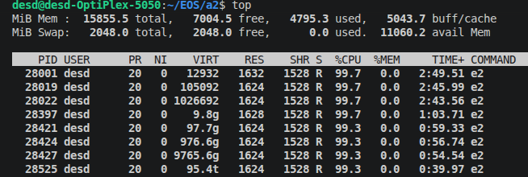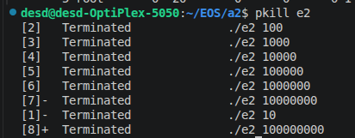
Observation: Memory allocation of 1000000000 MB Fails

