Q1
5 Child processes created

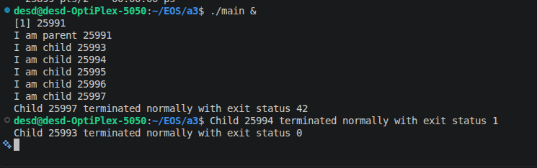
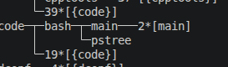
3 Child processes exit normally with their exit status collected by parent

2 child processes with infinite while loops stay running
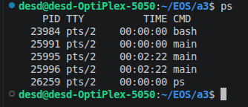

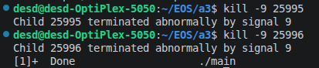

2 Child processes killed by SIGKILL
WIFEXITED captures normal termination
WIFSIGNALED captures processes terminated by a signal

Q2
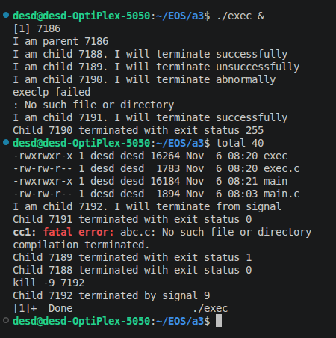

Two children terminated successfully
One child terminated unsuccessfully
One child failed to bind to a program. Abnormal termination
One child has to be killed by SIGKILL

Q3.
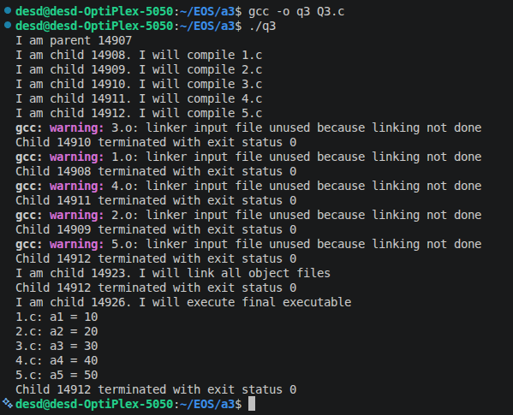

5 C source files compiled successfully by 5 children.
If exit status of all children == 0 only then compilation successful.
Link all object files using another child. Then execute them using another child.

