Q1.
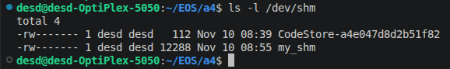
Share memory object my_shm is created. Its size of 12KB (3 pages)

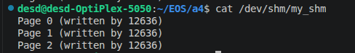
Content written to 3 pages by parent

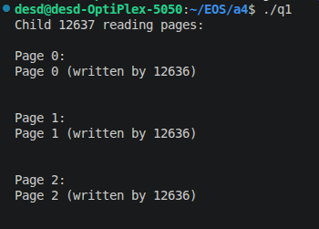
Content read by child process

Shared Memory between unrelated processes:
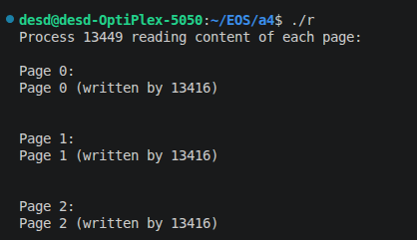
Reader reads each page written by writer
Then writes a response on page 2
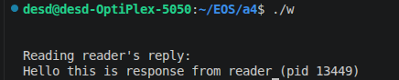
Writer reads response from reader from same shared memory.

