## **PostgreSQL Report**

## **What is PostgreSQL?**

PostgreSQL is a powerful, open source object-relational database system that uses and extends the SQL language combined with many features that safely store and scale the most complicated data workloads. The origins of PostgreSQL date back to 1986 as part of the **[POSTGRES](https://www.postgresql.org/docs/current/history.html)** project at the University of California at Berkeley and has more than 35 years of active development on the core platform.

## **Why use PostgreSQL?**

PostgreSQL comes with **[many features](https://www.postgresql.org/about/featurematrix/)** aimed to help developers build applications, administrators to protect data integrity and build fault-tolerant environments, and help you manage your data no matter how big or small the dataset. In addition to being **[free and open source](https://www.postgresql.org/about/license/)**, PostgreSQL is highly extensible. For example, you can define your own data types, build out custom functions, even write code from **[different programming languages](https://www.postgresql.org/docs/current/xplang.html)** without recompiling your database!

Below is an inexhaustive list of various features found in PostgreSQL, with more being added in every **[major release](https://www.postgresql.org/developer/roadmap/)**:

* ****Data Types****
  + Primitives: Integer, Numeric, String, Boolean
  + Structured: Date/Time, Array, Range / Multirange, UUID
  + Document: JSON/JSONB, XML, Key-value (Hstore)
  + Geometry: Point, Line, Circle, Polygon
  + Customizations: Composite, Custom Types
* ****Data Integrity****
  + UNIQUE, NOT NULL
  + Primary Keys
  + Foreign Keys
  + Exclusion Constraints
  + Explicit Locks, Advisory Locks
* ****Concurrency, Performance****
  + Indexing: B-tree, Multicolumn, Expressions, Partial
  + Advanced Indexing: GiST, SP-Gist, KNN Gist, GIN, BRIN, Covering indexes, Bloom filters
  + Sophisticated query planner / optimizer, index-only scans, multicolumn statistics
  + Transactions, Nested Transactions (via savepoints)
  + Multi-Version concurrency Control (MVCC)
  + Parallelization of read queries and building B-tree indexes
  + Table partitioning
  + All transaction isolation levels defined in the SQL standard, including Serializable
  + Just-in-time (JIT) compilation of expressions
* ****Reliability, Disaster Recovery****
  + Write-ahead Logging (WAL)
  + Replication: Asynchronous, Synchronous, Logical
  + Point-in-time-recovery (PITR), active standbys
  + Tablespaces
* ****Security****
  + Authentication: GSSAPI, SSPI, LDAP, SCRAM-SHA-256, Certificate, and more
  + Robust access-control system
  + Column and row-level security
  + Multi-factor authentication with certificates and an additional method
* ****Extensibility****
  + Stored functions and procedures
  + Procedural Languages: PL/pgSQL, Perl, Python, and Tcl. There are other languages available through extensions, e.g. Java, JavaScript (V8), R, Lua, and Rust
  + SQL/JSON path expressions
  + Foreign data wrappers: connect to other databases or streams with a standard SQL interface
  + Customizable storage interface for tables
  + Many extensions that provide additional functionality, including PostGIS
* ****Internationalisation, Text Search****
  + Support for international character sets, e.g. through ICU collations
  + Case-insensitive and accent-insensitive collations
  + Full-text search

There are many more features that you can discover in the PostgreSQL **[documentation](https://www.postgresql.org/docs/)**. Additionally, PostgreSQL is highly extensible: many features, such as indexes, have defined APIs so that you can build out with PostgreSQL to solve your challenges.

PostgreSQL has been proven to be highly scalable both in the sheer quantity of data it can manage and in the number of concurrent users it can accommodate. There are active PostgreSQL clusters in production environments that manage many terabytes of data, and specialized systems that manage petabytes.

Download PostgreSQL :

<https://www.postgresql.org/download/windows/>

Download PgAdmin 4:

<https://www.postgresql.org/ftp/pgadmin/pgadmin4/v7.0/windows/>

## PostgreSQL Features

It is one of the most popular databases supporting JSON (non-relational) queries and SQL for (relational) queries. PostgreSQL is an object-relational database management system (ORDBMS). It contains the various advanced data types and robust feature sets, which increase the extensibility, reliability, and data integrity of the software.

In this section, we are going to discuss the most advanced features, Database administration tools of PostgreSQL, and benefits and drawbacks, which will help us to enhance our knowledge of PostgreSQL.

[PostgreSQL](https://www.javatpoint.com/postgresql-tutorial) includes multiple features that are designed to help the developers in developing the applications, manage our data in the datasets, and managers can keep the data integrity, and create the Risk-tolerant environments. Whenever the new release comes into the market, the PostgreSQL Global group of developers will enhance the previous features and adds some new features based on the user's demand.

The essential features of PostgreSQL are as follows:

* ****Free to download:**** It is open-source, and we can easily download it from the official website of PostgreSQL.
* ****Compatible on several operation systems:**** PostgreSQL runs on all major operating systems such as Microsoft Windows, Linux, MacOS X, UNIX (AIX, BSD, HP-UX, SGI IRIX, Solaris, and Tru64), etc.
* ****Compatible with various programming languages:**** It supports multiple programming interfaces such asC/C++, JAVA, Python, Perl, Ruby, Tcl, and ODBC (Open Database Connectivity).

### pgAdmin

It is one of the most famous and open-source management and development platforms for PostgreSQL. PgAdmin is the most advanced database around the world. It can be used on various operating systems such as UNIX, [Linux](https://www.javatpoint.com/linux-tutorial), Mac OS X, and Windows to achieve PostgreSQL 9.2 and above versions.

## Advantages and disadvantages of PostgreSQL

The ****benefits**** of the PostgreSQL are as follows:

* PostgreSQL is easy to use; that why we do not require much training.
* It requires low maintenance management for enterprise as well as embedded usage.
* PostgreSQL manages data in a relational database as it is very powerful and robust.
* We can quickly get the source code of PostgreSQL as it is freely available in an open-source license, and we can immediately implement, change according to our requirements.
* It can execute dynamic web-application and website as the LAMP stack option.
* PostgreSQL is a highly risk-tolerant database.

The ****drawbacks**** of PostgreSQL are as follows:

* PostgreSQL does not support the various open-source applications as compared to MySQL.
* In this, creating replication is a bit complex.
* It is not maintained by one company.
* PostgreSQL speed performance is not as good as compare to further tools.
* It is a bit slow as compared to MySQL.
* Sometimes, the installation process is not easy for the learner.

# Connect to a PostgreSQL Database Server

In this section, we are going to understand how to connect the ****PostgreSQL database server through**** an interactive terminal software called ****pgAdmin**** and the ****SQL Shell(psql)**** application.

If we installed the PostgreSQL database server, then the PostgreSQL installer will also connect with some beneficial tools to work through the PostgreSQL database server.

Here, we are going to discuss how we can connect the PostgreSQL database server through the below tools:

* ****PgAdmin****
* ****SQL Shell (PSQL)****

****PgAdmin:**** It is a web-based front-end management tool for [PostgreSQL](https://www.javatpoint.com/postgresql-tutorial), which helps us connect the ****PostgreSQL database server.****

****SQL shell(psql):**** It is a terminal-based front-end application, and we can also use this application to connect the ****PostgreSQL database server****.

We will now connecting the PostgreSQL database server with the help of ****pgAdmin****.

* ****Connect to PostgreSQL database server using pgAdmin****

Firstly, we will understand how to connect to a database with the help of ****the pgAdmin**** application.

The pgAdmin tool permits us to relate with the PostgreSQL database server through an ****in-built user interface****. And here, we are using the ****pgadmin4 version**** to connected the database.

We will follow the below steps to connect the PostgreSQL database server using the ****pgAdmin GUI tool:****

****Step1: Launch the pgAdmin application****

Firstly, we will open the ****pgAdmin**** application. For this, we will enter ****pgAdmin**** into the search bar of our system, as shown in the below screenshot:

of our system, as shown in the below screenshot:

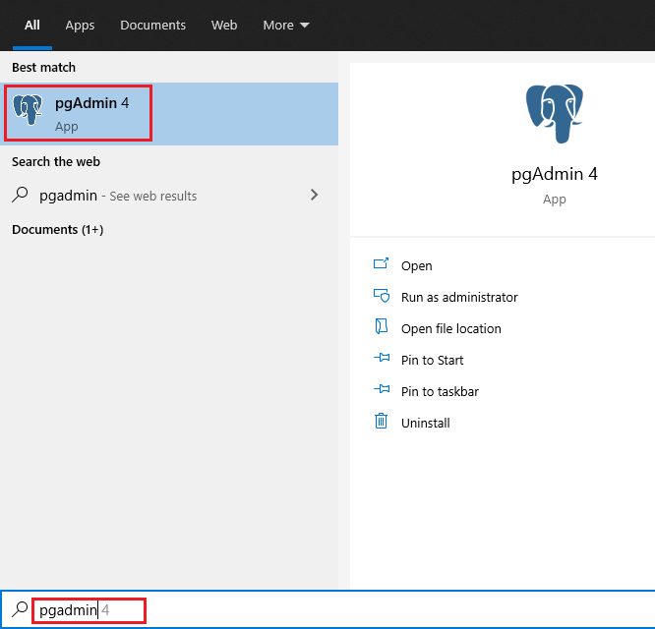

After clicking on the ****pgAdmin**** application, it will launch on the web browser, as we can see in the following screenshot:

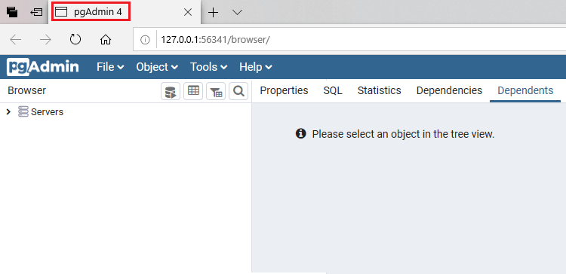

****Step2: Create a server****

After that, we will right-click on the ****Servers**** node and select the ****Create → Server…**** menu to ****create a server****, as we can see in the below image:

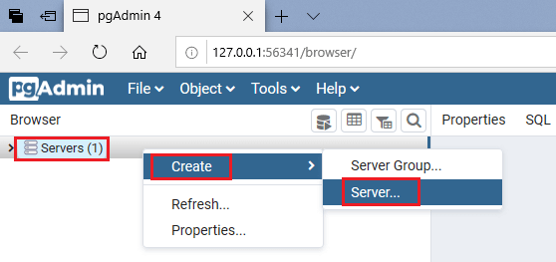

****Step3: Provide the server name****

After selecting the ****Server**** option, the ****Create-Server**** window will be opened, where we enter the ****server name**** in the ****Name column, for example, PostgreSQL1**** and then we will click on the ****Connection**** tab, as shown below:

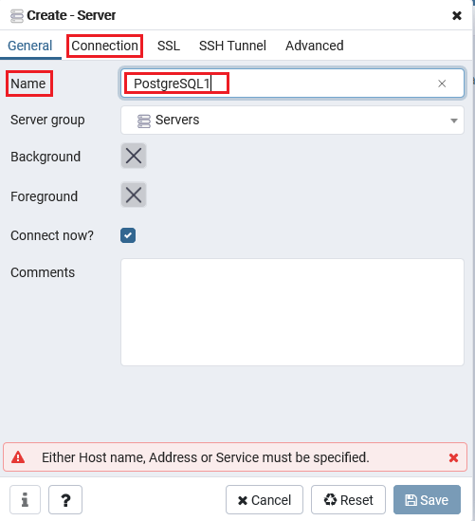

****Step4: Provide the host and password****

After clicking on the ****Connection tab****, we will provide the details of the ****host**** and ****password**** for the ****Postgres**** user, and after that, we will click on the ****Save**** button.

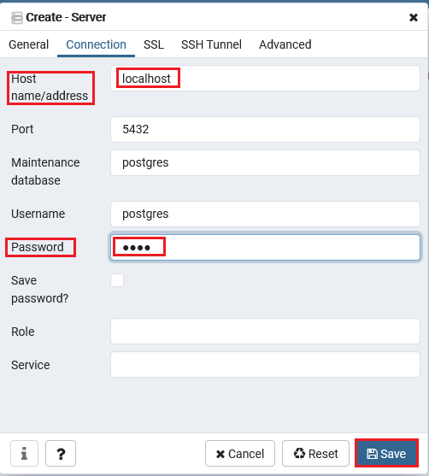

****Step5: Expanding the server****

In the next step, we will click on the ****Servers node**** to ****expand the server****. And PostgreSQL has a database named ****Postgres**** by default, as we can see in the following image:

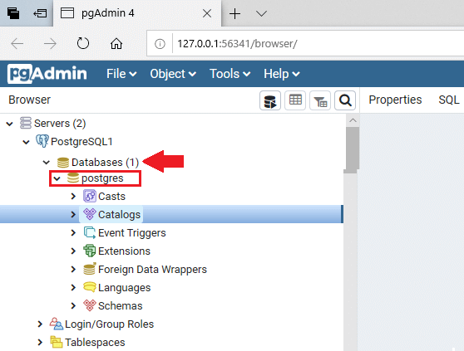

****Step6: Open the Query tool****

Now, we will open the ****query tool**** by selecting the menu item ****Tool → Query Tool,**** or we can directly click the ****query tool**** icon nearby ****Browser,**** as we can see in the following screenshot:

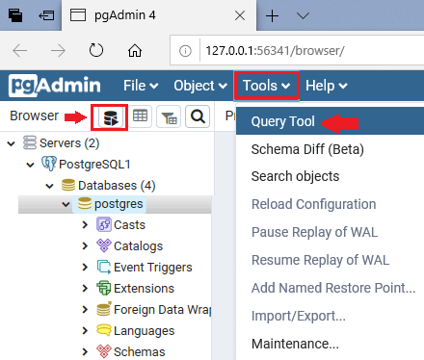

****Step7: Enter the command in the Query editor****

Once the ****query tool**** is opened successfully, we will enter the below command in the ****Query Editor**** and click on the ****Execute**** button.

1. **Select** Version();

And after implementing the above command, we will get the ****Data output**** of the Specified command, which display the complete information of the currently used ****version**** of ****PostgreSQL****, as shown in the below image:

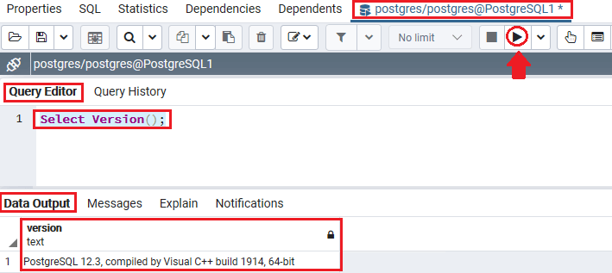

After understanding the ****PostgreSQL database server's connection through pgAdmin4****, we will learn the connection process of the ****PostgreSQL database server using SQL Shell(psql).****

* ****Connect to PostgreSQL database server using psql****

The ****psql**** is an ****interactive shell tool**** provided by PostgreSQL. The psql permits us to interrelate with the PostgreSQL database server, ****for example, working on the database objects**** and ****implementing the**[SQL](https://www.javatpoint.com/sql-tutorial)**commands****.

To connect to the PostgreSQL database server by using the **[SQL shell(psql)](https://www.javatpoint.com/psql-commands)** application, we will follow the below steps:

****Step1: Open the psql****

Firstly, we will open the ****psql**** in our local system. For this, we will go to the ****home**** button and search for ****SQL shell(psql)**** and click on the ****Open**** button, as shown in the below screenshot:

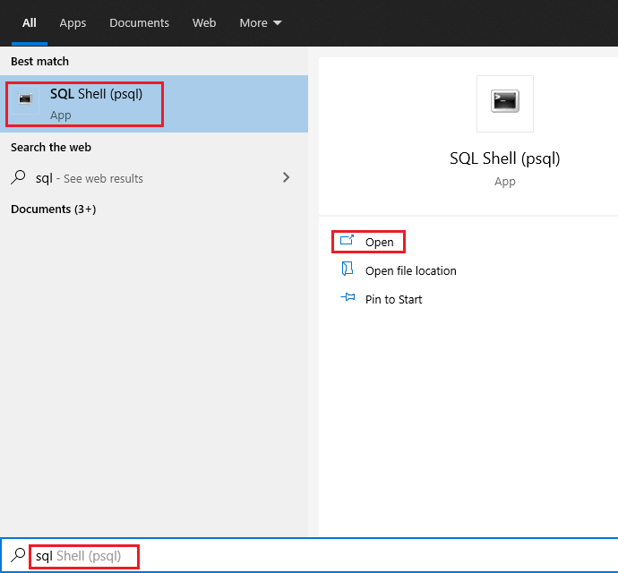

****Step2: Connect the Database****

Once the ****SQL shell**** is opened, we will press the enter key ****four to five times.****

And then provide the ****password**** for the user (which we created earlier) to connect the database server using the ****Postgres**** user who is a ****by default**** user in PostgreSQL, as shown in the below screenshot:

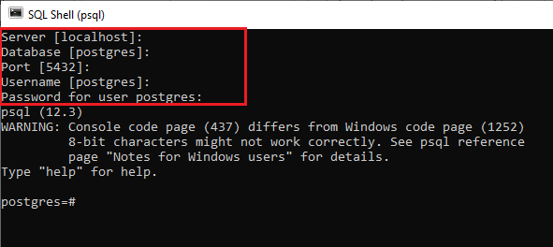

#### Note: If we want to provide all the details like Server, Database, Port, Username, and Password manually, we will press Enter key and the application will use the default values, which are defined in the square bracket [] and move the arrow to the new line.

Suppose we have ****localhost**** as the default database server, and we were providing the ****Postgres user password****, we will enter a similar password for the Postgres user-specified throughout the [PostgreSQL installation](https://www.javatpoint.com/install-postgresql).

****Step3: Entering a command to relate with the PostgreSQL Database Server****

In this step, we will write one SQL command, which helps us relate with the PostgreSQL Database Server.

In the below command, we are trying to get the complete details about the current version of PostgreSQL:

1. **SELECT** version();

After implementing or pressing the ****Enter key****, we will get the following output, which displays the full information about the existing version of PostgreSQL version of our system:

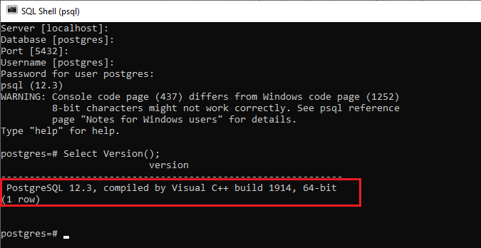

#### Note: While writing a command in psql, we should make sure that the specified command would end with a semicolon (;).

* ****Connecting the PostgreSQL database from other applications****

If any application supported by ODBC or [JDBC](https://www.javatpoint.com/java-jdbc) also be connected to the PostgreSQL database server.

Furthermore, when we develop an application that uses an explicit driver, the particular software can also connect to the PostgreSQL database server.

For example, we can connect the PostgreSQL from [JAVA](https://www.javatpoint.com/java-tutorial), connect the PostgreSQL from Python and connect to PostgreSQL from [PHP](https://www.javatpoint.com/php-tutorial).