**Java Full Stack with Angular and Spring Boot**

**Link:** <https://github.com/in28minutes/full-stack-with-angular-and-spring-boot>

**“node –v”**

**“npm –v”**

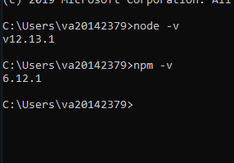

[**https://cli.angular.io/**](https://cli.angular.io/)

**“npm install -g @angular/cli”**

**“ng version”**

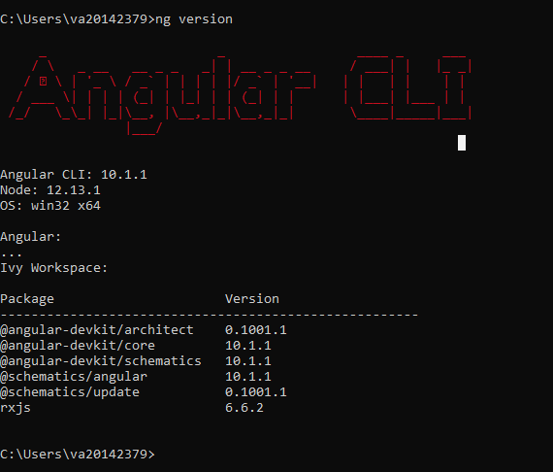

**“ng help”**

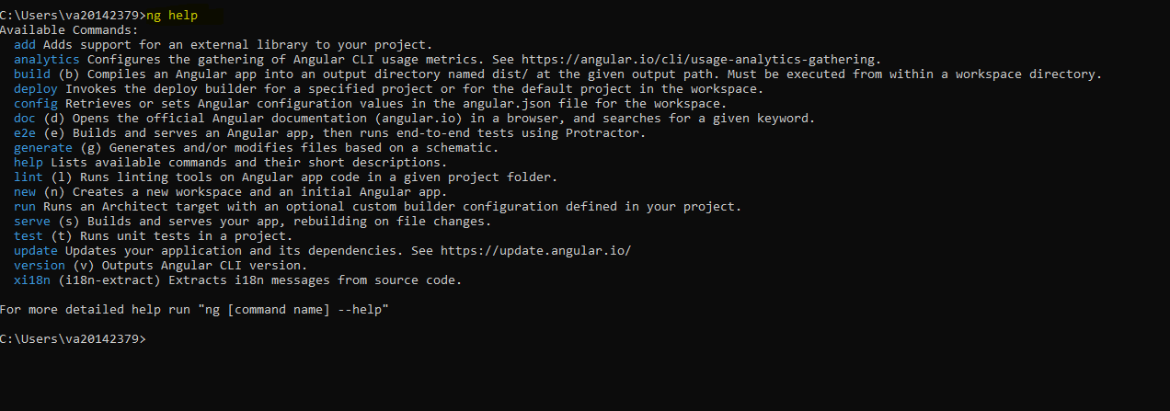

**Create a new angular project:**

Syntax**: “ng new “name of the project” “**

Ex**: “ng new todo”**

**Cd /todo**

Start todo app: **ng serve**

Started on : **http://localhost:4200/**

**To check coding standard:**

**“ng lint”**

* Without any error:



* With error:

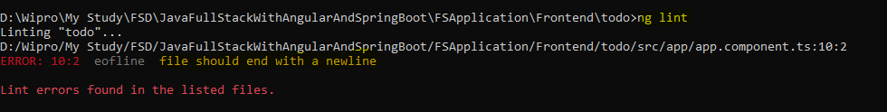

**Ng build command:**

**“ng build”**

->Several new files will be created.

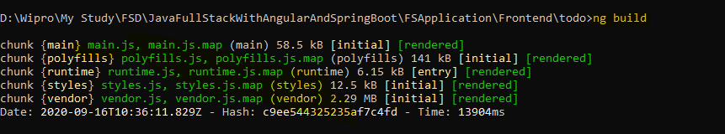

After that, a new folder ‘**dist’** will be created in workspace. We can deploy and run this folder ‘**dist’** directly in any web server.

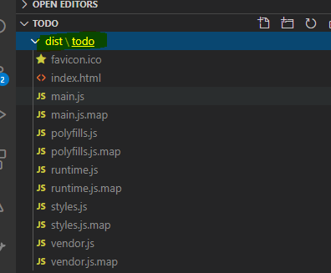

**Ng test command:**

**“ng test”**

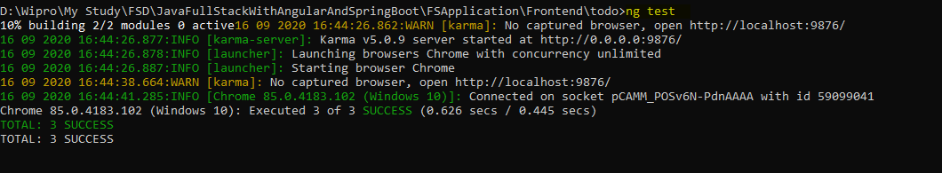

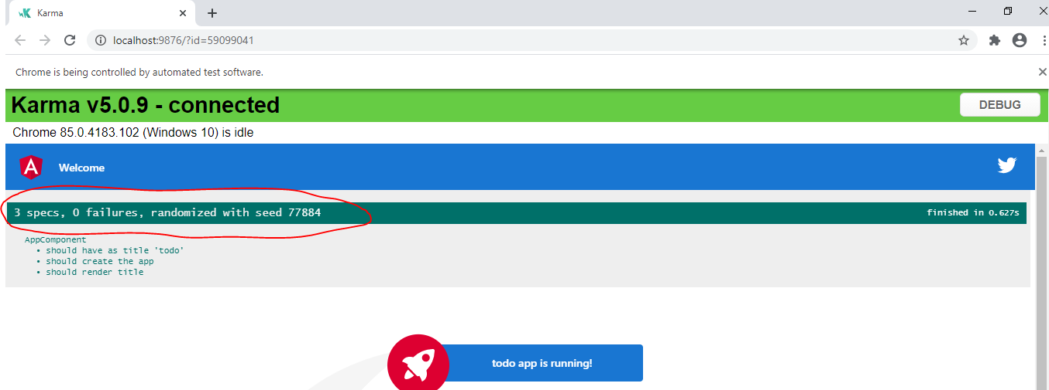

**End to end testing:**

**“ng e2e”:**

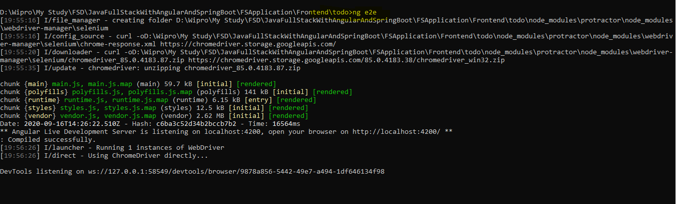

**Create the component in the Angular:**

**”ng generate component ‘component name’”**

**Ex: ng generate component welcome**

**Or ng g c welcome**

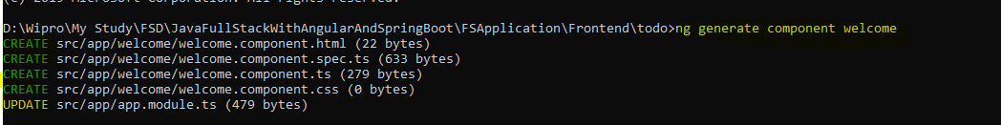

**Updated component name in “app.module.ts”:**

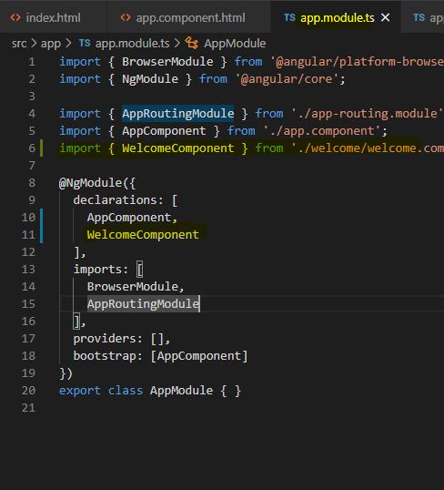

**“ng g c welcome2”**

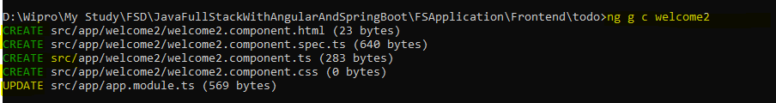

**“ng generate component welcome3”**

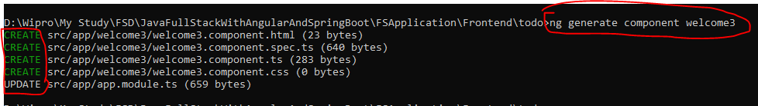

**Data binding:**

1. **Interpolation**



1. **Event binding**

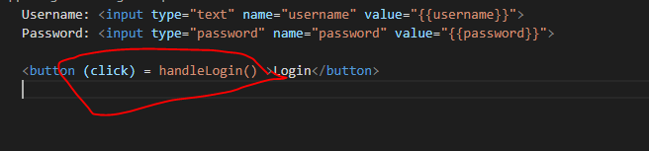

1. **Banana in box(2 way data binding)**

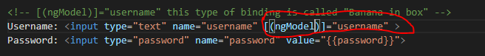

**[(ngModel)]=”username”**

**[(ngModel)] is also called as Angular Directive.**

**Creating service:**

**“ng generate service service/HardcodedAuthenticationService”**

