**SpendWise**

A Project Report

Submitted in the completion of the course.

**IT Venture Management   
In  
Department of computer science and engineering**

By

|  |  |
| --- | --- |
| A.J SWAROOP | 2110030209 |
| G. SRI VARDHAN REDDY | 2110030217 |
| R. SATYA SAI | 2110030256 |
| CH. DILEEP REDDY | 2110030307 |

**Under the Supervision of**

Mr. Chanda Rajkumar Rao

Assistant Professor

KLH - LMS  
Department of Computer Science and Engineering

KL University Hyderabad  
**Date: March, 2024**

**Declaration**

The report entitled "SpendWise" is a record of the original work of Swaroop (2110030209), Sri Vardhan Reddy (2110030217), Satya Sai (2110030256) and Dileep Reddy (2110030307) submitted in partial fulfilment for the award of B.Tech in the Department of Computer Science and Engineering at KL University Hyderabad. The content of this report has not been copied from any other sources.



AJ SWAROOP

SRI VARDHAN REDDY

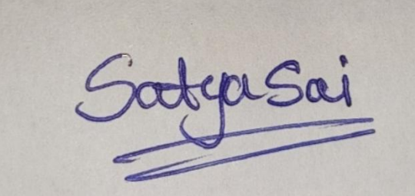

SATYA SAI



DILEEP REDDY

**Abstract**

Mental health issues have become a significant global concern, influenced by factors such as stress, isolation, and trauma. The lack of access to mental health resources exacerbates this problem.

* Stress, isolation, and trauma contribute to mental health challenges on a global scale.
* Limited access to mental health resources compounds the issue, leaving many individuals without adequate support.
* Financial stress is a significant contributor to poor mental well-being.
* SpendWise aims to address these challenges by providing users with financial wellness guidance.
* The platform recognizes the interconnection between financial health and mental well-being.
* By offering practical tools and resources, SpendWise empowers individuals to manage their finances effectively.
* Improved financial management can lead to enhanced mental health and resilience.
* SpendWise seeks to make a positive impact by supporting individuals in their journey towards better mental well-being.

**Introduction**

SpendWise is designed to help users achieve financial wellness, recognizing the link between financial stress and mental health. By providing insights, tools, and resources for better expense tracking and financial management, SpendWise aims to alleviate financial burdens and promote mental well-being.

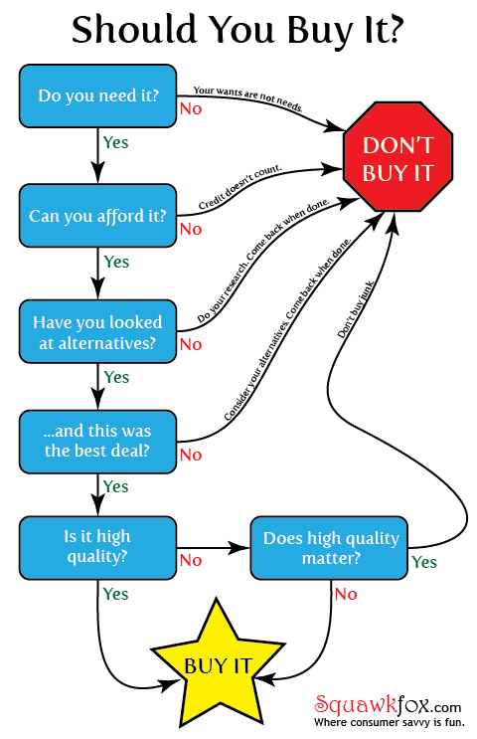

**Problem Statement**

* Financial stress is a major contributor to mental health issues, causing anxiety and despair for many individuals dealing with financial instability.
* Numerous people struggle with managing their expenses effectively, leading to heightened levels of financial stress and subsequent mental health challenges.
* The correlation between financial instability and poor mental well-being underscores the urgent need for effective solutions.
* SpendWise recognizes this pressing issue and endeavors to empower users by offering comprehensive financial literacy and tools.
* By equipping individuals with the knowledge and resources to manage their expenses more effectively, SpendWise aims to alleviate financial stress and mitigate its adverse effects on mental health.
* Through its initiatives, SpendWise strives to make a meaningful difference in the lives of those grappling with financial insecurity and its detrimental impact on mental well-being.

**Objective**

The goal of SpendWise is to provide users with the guidance and resources they need to achieve financial wellness, thereby improving their overall mental well-being. By promoting responsible financial habits and providing support, SpendWise aims to alleviate the burden of financial stress on mental health.

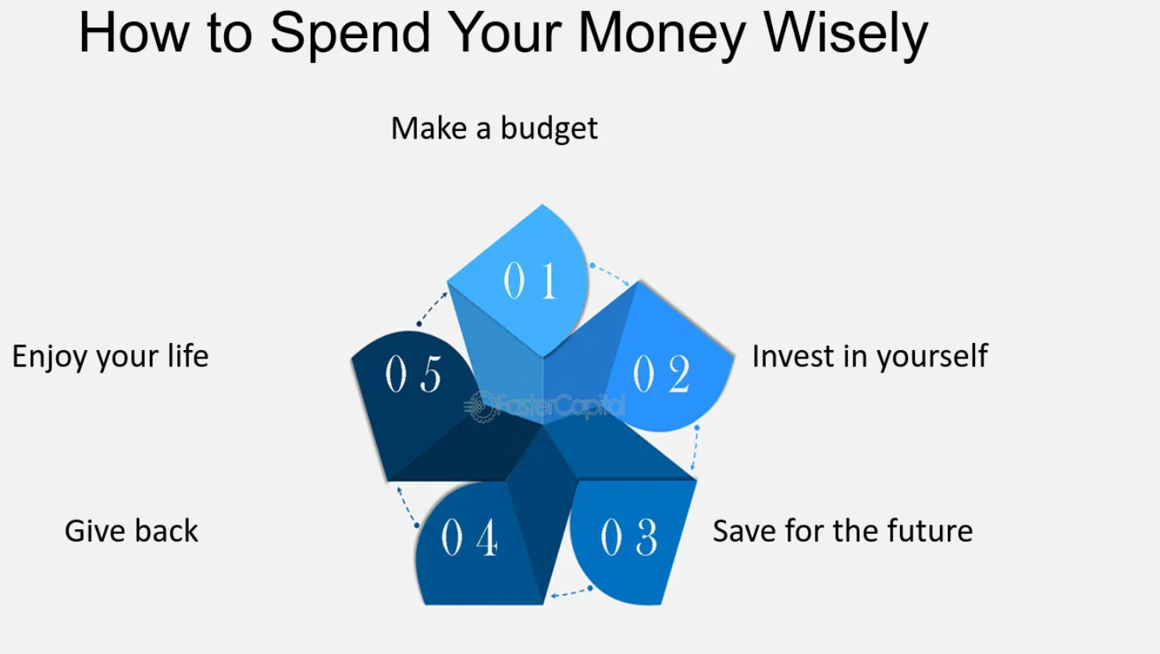

**Why SpendWise?**

SpendWise recognizes the importance of financial well-being in overall mental health. By addressing financial stressors and promoting responsible financial habits, SpendWise aims to empower users to take control of their finances and improve their mental well-being.



**Implementation**

SpendWise utilizes a chatbot interface powered by natural language processing to provide users with personalized financial guidance and support. The platform offers features such as expense tracking, budgeting tools, and financial literacy resources to help users make informed financial decisions.

1. **Chatbot Interface Development:**
   * SpendWise begins by developing a chatbot interface leveraging natural language processing (NLP) technology.
   * This chatbot interface is designed to engage with users in natural language, providing an intuitive and user-friendly experience.
2. **User Registration and Onboarding:**
   * Users register on the SpendWise platform through a simple sign-up process, providing basic information such as name, email, and password.
   * Upon registration, users are guided through an onboarding process where they set up their financial goals and preferences.
3. **Personalized Financial Guidance:**
   * Upon completion of onboarding, users are greeted by the chatbot interface, which begins by asking questions to understand their financial situation, goals, and concerns.
   * Based on the information provided, the chatbot offers personalized financial guidance and support tailored to the user's specific needs.
4. **Expense Tracking:**
   * SpendWise allows users to track their expenses conveniently through the chatbot interface.
   * Users can input their expenses manually or integrate their bank accounts to automate expense tracking.
5. **Budgeting Tools:**
   * The platform provides users with budgeting tools to help them set and track their spending limits across various categories such as groceries, utilities, entertainment, etc.
   * Users receive notifications and alerts when they are approaching or exceeding their budget limits, helping them stay on track with their financial goals.
6. **Financial Literacy Resources:**
   * SpendWise offers a range of financial literacy resources accessible through the chatbot interface.
   * These resources include articles, tips, and tutorials covering topics such as saving, investing, debt management, and retirement planning, aimed at enhancing users' financial knowledge and decision-making skills.
7. **Continuous Improvement and Feedback:**
   * SpendWise continuously gathers feedback from users to improve its services and features.
   * The platform analyzes user interactions with the chatbot to identify areas for enhancement and refinement, ensuring an increasingly effective and personalized user experience over time.
8. **Security and Privacy Measures:**
   * SpendWise prioritizes the security and privacy of user data.
   * The platform employs robust encryption protocols and adheres to strict privacy policies to safeguard user information and financial data.
9. **Community Engagement and Support:**
   * SpendWise fosters a supportive community where users can share experiences, tips, and advice related to financial management and mental well-being.
   * The platform may host webinars, forums, and events to promote community engagement and facilitate peer support among users.
10. **Monitoring and Evaluation:**
    * SpendWise monitors user engagement, satisfaction, and outcomes to assess the effectiveness of its interventions in reducing financial stress and improving mental well-being.
    * Regular evaluations and assessments help the platform refine its strategies and tailor its services to better meet the needs of its users.

**Challenges and Accomplishments**

Challenges:

* Integrating complex financial algorithms into the chatbot interface.
* Ensuring user-friendly design while accommodating various financial needs and preferences.
* Addressing privacy and security concerns related to handling sensitive financial data.
* Developing personalized financial guidance that caters to diverse user demographics and situations.

Accomplishments:

* Successful implementation of SpendWise, providing users with accessible and personalized financial guidance.
* Bridging the gap between financial wellness and mental health support through innovative technology.
* Empowering users to manage their expenses effectively and reduce financial stress.
* Fostering a supportive community environment where users can share experiences and receive peer support.
* Continuous refinement and improvement based on user feedback, ensuring ongoing effectiveness in promoting financial well-being and mental health.

**Promotion Strategies**

SpendWise will be promoted through partnerships with financial institutions, social media marketing campaigns, influencer collaborations, and offering free trials to users. These strategies aim to increase awareness of SpendWise and its benefits in promoting financial wellness and mental health.

**Revenue Strategies**

* **Subscription-Based Models:** SpendWise will offer subscription plans with different tiers, providing users with varying levels of access to premium features and services. Subscribers will benefit from advanced budgeting tools, personalized financial coaching, and exclusive content. The subscription model will ensure a steady stream of recurring revenue, contributing to the platform's sustainability and growth.
* **In-App Purchases for Premium Features:** In addition to subscription plans, SpendWise will offer individual premium features as in-app purchases. Users can choose to unlock specific functionalities or advanced tools on a pay-per-use basis, allowing them to tailor their experience according to their needs and budget.
* **Sponsored Content:** SpendWise will collaborate with relevant brands and financial institutions to offer sponsored content within the platform. Sponsored content may include educational articles, product recommendations, and promotional offers tailored to users' financial goals and interests. Through strategic partnerships, SpendWise can generate revenue while providing valuable resources and insights to its users.
* **Partnerships with Financial Institutions:** SpendWise will establish partnerships with banks, credit unions, and other financial institutions to offer integrated services and special deals to users. These partnerships may involve revenue-sharing agreements, referral commissions, or promotional incentives, creating mutually beneficial relationships between SpendWise and its financial partners.
* **Data Monetization:** SpendWise may explore opportunities to monetize anonymized user data by providing insights and analytics to third-party companies, market researchers, and advertisers. While prioritizing user privacy and data security, SpendWise can leverage aggregated data to generate additional revenue streams and enhance its value proposition to users and partners.
* **White-Label Solutions:** SpendWise may offer white-label solutions to businesses, organizations, and institutions seeking to provide financial wellness services to their employees, members, or customers. By licensing its platform and technology, SpendWise can generate revenue through upfront fees, licensing royalties, and customization services, expanding its reach and impact across different sectors and markets.
* **Consulting and Training Services:** SpendWise may offer consulting and training services to individuals, businesses, and organizations seeking expertise in financial wellness, budgeting strategies, and digital transformation. Through workshops, seminars, and customized training programs, SpendWise can generate revenue while sharing its knowledge and best practices with clients looking to improve their financial health and well-being.

**Conclusion**

SpendWise represents a holistic approach to addressing mental health issues by promoting financial wellness. By empowering users with financial literacy and tools for better expense management, SpendWise aims to alleviate financial stressors and improve overall mental well-being.

**Future Scope**

In the future, SpendWise plans to enhance its features, including integrating AI-driven financial coaching and expanding its partnerships with financial institutions. Additionally, SpendWise aims to explore opportunities for collaboration with mental health organizations to provide comprehensive support to users.