

**SCHOOL OF INFORMATION TECHNOLOGY AND ENGINEERING**

**DIGITAL ASSIGNMENT- 1**

**WINTER SEMESTER 2023-24**

**COURSE: ARTIFICIAL INTELLIGENCE LAB**

**COURSE CODE: BITE308P**

**NAME: POLI VARDHINI REDDY**

**REGISTER NUMBER: 21BIT0382**

1. **A* ALGORITHM**

**CODE:**

class Node():

def __init__(self, parent=None, position=None):

self.parent = parent

self.position = position

self.g = 0

self.h = 0

self.f = 0

def __eq__(self, other):

return self.position == other.position

def astar(maze, start, end):

start_node = Node(None, start)

start_node.g = start_node.h = start_node.f = 0

end_node = Node(None, end)

end_node.g = end_node.h = end_node.f = 0

open_list = []

closed_list = []

open_list.append(start_node)

while len(open_list) > 0:

current_node = open_list[0]

current_index = 0

for index, item in enumerate(open_list):

if item.f < current_node.f:

current_node = item

current_index = index

open_list.pop(current_index)

closed_list.append(current_node)

if current_node == end_node:

path = []

current = current_node

while current is not None:

path.append(current.position)

current = current.parent

return path[::-1]

children = []

for new_position in [(0, -1), (0, 1), (-1, 0), (1, 0), (-1, -1), (-1, 1), (1, -1), (1, 1)]:

node_position = (current_node.position[0] + new_position[0], current_node.position[1] + new_position[1])

if node_position[0] > (len(maze) - 1) or node_position[0] < 0 or node_position[1] > (len(maze[len(maze) - 1]) - 1) or node_position[1] < 0:

continue

if maze[node_position[0]][node_position[1]] != 0:

continue

new_node = Node(current_node, node_position)

children.append(new_node)

for child in children:

for closed_child in closed_list:

if child == closed_child:

continue

child.g = current_node.g + 1

child.h = ((child.position[0] - end_node.position[0]) ** 2) + ((child.position[1] - end_node.position[1]) ** 2)

child.f = child.g + child.h

for open_node in open_list:

if child == open_node and child.g > open_node.g:

continue

open_list.append(child)

def main():

maze = [[0, 0, 0, 0, 1, 0, 0, 0, 0, 0],

[0, 0, 0, 0, 1, 0, 0, 0, 0, 0],

[0, 0, 0, 0, 1, 0, 0, 0, 0, 0],

[0, 0, 0, 0, 1, 0, 0, 0, 0, 0],

[0, 0, 0, 0, 1, 0, 0, 0, 0, 0],

[0, 0, 0, 0, 0, 0, 0, 0, 0, 0],

[0, 0, 0, 0, 1, 0, 0, 0, 0, 0],

[0, 0, 0, 0, 1, 0, 0, 0, 0, 0],

[0, 0, 0, 0, 1, 0, 0, 0, 0, 0],

[0, 0, 0, 0, 0, 0, 0, 0, 0, 0]]

start = (0, 0)

end = (7, 6)

path = astar(maze, start, end)

print(path)

if __name__ == '__main__':

main()

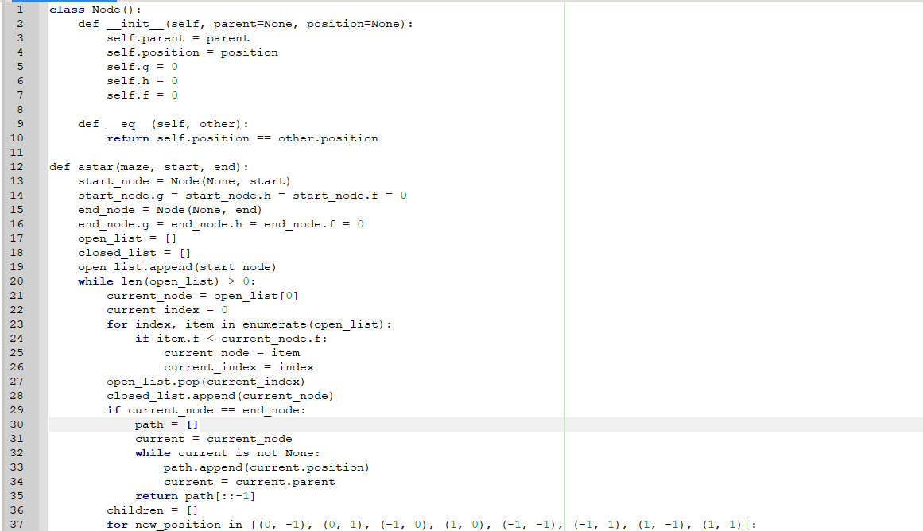

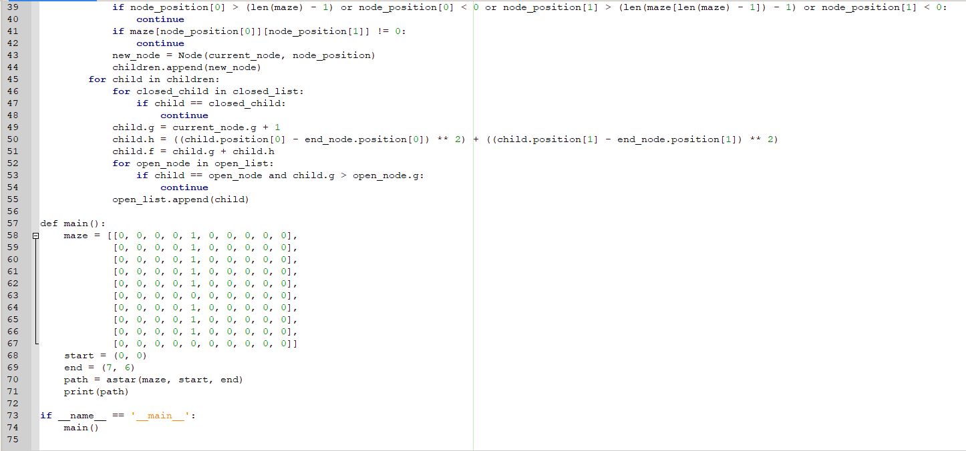

**OUTPUT-**

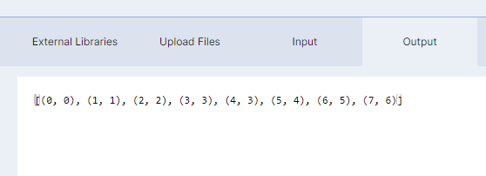

1. **DFS ALGORTIHM**

**CODE:**

from __future__ import print_function

def dfs(graph, start, visited=None):

if visited is None:

visited = set()

visited.add(start)

print(start),

for next_node in graph[start] - visited:

dfs(graph, next_node, visited)

return visited

# Example graph represented as an adjacency list

graph = {

'A': {'B', 'C'},

'B': {'A', 'D', 'E'},

'C': {'A', 'F'},

'D': {'B'},

'E': {'B', 'F'},

'F': {'C', 'E'}

}

print("DFS traversal:")

dfs(graph, 'A')

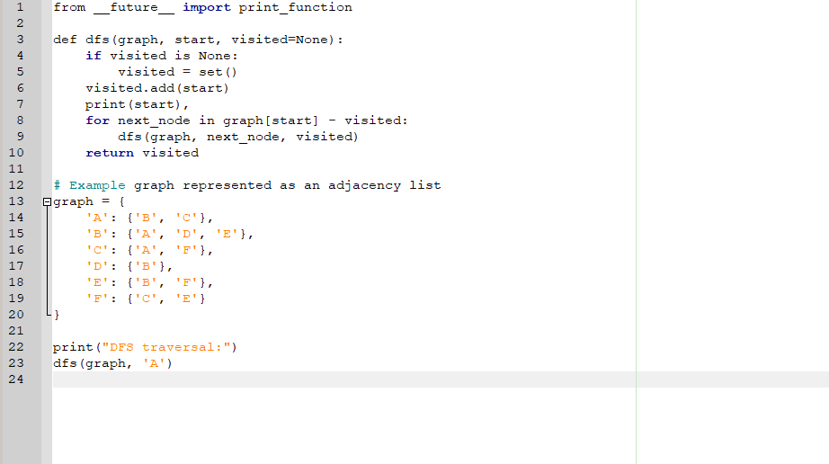

**OUTPUT:**

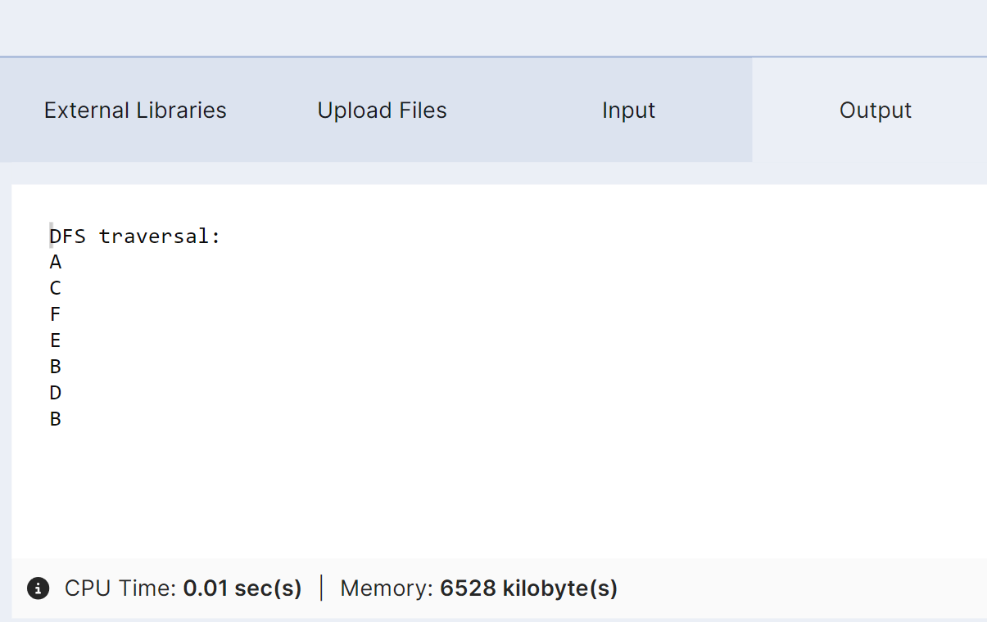

1. **BFS ALGORITHM**

**CODE:**

from collections import deque

def bfs(graph, start):

visited = set()

queue = deque([start])

visited.add(start)

while queue:

vertex = queue.popleft()

print vertex,

for neighbor in graph[vertex]:

if neighbor not in visited:

queue.append(neighbor)

visited.add(neighbor)

# Example graph represented as an adjacency list

graph = {

'A': ['B', 'C'],

'B': ['A', 'D', 'E'],

'C': ['A', 'F'],

'D': ['B'],

'E': ['B', 'F'],

'F': ['C', 'E']

}

print "BFS traversal:"

bfs(graph, 'A')

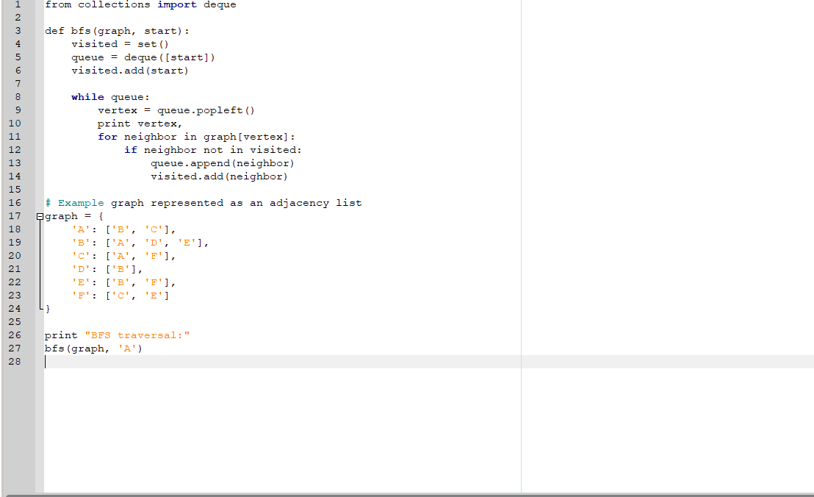

**OUTPUT:**

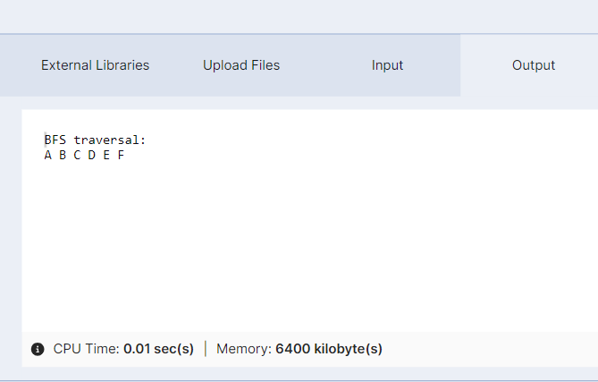

1. **MINIMAX ALGORITHM**

**CODE:**

def minimax(position, depth, maximizing_player):

if depth == 0 or game_over(position):

return evaluate_position(position)

if maximizing_player:

max_eval = float('-inf')

for move in possible_moves(position):

eval = minimax(move, depth - 1, False)

max_eval = max(max_eval, eval)

return max_eval

else:

min_eval = float('inf')

for move in possible_moves(position):

eval = minimax(move, depth - 1, True)

min_eval = min(min_eval, eval)

return min_eval

def game_over(position):

return position == "Terminal"

def evaluate_position(position):

return 1

def possible_moves(position):

return ["Move 1", "Move 2", "Move 3"]

initial_position = "Initial Position"

best_move = None

best_score = float('-inf')

for move in possible_moves(initial_position):

score = minimax(move, depth=3, maximizing_player=False)

if score > best_score:

best_score = score

best_move = move

print("Best move:", best_move)

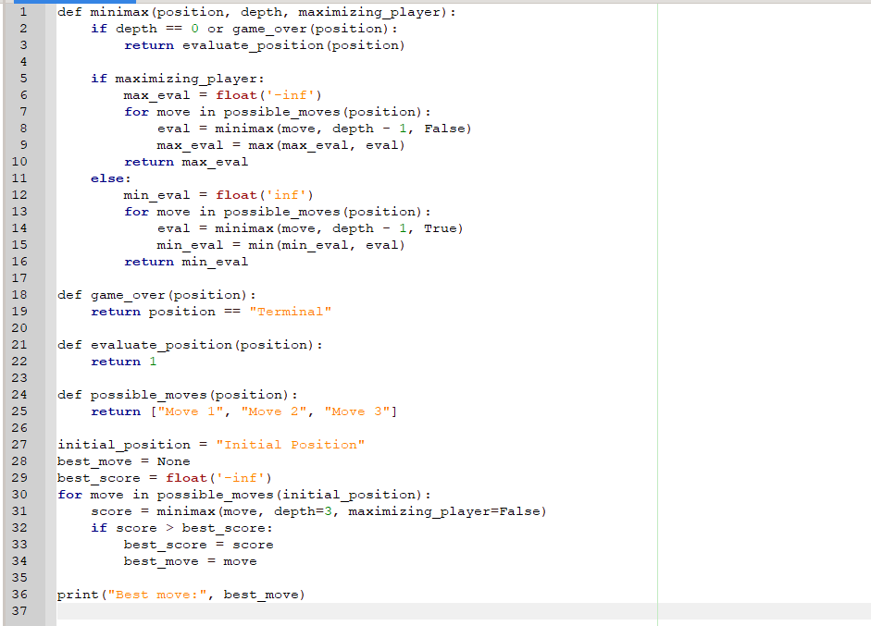

**OUTPUT:**

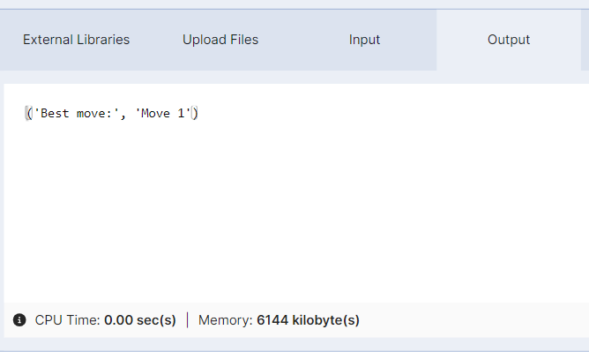

1. **ALPHABETA PRUNING ALGORITHM**

**CODE:**

def alphabeta(position, depth, alpha, beta, maximizing_player):

if depth == 0 or game_over(position):

return evaluate_position(position)

if maximizing_player:

max_eval = float('-inf')

for move in possible_moves(position):

eval = alphabeta(move, depth - 1, alpha, beta, False)

max_eval = max(max_eval, eval)

alpha = max(alpha, eval)

if beta <= alpha:

break

return max_eval

else:

min_eval = float('inf')

for move in possible_moves(position):

eval = alphabeta(move, depth - 1, alpha, beta, True)

min_eval = min(min_eval, eval)

beta = min(beta, eval)

if beta <= alpha:

break

return min_eval

def game_over(position):

return position == "Terminal"

def evaluate_position(position):

if position == "Move 3":

return 100 # Assign a high score to "Move 3"

else:

return 1

def possible_moves(position):

return ["Move 1", "Move 2", "Move 3"] # Ensure "Move 3" is one of the options

initial_position = "Initial Position"

best_move = None

alpha = float('-inf')

beta = float('inf')

for move in possible_moves(initial_position):

score = alphabeta(move, depth=3, alpha=alpha, beta=beta, maximizing_player=False)

if score > alpha:

alpha = score

best_move = move

print("Best move:", best_move)

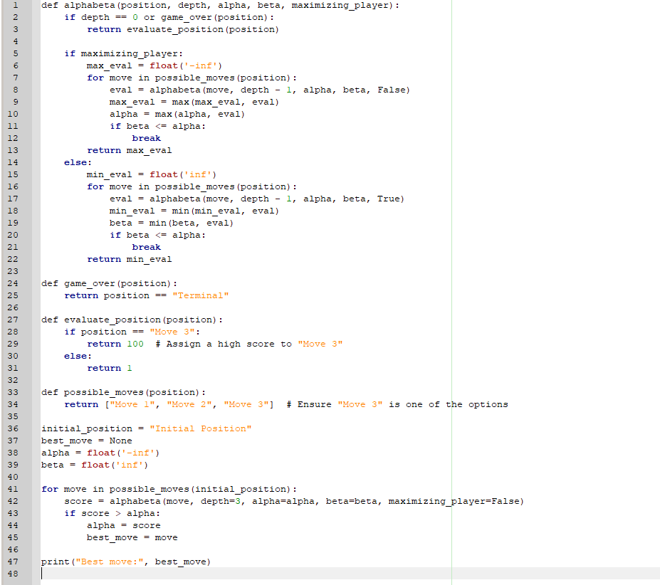

**OUTPUT:**

