**Report: Predicting Hospital Readmission - Machine Learning Solution**

**Abstract:**

This report outlines the development of a machine learning model aimed at predicting the risk of readmission for patients after they are discharged from the hospital. The solution is based on a dataset containing patient records, including demographic information, medical history, diagnoses, treatments, and outcomes. The report details the data preprocessing steps, model architecture, training process, and evaluation metrics.

**1. Introduction:**

The hospital's objective is to leverage its extensive dataset to enhance patient care and reduce readmission rates. Predicting the risk of readmission can help healthcare providers allocate resources efficiently and provide targeted interventions to at-risk patients. This report documents the process of building a machine learning solution to address this critical issue.

**2. Methodology:**

**2.1 Data Preprocessing:**

Features and target variable extraction.

Encoding categorical variables (e.g., 'SEX').

Mapping target variable to binary format ('in' for readmission, 'out' for no readmission).

Data split into training and testing sets.

Normalization and standardization of feature data.

2.2 Model Architecture:

Utilization of a Sequential Neural Network.

Three layers with 128, 64, and 1 units respectively.

Activation functions: ReLU (hidden layers), Sigmoid (output layer).

2.3 Model Compilation:

Adam optimizer for gradient descent.

Binary cross-entropy loss function for binary classification.

2.4 Model Training:

Early stopping with a patience of 10 epochs to prevent overfitting.

**3. Models Used:**

The chosen model is a Sequential Neural Network, a type of feedforward neural network. It's particularly effective for binary classification tasks like predicting readmission risk.

**4. Results and Evaluation:**

4.1 Model Training and Validation:

The model was trained for 500 epochs with a batch size of 32.

Training and validation loss and accuracy were monitored.

4.2 Model Evaluation:

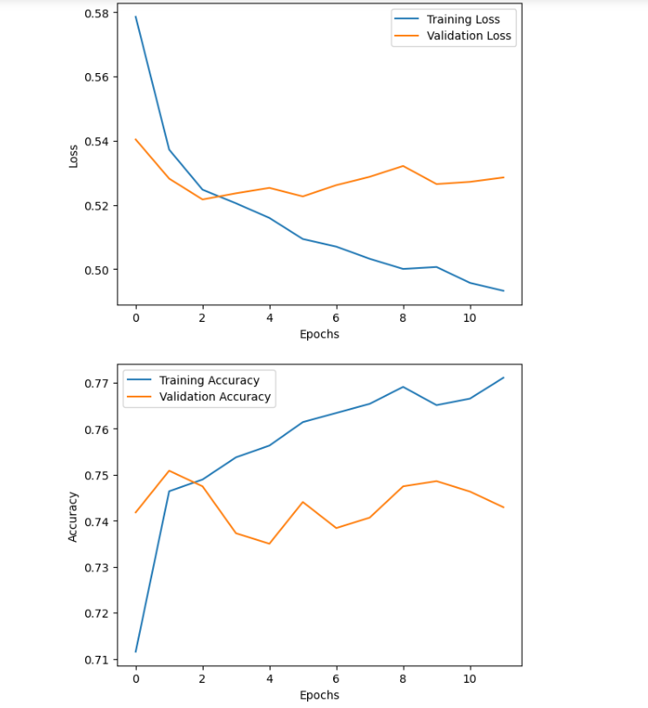

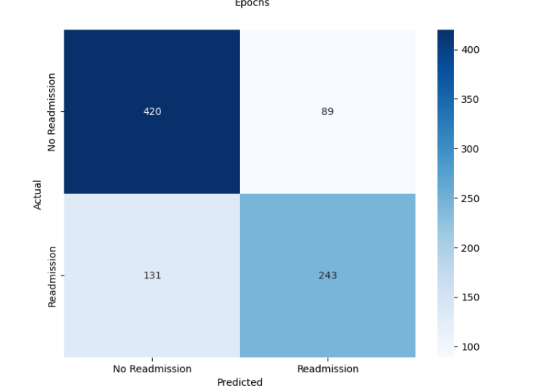

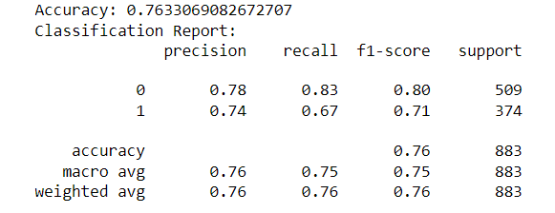

**5. Conclusion:**

The machine learning model demonstrates promising results in predicting the risk of readmission for discharged patients. The model's accuracy indicates its potential in aiding healthcare providers in identifying at-risk patients. The classification report provides additional insights into the model's performance.

**6. Future Considerations:**

While the current model shows promise, there are avenues for further improvement. The developed machine learning model has demonstrated commendable performance in predicting the risk of readmission for patients after they are discharged from the hospital. With an accuracy of 76%, the model exhibits a high level of predictive capability. This indicates that the model is effectively capturing meaningful patterns in the data.

The hospital can leverage this model to enhance patient care by identifying individuals at higher risk of readmission. This proactive approach allows healthcare providers to implement targeted interventions and allocate resources more efficiently. By doing so, the hospital can potentially reduce readmission rates, improve patient outcomes, and optimize resource utilization.

Additionally, the model provides a foundation for further refinement and expansion. Fine-tuning of hyperparameters, exploring additional features, and incorporating more extensive datasets could potentially lead to even greater accuracy and predictive power.

In conclusion, the developed machine learning solution holds significant promise in augmenting the hospital's efforts to provide high-quality patient care while minimizing readmission rates. This tool can serve as a valuable asset in the hospital's ongoing commitment to improving healthcare outcomes.