Offer Brief Template
File > make a copy

Potential Product Name Ideas:

Level of consciousness: Low/High

Level of Awareness:

Stage of Sophistication:

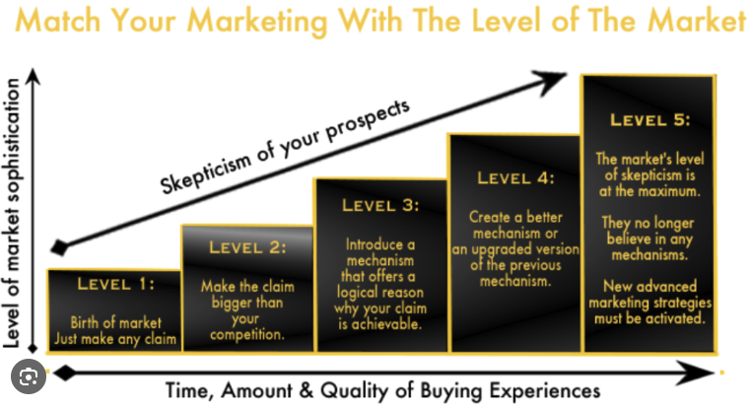

Big Idea

Metaphor

Potential UMP (unique mechanism of the problem)

Potential UMS (unique mechanism of the solution)

Guru:

Discovery Story

Product:

Potential Headline/Subheadline Ideas

List all objections you can think of

Belief Chains (what does the prospect have to believe in order to buy)

Funnel Architecture

Potential domains

Examples/Swipes

Other notes

