LapsoCarte

A web platform to visualize and interact with temporal and spatial referenced data

Camilo Vargas Cabrera

c.vargas124@uniandes.edu.co

Bachelors Degree's Project

Systems and Computer Engineering

Los Andes University

2015

Introduction
A common characteristic in urban planning and modeling is the temporal-spatial nature of information. Researchers of multiple disciplines use different tools and approaches to explore historical data or build and run simulation models.
Systems dynamics, cellular automata and agent based models are implemented in plain programming languages and domain specific tools. Temporal-spatial information visualization often requires to manually export and transform data. Otherwise the visualization is limited by the ones available in the used tool.
It is common to find a grow number of data specific visualizations that use what Bach et al. (2014) define as time juxtaposing representation for temporal-spatial information. Most visualizations rely on the target data schema, which makes them not reusable in other contexts.
Since the nature of the results and its expected representation is essentially the same, LapsoCarte proposes a generic data representation coupled with a case-specific data-level integration strategy. This approach provides a reusable codebase for basic temporal-spatial data analysis and exploration. In addition, the web-based nature of LapsoCarte provides a platform-independent access to the visualization, which allows the analyst to use the tool from any web browser.

Background
The following are some examples of time juxtaposing visualizations for temporal spatial data sets:
Emberger, Pfaffenbichler y Riedl (2010) developed a web representation for the results of the Metropolitan Activity Relocation Simulator. ANIMAP provides a set of maps to explore the spatial dimension and a slider to navigate in the temporal dimension. It uses a choropleth function to represent data magnitudes in the maps' polygons and graphs on bottom to support data analysis. There is a data table with a filter to inspect granular data:
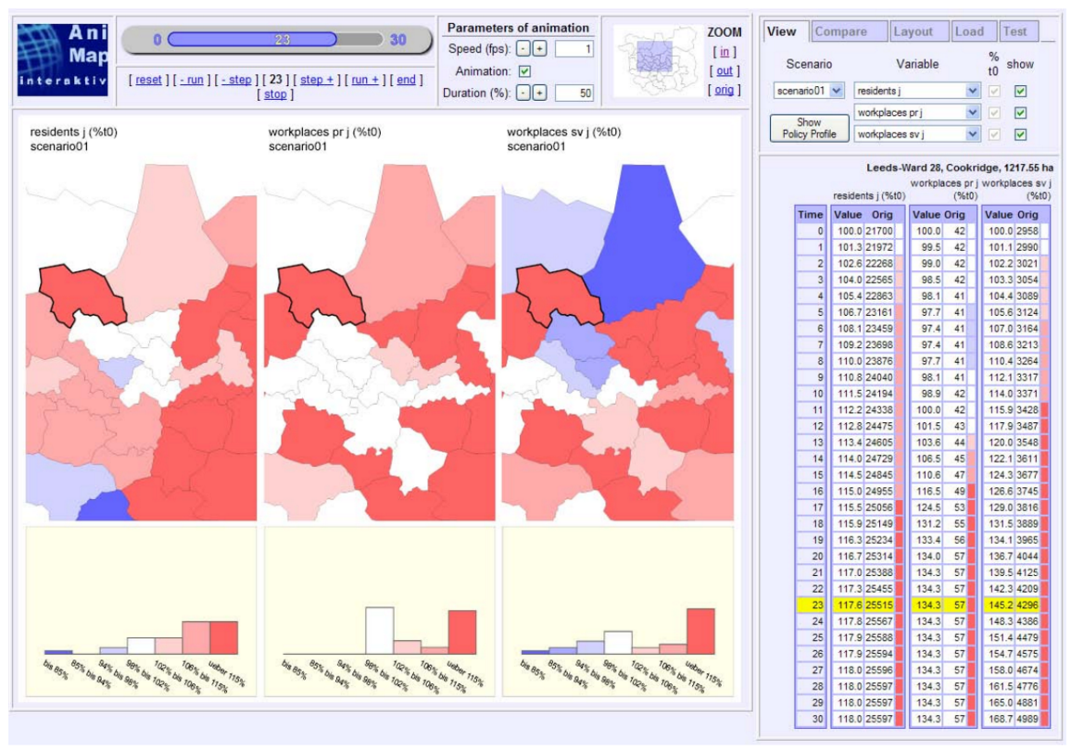
ANIMAP Interface (Emberger, Pfaffenbichler y Riedl 2010)

Berenjkoub et al. (2015) proposed a web-based tool to analyze the longitudinal transportation data of Great Britain. The application processes the data of routes and frequencies published by the Great Britain Transport Authority and depicts it in an interactive web application. A map in the center represents the spatial dimension and two sliders on top allows to navigate in the temporal dimension. The application provides filters for the represented data and a plot view in the bottom:
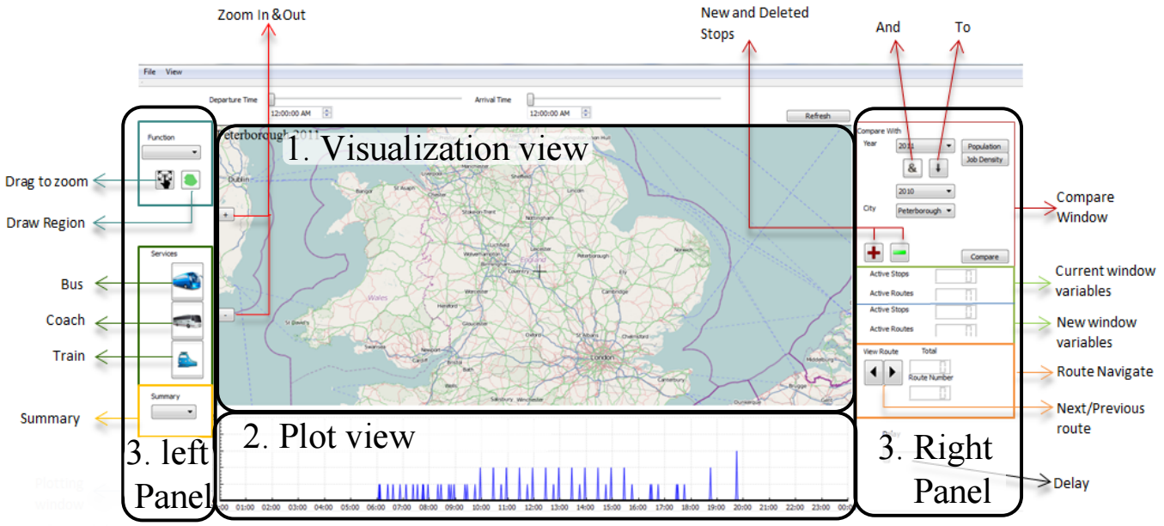
Graphical User Interface (Berenjkoub et al. 2015)

Tableau is a commercial data visualization tool for business intelligence. Bracco presents a Tableau based data exploration tool in his 2014 blog post Mapping the City of Houston's Electricity Usage Over Time. The visualization has a slider on top to navigate in the temporal dimension and a map in the center to explore the spatial dimension. Data magnitudes are represented by the circles' radius and colors:
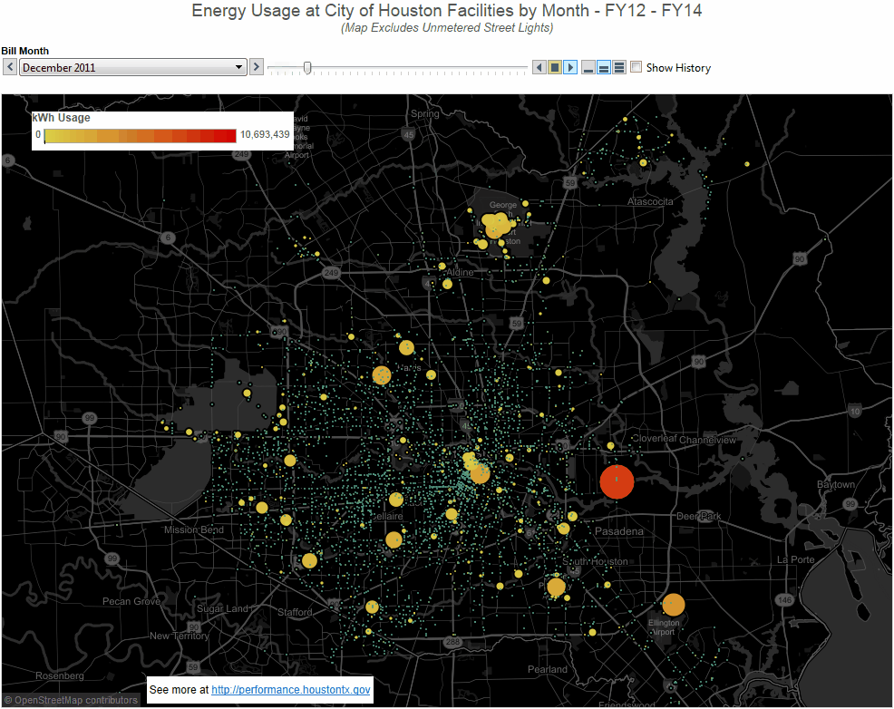
Tableau based visualization (Bracco 2014)

The World Bank's Data Visualizer tool features a choropleth map to explore the spatial dimension and an animated slider on bottom to navigate in the temporal dimension:
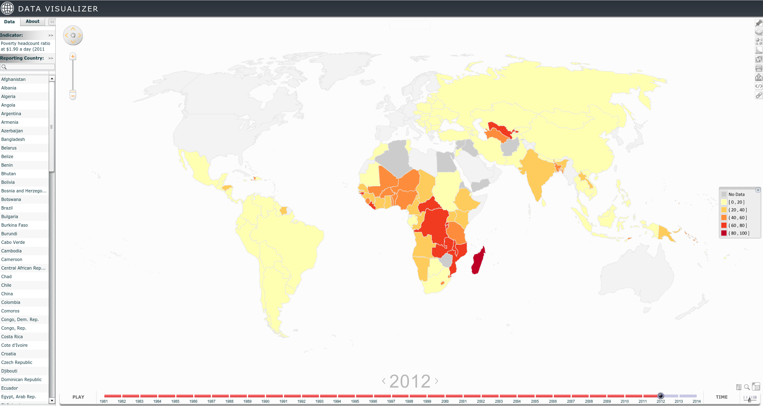
World Bank data visualizer

Dimensions
In LapsoCarte data is stored, indexed, retrieved and explored in a generic four dimensional schema:
- How: Main grouping level to differentiate between data types or alternatives. Hows are represented as strings.
- What: Secondary grouping level to differentiate between data sets. Whats are represented as strings.
- When: Temporal dimension. Whens are enumerable and sortable elements, represented as integers.
- Where: Spatial dimension. Wheres are geometries represented as points, lines, polylines or polygons.
This data structure is influenced by the Spatial-temporal Data Exploration Model (MEDET) proposed by Nemocon (2015) to explore temporal-spatial referenced information.

Server side data model
The back-end relies on a given database structure of two tables:
- Main data table: This table has five columns, one for each dimension plus the data itself. The primary key is a compound key of the four dimensions.
- Geometries table: This table is used to normalize the geometries information. It has a primary key, a geometry and an arbitrary number of additional columns for geometry's properties.
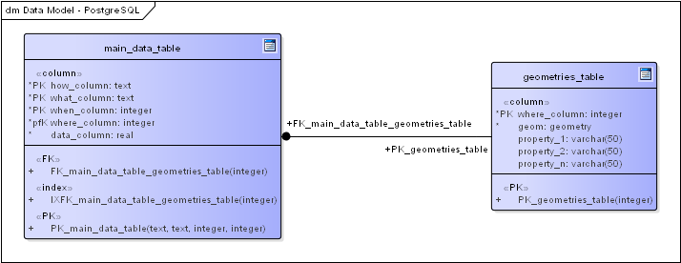
Server-side data model

By design, the database is in third normal form for dimensions, data and geometries. Normalization is enforced on geometries' features but not on geometries' properties.
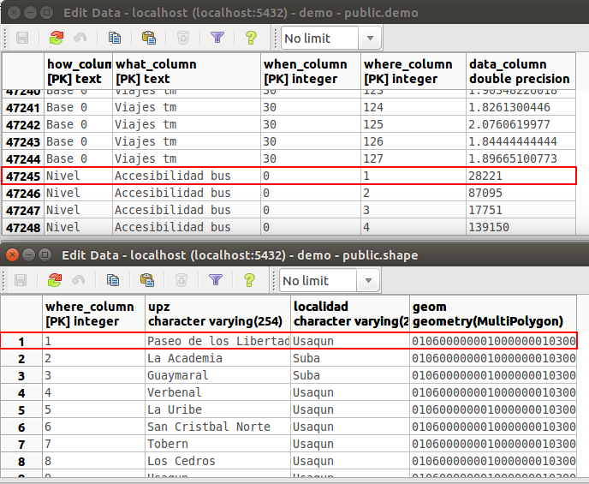
Server-side sample data

Client side data model
In the front-end data, exploration follows a hierarchical structure: How, What, When, Where. When the user loads LapsoCarte for the first time, the browser downloads all data and geometries in JSON format.
Data is sent by the server in the aforementioned hierarchical structure. Once it is received, the client builds a JavaScript map to efficiently browse data. For example, the code to access the element in row 47245 of the server-side sample data is:
let data = dataMap.get('Nivel')
.get('Accesibilidad bus')
.get(0)
.get(1); // data = 28221

Geometries are sent in an indexed JSON object. The index is the geometries' table primary key and the element is the geoJSON representation of the geometry. The client builds a JavaScript map for geometries' features and properties:
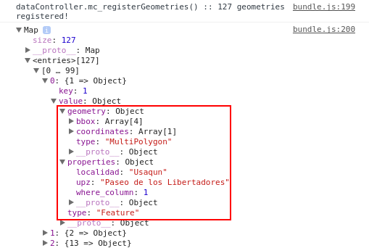
Client-side geometries map
Each geometry exists only once on the client's *Leaflet Controller* and its style is updated on each dimension change.

Drivers
A driver is a bridge between data producers and LapsoCarte’s data schema. Drivers are essentially small applications who systematically take a given data input and populate the dimensions based data structure.
In a simple implementation, a driver is a parser coupled with a bash script which processes a text file with a given structure. The parser reads the file and produces a SQL script which creates the dimensions based structure in a database. The bash script automates the process of retrieving the information, running the parser and populating the database.
Most drivers are a one-time problem-specific implementation because they are strongly linked with the source system output.

Architecture
LapsoCarte architecture is based on a variation of the Mediator Pattern:
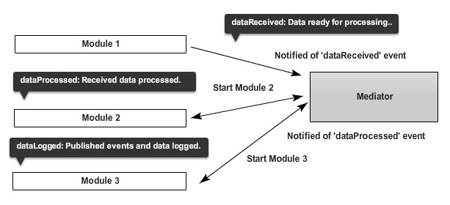
Mediator Pattern example (Osmani 2011)
Osmani in its Patterns For Large-Scale JavaScript Application Architecture blog post explains: Notice how at no point do any of the modules directly communicate with one another. It (the mediator) decouples modules by introducing an intermediary as a central point of control (...) It is typically easier to add or remove features to systems which are loosely coupled like this.
The mediator approach works well to synchronise events between modules. However, this could be needlessly complex to handle shared objects like the GUI current state, the dimensions-indexed JavaScript's map or some library specific objects. To overcome this, LapsoCarte implements a global accessible PROJECT and INSTANCE objects.

Controllers and Events
In LapsoCarte a controller is a piece of code responsible of handle a specific task. MainControllers are mediators while SubControllers are modules. Most SubControllers encapsulate the logic to drive a specific JavaScript library. However, when the task is too complex, a SubController could act as a mediator between a group of child controllers. This structure generates a hierarchical MainController - SubControllers tree.
Events trigger a call to controllers' methods. Each controller have mc_ and sc_ methods. mc_ methods are called by MainControllers while sc_ methods are called by SubControllers. Mediators sync actions between its SubControllers on each mc_ or sc_ method call.

Shared Global Objects
There are some objects, such as the current when, where and data set, that are constantly changing by user interaction and are required for multiple controllers. Passing these objects back and forth between controllers could produce synchronization problems and memory leaks, besides an unnecessary overhead.
Issues arise when one controller stores a reference to an object that could be changed for another controller. The controller with the wrong reference not only misbehaves but also the old object can not be destroyed by the garbage collector.
To overcome this, LapsoCarte uses a simplified blackboard pattern for compile-time constants and run-time objects. The objects are indexed using global constants, which allows them to be reached from any controller and eases code refactoring. Unlike standard blackboard pattern implementations, all the controllers accessing the global objects run in the same thread, so concurrency is not a problem.
All the global constants and shared objects reside in the Globals.js file in the project root. This file exports three objects used in both server and client code:
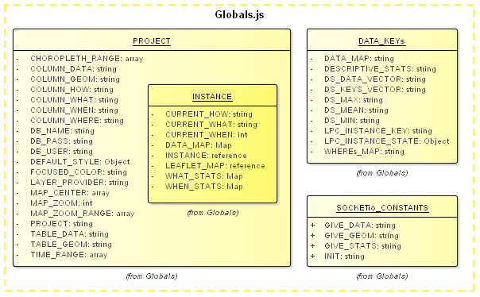
Global objects
- The PROJECT object: This object defines all the project-specific variables used across all controllers. The PROJECT object acts as a single point of intervention to easily adjust LapsoCarte to different data sets. It is a compile-time object in the sense that it is defined before the application execution.
- The INSTANCE object: This is a run-time object stored inside the PROJECT object. The INSTANCE object is the blackboard that contains the references to the objects used by multiple controllers.
- Data keys object: This object defines the keys used to save and retrieve the elements in the INSTANCE object.
- Socketio constants: This object contains the strings used by server and client SocketioControllers to identify the messages sent through the socket.

Putting it all together
The color convention for the next graphs is:
- Controllers:
  - Red controllers are mediators.
  - Blue controllers are modules.
  - Green controllers provide support code used by multiples controllers.
  - Aqua controllers are embedded modules whose code resides in its parent controller.
- Globals:
  - Yellow-border controllers access or update elements in the _PROJECT_ or _INSTANCE_ objects.

Server side architecture
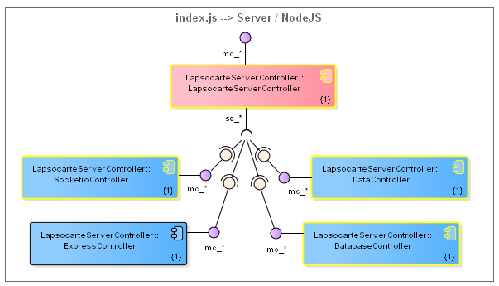
Server side prototype's architecture
The server side has five controllers: four modules and one mediator. The ExpressController handles the Express Framework which acts as HTTP server. The SocketioController drives the Socket IO library for socket communication between server and client. The DatabaseController connects and makes the queries to the PostgreSQL database. The DataController builds the hierarchical data structure and calculates descriptive statistics for each level.
The LapsoCarteServerController acts as mediator between the four modules. In particular, the server controller initializes the modules in order so the web server only accepts connections when all modules are ready.

Client side architecture
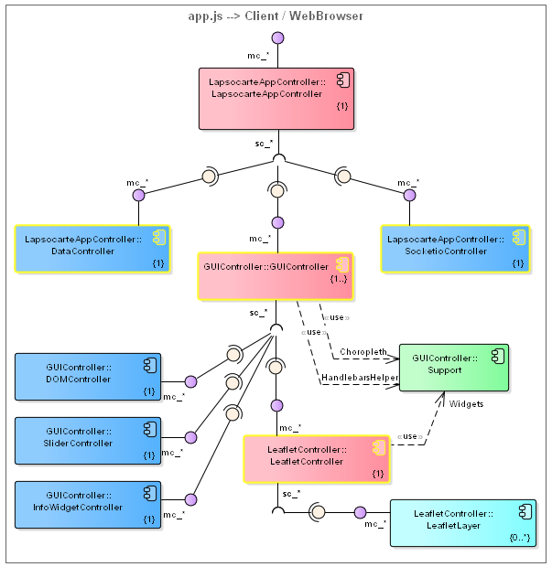
Client side prototype's architecture
The client side has ten controllers: six modules, three mediators and one support controller. LapsoCarteAppController is the mediator for the client's backend. It syncs the client-side communication and data modules with the user interface.
The GUIController handles the client frontend, synchronizing the visual elements on user interaction. The next code segment shows the GUIController actions when the user fires a mouse over event on an element in the Where dimension:
/*
The LeafletController calls this GUIController's method when
an instance of its child LeafletLayerController recive a mouse over
event. The gid parameter is the LeafletLayerController WHERE dimension id.
*/
sc_spatialObjectOver(gid) {
// Get color for focused elements from the global PROJECT object:
let color = glbs.PROJECT.FOCUSED_COLOR;

// Tell LeafletController to change the color of the object:
_leafletController.mc_colorGeometry(gid, color);

// Get the properties for the given WHERE:
let info = Object.assign({}, geometriesMap.get(gid)['properties']);

// If there is data for the current state:
if(instance[DATA_MAP]) {
// Retrieve the current WHEN from the global INSTANCE
// and add it to the object
info[glbs.PROJECT.COLUMN_WHEN] = instance[CURRENT_WHEN];
// Retrieve the data for the current WHAT in the current WHEN
// for the selected WHERE
info[instance[CURRENT_WHAT]] = instance[DATA_MAP].get(gid);
}
// Display the information in the InfoWidgetController
_infoWidgetController.mc_updateInfo(info);
}
The last code segment shows the key elements of the prototype's architecture:
- A controller captures an event and notifies its mediator.
- The mediator handles the event logic:
  - Retrieves configuration parameters from the global PROJECT object.
  - Retrieves current state variables from the global INSTANCE object.
  - Calls the required methods on its SubControllers.

Graphical Interface
LapsoCarte features a simple and intuitive user interface:
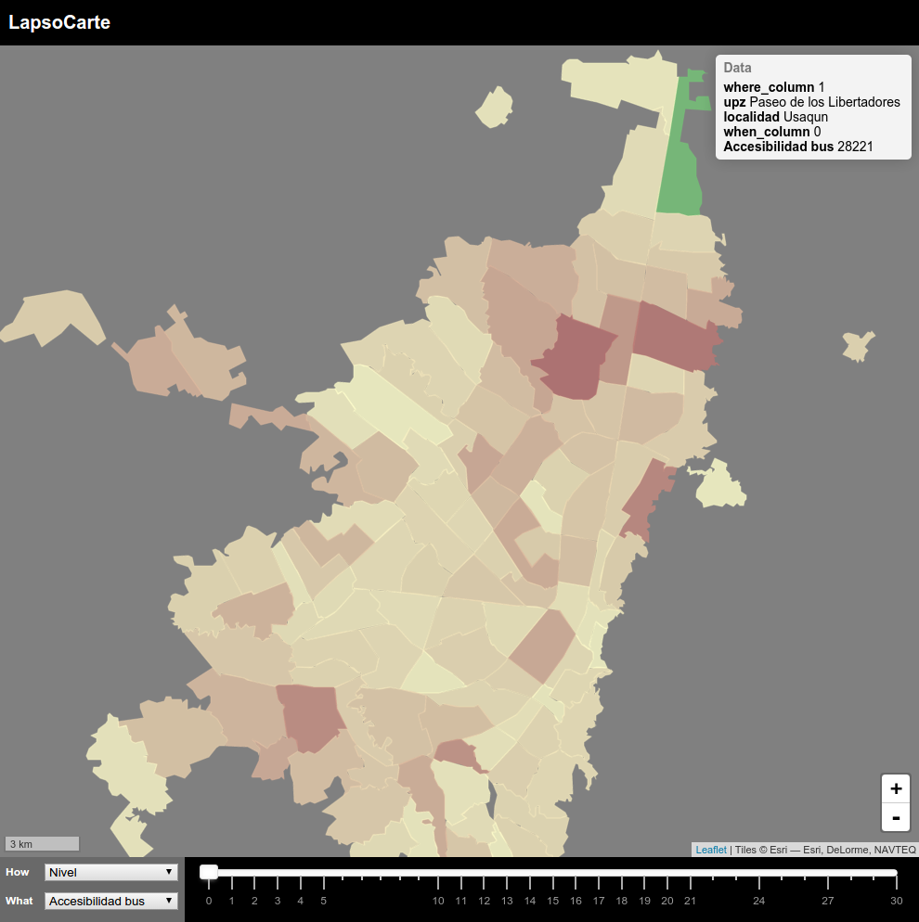
LapsoCarte Graphical User Interface
The How and What dimensions selectors are located on the bottom left corner. Once the user selects a How and What, the application loads the When and Where dimensions.
The When dimension is represented as a slider on the bottom right of the window. The slider adjusts its scale to graphically show the available Whens for the selected How and What dimensions. The user can interact with the slider using the keyboard's right and left keys, the mouse or by touch if using a touch-screen.
The Where dimension is represented as a map in the center of the window. Each Where is drawn as its corresponding geometry. The color of the geometry is calculated from the spatial-temporal data using a linear choropleth function. The function minimum and maximum are the absolute min and max values for the whole How-What data set. The user can navigate the Where dimension using the standard pan and zoom actions through the keyboard, mouse or touch gestures.

Implementation
LapsoCarte code is written in ECMAScript 6 and uses Babel for backward compatibility. LapsoCarte implementation is based on a set of popular open source libraries and tools. The backend relies on PostGIS as a database engine. NodeJS, Express and Socket.io are used as a server-side platform. jStat is used by the DataController to calculate descriptive statistics.
The frontend uses LeafletJS to represent the Where or spatial dimension. noUiSlider handles the When or temporal dimension. jQuery is used to manage web browser events, Less to compile the CSS stylesheets and Handlebars to manage HTML templates.

Use Cases
LapsoCarte usage cycle has been tested with two different data sets:

Generic Schelling Model
The Schelling's Segregation Model was proposes by Thomas Schelling in 1971. In the model there are dwellings, individuals and populations. Each individual belongs to a population. On each iteration every individual decides if stay on his current dwelling or move to another one. The decision depends on the number of neighbors of his same population, respect to a given tolerance factor.
A basic Schelling Model was implemented using JavaScript. Dwellings were the 43225 blocks of the city of Bogotá. Each dwelling was randomly assigned to a given population. A fixed tolerance level was set for all populations. A neighbor was any individual in radius of 1 kilometer of the current dwelling. If the individual moves, he randomly selects a new dwelling from the empty ones.
Tests made with the model's results dataset revealed two performance issues. The first one was related to an early proposed single-table database structure for the server side data model. The duplicate geometries's data consumed a significant amount of storage, RAM and bandwidth. Next prototypes solved this by normalizing the geometries information on the database.
The second identified limitation is related to the number of polygons that Leaflet can handle simultaneously. Tests show a significant performance drop when working over 3000 polygons. There is a series of proposed alternatives to deal with this:
- Migrate to the next Leaflet version once available for production. Leaflet version 1 is a major library update, which significantly improves performance, specially when working with polygons.
- Reduce geometries complexity on the server-side using the PostGIS's simplify function. This function reduces geometries's complexity using the Douglas-Peucker algorithm.
- Implement a semantic zoom to reduce the number of simultaneously-displayed polygons.

VENSIM MARS Simulation
This dataset is the result of a Metropolitan Activity Relocation Simulator (MARS) model for the city of Bogotá. The model is implemented in VENSIM, a general purpose systems dynamics simulator. The output is a comma-separated file with the data series for ten different variables across 30 time periods. The spatial dimension is a shape of 127 districts of Bogotá.
The driver was implemented in Python and Bash. The Python parser takes the VENSIM's csv output file and generates a SQL script which recreates the main_data_table. The SQL script for the gometries_table is generated using the PostGIS's shp2pgsql tool. The bash-script automates the parser and shp2pgsql execution and populates the PostgreSQL database.
The application was deployed in a local server at Los Andes University. Researches of the Urban and Regional Sustainability group used LapsoCarte to visualize the MARS model's results.
Users valued the tool but evidence the need of:
- Add a legend to know data ranges of the choropleth function.
- Add descriptive statistics for the displayed data.
- Add contextual graphics to support data analysis.
- Implement a sync side by side view to compare two data-sets.

Future Work
The user tests presented above, Generic Schelling Model and VENSIM MARS Simulation, give valuable insights on the future development of LapsoCarte. From the user experience perspective, a descriptive statistics table and support graphics are needed in order to analyze and contextualize data. A synchronized side-by-side visualization would help experts to observe correlations evolution on multiple-variable data sets. Performance issues must be solved in order to visualize data sets involving over a thousand polygons.
It would be interesting to implement a logger module to save the analysis session, so it could be recreated. Another useful feature to add would be a MEDET query builder. Finally, the application should have an authentication layer to access the visualization.

References
- Benjamin Bach, Pierre Dragicevic, Daniel Archambault, Christophe Hurter, Sheelagh Carpendale. *A Review of Temporal Data Visualizations Based on Space-Time Cube Operations*. Eurographics Conference on Visualization, Jun 2014, Swansea, Wales, United Kingdom. 2014. [https://hal.inria.fr/hal-01006140]
- Günter Emberger, Paul Pfaffenbichler & Leopold Riedl. *MARS meets ANIMAP: Interlinking the Model MARS with dynamic Internet Cartography*, Journal of Maps, 6:1, 240-249, DOI: 10.4113/jom.2010.1079. 2010. [http://dx.doi.org/10.4113/jom.2010.1079]
- Marzieh Berenjkoub, Harsha Nyshadham, Zhigang Deng, Guoning Chen. *A Visual Analytic System for Longitudinal Transportation Data of Great Britain*. Department of Computer Science, University of Houston, Houston, Texas, United States of America. 2015. [http://www.cs.uh.edu/docs/cosc/technical-reports/2015/15_01.pdf]
- Frank Bracco. *Mapping the City of Houston's Electricity Usage Over Time* (blog). The City of Houston Official Site. 2014. [http://performance.houstontx.gov/content/mapping-city-houstons-electricity-usage-over-time].
- Camilo Nemocon. *MEDET - Modelo para la exploración de datos espacio-temporales*. Master Thesis, Systems and Computing Engineering Department, Los Andes University, Bogotá, Colombia. 2015.
- Addy Osmani. *Learning JavaScript design patterns*. Sebastopol, CA: O'Reilly Media. 2012.
- Addy Osmani. *Patterns For Large-Scale JavaScript Application Architecture* (blog). Addy Osmani Blog. 2011. [http://addyosmani.com/largescalejavascript/]
- Schelling, Thomas C. 1971. "Dynamic Models of Segregation." Journal of Mathematical Sociology 1:143-186.

