FIG. 1: ECOSHARE AI — UNIFIED CYBER-PHYSICAL MASTER ARCHITECTURE FLOWCHART
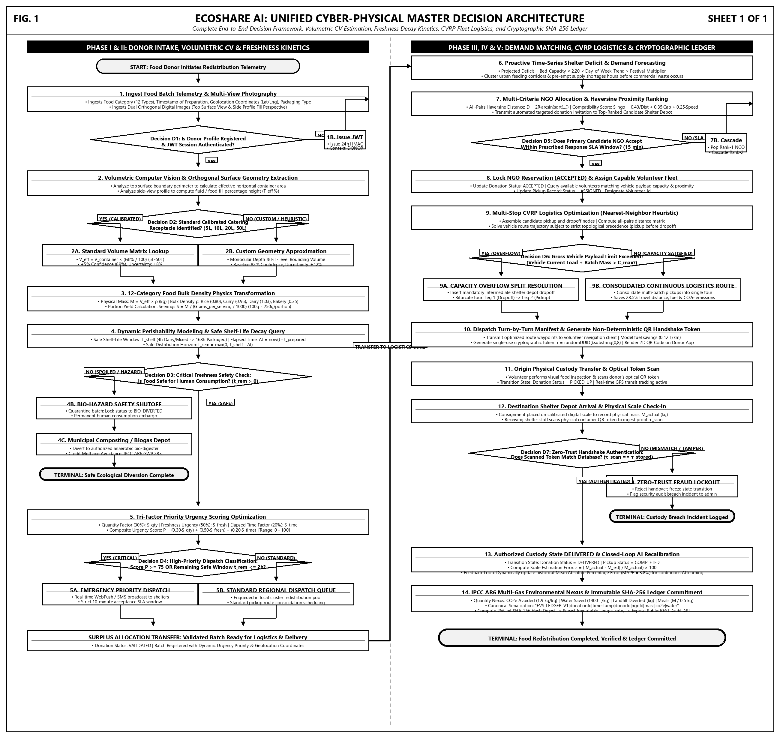
SHEET 1 OF 1 | PATENT DRAWING SPECIFICATION | ECOSHARE AI AUTONOMOUS REDISTRIBUTION PLATFORM

