Setting up of an Ad account:

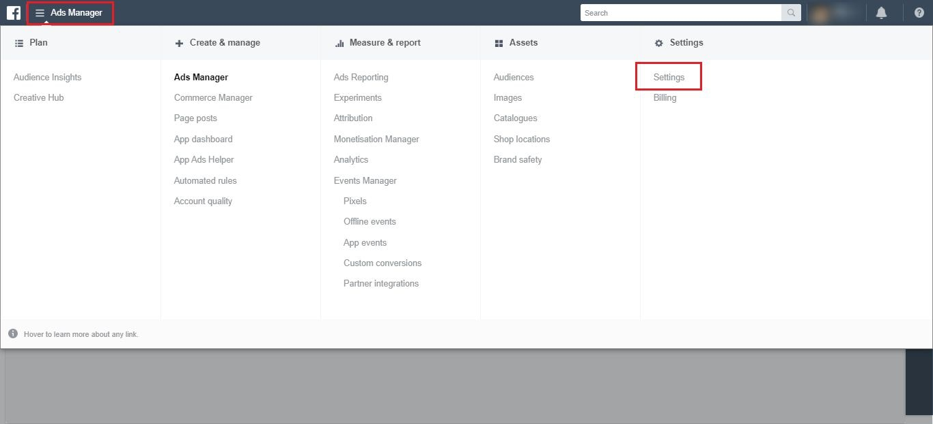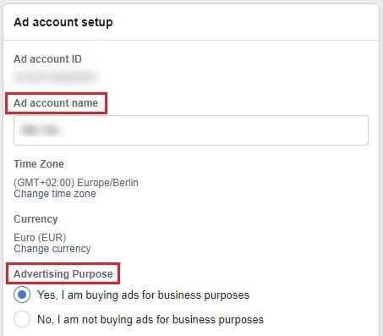

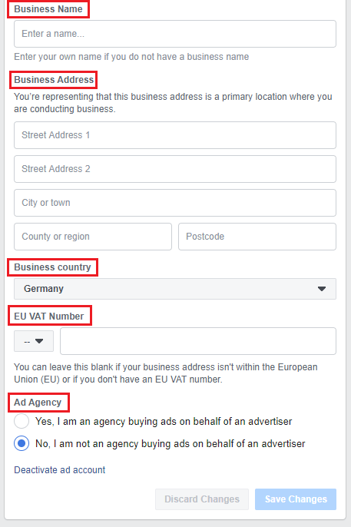

Billing:

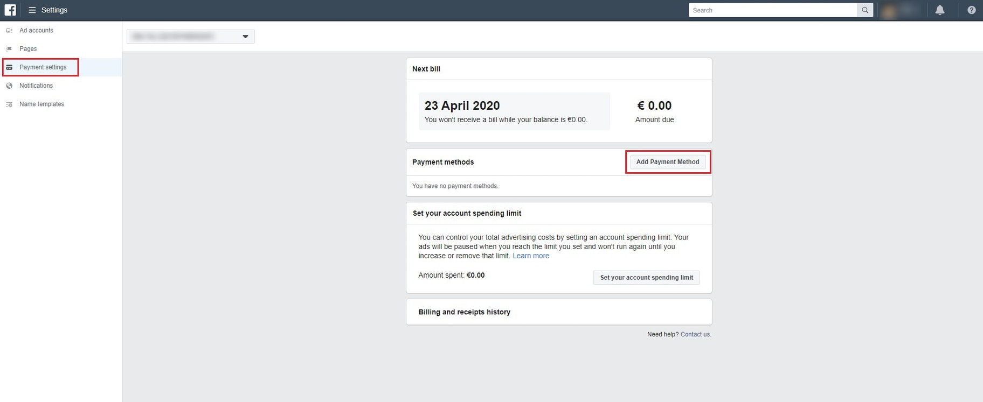

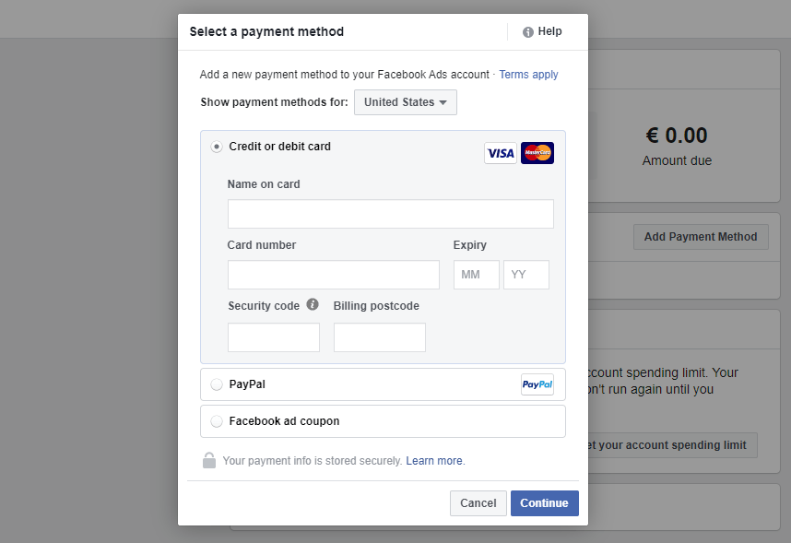

Facebook Ads Guide: Audience Research

This helps you find the right audience for your ads. The research guides takes key questions before you begin with Facebook advertising strategy.

1. Who are the authority figures, thought leaders, or big brands in your niche?

* Name the key players in the industry.

1. What books/magazines/newspapers does your ideal customer read?

* Try targeting either the popular books or authors in that field.

1. What events do they attend?

* Name the events your target group is interested in or is attending.

1. What websites do they frequent?

* To understand what sort of websites your audience is interested in.

1. Where do they live?

* To zero the target audience for your ads

1. What tools do they use?

* List down software services/ subscriptions/ tools that your audience use

1. What’s completely unique about this group?

* Be specific to narrow down the group.

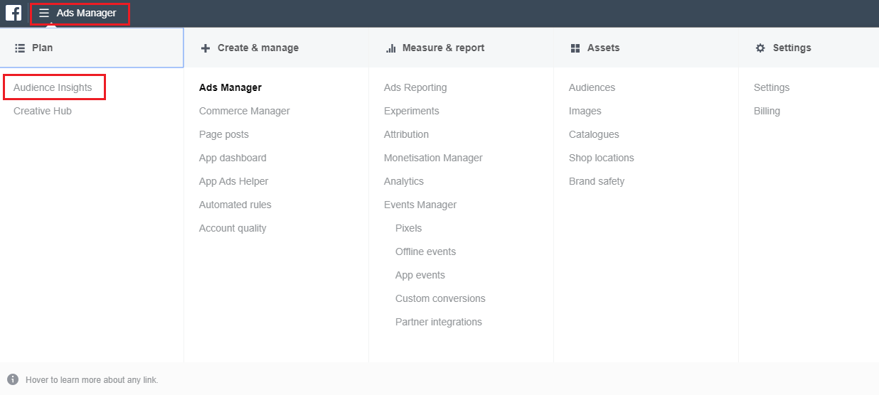

Seed Audience:

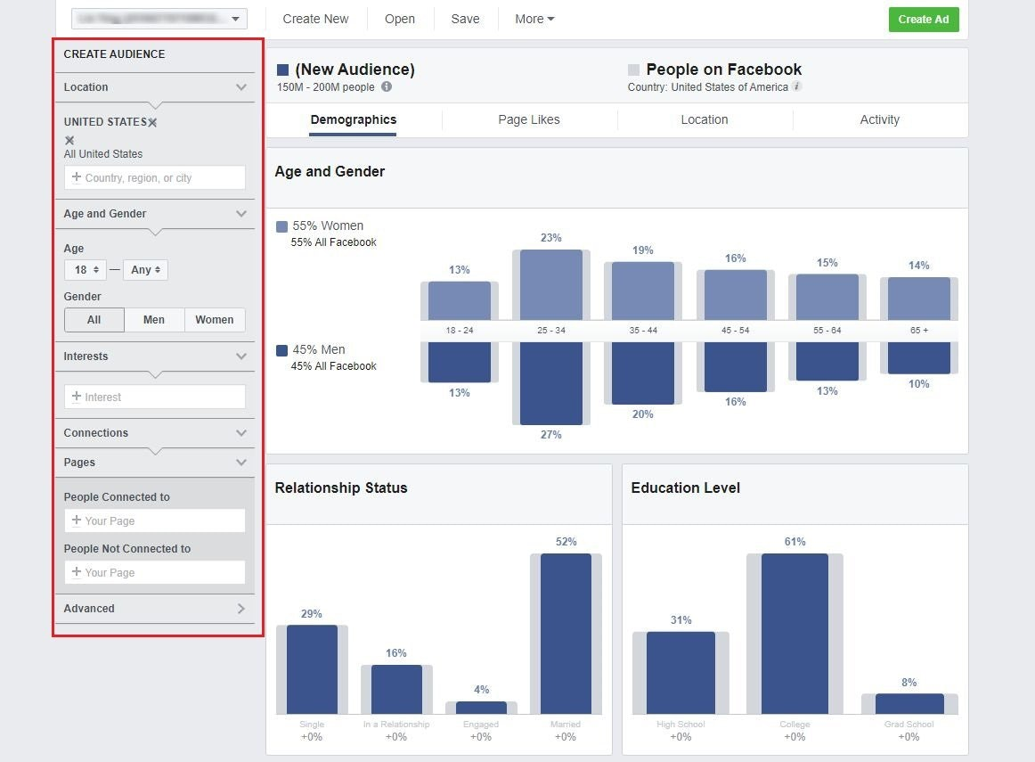

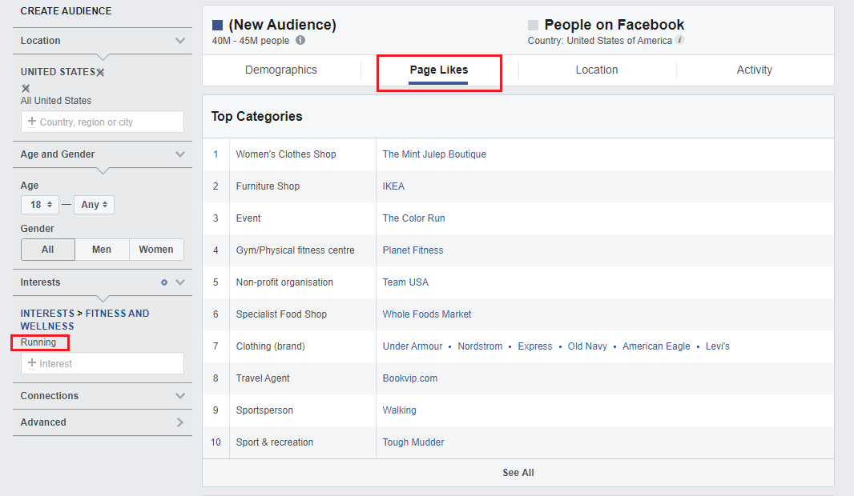

Creating Advertising Campaign: These are the main ways to launch a Facebook Ad campaign.

1. Boost post on Facebook pages
2. Self-serve ads Create tool
3. Power Editor tool

Go to ‘Ads Manager – Creation’ page under Ads Manger tab or ‘Create Ad’ on the main page.

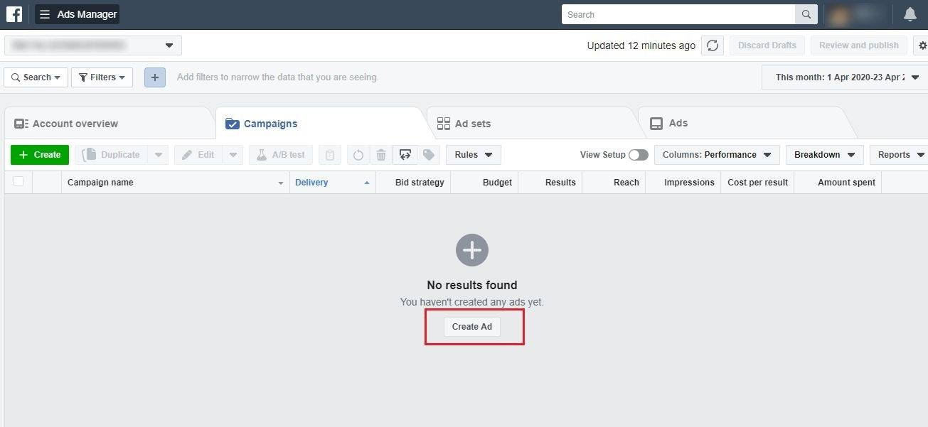

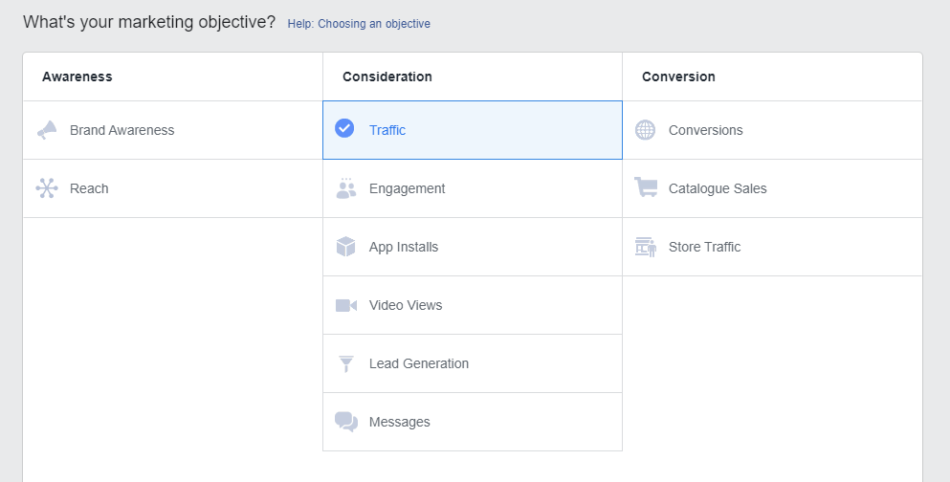

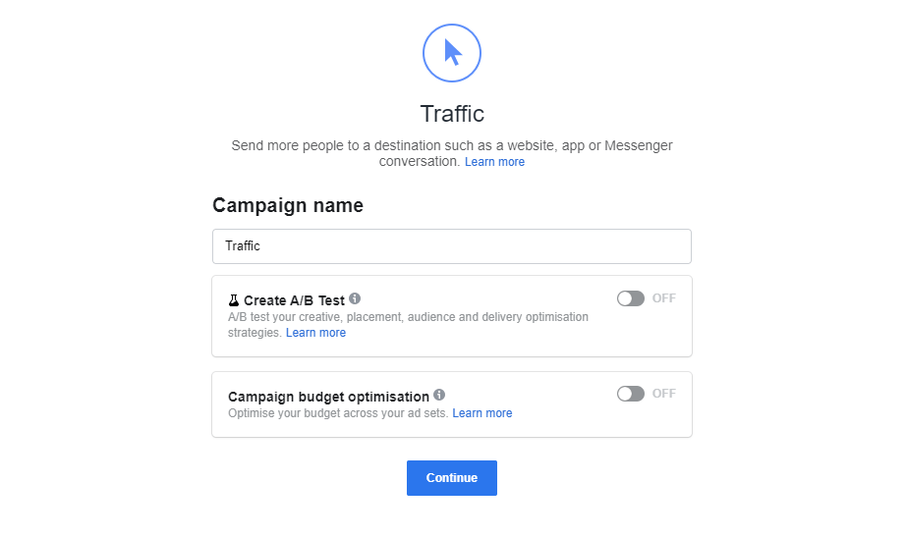

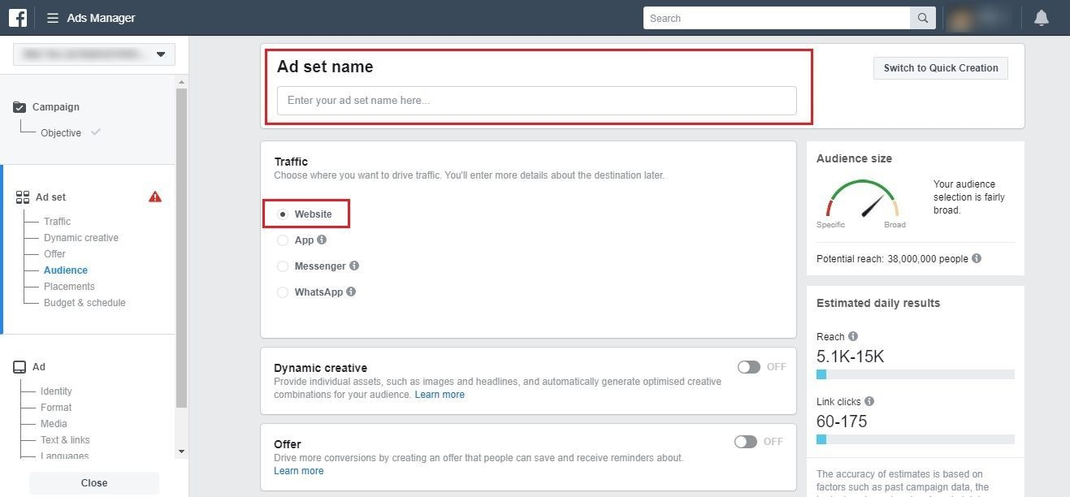

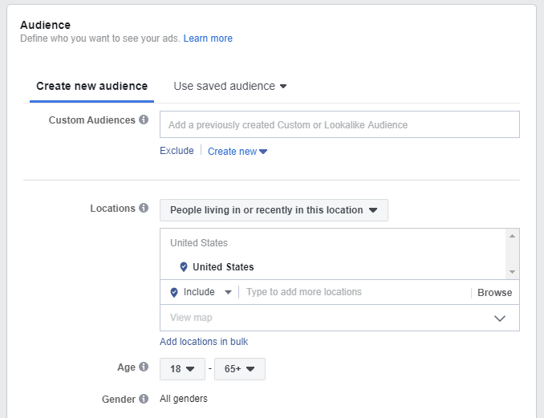

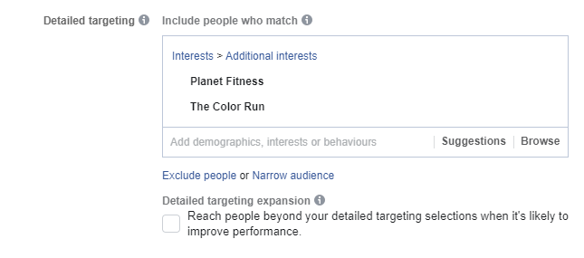

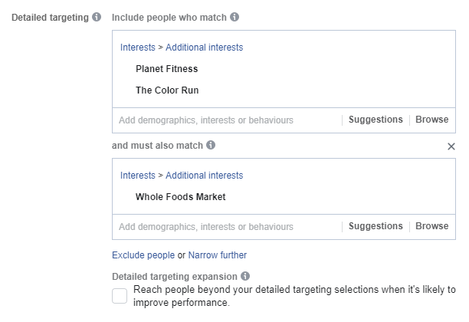

Decide on the placements

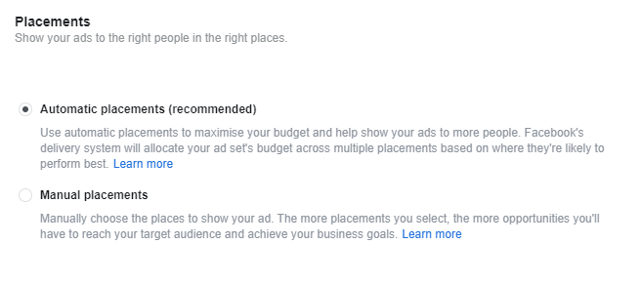

Budgeting and Schedule

