Setting up of an Ad account:

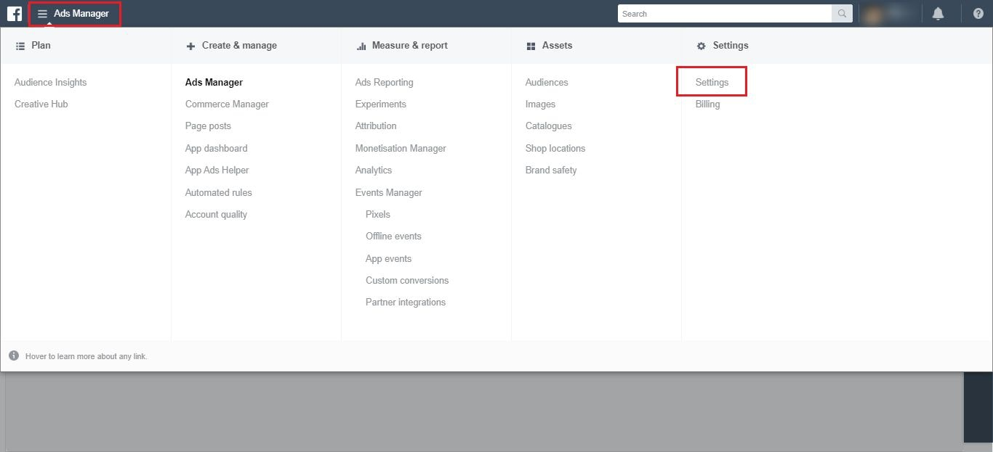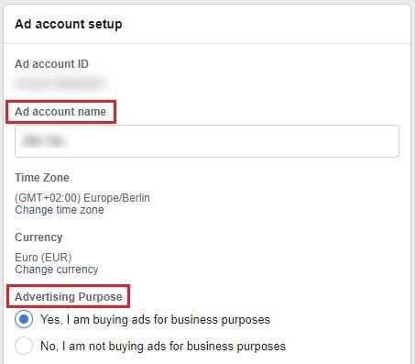

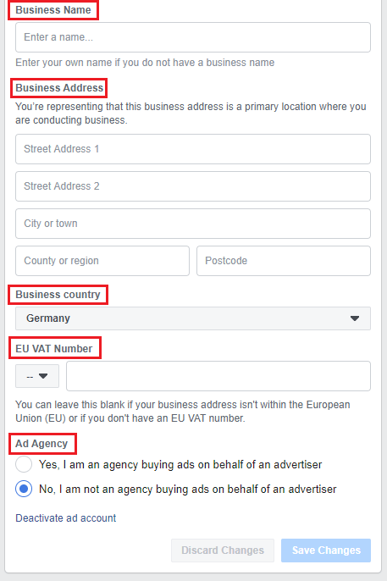

Billing:

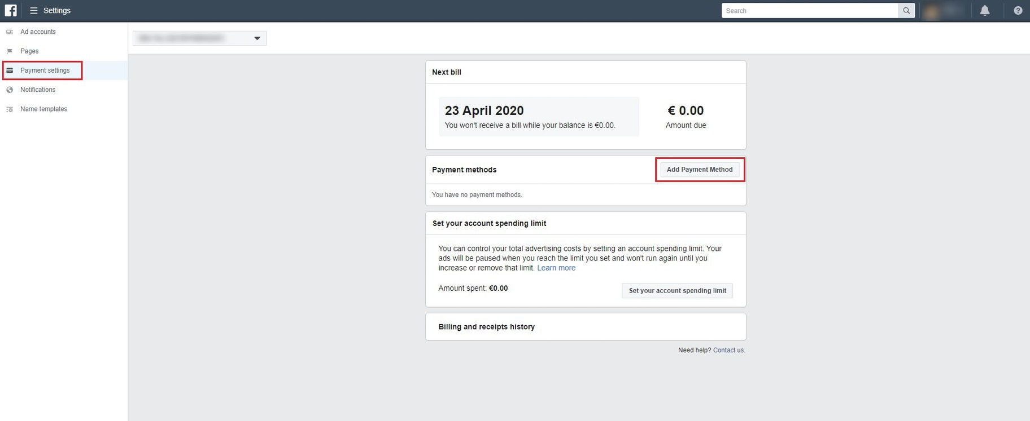

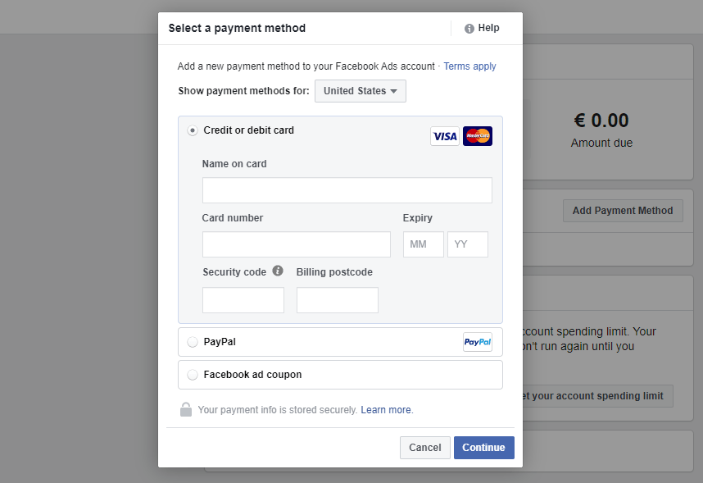

Facebook Ads Guide: Audience Research

This helps you find the right audience for your ads. The research guides takes key questions before you begin with Facebook advertising strategy.

1. Who are the authority figures, thought leaders, or big brands in your niche?

* Name the key players in the industry.

1. What books/magazines/newspapers does your ideal customer read?

* Try targeting either the popular books or authors in that field.

1. What events do they attend?

* Name the events your target group is interested in or is attending.

1. What websites do they frequent?

* To understand what sort of websites your audience is interested in.

1. Where do they live?

* To zero the target audience for your ads

1. What tools do they use?

* List down software services/ subscriptions/ tools that your audience use

1. What’s completely unique about this group?

* Be specific to narrow down the group.

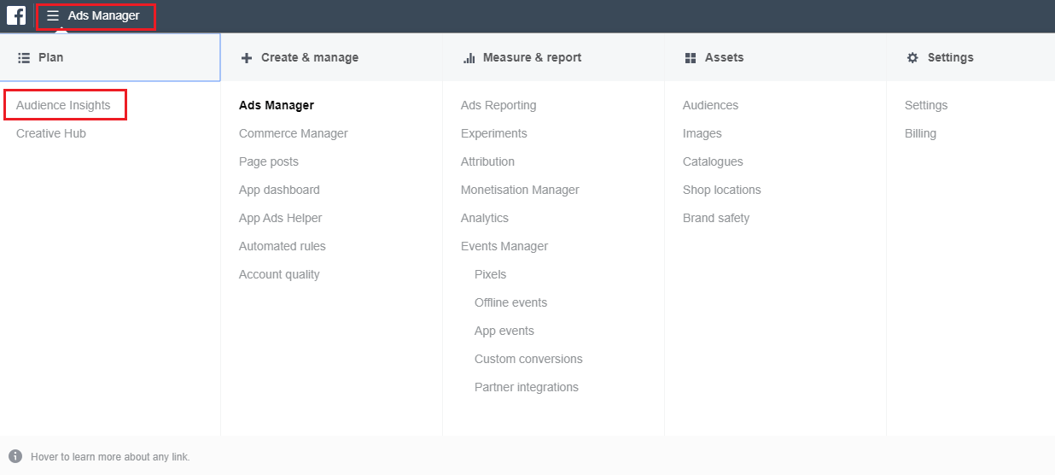

Seed Audience:

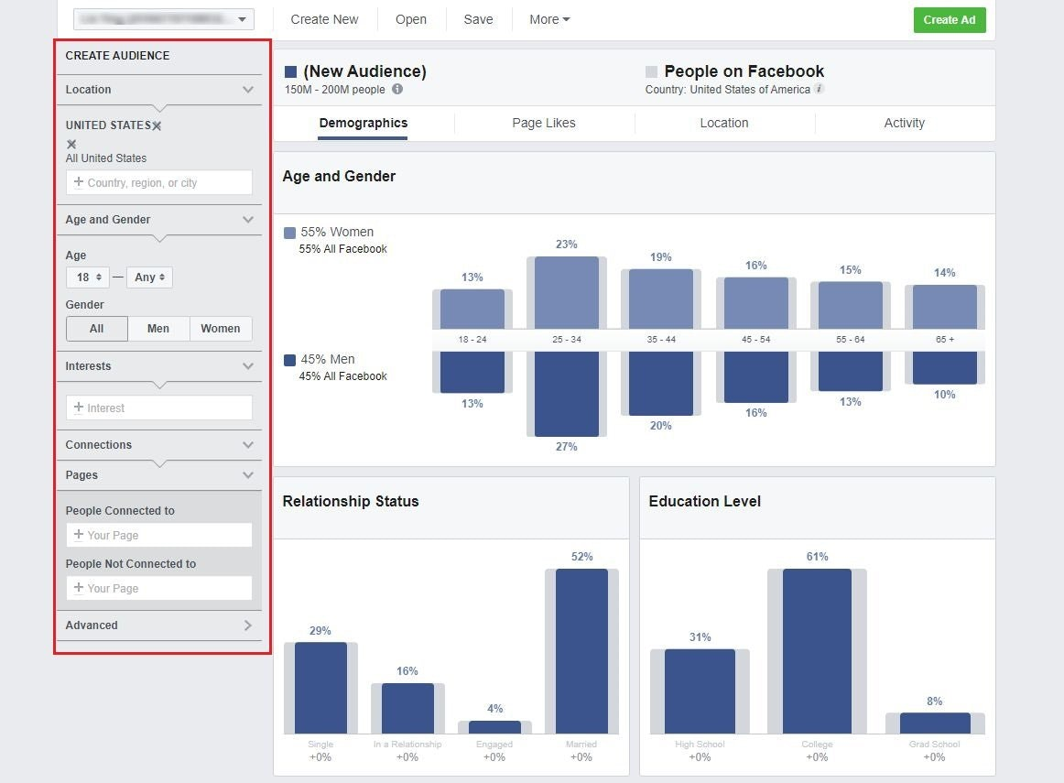

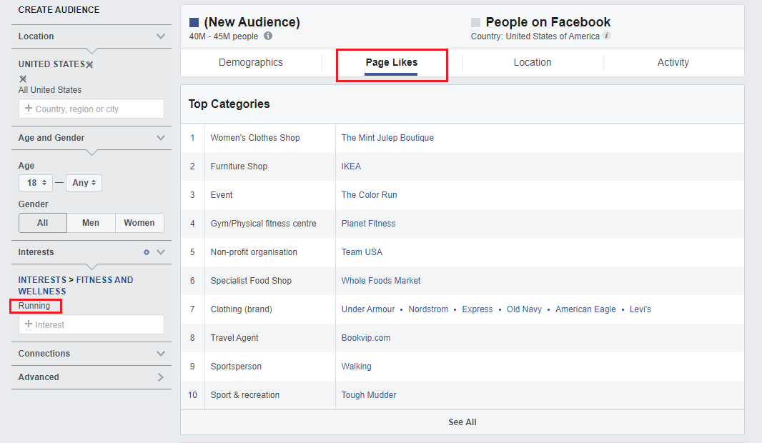

Creating Advertising Campaign: These are the main ways to launch a Facebook Ad campaign.

1. Boost post on Facebook pages
2. Self-serve ads Create tool
3. Power Editor tool

Go to ‘Ads Manager – Creation’ page under Ads Manger tab or ‘Create Ad’ on the main page.

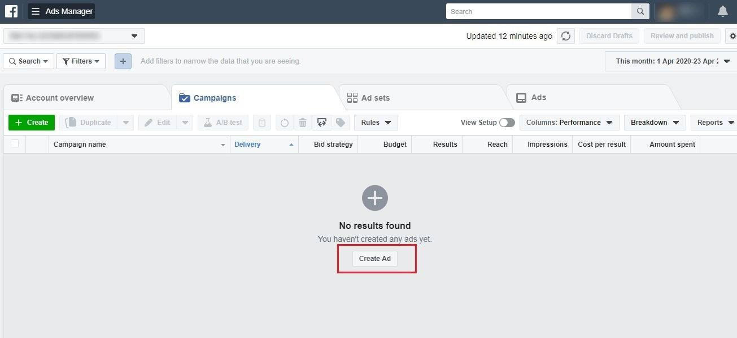

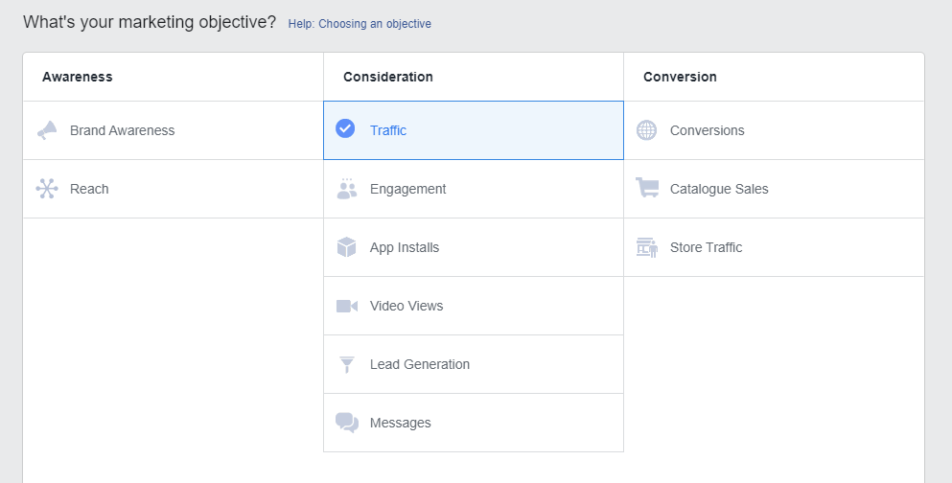

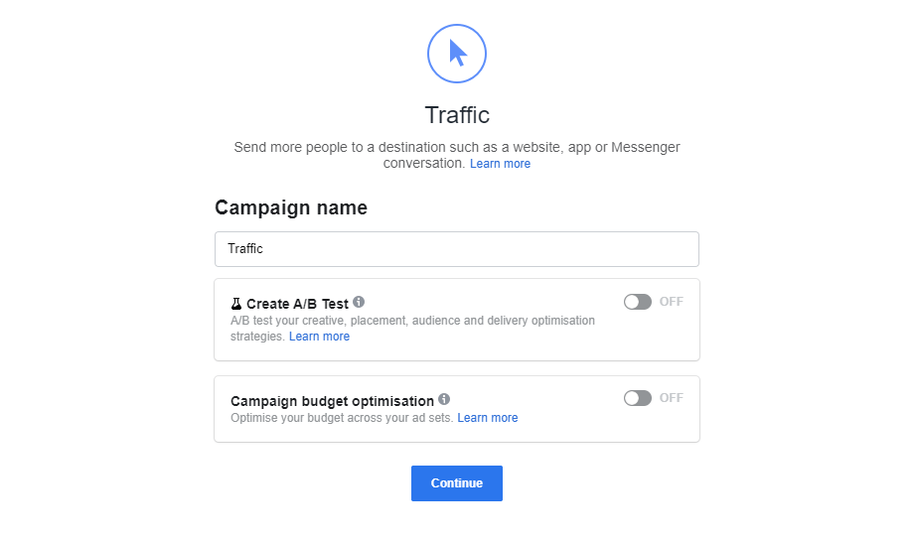

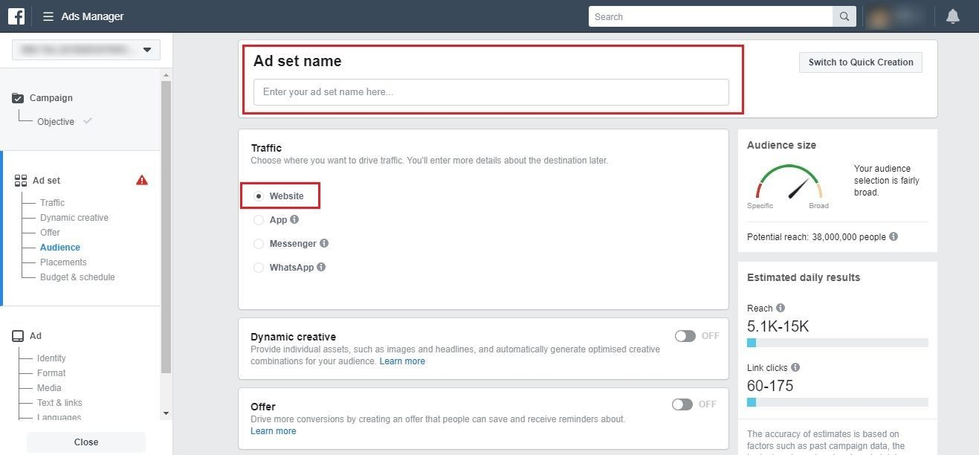

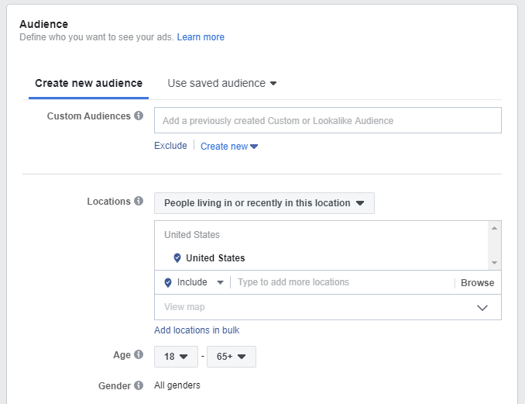

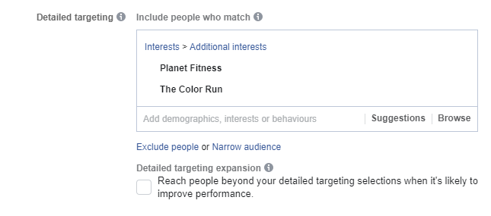

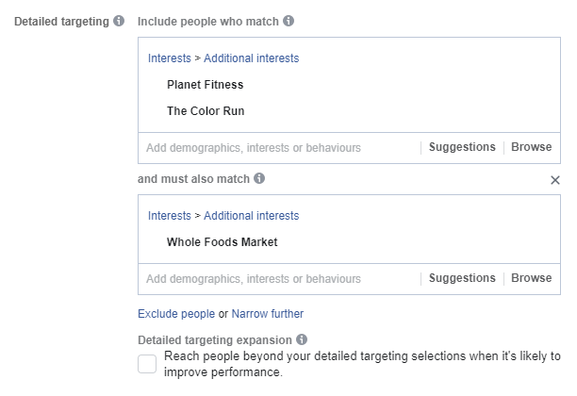

Decide on the placements

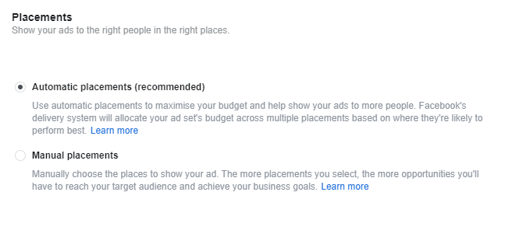

Budgeting and Schedule

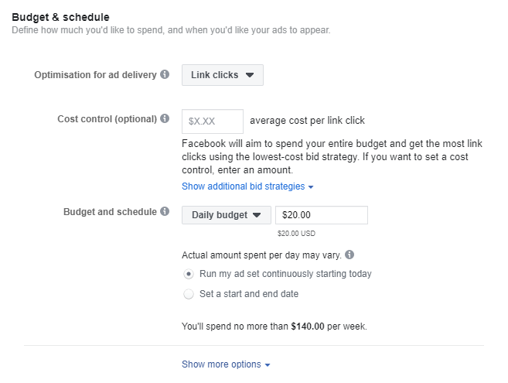

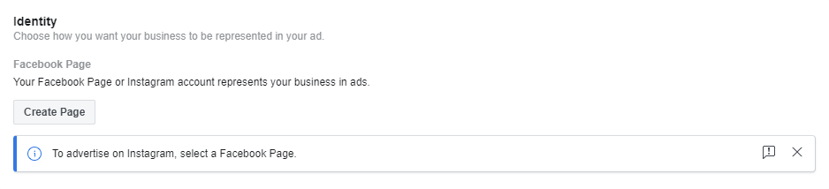

Design Your Ads

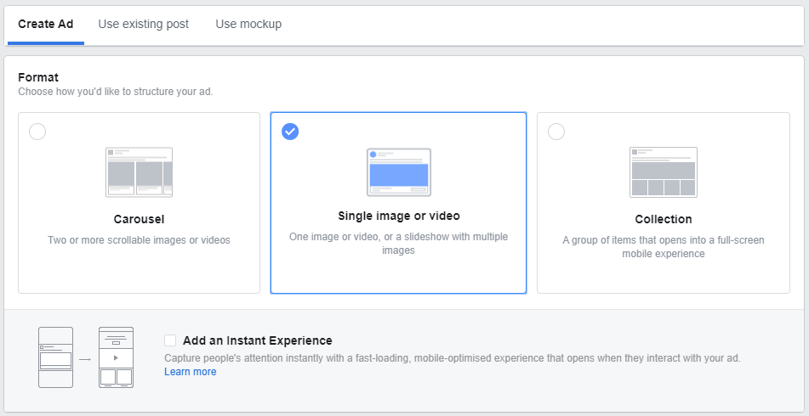

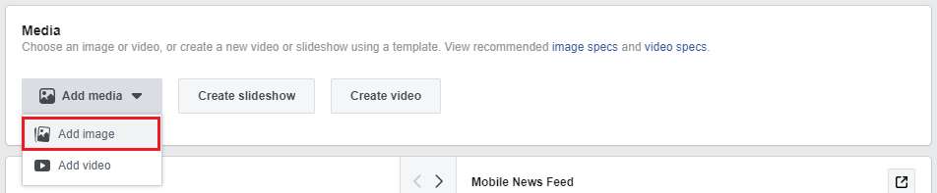

You can select up to 6 images when creating a new Facebook ad campaign, it will create up to 6 ad variations of your campaign.

By creating a few ads, you can quickly see which image is working the best.

The recommended image size is 1200 X 628 pixels and saving them in .png format.

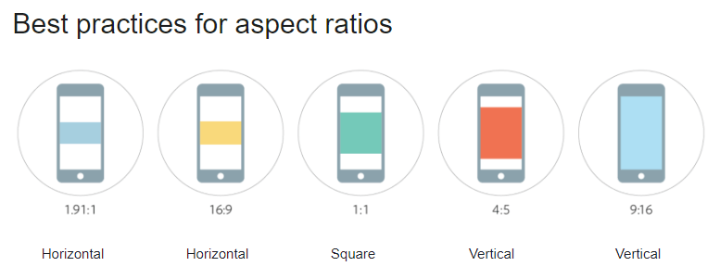

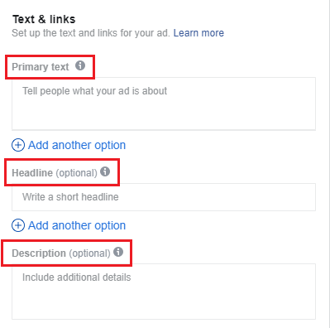

For the headline, you have a character limit of 25 symbols, and for a post text, you have 90 characters.

Primary Text: Emphasize the value your product. State out Call-to-action

Example: “Shop Now”, “Buy Now”, “Get one now”..

Headline: It should be short and reveal the main characteristics of your product.

Description: FB Algo will decide whether to show it depending upon its relevance to the viewer.

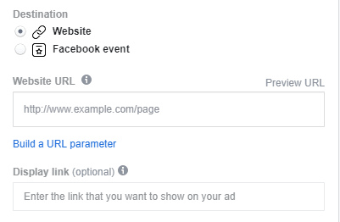

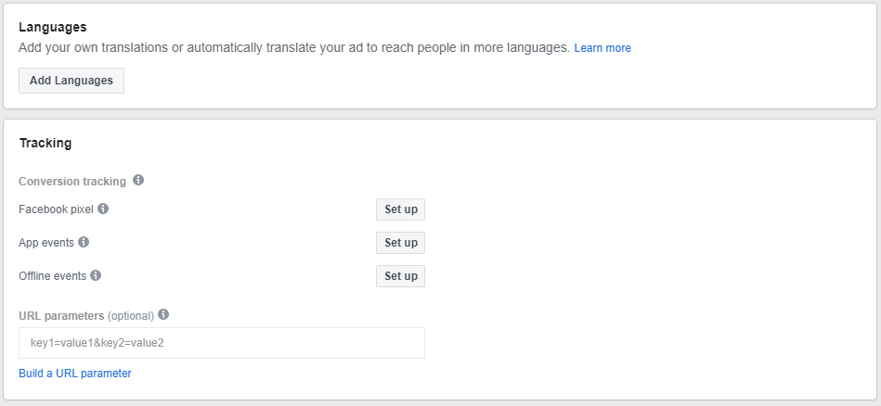

End of Ad creation.

Facebook Advertising Guide: After

This part talks about getting the insights and analyzing reports to find the effectiveness of your ad.

FB algorithm will learn more about audience and start displaying ads to them. And It will ad more and more data to your reports to evaluate your campaigns.

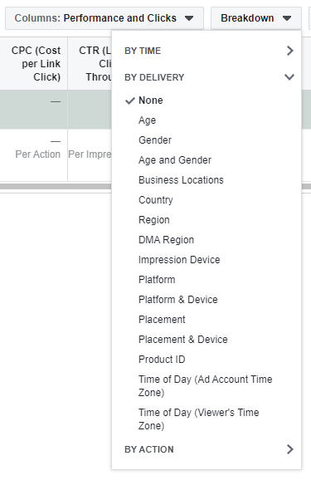

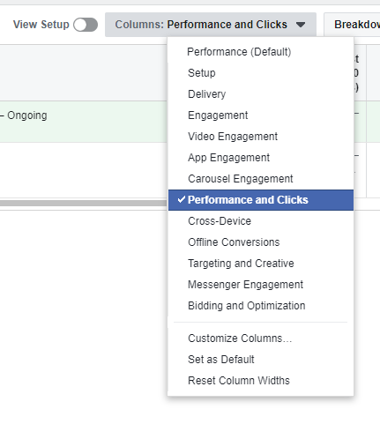

Click-Through rate: The average rule is to get at least 1% on Desktop News Feed or Mobile News Feed.

You can also check the breakdown of the results on your FB campaign by segments.

FB Advertising Know-hows:

1. Write Different FB Ads for Different People.
2. Ensure your FB Ad Copy Goes with Your Visual

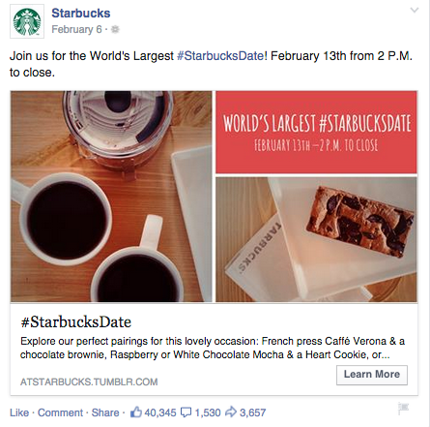

1. Stay Focused with One Call-to-Action

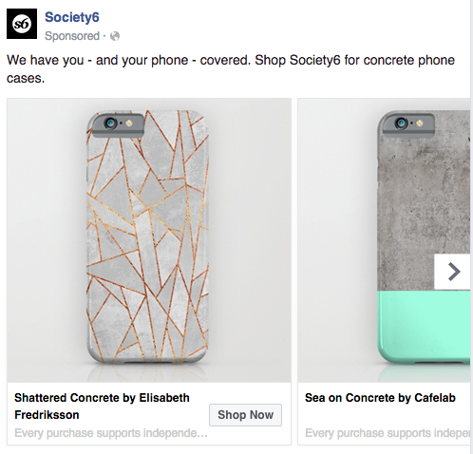

1. Keep it short and Lead with Value

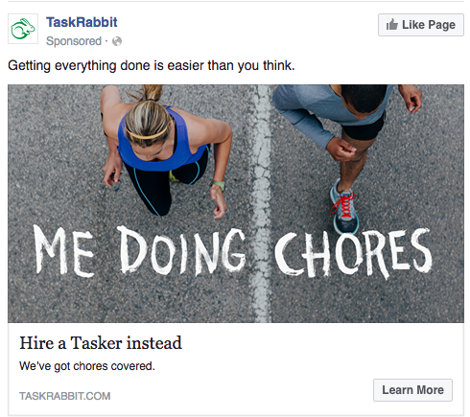

1. Use Simple Language that’s easy to understand

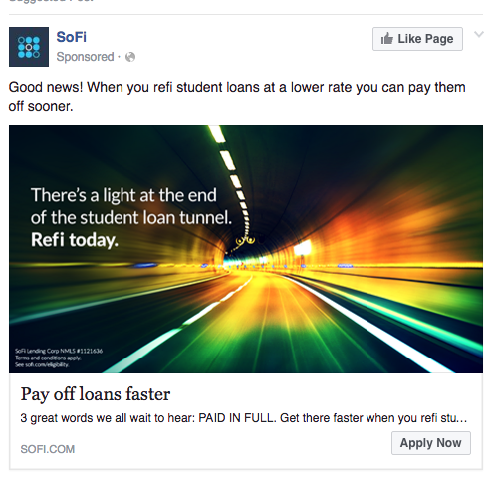

1. Be Upfront about the Numbers



1. Test your Ad Copy

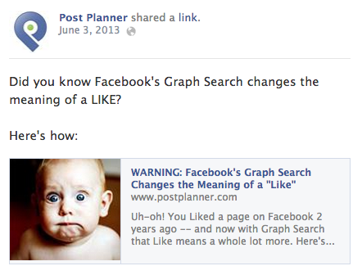

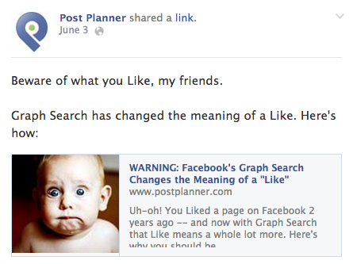

Some Sample FB Ad’s for reference:

