Alva Dynamics, LLC

**MedVoice (Health Awareness Mobile Application)**

Software Design Document

Name (s): Megan Lyn A. Del Rosario

Date: (12/17/2015)

**TABLE OF CONTENTS**

**1. INTRODUCTION 2**

1.1 Purpose 2

1.2 Scope 2

1.3 Overview 2

1.4 Reference Material 2

1.5 Definitions and Acronyms 2

**2. SYSTEM OVERVIEW 2**

**3. SYSTEM ARCHITECTURE 2**

3.1 Architectural Design 2

3.2 Decomposition Description 3

3.3 Design Rationale 3

**4. DATA DESIGN 3**

4.1 Data Description 3

4.2 Data Dictionary 3

**5. COMPONENT DESIGN 3**

**6. HUMAN INTERFACE DESIGN 4**

6.1 Overview of User Interface 4

6.2 Screen Images 4

6.3 Screen Objects and Actions 4

**7. REQUIREMENTS MATRIX 4**

**8. APPENDICES 4**

**1. INTRODUCTION**

**1.1 Purpose**

The purpose of this Software Design Document is to ensure that database transactions with the MedVoice mobile application meets its requirements outline in the MedVoice SRS document.

**1.2 Scope**

MedVoice will have the ability to retrieve and send data to and from a selected database upon logging into the mobile application. Using the collected data, users will be grouped according to interests and similarities.

This Software Design Document will focus solely on aggregating user data upon logging into the mobile application via Facebook, and describe transactions between MongoDB and the mobile application.

**1.3 Overview**

This document will

**1.4 Reference Material**

[1] Docs.mongodb.org, "The MongoDB 3.2 Manual — MongoDB Manual 3.2", 2015. [Online]. Available: https://docs.mongodb.org/manual/?_ga=1.115763206.1624318876.1449113191. [Accessed: 18- Dec- 2015].

[2] C. Sears, "Components · Ratchet", *Goratchet.com*, 2015. [Online]. Available: http://goratchet.com/components/. [Accessed: 18- Dec- 2015].

[3] Getbootstrap.com, "Components · Bootstrap", 2015. [Online]. Available: http://getbootstrap.com/components/. [Accessed: 18- Dec- 2015].

[4] W3schools.com, "W3Schools Online Web Tutorials", 2015. [Online]. Available: http://www.w3schools.com/. [Accessed: 18- Dec- 2015].

[5] Facebook Developers, "Facebook Login for Apps - Developer Documentation - Facebook for Developers", 2015. [Online]. Available: https://developers.facebook.com/docs/facebook-login. [Accessed: 18- Dec- 2015].

**1.5 Definitions and Acronyms**

|  |  |
| --- | --- |
| SRS | Software Requirements Specification. |
| SDD | Software Design Document |
| XAMPP | X(“Cross”-platform), Apache HTTP Server, MariaDB (MongoDB), PHP and Perl |
| GUI | Graphical User Interface |
| **DB** | **Database; a place where data is stored for a web server.** |
| **RDBS** | **Relational Database** |
| **NoSQL** | **Refers to a database that is “non relational”, provides a mechanism for storage and retrieval of data that is modeled in means other than tabular relations used in relational databases.** |
| HTML | Hypertext Markup Language |
| CSS | Cascading Style Sheets |
| JS | JavaScript |
| PHP | PHP Hypertext Preprocessor |
| **Client** | **Remote server; any software application that requests data from a web server.** |
| **Browser** | **A software application for retrieving, presenting, and traversing information resources on the World Wide Web.** |
| **Web Server** | **A computer that is configured to be a web server whose job is to serve web pages when a request is made by a client.** |

**2. SYSTEM OVERVIEW**

PHP Scripting

Web Server

(Computer)

Apache

Database

MongoDB

Client

(Browser)

Localhost

**3. SYSTEM ARCHITECTURE**

**3.1 Architectural Design**

|  |  |
| --- | --- |
| **System Overview** | **Details** |
| GUI | * Register an account to collect data * Sign into app with existing user account   + Check Credentials   + Forgot Password?   + (Edit) User Profile   + Send data to MongoDB * Ability to login through Facebook   + Permissions   + Send data to MongoDB |
| XAMPP | * Creation and Test Environment   + Apache HTTP Server     - Localhost   + Connect to database   + Serve Website (GUI) |
| MongoDB | * Store data for web server/ Communicate with web werver * Render Data * Data Modeling |

**3.2 Decomposition Description**

* XAMPP: X (“Cross”-platform), Apache HTTP Server, MariaDB (MySQL), PHP and Perl
  + Free and open source cross-platform web server solution stack package developed by Apache Friends
  + Development package/development environment (creation and test environment)
  + Not meant to be deployed, insecure because default settings are insecure

PHP Scripting

Web Server

(Computer)

Apache

Database

MongoDB

Client

Browser

Localhost

XAMPP

* MongoDB
  + Cross-platform, open source document-oriented database
  + Classified as NoSQL database
  + Horizontal Scalability
  + Query Language
    - Ad hoc queries
  + Fast performance
  + Embedded Data model
  + Replication
  + Duplication of Data
  + Load balancing
  + Aggregation: MapReduce
  + Server-side JavaScript Execution
  + Special Support for Locations: understands longitude and latitude natively
  + Driver Support (Java, JavaScript, Python, Ruby, C#, PHP, more)

No SQL Database

Document Oriented Databases

**3.3 Design Rationale**

MongoDB

Could be used in

Big Data Applications

Traditional Applications

Not a suitable solution for

Applications involving complex transactions

NoSQL vs. RDBMS

MongoDB vs. MySQL

* No joins support
* No complex transaction support
* No constraints support

|  |  |  |
| --- | --- | --- |
| **Legend: 1-10**  **(1:Poor, 10:Excellent)** | **XAMPP** | **WAMP** |
| Usability | **10** | **1** |
| User Interface | **8** | **5** |
| Performance | **10** | **10** |
| **Score** | **28** | **16** |

|  |  |  |
| --- | --- | --- |
| **Legend: 1-10**  **(1:Poor, 10:Excellent)** | **MongoDB** | **MySQL** |
| **(Horizontal) Scalability** | **8** | **2** |
| **Performance** | **7** | **5** |
| **Format Flexibility** | **8** | **5** |
| **Driver Support** | **7** | **5** |
| **Score** | **30** | **17** |

Performance

Functionality

Object Oriented Programming Language

RDBS

MongoDB

Converts records into objects

No conversion required

**4. DATA DESIGN**

**4.1 Data Description**

RDBS

Table

MongoDB

Collection

* JSON-like documents (BSON)
* Embedded Data model
* Array structure
* Indexing
* Replication
* Capped collections
  1. **Data Dictionary**
* Collections:
  + Care clients
    - Document
  + Care providers/givers
    - Document
  + Admin
    - Document

**5. COMPONENT DESIGN**

|  |  |
| --- | --- |
| **System Overview** | **Details** |
| GUI | * Register an account to collect data * Sign into app with existing user account   + Check Credentials   + Forgot Password?   + (Edit) User Profile   + Send data to MongoDB * Ability to login through Facebook   + Permissions   + Send data to MongoDB |
| MongoDB | * Store data for web server/ Communicate with web werver * Render Data * Data Modeling |

**6. HUMAN INTERFACE DESIGN**

**6.1 Overview of User Interface**

Describe the functionality of the system from the user’s perspective. Explain how the user will be able to use your system to complete all the expected features and the feedback information that will be displayed for the user.

**6.2 Screen Images**

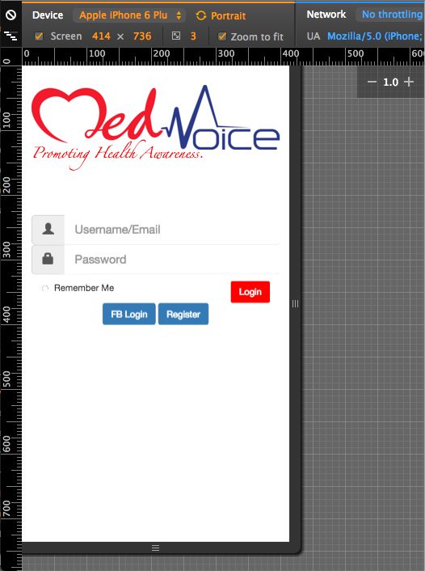

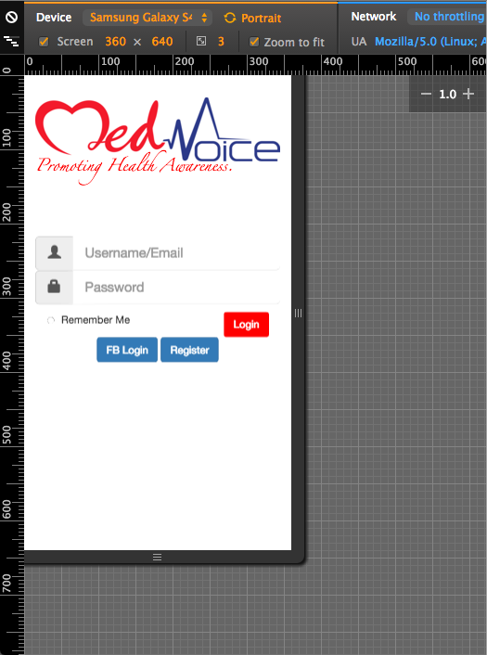

**6.3 Screen Objects and Actions**

|  |  |
| --- | --- |
| **Object** | **Action** |
| Login | * User authentication * Link to Dashboard |
| FB Login | * Permission |
| Register | * Required Info   + First/Last Name   + Age   + Weight   + Height   + Email/username   + Password |

**7. REQUIREMENTS MATRIX**

|  |  |
| --- | --- |
| **SRS Document** | **SDD Document** |
| * 1.2 Scope | * 1.2 Scope |
| * 2 Overall Description | * 2 System Overview * 3 System Architecture |
| * 3 Specific Requirements | * 4 Data Design * 5 Component Design |

**8. APPENDICES**

*This section is optional.*