**MedVoice Internship**

Software Requirements Specification

MedVoice Bio Tech

Mike Maryn

August 2, 2106

**Table of Contents**

1. Introduction.

**1.1. Purpose.**

**1.2. Scope.**

* 1. **Definitions, acronyms, and abbreviations**
  2. **References.**
  3. **Overview.**

1. **Overall description**
   1. **Product Perspective.**
      1. **System Interfaces.**
      2. **User Interfaces.**
      3. **Hardware interfaces.**
      4. **Software interfaces.**
      5. **Communication interfaces.**
      6. **Memory constraints.**
      7. **Operations.**
   2. **Product functions.**
   3. **User characteristics.**
   4. **Constraints.**
   5. **Assumptions and dependencies**
   6. **Apportioning of requirements**
2. **Specific requirements.**
   1. **External interfaces.**
   2. **Functions.**
   3. **Performance requirements.**
   4. **Logical database requirements.**
   5. **Design compliance.**
   6. **Software system attributes.** 
      1. **Reliability.**
      2. **Availability.**
      3. **Security.**
      4. **Maintainability.**
      5. **Portability.**
   7. **Organizing the specific requirements.**
      1. **System mode.**
      2. **User Class.**
      3. **Objects.**
      4. **Feature.**
      5. **Stimulus.**
      6. **Response.**
      7. **Functional hierarchy.**
   8. **Additional comments.**

**1 Introduction**

* 1. **Purpose**

The purpose of this project is to create an easy, user friendly, in real-time app that can search through the large amounts of data gathered by the MedVoice app, and display that data in a readable manner.

* 1. **Scope**

To easily display log data, which can be difficult to decipher due to a lack of standardization, and make it easy to understand for business/analytic purposes. The software will take in log data, store them in a generalized format and allow that data to be queried.

**1.3 Definitions, acronyms, and abbreviations**

|  |  |
| --- | --- |
| SRS | Software Requirements Specification |

**1.4 References**

[1] IEEE Recommended Practice for Software Requirements Specifications Software Engineering Standards Committee of the IEEE Computer Society. 1998.

**1.5 Overview**

The rest if the document will contain all the product outlines, perspective, function, interface, and user characteristic

1. **Overall Description**

This section will give an overview of the whole system.

**2.1 Product Perspective**

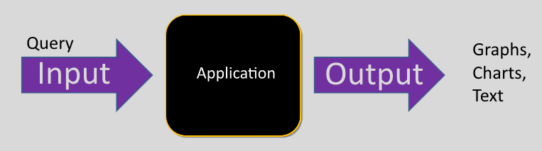

**2.1.1 System Interfaces**

The interfaces with be several connected servers

**2.1.2 User Interface**

Web browser

**2.1.3 Hardware Interfaces**

Mouse and Keyboard, also smart phone.

**2.1.4 Software Interfaces**

Viewed in a web browser

**2.15 Communication Interfaces**

Not Required

**2.1.6 Memory Constraints**

N/A

**2.1.7 Operations**

Continuous, can be accessed at anytime

**2.2 Product Functions**

Users log data will be taken in and stored in a database, then web browser will let user query through said data and get results.

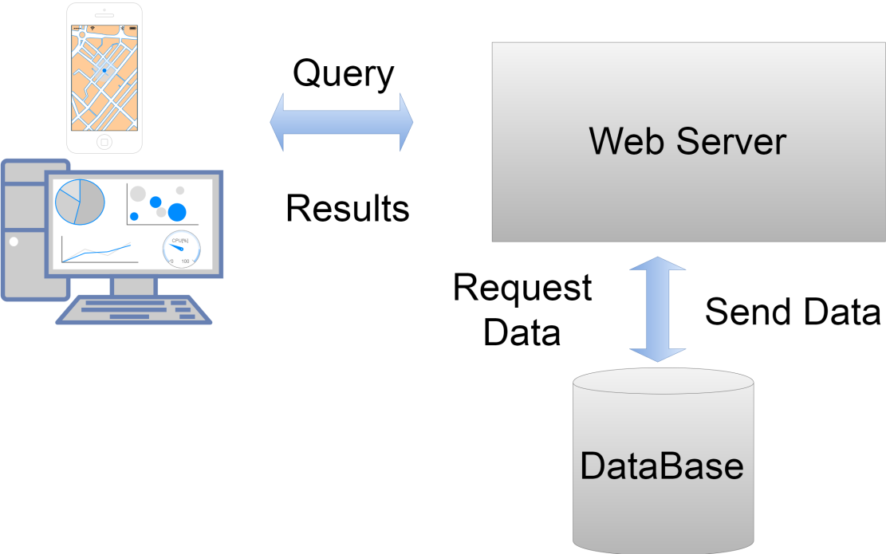

**2.3 User Characteristics**

Data analysists, upper management, marketing

**2.4 Constraints**

Multiple users could be logged in at the same time. Internet is a constraint since users log onto a webserver. A work around would be to download the data to the mobile app, however internet connection would still be required to update.

**2.5 Assumptions and Dependencies**

Can be accessed through a web browser

* 1. **Apportioning of Requirements**

N/A

**3 Specific Requirements**

**3.1 External Interfaces**

Web page such display not only text results but also graphs, charts, maps and should update in real time.

**3.2 Functions**

TBA

**3.3 Performances Requirement**

Needs to be optimized to handle multiple users using the website. Info needs to update with new data.

**3.4 Logical Database Requirements**

Instruct server when a change is made

**3.5 Design Compliances**

The Software will comply with software coding standards.

**3.6 Software System Attributes**

**3.6.1 Reliability**

Software should always be functional.

**3.6.2 Availability**

Should be accessible by any web browsers.

**3.6.3Security**

Users should not have direct access to databases.

**3.6.4 Maintainability**

Code will be well document, and hopefully modules with be reusable. Scalable so updates should come easily.

**3.6.5 Portability**

Coding is done on servers. However, the program can be accessed through smart phone.

**3.7 Organizing the Specific Requirements**

**3.7.1 Systems Mode**

Administrator, Doctors, and Developers. All users have their own profiles

**3.7.2 User class**

Multiples users of the Software.

**3.7.3Objects**

None

**3.7.4 Features**

No external features.

**3.7.5 Stimulus**

This software supports submission from the Software.

**3.7.6 Response**

All data will be available on startup page.

**3.7.7 Functional Hierarchy**

TBD

**3.8 Additional Comments**

None