MedVoice

Software Requirements Specification

Alva Dynamics LLC
September 20, 2015

Table of Contents

Introduction.
1.1. Purpose.
1.2. Scope.
  - Definitions, acronyms, and abbreviations
  - References.
  - Overview.
- Overall description
  - Product Perspective.
    - System Interfaces.
    - User Interfaces.
    - Hardware interfaces.
    - Software interfaces.
    - Communication interfaces.
    - Memory constraints.
    - Operations.
  - Product functions.
  - User Class and Characteristics.
  - Constraints.
  - Assumptions and dependencies
  - Apportioning of requirements
- Specific requirements.
  - External interfaces.
  - Functions.
  - Performance requirements.
  - Logical database requirements.
  - Design compliance.
  - Software system attributes.
    - Reliability.
    - Availability.
    - Security.
    - Maintainability.
    - Portability.
  - Organizing the specific requirements.
    - System mode.
    - Use Case.
    - Objects.
    - Feature.
    - Stimulus.
    - Response.
    - Functional hierarchy.
  - Additional comments.
1. Introduction

1.1. Purpose
The purpose of this Software Requirements Specification (SRS) document is to provide a complete description of the requirements for a MedVoice application. It will present the scope of the system, the constraints, the interfaces of the system, and the features of the system. The intended audience of this document is for all the stakeholders for this MedVoice application. This includes, the software developers, the project managers, and the users.
  - Scope
MedVoice is a social health awareness application.

  - Definitions, acronyms, and abbreviations

Acronyms | Definition
SRS | Software Requirements Specification.
GUI | Graphical User Interface
App | Application
IEEE | Institute of Electrical and Electronics Engineers
Admin | Administrator
Ad | Advertisement
UI | User Interface
UC | Use Case

  - References:
[1] IEEE Recommended Practice for Software Requirements Specifications Software Engineering Standards Committee of the IEEE Computer Society. 1998.
[2] Wiegers, Karl, Software Requirements (3rd Edition), Microsoft Press 2013.

  - Overview:
The rest of this document will have two major sections and Appendixes and will be ended with an index for the SRS documents [1]. The second section will contain all the product outlines, perspective, function, interface, and user characteristics. The third section will include the some specific requirements (e.g. hardware requirements).

- Overall description

  - Product Perspective
The product is an internet-based system that will interact with users and other systems in the following ways:
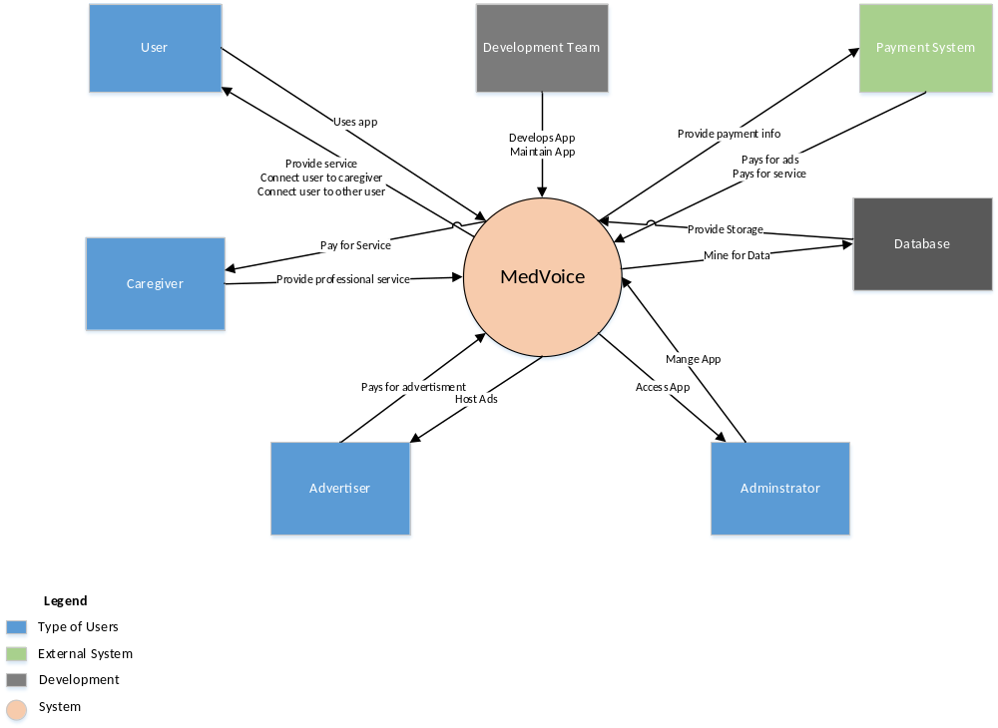
Figure 1: Context Diagram
    - System Interfaces
The interface for this software is a web browser.

    - User Interfaces
The user interface will be the web browser.

    - Hardware interfaces
Mouse and keyboard are required. A phone with internet connection is also required.

    - Software interfaces
The project software interface will be viewed on a phone. MedVoice will also be viewable on a web browser.

    - Communication interfaces
CI-1 MedVoice communication interface shall send a verification email to confirm that the user had registered at MedVoice.
CI-2 MedVoice communication interface shall send an email to the user if there are any suspicious activities such as three failed login attempts.
CI-3 MedVoice communication interface shall return the searched user/caregiver results to the user. Else, the MedVoice communication interface shall send a message to the user to say that the searched user/caregiver was not found.
    - Memory constraints
N/A.

    - Operations
Operation will be when the program is executed until the program is exited.

    - Site adaptation requirements
There is no site adaption requirement.

  - Product functions
The sequence diagrams below.
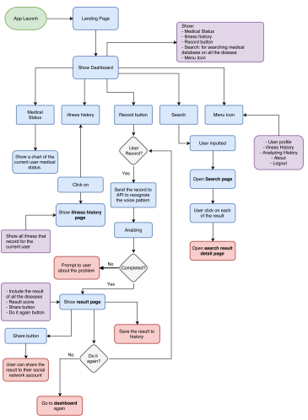
Figure 1. Sequence Diagram
  - User Classes and Characteristics
User Class | Description
Care Client (favored) | The care client is a user whom had registered for an account with the MedVoice app. If the care client wants a report, he must pay per each report. The user shall use an android device to access the app.
Subscribed user | A subscribed user is a person whom had registered for an account with the MedVoice app. The subscribed user had paid a subscription fee. The subscribed user is allowed to download an unlimited number of reports for free. The subscribed user shall use an android device to access the app.
Caregiver | The caregiver is a medical professional who is will provide medical advice and consultation to the user. The caregiver could access the app through the MedVoice website or the android app.
Advertiser | Advertiser is a person whom had paid MedVoice to host his ads on the app.
Administrator | An administrator is a person who works for MedVoice. The administrator monitors the activities on app and ensure that all the users adheres to the terms and condition agreement.

  - Constraints
System should be able to handle multiple users logged into the system. There is a maximum number of people working on implementing the project. MedVoice can only be built using the current software tools and IDE that are available. Another important constraint is time. There is a timeline for each releases of MedVoice. Any features not implemented in each release need to be moved to the next one or reprioritized.

  - Assumptions and dependencies
AS-1 Users are actual people and not robots
AS-2 App is well designed and easily navigable
AS-3 App have a fast response time
DE-1 Servers are able to handle all incoming traffic
DE-2 Users have the plugins that are required to watch videos
DE-3 Users have internet connection to access the application

  - Apportioning of requirements
Not Applicable.

- Specific requirements

  - External interface
The following describes the user interfaces.

  - Functions

  - Performance requirements
PER-1 Coding shall be done to optimize to handle processing of multiple users using the system.
PER-2 Report download should be completed within 1 minute from the time the user had purchased and requested the report over a 20 Mbps or faster internet connection.
PER-3 System shall display confirmation messages to users within an average of 4 seconds to a maximum of 10 seconds after the user submits information to the system.

  - Logical database requirements
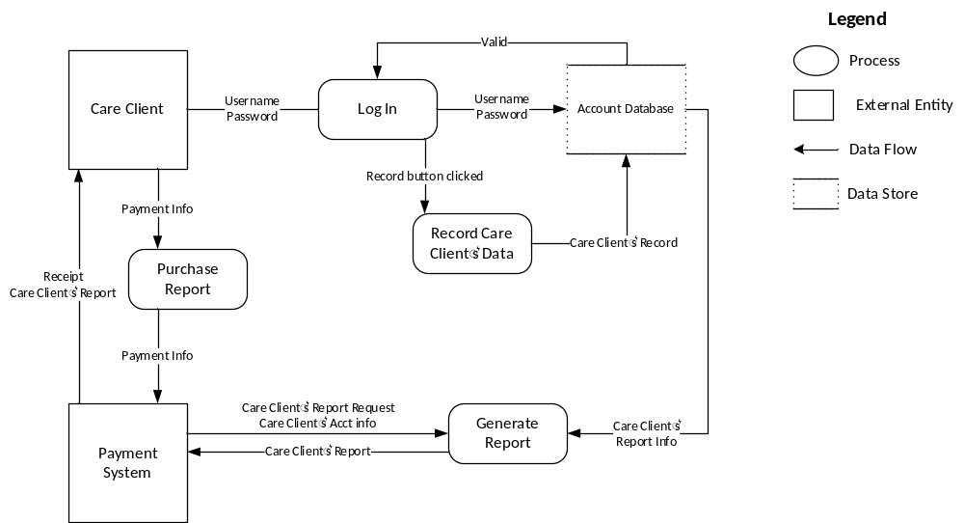Figure 2: Data Flow Diagram
  - Design constraints

    - Standards compliance
All HTML code shall conform to the HTML 5.0 standard.

  - Software system attributes

    - Reliability
The Software shall be functional during execution. The app shall not crash while the user is using it.

    - Availability
The Software shall be accessible by Internet Explorer, Firefox, and Safari web browsers. Also, the app shall be accessible by Android. The app shall be available for the users at least 90% of the time, excluding scheduled maintenance windows.

    - Security
The Software should have security features for only users that have access to the Software. The app shall require users to log into the app to access the app’s features. The app shall permit users to access only the report that pertained to them.

    - Maintainability
The code shall be well documented and most modules will be reusable.

    - Portability
The code used in this program will be completely portable, allowing the code to go from one application to another as long as they comply with the hardware and software requirements detailed in this document.

  - Organizing the specific requirements

    - System mode
Single mode of operation (normal mode).

    - User class
There are multiple users of the Software.

    - Objects
See the Sequence Diagram in Figure 1.

    - Feature
This software contains no external features.

    - Stimulus
This software supports submission from the Software.

    - Response
All responses to user input are described in section 2.

    - Functional hierarchy
TBD (i.e. add software diagram)

  - Additional Comments
No additional comments.

