MedVoice Internship

Software Requirements Specification

Alva Dynamics LLC
MedVoice Bio Tech
Vehans Ayvazi
December 21, 2015

MedVoice: Data Presentation

1. Introduction

1.1. Purpose
To provide developers, application owners, and other members of the organization essential analytics tools to transform, analyze, and visualize important data.

  - Scope
The Software will present visual representations of essential data.

There are three users Administrator, Doctors, Developers. All users have their own profiles.
Doctors and Developers will have access to everything but the financial data.
Admin will have access to all data.

  - Definitions, acronyms, and abbreviations

SRS | Software Requirements Specification.
GUI | Graphical User Interface

  - References:
Microsoft Power BI website: https://powerbi.microsoft.com/en-us/

  - Overview:
The rest of this document will have two major sections and Appendixes and will be ended with an index for the SRS documents [1]. The second section will contain all the product outlines, perspective, function, interface, and user characteristics. The third section will include the some specific requirements (e.g. hardware requirements).

- Overall description

  - Product Perspective
This project will provide developers, application owners, and other members of the organization essential graphs, charts, maps, and diagrams.

    - System Interfaces
The interface for this software is a web browser.

    - User Interfaces
The user interface will be the web browser.

    - Hardware interfaces
Mouse and keyboard are required. A smart phone will also be required.

    - Software interfaces
The project software interface will be viewed on a web browser.

    - Communication interfaces
Not required.

    - Memory constraints
N/A.

    - Operations
Operation will be when the program is executed until the program is exited. The graphs/charts/maps will be archived for future reference.

    - Site adaptation requirements
There is no site adaption requirement.

  - Product functions
The sequence diagrams below.

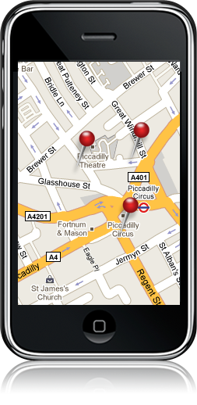
PHP Scripting
Web Server

(Apache)

PHP Scripting
(When a change in the database occurs)



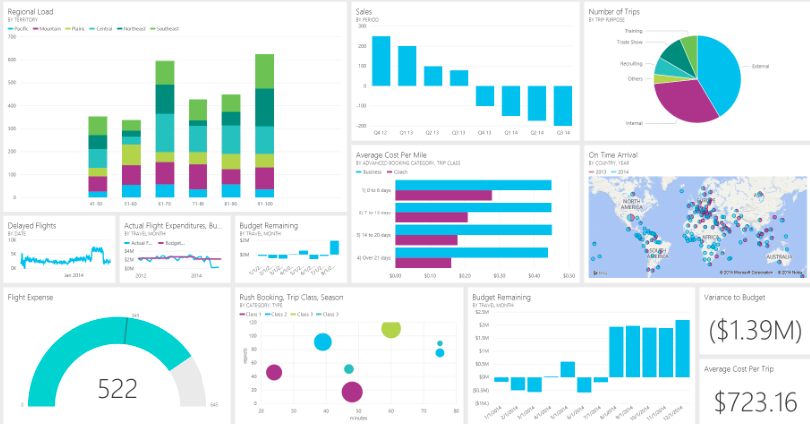

Database

(MongoDB or SQL)

M

Figure 1. Sequence Diagram -
2.3. User characteristics
The projected users of the Software are developers, doctors, office administrators, and other organizations members.

  - Constraints
System should be able to handle multiple users logged into the system.

  - Assumptions and dependencies
Application window will be 800 x 600 pixel resolution with ability to do full screen.

  - Apportioning of requirements
Not Applicable.

- Specific requirements

  - External interface
The user interface will include several boxes with a variety of analytics subjects. The boxes will be updated at real time.

  - Functions
TBA

  - Performance requirements
Coding will be done to optimize to handle processing of multiple users using the system. The graphs/charts/maps will need to be updates every time there is a change in the database.

  - Logical database requirements
To instruct the server when it changes.

  - Design constraints

    - Standards compliance
The Software will comply with software coding standards.

  - Software system attributes

    - Reliability
The Software should be functional during execution.

    - Availability
The Software will accessible by Internet Explorer, Firefox, and Safari web, Google Chrome browsers.

    - Security
The Software should have security features for only users that have access to the Software.

    - Maintainability
The code will be well documented and most modules will be reusable. The software will be very scalable and will be able to adapt to the appropriate number of application users.

    - Portability
The code used in this program will be completely portable, allowing the code to go from one application to another as long as they comply with the hardware and software requirements detailed in this document.

  - Organizing the specific requirements

    - System mode
There are three modes of operation based on what type of user has logged in; Administrator, Doctors, or Developers. All users have their own profiles.
    - User class
There are multiple users of the Software.

    - Objects
None.

    - Feature
This software contains no external features.

    - Stimulus
This software supports submission from the Software.

    - Response
All graphs/charts/diagrams will be available on the start up page. Users will be able to click and zoom in on which ever they want to.

    - Functional hierarchy
TBD

  - Additional Comments
No additional comments.

- Support Information

4.4.1 Table of Contents and index
Table of Contents

Introduction.
1.1. Purpose.
1.2. Scope.
  - Definitions, acronyms, and abbreviations
  - References.
  - Overview.
- Overall description
  - Product Perspective.
    - System Interfaces.
    - User Interfaces.
    - Hardware interfaces.
    - Software interfaces.
    - Communication interfaces.
    - Memory constraints.
    - Operations.
  - Product functions.
  - User characteristics.
  - Constraints.
  - Assumptions and dependencies
  - Apportioning of requirements
- Specific requirements.
  - External interfaces.
  - Functions.
  - Performance requirements.
  - Logical database requirements.
  - Design compliance.
  - Software system attributes.
    - Reliability.
    - Availability.
    - Security.
    - Maintainability.
    - Portability.
  - Organizing the specific requirements.
    - System mode.
    - User Class.
    - Objects.
    - Feature.
    - Stimulus.
    - Response.
    - Functional hierarchy.
  - Additional comments.

- Supporting information:
  - Table of contents and index.

