**Project Proposal**

**Vijay shopping**

**Submitted by**

**Incredibles**

**Team members**

**Varinder kaur(300303886)**

**Akwinder Kaur (300297906)**

**Gaurav Rana( )**

**Project objective:**

The vjay is the shopping site where tremendous products such as clothing, jewellery, technology stuff is available for customers to buy. Adults would be the main target audience. This product is very helpful during this pandemic when people feel unsafe to go out for shopping. Therefore, this product is very helpful to provide the needed products at the customer’s doorstep. There are a lot of similar systems in the marketplace in which there are staples, amazon, wish and many more. This system is user friendly as compared to others. If a customer experience would be hassle free by providing one click payment instead of adding products in the cart or filling up their detail repeatedly

**Products Major features:**

* **Login:** This feature allows customers to login to their specific profile.
* **Registration**: During registration customers can key in their details and that details will save into the database.
* **Homepage dashboard**: On this dashboard there would be navigations to the specific products and hot deals of this site.
* **Product category:** This feature will provide the details list of items under specific categories.
* **Add to Cart**: Customers can save items by putting the products into the cart and after shopping the customer can pay.
* **Validation**: validations perform for checking the correct address information.
* **order delivery status**: Under this feature customers can get the information about the number of days for delivery.
* **confirmation mail**: confirmation mail will be sent to customers when order will successfully be placed.
* **location pick up:** Customers can pick their orders from specific distribution centres.

**A brief work flow of this system is given below:**

Customer would log into the system if the customer would be a guest then he/she can register. If they are already a registered user then they can log into the user. After login users redirect to home page, further redirect the user to the product categories or to the logout page. If a customer goes to the product category page, then they would place an order after that they will get a confirmation of order.

**Use case of the project**

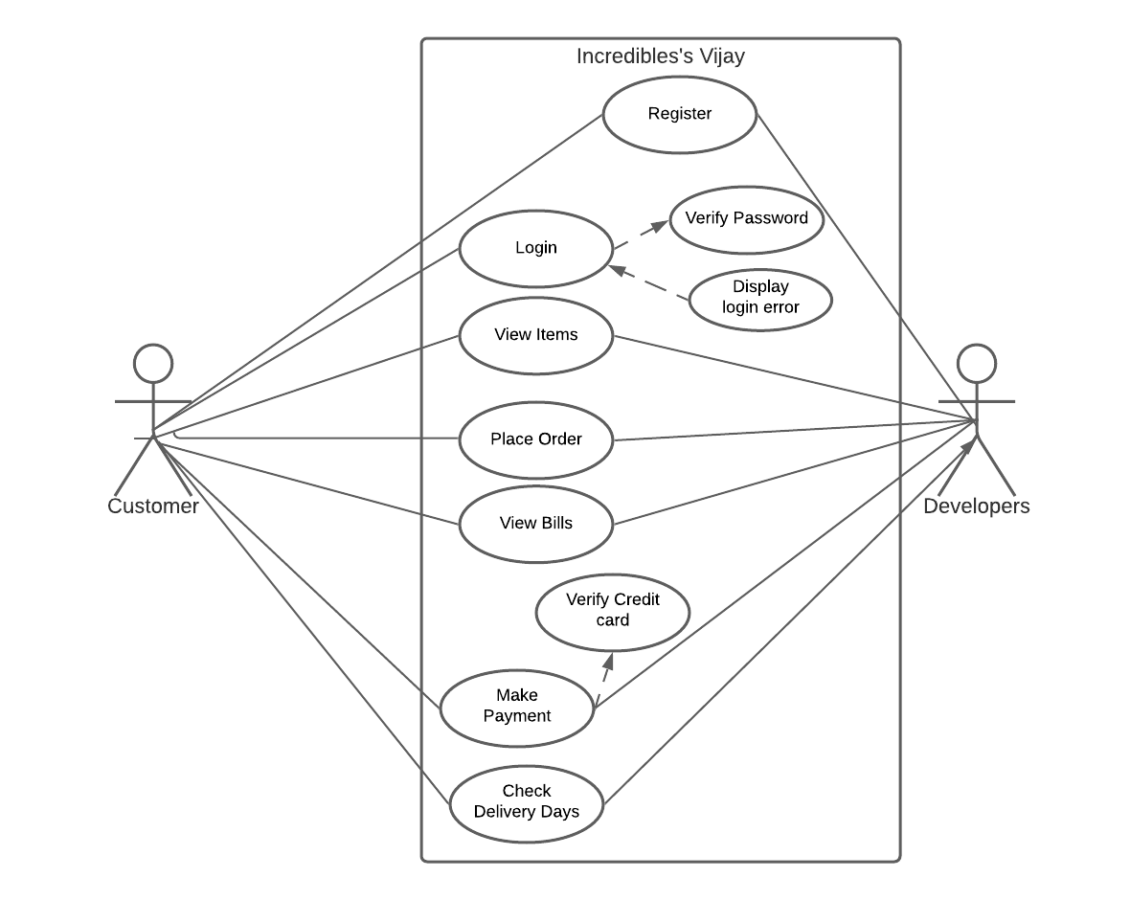

**Group Dynamics:**

Team Leader: The team leader for this project will be Gaurav Rana. All the team members will be equally responsible in the development of the project. The coding part will be handled by each team member. Gaurav rana and Akwinder kaur will be responsible for use cases, whereas Varinder kaur and Harshvardhan Varma. All the roles were mutually decided between the team members.

**Iteration 1#**

Feature Team Member Points

1 Customer Registration Gaurav Rana 3

1 Login Akwinder Kaur 2

1 Home-Page Dashboard Varinder Kaur 3

1 Logout Harshvardhan 2

**Iteration 2#**

Feature Team Member Points

2 Payment Calculation Gaurav Rana 2

2 Shop by category Akwinder Kaur 3

2 Add to cart Varinder Kaur 3

2 Pickup Location Harshvardhan 2

**Iteration 3#**

Feature Team Member Points

3 Shipping Details Gaurav Rana 2

3 Payment Information Akwinder Kaur 3

3 Delivery Status Varinder Kaur 3

3 Success Page Harshvardhan 2

**Meeting minutes:**

|  |  |  |  |
| --- | --- | --- | --- |
| Date | minutes | Description | Attendees |
| 3/October/2020 | 2 hours | Discussed about Assignment 2 and project | Varinder, Akwinder,  Gaurav Rana |
| 4/October/2020 | 4 hours | Discussed about  Project features | Varinder Kaur,  Akwinder Kaur,  Gaurav Rana |
| 5/October/2020 | 2 hours | Worked on  Project Proposal | Varinder Kaur,  Akwinder Kaur,  Gaurav Rana |
| 6/October/2020 | 1:30 hour | Worked on use cases and web app | Varinder Kaur,  Akwinder Kaur,  Gaurav Rana |
| 7/October/2020 | 3 hours | worked on git-hub | Varinder Kaur,  Akwinder Kaur,  Gaurav Rana |

**Software Toolset:** For this project, we will use java and JSP languages and JDBC for databases. The eclipse and GitHub are two main platforms we will use for this platform.