# LENGTH OF STAY PREDICTION IN HOSPITAL

# Weekly Project Meeting Minutes

*The main purpose of the document is to capture all the work that has been done by the group over the course of one week and* ***not*** *to write down what was discussed in a single meeting. You should be meeting and/or working throughout the week*.

**Time group spent on project:** 6 hours

**Group Number: 11**

**Group members present (Name, ID):**

* **Varinderjit singh (0730482)**
* **Jaspreet kaur (0730470)**
* **Kanchan bagga(0732356)**

**Specific Activities from prior week:**

* **List brief description of activities carried out by group member**
* We all are working together on our project. Now we got our dataset and we have explorer it. Moreover, the cleaning part has completed, and we did that in the excel.
* Apart from this, we are reading more tutorial as well as watching videos related to our project to come to know more about it.
* As according to our project neural network is most important, but we are not much familiar with it, that’s why we are searching more about it. As, how it works and how we will implement it in python.

**Specific Output from prior week:**

* **Include brief summary of any written work, experiments, or code developed**
* **Attach actual output as a separate file when submitting minutes; for example, export your Jupyter notebook as an html file and upload that with your minutes**

1. Import the dataset, packages and the import libraries. Moreover, read the files.

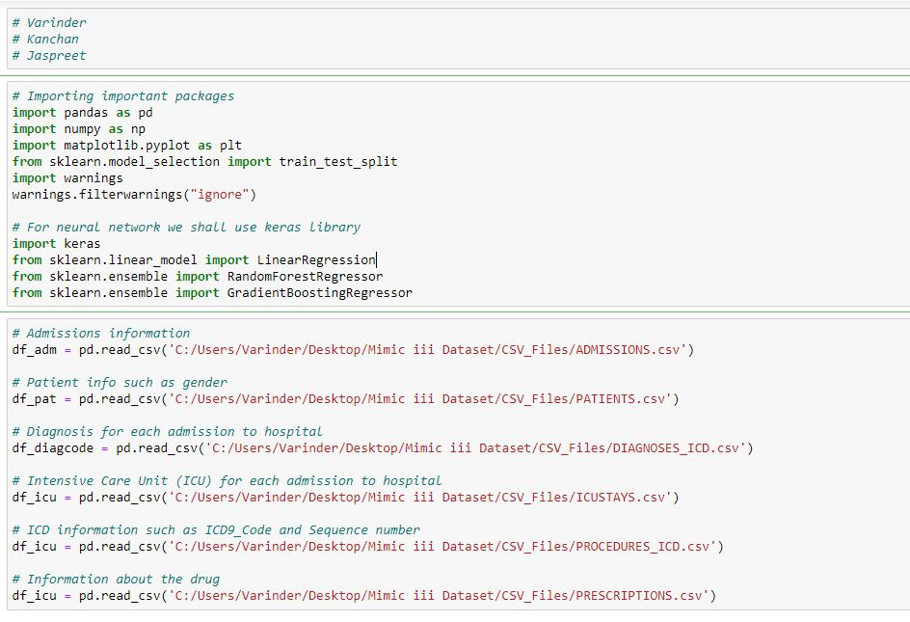

1. Here, we are exploring more about admission table, as according to the admission csv. File we having 19 columns and observations are 58975 which is unique admissions in our dataset and the number of unique patients are 46520.

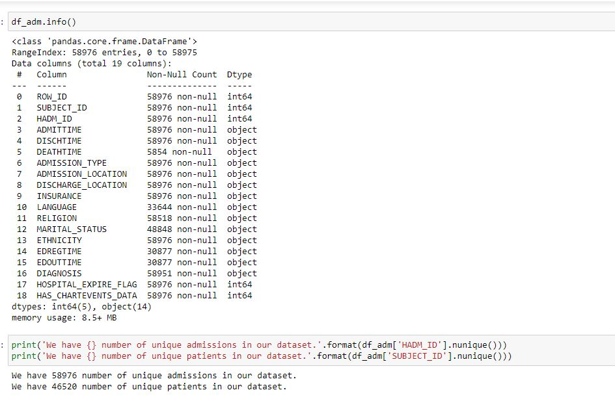

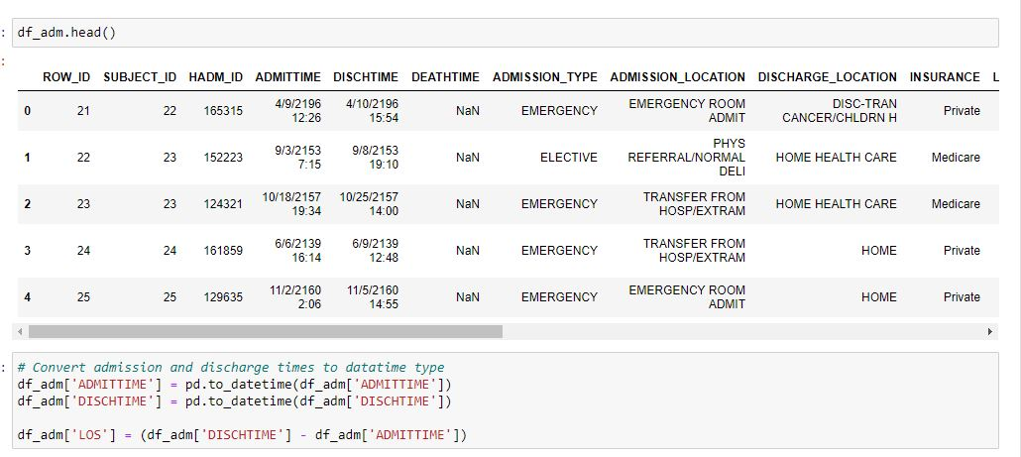

According to the above code, we find the length of stay which is the difference between admission time and discharge time. Below of this is the output of this code.

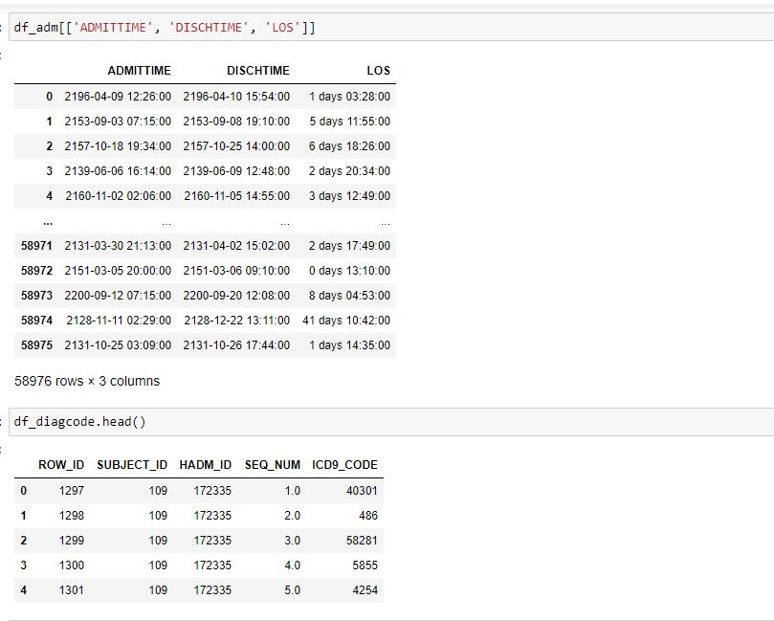

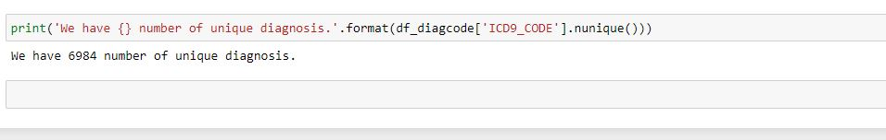

**On Target:**

* **Indicate the current status of your project**
  + _____ green: everything on track for completion by due date

**Challenges/Disagreements:**

* **List any particular challenges identified/discussed and possible solutions**
  + **include tasks causing a yellow or red flag for your project**
* As we are not much familiar with the neural network so, we are trying to learn more about it. That’s why it is a biggest challenge for us.
* In SQL we are unable to read the all data we are using the online SQL server.
* **List any notable disagreements and subsequent discussion and resolution**

All members in our project are very polite so any disagreement we encountered.

**Planned Activities for coming week:**

* **List brief description of activities by group member**
* **Make sure tasks are assigned to address yellow and red flag items**
* Yellow Flag: We will work on python programming and try to find the relationship between the variable which are more effective to build the model.
* Yellow Flag: We will start report writing on our project.

Reference: <https://physionet.org/content/mimiciii/1.4/>

<https://en.wikipedia.org/wiki/Artificial_neural_network>