**Microservices assignment 2023**

**Booking System**

**Table of contents**

**Flight Booking**

**Services identified for flight booking system**

1. discovery-server
2. apigateway
3. identity-service
4. db-flights-service
5. flights-service
6. booking-service
7. booking-saga-orchestrator
8. payments-service

The above mentioned services are elaborated in next sections.

**A data flow diagram of the proposed system is shown below**

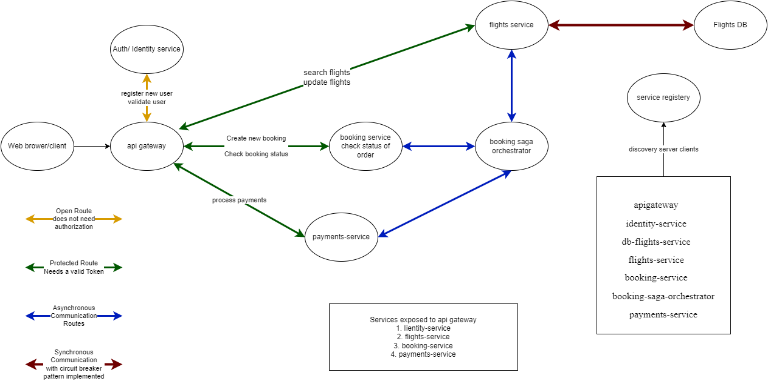

**Description and usage of various microservices implemented**

1. **Api gateway :**This service is used to map endpoints of different microservices under a single domain.  
     
   Base Uri : <http://localhost:8001>  
   1. **Register a new user**  
      Uri : <http://localhost:8001/users>  
      Method : Post  
      All fields are required  
      Request Body : JSON  
      Result :  
      
   2. **Login user**  
      Uri : <http://localhost:8001/users/login>   
      Method : Post  
      All fields are required  
      Request Body : JSON  
      Result :  
      
   3. **Search Flight**Uri : http://localhost:8001/flights?source=Amritsar&destination=Delhi&departureDate=24-04-2023  
      Method : Get  
      Authentication is Required, kindly provide valid token under Bearer Token in Postman.  
        
      Query params (all query params are optional, if not provided all flights will be shown)  
      1. source = name of the source city  
      2. destination = name of the destination city  
      3. departureDate = date of travel must be in DD-MM-YYY format  
        
      Request  
      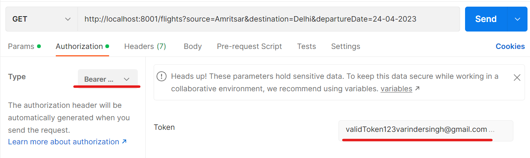  
        
        
        
        
        
        
        
        
        
        
      Result  
      Graphical user interface, text, application, email

      Description automatically generated
   4. **Search a specific flight**  
      Uri : [http://localhost:8001/flights/{flightd}](http://localhost:8001/flights/%7bflightd%7d)  
      Method : Get  
      Authentication is Required, kindly provide valid token under Bearer Token in Postman.  
        
      Path Variable (required)  
      1. flightId = Flight Id of a flight.  
        
      Request  
      Graphical user interface, text, application

      Description automatically generated  
        
        
        
        
        
        
        
        
        
        
        
        
        
        
        
        
      Response  
      Graphical user interface, text, application, email

      Description automatically generated
   5. **Book a Flight**Uri : http://localhost:8001/booking/flights  
      Method : Post  
      Authentication is Required, kindly provide valid token under Bearer Token in Postman.  
        
      Request Body : Json (All fields required)  
      1. username = username of the user booking flight  
      2. flightId = Flight Id of the flight to be booked  
      3. seatNumbers = Array of seat numbers user wish to book. (seats available 1 to 30)   
      Response :  
      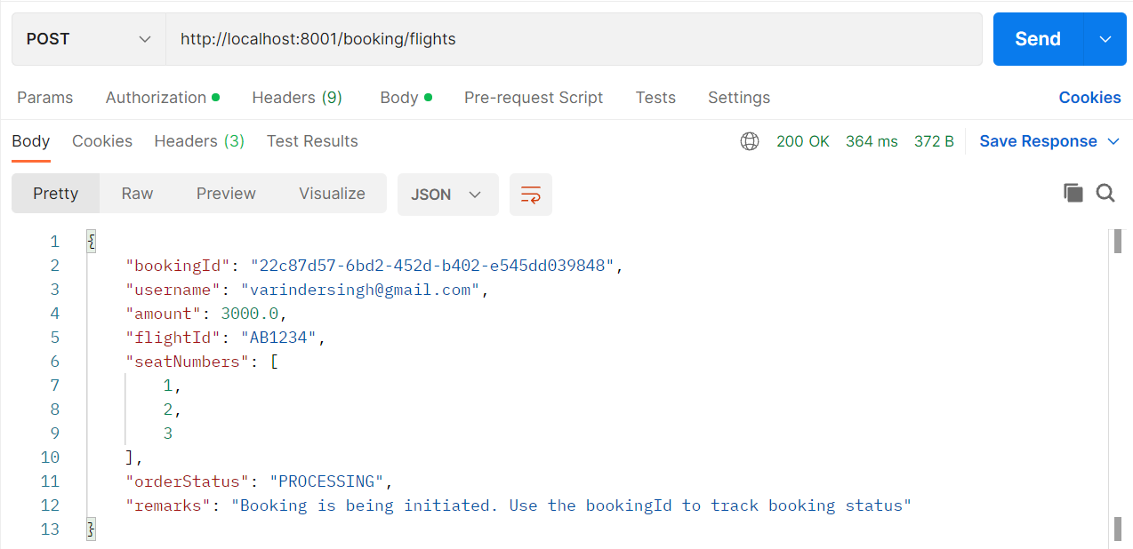
   6. **Check Booking status**Uri : http://localhost:8001/booking/flights/{bookingId}  
      Method : Get  
      Authentication is Required, kindly provide valid token under Bearer Token in Postman.  
        
      Path Variable (required)  
      1. bookingId = bookingId is unique id to track the status of the booking order.  
        
      Request:  
      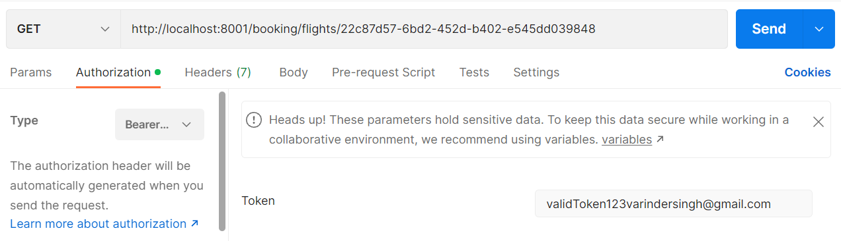  
        
      Response:  
      Graphical user interface, text, application

      Description automatically generated  
      **To Be Continued…**