MSc Dissertation Report
PERFORMANCE EVALUATION OF YOLO-BASED VEHICLE DETECTION UNDER ADVERSE ENVIRONMENTAL CONDITIONS USING SIMULATION AND REAL-WORLD DATASETS
A dissertation submitted in partial fulfilment of the requirements of Sheffield Hallam University for the degree of Master of Science in Artificial Intelligence
Student Name: Varis Jahirbhai Kureshi
Student ID: 35042321
Supervisor: Yasir Javed
Date of Submission: 10 September 2026

STATEMENT 1:
This dissertation does NOT contain confidential material and thus can be made available to staff and students via the library.

Word count: 2,972 words for the assessed main text from Introduction to Conclusion, including section headings, table text and figure captions; excluding the Abstract, Contents, References and Appendices. Maximum permitted: 3,000 words.
varisjaher2004-byte/Vehicle_Detection_Adverse_Weather: dissertation

Acknowledgements
I would like to thank my supervisor, Yasir Javed, for his guidance throughout the project, and Sheffield Hallam University for access to the academic and computing resources that supported this research.

Abstract
Camera-based vehicle detection can deteriorate when adverse conditions and dataset shift alter visual evidence. This study evaluated transfer-learned Ultralytics YOLOv8l checkpoints using prepared ACDC, corrected DAWN and combined ACDC+DAWN data, while treating CARLA scenarios as separate qualitative diagnostics. A pragmatist, predominantly quantitative design linked every reported metric to a defined validation invocation and checkpoint identity. An integrity audit found that archived DAWN validation labels retained an older numeric class scheme; a non-destructive corrected copy was verified before DAWN Fog, Rain, Entire and Combined models were retrained for 100 epochs at 640-pixel resolution. A seven-cell matrix then compared locked ACDC, corrected DAWN and Combined checkpoints under one Ultralytics validation protocol. Direct transfer was weak: ACDC-to-DAWN mAP@0.5 was 0.1362 and DAWN-to-ACDC was 0.1122, compared with within-domain estimates of 0.4221 and 0.6277. Combined training provided the strongest descriptive cross-dataset balance, retaining 0.4069 on ACDC and reaching 0.6382 on DAWN, although it did not dominate every metric. DAWN Rain reached 0.9916 mAP@0.5 on only 42 in-domain validation images and is not interpreted as universal rain robustness. Historical ACDC Fog evidence further illustrates missed objects, overlapping labels and unstable rare-class estimates. CARLA Clear, Rain, Fog and synthetic Night outputs remain non-equivalent presentation or diagnostic assets and are not pooled with real-world validation metrics. The contribution is an auditable evaluation workflow with label-remap evidence, same-row F1 calculation, checkpoint hashes and explicit construct boundaries. Findings are validation-bound, single-seed, descriptive and non-causal; they do not establish deployment safety, confidence intervals or generalised real-world performance.

Contents
Acknowledgements II
Abstract III
Contents IV
List of Tables VI
List of Figures VII
1. Introduction 1
1.1 Context and problem 1
1.2 Research question 1
1.3 Aim and objectives 1
1.4 Proposed solution, scope and contribution 1
2. Literature Review 2
2.1 Review design and search process 2
2.2 Screening and thematic organisation 2
2.3 Models used and speed-accuracy trade-offs 2
2.4 Datasets used and adverse-weather degradation 3
2.5 Domain shift, joint training and metric interpretation 3
2.6 Critical analysis of current studies 4
2.7 Synthetic weather, CARLA and the research gap 4
3. Research Design 6
3.1 Research philosophy: pragmatism 6
3.2 Overall methodology, strategy and horizon 6
3.3 Data sources and preparation 6
3.4 Checkpoint selection and metric governance 7
3.5 CARLA simulation design 7
3.6 Ethics and data governance 8
3.7 System architecture and evidence flow 8
3.8 Requirements 8
3.9 Verified implementation configuration 8
3.10 System testing 8
3.11 Risk assessment 8
3.12 Repository traceability 8
4. Results 9
4.1 Aggregate real-world performance 9
4.2 Error profile and class imbalance 9
4.3 Canonical results table 9
4.4 Qualitative real-world evidence 10
4.5 CARLA condition-specific evidence 10
4.6 Failure analysis 10
5. Evaluation 11
5.1 Technical evaluation 11
5.2 Validity and evidence integrity 11
5.3 Ethical and assessment boundary 11
6. Discussion 12
6.1 Interpreting performance variation 12
6.2 Comparison with prior research 12
6.3 Relationship between simulation and real-world evidence 12
6.4 Implications and contribution 12
7. Conclusion 13
7.1 Answer to the research question 13
7.2 Contribution and objective completion 13
7.3 Future work 13
References 14
Appendices 17
Appendix A - AI Declaration 18
Appendix B - Ethics Form and Approval Evidence 19
Appendix C - Official Publication Procedure Form 20
Appendices D-F - Participant Materials 21
Appendix G - Data, Code and Evidence 22
Appendix H - Actual Research Project Plan 31
Appendix I - Planned versus Actual Gantt Chart 41
Appendix J - Supporting Evidence 45

List of Tables
Table 4.1. Protocol-matched validation matrix. 9
Table G.1. Final evidence groups and reporting status. 22
Table G.2. Class mapping shared by the active YOLO configurations. 23
Table G.3. Core functional and research-quality requirements. 25
Table G.4. Training configuration reconstructed from the approved presets. 25
Table G.5. Software and hardware provenance. 26
Table G.6. Core system and evidence-integrity tests. 27
Table G.7. Risk log and register used during the project. 28
Table G.8. Corrected training and locked post-training records. 29
Table G.9. Accepted checkpoint identities. 30
Table H.1. Detailed project activity register (activities 1-15). 31
Table H.2. Detailed project activity register (activities 16-30). 34
Table H.3. Detailed project activity register (activities 31-45). 36
Table H.4a. Detailed project activity register (activities 46-52). 38
Table H.4b. Detailed project activity register (activities 53-60). 40
Table J.1. Low-level implemented architecture and evidence controls. 45
Table J.2. Formal verification cases and retained status. 46
Table J.3. ACDC Fog class-level validation evidence. 53
Table J.4. Locked CARLA route and capture parameters. 57
Table J.5. Provenance audit for selected qualitative outputs. 58
Table J.6. Final corrected training outcomes. 68
Table J.7. Historical ACDC Fog class support. 69

List of Figures
Figure I.1. Status-coded Gantt for activities 1-20. 42
Figure I.2. Status-coded Gantt for activities 21-40. 43
Figure I.3. Status-coded Gantt for activities 41-60. 44
Figure J.1. High-level real-data architecture. 48
Figure J.2. Evidence-flow and construct-boundary diagram. 49
Figure J.3. Project risk map. 50
Figure J.4. Protocol-matched real-world validation overview. 51
Figure J.5. CARLA four-condition diagnostic presentation. 53
Figure J.6. ACDC Fog training and validation diagnostics. 54
Figure J.7. Historical DAWN Fog diagnostic. 55
Figure J.8. Historical Combined diagnostic. 56
Figure J.9. Selected ACDC Entire success. 60
Figure J.10. Selected shared Fog success. 61
Figure J.11. Selected ACDC Night success. 62
Figure J.12. Selected shared Rain success. 63
Figure J.13. Selected ACDC Snow success. 64
Figure J.14. Selected DAWN Entire success. 65
Figure J.15. Selected Combined success. 66
Figure J.16. Matched ACDC Fog prediction and ground truth. 70

1. Introduction

1.1 Context and problem
Adverse weather changes contrast, visibility, reflections and illumination, while cameras, scene composition, class support and annotation policy create additional dataset shift. A detector that scores well within one prepared domain may therefore fail after transfer. This project evaluates that risk using real ACDC and corrected DAWN validation data, with CARLA retained only as controlled diagnostic evidence.

1.2 Research question
To what extent does YOLOv8l performance vary across ACDC, corrected DAWN and Combined configurations, and what complementary, non-equivalent evidence do CARLA Clear, Rain, Fog and synthetic Night scenarios provide?

1.3 Aim and objectives
The aim was to produce a traceable cross-domain evaluation. Objectives were to harmonise labels, audit integrity, train fixed configurations, lock checkpoints, run a seven-cell validation matrix, retain bounded simulation evidence and report limitations without causal or deployment claims.

1.4 Proposed solution, scope and contribution
The proposed solution evaluates one existing detector family through an evidence-controlled comparison that exposes label-schema failure and domain disagreement. It does not claim a new architecture. All quantitative outcomes are validation-bound estimates, not independent test accuracy or generalised real-world performance.

2. Literature Review

2.1 Review design and search process
A focused literature audit used IEEE Xplore, ScienceDirect, SpringerLink and the ACM Digital Library, supplemented by citation tracing from primary dataset and benchmark papers. Searches combined vehicle or object detection with adverse weather, YOLO, autonomous driving, domain shift, DAWN, ACDC, CARLA and synthetic-to-real terms. Database syntax was adapted to each interface. Exact historical hit counts and a complete screening log were not retained, so the chapter is not presented as a systematic or PRISMA-compliant review. Its purpose is design justification and critical comparison rather than exhaustive coverage or publication-bias estimation.
The final query groups paired detection terms with rain, fog, snow or night; compared one-stage and two-stage architectures; linked domain shift with autonomous-driving perception; and combined CARLA or synthetic data with simulation-to-real evaluation. Backward and forward citation tracing was used to locate foundational detector, dataset and robustness studies. Because the searches were an audit of an existing project rather than a preregistered review, no retrospective precision or recall of the literature search is claimed.

2.2 Screening and thematic organisation
English-language primary research, official dataset or simulator papers, and authoritative software documentation were prioritised when they informed detector design, adverse-weather sensing, domain shift, evaluation or reproducibility. Duplicates, unverifiable claims and non-road studies without transferable relevance were excluded. The evidence was organised around detector architecture, sensing and dataset construction, cross-domain robustness, and simulation-to-real validity. This thematic structure keeps literature claims separate from results reproduced in the present project.

2.3 Models used and speed-accuracy trade-offs
Faster R-CNN represents two-stage detection: a region proposal network identifies candidates before class and box refinement (Ren et al., 2015). YOLO instead predicts boxes and class probabilities in a single end-to-end evaluation (Redmon et al., 2016), establishing a practical low-latency alternative while retaining localisation trade-offs. The project uses Ultralytics YOLOv8l because its transfer-learning and validation workflow was feasible on the available hardware. Faster R-CNN, RT-DETR and other families remained literature-only; consequently, the experiments cannot establish architectural superiority. Holding the detector family and metric protocol fixed instead makes dataset-dependent behaviour more visible.

2.4 Datasets used and adverse-weather degradation
Fog reduces contrast and visibility; rain introduces streaks, spray and wet-surface reflections; snow obscures boundaries; and low illumination changes noise and glare. Actual-road sensing results show that degradation also depends on intensity, distance and target properties (Kim et al., 2023). Multimodal evidence can recover information unavailable to one camera (Bijelic et al., 2020), confirming that a detector error may originate in image formation, sensing, scene composition, labels or learned features. The present RGB comparisons observe domain outcomes but cannot isolate one physical cause.
DAWN contains 1,000 real-traffic images divided across fog, rain, snow and sandstorm and uses bounding boxes (Kenk and Hassaballah, 2020). ACDC contains 4,006 adverse-condition driving images across fog, night, rain and snow with pixel-level panoptic annotation and corresponding normal-condition views (Sakaridis et al., 2021). Converting prepared ACDC artefacts and DAWN labels into one eight-class YOLO scheme enables procedural comparison, but it cannot equalise cameras, locations, traffic density, condition severity or annotation policy.

2.5 Domain shift, joint training and metric interpretation
Models can exploit collection-specific regularities that fail across datasets (Torralba and Efros, 2011), while confidence may remain high under distribution shift (Ovadia et al., 2019). Domain-generalisation conclusions also depend on source composition, model selection and evaluation protocol (Gulrajani and Lopez-Paz, 2021; Koh et al., 2021). Kumar and Muhammad (2023) motivate merged ACDC and DAWN training, but more images do not ensure equal exposure. In this study ACDC supplies 79.1% of Combined training images and 77.2% of union validation images; separate constituent-domain rows are therefore more informative than the union score alone.
mAP@0.5 uses a permissive intersection-over-union threshold relative to mAP@0.5:0.95, and aggregate AP may conceal rare-class weakness (Lin et al., 2014). Precision, Recall and F1 expose different error costs only when taken from the same invocation. Validation used for checkpoint selection can be optimistic relative to an untouched target test set. The dissertation therefore reports same-row metrics, image and instance support, selection status and checkpoint provenance, and avoids relabelling validation as deployment testing.

2.6 Critical analysis of current studies
Lee and Kang (2025) proposed YOLOv8-SCS by adding a Swin Transformer, CBAM and SCDown to YOLOv8, with DAWN folds, ablations and efficiency reporting. It is a relevant adverse-weather comparator, but it was not implemented here and its splits and scale are not protocol-matched. A later correction changed a YOLOv5 table entry and corrected the C2f illustration and SCDown stride in the architecture figure (Lee and Kang, 2026). This reinforces the need to distinguish cited claims from reproduced baselines and to preserve exact implementation provenance.
The corrected record does not invalidate the comparator, but it shows why headline scores alone are insufficient: architecture descriptions, folds, checkpoint rules and efficiency measurements jointly determine comparability. Accordingly, this study uses YOLOv8-SCS as contextual evidence, not a numerical baseline, and reserves empirical comparison for executions sharing data partitions, selection rules and metric procedures.

2.7 Synthetic weather, CARLA and the research gap
Synthetic data provides control but introduces a domain gap. Studies of synthetic fog and physics-based rain gain credibility by evaluating against separate real target data and calibrated severity (Sakaridis et al., 2018; Halder et al., 2019). CARLA supports configurable maps, actors, sensors and weather (Dosovitskiy et al., 2017), yet shader reflections, wet-asphalt specular highlights, camera response, traffic composition and atmospheric effects differ from DAWN and ACDC. A visually successful simulated detection is therefore diagnostic evidence, not a numerical estimate of real-weather robustness.
The research gap is methodological rather than a claim to a new state-of-the-art detector: published gains are difficult to compare when mappings, partitions, checkpoint rules and validation protocols differ. This study provides an auditable ACDC, corrected-DAWN and joint-training comparison, direct transfer in both directions, and a strict simulation boundary. It can reveal domain disagreement and measurement-integrity failure, but not causal weather effects, deployment safety or detector-family superiority.
A stronger successor would preregister scene-grouped splits, repeat independent seeds, retain an untouched target test set and compare architecture, latency and calibration under one protocol. Those controls are future requirements rather than implied achievements of the present evidence.

3. Research Design

3.1 Research philosophy: pragmatism
Pragmatism was adopted because methods were judged by their usefulness to the practical question (Saunders et al., 2019). Standard detection metrics answer performance questions; hashes and repository controls address reproducibility; and bounded CARLA observations address engineering demonstration. These evidence forms are complementary but not interchangeable.

3.2 Overall methodology, strategy and horizon
The study is quantitative and mono-method at the level of its claims: Precision, Recall, F1, mAP@0.5 and mAP@0.5:0.95 were generated by one Ultralytics framework and compared descriptively across fixed cells. Pragmatism accommodates provenance and bounded CARLA diagnostics without treating them as participant-based mixed methods. Positivist, inferential or critical-realist claims are unavailable because neither independent sampling nor causal-mechanism isolation was designed.
Under one detector and reporting protocol, performance was expected to differ across prepared domains and joint exposure might improve balance. The cross-sectional comparative experiment locked datasets, checkpoints and rules for one final comparison; it does not estimate temporal drift, seasonal variation or model ageing.
No causal hypothesis was significance-tested. The unit is a recorded model-to-validation invocation, not an independently sampled road user or weather population; the seven cells therefore support reproducible descriptive comparison, not inferential statistics.

3.3 Data sources and preparation
DAWN and ACDC were treated as distinct domains and harmonised to eight YOLO classes. The final local DAWN protocol used 422 training and 120 validation images; no complete file-level ledger supports claims about the remainder of the 1,000-image release. ACDC was consumed as a prepared derived artefact with 1,600 training and 406 validation images and normalised boxes; the retained evidence does not reconstruct the upstream panoptic-to-box conversion. Appendix G records these provenance boundaries.
The corrected DAWN audit paired images and labels, checked identifiers and box bounds, preserved original labels, and semantically checked all 78 Fog validation images. It did not establish exhaustive perceptual-duplicate or scene-grouped leakage control across both datasets. Combined training contained 2,022 images, 79.1% from ACDC, without retained evidence of domain-balanced sampling or loss reweighting.

3.4 Checkpoint selection and metric governance
Historical and corrected evidence use different documented selection statements. Historical rows were taken retrospectively from results.csv at maximum mAP@0.5, retaining Precision, Recall and both mAP values from the same row. Corrected best.pt files were created through the Ultralytics training-validation process, then hash-locked before the common seven-cell matrix. Corrected checkpoints are not described as retrospective CSV-row choices, and training-trajectory metrics are not substituted for the matrix.
F1 was recalculated as 2PR/(P+R) from unrounded same-row Precision and Recall. Training outcomes and post-training matrix cells remain distinct invocations and are neither averaged nor treated as errors when small differences occur. Appendix G records checkpoint hashes, dataset weighting and metric lineage.
The authoritative ACDC-to-DAWN row uses P 0.595542 and R 0.118977, producing F1 0.198331 and therefore 0.1983 at four decimals. This rule prevents rounding drift and cross-row assembly. Five accepted checkpoint digests are retained outside the narrative so each reported configuration remains attributable without committing weight binaries to Git.

3.5 CARLA simulation design
CARLA 0.9.16 used Town10HD_Opt, 640 x 360 RGB, 10 sensor FPS and a 20-tick/s world. Clear, Rain, Fog and CPU day-for-night outputs were retained as non-equivalent qualitative diagnostics; none entered the real-data matrix.

3.6 Ethics and data governance
The implemented study uses public secondary data and simulation with no participants. Signed UREC1 evidence and the publication form remain external administrative prerequisites; no human or supervisor feedback is reported as research data.

3.7 System architecture and evidence flow
Appendix J specifies the implemented configuration, correction, training, checkpoint, validation, metric and evidence stages, plus formal tests T01-T15. This keeps low-level detail auditable without inflating the main methodology.

3.8 Requirements
Functional and research-quality requirements are retained in Appendix G, Table G.3.

3.9 Verified implementation configuration
Training and environment controls are reported in Appendix G, Tables G.4-G.5.

3.10 System testing
Formal verification status, including Partial and Not established outcomes, is retained in Appendix J, Table J.2.

3.11 Risk assessment
The risk register is retained in Appendix G, Table G.7; unresolved approval and evidence-classification risks remain explicit.

3.12 Repository traceability
Experimental evidence is pinned to commit 1eb81b5; the Day-1 audit is preserved at commit 5710c39 on branch codex/day1-evidence-lock.

4. Results

4.1 Aggregate real-world performance
Direct transfer was substantially weaker than within-domain validation: ACDC-to-DAWN mAP@0.5 was 0.1362 versus 0.4221 on ACDC, while DAWN-to-ACDC was 0.1122 versus 0.6277 on DAWN. Combined training retained 0.4069 on ACDC and reached 0.6382 on DAWN, providing the strongest descriptive balance without dominating every metric.
As a supplementary balance lens, the unweighted mean of ACDC and DAWN mAP@0.5 was 0.5226 for Combined, compared with 0.2791 for ACDC-only and 0.3700 for DAWN-only; Combined also had the highest worst-domain value. These arithmetic summaries are descriptive, not new benchmarks or significance tests, and do not correct unequal image or instance support.

4.2 Error profile and class imbalance
Off-diagonal Recall fell to 0.1190 and 0.1330, showing missed detections as the clearest aggregate transfer failure. Corrected DAWN Rain reached 0.9916 mAP@0.5 on only 42 validation images with car-dominated support, so saturation and framing diversity limit interpretation.
Within that Rain split, 266 of 319 instances were cars, while bus and person had only five and two instances. Aggregate mAP can therefore remain high without demonstrating reliable behaviour for rare classes, backgrounds, object scales or all natural rain mechanisms.

4.3 Canonical results table
Table 4.1. Protocol-matched validation matrix. All rows are validation-bound; F1 uses unrounded same-row Precision and Recall.
Train-to-eval | Images | P | R | F1 | mAP50 | mAP50-95
ACDC to ACDC | 406 | .6226 | .4014 | .4881 | .4221 | .2634
ACDC to DAWN | 120 | .5955 | .1190 | .1983 | .1362 | .0797
DAWN to ACDC | 406 | .2055 | .1330 | .1615 | .1122 | .0666
DAWN to DAWN | 120 | .8465 | .5794 | .6879 | .6277 | .4369
Combined to ACDC | 406 | .5225 | .4129 | .4613 | .4069 | .2452
Combined to DAWN | 120 | .8142 | .6093 | .6970 | .6382 | .4228
Combined to Union | 526 | .5808 | .4376 | .4991 | .4472 | .2720

4.4 Qualitative real-world evidence
Appendix J separates deliberately selected high-confidence successes from a matched historical ACDC Fog failure panel. The DAWN-labelled Fog and Rain presentation folders were byte-identical to corresponding ACDC folders, so each pool is shown once; this duplication is not evidence of train-validation leakage.

4.5 CARLA condition-specific evidence
CARLA Clear is raw YOLOv8s tracking evidence, whereas Rain, Fog and synthetic Night use stable or actor-aided presentation procedures. Their non-uniform construction prevents a numerical cross-weather ranking.

4.6 Failure analysis
The matched ACDC Fog batch shows absent predictions, crowded boxes and class confusion. Historical support is heavily car-weighted (496 of 640 instances); bus and train estimates use only five and three instances. The panel is illustrative, not a corrected-matrix error rate, and the retained matrix lacks per-class false-positive, false-negative and localisation counts needed for a causal weather taxonomy.

5. Evaluation

5.1 Technical evaluation
Four corrected runs, seven validation cells, same-row F1 checks and checkpoint hashes passed the retained verifier. Reproduction is supported at code, configuration, metric and provenance level, but raw datasets and weights remain separately controlled.

5.2 Validity and evidence integrity
Validity is strongest in traceability and direct transfer. It remains limited by validation-based checkpoint selection, one seed, unequal domains, no confidence intervals, no significance tests, no final per-class error matrix and no detector-family or hyperparameter ablation.
The off-diagonal cells are the clearest transfer evidence because checkpoints were selected elsewhere. Within-domain and Combined slice results remain selection-conditioned. The lack of a scene-grouped duplicate ledger and independent hold-out test restricts external validity, while deliberate successful visual examples cannot substitute for confidence-ranked false-positive, false-negative and localisation analysis.
Interpretation also depends on operating thresholds. A checkpoint can trade precision against recall when confidence or intersection over union settings change, so the reported operating point should not be read as a performance curve. The retained matrix uses a validation procedure, but threshold sensitivity was not evaluated. Likewise, no calibration measure, latency distribution, energy measurement or safety weighted cost function was retained. These omissions matter in autonomous driving because missed pedestrians and false vehicle alarms can have different consequences. Future replication should preserve confidence curves, per class precision recall traces, latency, calibration error and an application defined error cost alongside average precision.

5.3 Ethical and assessment boundary
No participant evaluation is claimed. Any beneficiary or expert study requires an institutionally approved route before recruitment or data collection.

6. Discussion

6.1 Interpreting performance variation
Weak off-diagonal mAP and Recall demonstrate dataset shift, not that one named weather condition is intrinsically harder. Cameras, scenes, object scale, class prevalence and annotation policy remain confounded; aggregate rows cannot prove which class failed for which physical mechanism.
The historical ACDC Fog panel supports a narrower mechanism discussion: distant or overlapping objects are missed and a bus can be confused with the rare train class. Because this panel is not a final matrix cell and no matched class-stratified panel exists for every domain, it illustrates plausible errors rather than quantifying their frequency.

6.2 Comparison with prior research
Combined raised the two-domain mean mAP@0.5 to 0.5226, versus 0.2791 for ACDC-only and 0.3700 for DAWN-only, but remained below specialists on ACDC F1 and mAP and DAWN mAP@0.5:0.95. This directional agreement with Kumar and Muhammad (2023) indicates a balance-specialisation trade-off, not protocol-matched replication or universal dominance.

6.3 Relationship between simulation and real-world evidence
CARLA supports repeatable engineering observation but does not match real camera response, shader reflections, wet-asphalt highlights, atmospheric variability or traffic composition. Unlike studies calibrated against real target data, this project provides no sim-to-real bridge experiment. CARLA therefore supports demonstration and debugging only.
Numerical comparison with ACDC or DAWN would conflate rendering fidelity, ground-truth availability and different output procedures with detector performance. Keeping simulation outside the matrix protects construct validity while retaining its value for controlled inspection.

6.4 Implications and contribution
The contribution is an evidence-governance protocol combining label audit, original preservation, checkpoint locking, same-invocation metrics, bidirectional transfer and a simulation boundary. It exposes schema failure and transfer risk, but cannot establish deployment safety, causality or architectural superiority.

7. Conclusion

7.1 Answer to the research question
YOLOv8l performance was strongly domain-dependent under the locked validation protocol. Direct transfer was weak, while Combined training provided the most balanced descriptive result across ACDC and corrected DAWN. CARLA supplied complementary qualitative evidence only.

7.2 Contribution and objective completion
The objectives were met through label harmonisation, non-destructive DAWN correction, hash-locked checkpoints, same-invocation metrics, bidirectional transfer and explicit construct boundaries. Originality lies in integrating these controls into one auditable workflow; the contribution is methodological rather than a new detector.

7.3 Future work
Future work should use scene-grouped untouched tests, repeated seeds, uncertainty estimates, class-stratified error analysis and protocol-matched architecture and hyperparameter ablations. CARLA should be calibrated against real targets before quantitative sim-to-real claims, and any human evaluation must follow approved ethics procedures.
Until those controls exist, the reported deltas remain evidence about this locked validation protocol rather than population-level guarantees at present.

References
Bijelic, M., Gruber, T., Mannan, F., Kraus, F., Ritter, W., Dietmayer, K., & Heide, F. (2020). Seeing through fog without seeing fog: Deep multimodal sensor fusion in unseen adverse weather. Proceedings of the IEEE/CVF Conference on Computer Vision and Pattern Recognition, 11682–11692. https://doi.org/10.1109/CVPR42600.2020.01170
Dosovitskiy, A., Ros, G., Codevilla, F., Lopez, A., & Koltun, V. (2017). CARLA: An open urban driving simulator. Proceedings of Machine Learning Research, 78, 1–16. https://proceedings.mlr.press/v78/dosovitskiy17a.html
Gulrajani, I., & Lopez-Paz, D. (2021). In search of lost domain generalization. International Conference on Learning Representations. https://openreview.net/forum?id=lQdXeXDoWtI
Halder, S. S., Lalonde, J.-F., & de Charette, R. (2019). Physics-based rendering for improving robustness to rain. Proceedings of the IEEE/CVF International Conference on Computer Vision, 10203–10212.
Hendrycks, D., & Dietterich, T. (2019). Benchmarking neural network robustness to common corruptions and perturbations. International Conference on Learning Representations. https://openreview.net/forum?id=HJz6tiCqYm
Jocher, G., Qiu, J., & Chaurasia, A. (2026). Ultralytics YOLO (Version 8.4.104) [Computer software]. GitHub. https://github.com/ultralytics/ultralytics
Kenk, M. A., & Hassaballah, M. (2020). DAWN: Vehicle detection in adverse weather nature dataset. arXiv. https://doi.org/10.48550/arXiv.2008.05402
Kim, J., Park, B.-J., & Kim, J. (2023). Empirical analysis of autonomous vehicle's LiDAR detection performance degradation for actual road driving in rain and fog. Sensors, 23(6), 2972. https://doi.org/10.3390/s23062972
Koh, P. W., Sagawa, S., Marklund, H., Xie, S. M., Zhang, M., Balsubramani, A., Hu, W., Yasunaga, M., Phillips, R. L., Gao, I., Lee, T., David, E., Stavness, I., Guo, W., Earnshaw, B., Haque, I., Beery, S. M., Leskovec, J., Kundaje, A., ... Liang, P. (2021). WILDS: A benchmark of in-the-wild distribution shifts. Proceedings of Machine Learning Research, 139, 5637–5664. https://proceedings.mlr.press/v139/koh21a.html
Kumar, D., & Muhammad, N. (2023). Object detection in adverse weather for autonomous driving through data merging and YOLOv8. Sensors, 23(20), 8471. https://doi.org/10.3390/s23208471
Lee, Y., & Kang, J. (2025). YOLOv8-SCS: Improved object detection for autonomous driving under adverse weather conditions. IEEE Access, 13, 149933–149946. https://doi.org/10.1109/ACCESS.2025.3602211
Lee, Y., & Kang, J. (2026). Corrections to “YOLOv8-SCS: Improved object detection for autonomous driving under adverse weather conditions.” IEEE Access, 14, 48898–48900. https://doi.org/10.1109/ACCESS.2026.3675278
Lin, T.-Y., Maire, M., Belongie, S., Bourdev, L., Girshick, R., Hays, J., Perona, P., Ramanan, D., Dollar, P., & Zitnick, C. L. (2014). Microsoft COCO: Common objects in context. In Computer Vision–ECCV 2014 (pp. 740–755). Springer. https://doi.org/10.1007/978-3-319-10602-1_48
Ovadia, Y., Fertig, E., Ren, J., Nado, Z., Sculley, D., Nowozin, S., Dillon, J. V., Lakshminarayanan, B., & Snoek, J. (2019). Can you trust your model's uncertainty? Evaluating predictive uncertainty under dataset shift. Advances in Neural Information Processing Systems, 32. https://proceedings.neurips.cc/paper/2019/hash/8558cb408c1d76621371888657d2eb1d-Abstract.html
Redmon, J., Divvala, S., Girshick, R., & Farhadi, A. (2016). You only look once: Unified, real-time object detection. Proceedings of the IEEE Conference on Computer Vision and Pattern Recognition, 779–788. https://doi.org/10.1109/CVPR.2016.91
Ren, S., He, K., Girshick, R., & Sun, J. (2015). Faster R-CNN: Towards real-time object detection with region proposal networks. Advances in Neural Information Processing Systems, 28, 91–99.
Sakaridis, C., Dai, D., & Van Gool, L. (2018). Semantic foggy scene understanding with synthetic data. International Journal of Computer Vision, 126, 973–992. https://doi.org/10.1007/s11263-018-1072-8
Sakaridis, C., Dai, D., & Van Gool, L. (2021). ACDC: The adverse conditions dataset with correspondences for semantic driving scene understanding. Proceedings of the IEEE/CVF International Conference on Computer Vision, 10765–10775. https://doi.org/10.1109/ICCV48922.2021.01059
Saunders, M. N. K., Lewis, P., & Thornhill, A. (2019). Research methods for business students (8th ed.). Pearson.
Torralba, A., & Efros, A. A. (2011). Unbiased look at dataset bias. Proceedings of the IEEE Conference on Computer Vision and Pattern Recognition, 1521–1528. https://doi.org/10.1109/CVPR.2011.5995347

Appendices

Appendix A - AI Declaration
AI Transparency Scale declaration: AITS 2 - AI for Shaping.
Artificial Intelligence tools were used within AITS 2 for discrete shaping tasks: considering outline alternatives, checking section order and handbook alignment, identifying consistency, word-count and evidence-integrity risks, suggesting language edits, assisting with debugging and script refinement, and helping format original project diagrams, the Gantt chart and presentation. AI outputs were treated as proposals rather than evidence, and AI was not treated as an author or scholarly source. The student configured and executed the experiments, prepared the datasets, selected the retained evidence, checked metrics against source CSV and repository records, reviewed citations and factual claims against primary or official sources, and accepts responsibility for the final submission. No live participant data, personal data, confidential material or unpublished supervisor feedback was entered into an open generative-AI system. AI did not generate experimental measurements, ethics approval, supervisor feedback or participant evidence. Unsupported or unverifiable suggestions were removed.

Appendix B - Ethics Form and Approval Evidence
Supervisor instruction received on 30 August 2026: after UREC approval is announced to the group, the student must download the signed UREC1 form from Blackboard and insert it in Appendix B before submission. Until that signed institutional record is inserted, no ethics approval is claimed within this document and no human-participant, supervisor, expert or beneficiary feedback is treated as research data.

Appendix C - Official Publication Procedure Form
The official publication form follows the UREC1 material. Before submission, the student must add their own signature and date to the form, as instructed by the supervisor on 30 August 2026. No additional supervisor signature is asserted here.


Appendices D-F - Participant Materials
Under the submitted UREC1 route, the implemented research uses public secondary datasets and synthetic CARLA data and has recruited no human participants; Appendices D-F are therefore not currently applicable. If an amended proforma or UREC2 route is approved for user, expert or beneficiary evaluation, the final submission must include the approved official Participant Information Sheet in Appendix D, anonymised consent evidence in Appendix E and the approved student-designed data-gathering instrument in Appendix F. No participant material or feedback will be invented or collected before approval.

Appendix G - Data, Code and Evidence
Repository review branch: https://github.com/varisjaher2004-byte/Vehicle_Detection_Adverse_Weather/tree/codex/final-corrected-evidence
Corrected evidence commit: 1eb81b5 on branch codex/final-corrected-evidence. The commit adds the non-destructive label-remap procedure, portable corrected training and cross-domain validation entry points, compact final metrics, checkpoint hashes and automated checks. Raw datasets, trained weights, generated videos, archives and local caches remain intentionally excluded.
Table G.1. Final evidence groups and reporting status.
Evidence group | Dataset / relationship | Final source | Reporting status
ACDC historical | Entire, Fog, Night, Rain, Snow | results/ACDC/ | Valid within-domain provenance
DAWN corrected | Fog, Rain, Entire | results/CORRECTED_2026-08-27/corrected_training_metrics.csv | Final corrected evidence
Combined corrected | ACDC+DAWN union | results/CORRECTED_2026-08-27/corrected_training_metrics.csv | Final corrected evidence
Validation matrix | ACDC↔DAWN and Combined | results/CORRECTED_2026-08-27/final_cross_domain_validation_matrix.csv | Final corrected evidence
Table G.2. Class mapping shared by the active YOLO configurations.
Class ID | Class name | Class ID | Class name
0 | person | 4 | bus
1 | rider | 5 | train
2 | car | 6 | motorcycle
3 | truck | 7 | bicycle
Dataset-count boundary: the corrected audit verifies 1,600 ACDC training images, 406 ACDC validation images, 422 DAWN training images and 120 DAWN validation images in the local prepared splits used for the final protocol. Raw datasets remain excluded from Git, and the repository does not claim that these counts describe every upstream dataset release.
Dataset and software access points: ACDC project site — https://acdc.vision.ee.ethz.ch/; DAWN primary dataset record — https://doi.org/10.48550/arXiv.2008.05402; CARLA 0.9.16 documentation — https://carla.readthedocs.io/en/0.9.16/; corrected project evidence — https://github.com/varisjaher2004-byte/Vehicle_Detection_Adverse_Weather/tree/codex/final-corrected-evidence. Access is subject to the source providers’ terms. Raw datasets are not embedded in the repository.

The source releases and local training artefacts are distinct. DAWN is officially described as a 1,000-image real-traffic dataset divided into fog, rain, snow and sandstorm folders and annotated with bounding boxes. Those folders describe weather categories, not the fixed split used here. The corrected local protocol contains 422 training and 120 validation images. No complete file-level ledger links every upstream image to inclusion or exclusion, so no undocumented exclusion reason is asserted.
ACDC is released for dense semantic and panoptic scene understanding, with adverse-condition images and corresponding normal-condition views; it is not a native YOLO bounding-box dataset. The prepared study artefact contains 1,600 training and 406 validation images with normalised YOLO boxes. The audit confirms the format consumed by training but does not reconstruct the upstream mask or instance to box conversion. No connected-component, filtering or occlusion rule is attributed without the missing conversion record.
Leakage control is limited to retained evidence. The corrected DAWN audit paired images and labels, verified identifiers and bounds, preserved originals and semantically checked all 78 Fog validation images against Pascal VOC names. An exhaustive cross-split byte-hash, perceptual-near-duplicate and scene-identifier audit is not retained for every ACDC and DAWN image. Scene leakage is therefore not claimed to have been eliminated.
Combined training contains 2,022 images: 1,600 ACDC and 422 corrected DAWN, making ACDC 79.1% of training images. Union validation contains 526 images: 406 ACDC and 120 corrected DAWN, making ACDC 77.2%. No explicit domain-level loss reweighting or balanced domain sampling is evidenced. Constituent Combined-to-ACDC and Combined-to-DAWN rows, rather than the union alone, are the appropriate balance evidence.
Detailed implementation artefacts are retained below so that the concise Research Design section can focus on methodological justification while the evidence remains directly auditable.
Table G.3. Core functional and research-quality requirements.
ID | Requirement | Acceptance evidence
FR1 | Load active ACDC, DAWN and Combined YAML configurations. | Repository verifier passes all nine active configurations.
FR2 | Train the selected YOLOv8l model through a documented preset. | Portable runner resolves the model, data path and output directory.
FR3 | Select the row with maximum mAP@0.5 and retain P, R and both mAP values from that same row. | Verified evidence manifest matches each source results.csv.
FR4 | Generate and retain Clear, Rain, Fog and synthetic Night CARLA evidence. | Approved scripts, route and condition artefacts are present.
QR1 | Keep raw, diagnostic, presentation and research evidence distinguishable. | Evidence-integrity rules and qualified captions are applied.
QR2 | Avoid machine-specific assumptions in the supported rerun route. | Relative configs, portable runner and documented environment are committed.
Table G.4. Training configuration reconstructed from the approved presets.
Configuration item | Verified value
Detector | Ultralytics YOLOv8l pretrained weights (yolov8l.pt)
Training duration | 100 epochs for all nine retained real-world experiments
Image size | 640 pixels
Batch size | 4 for ACDC and DAWN condition runs; 2 for DAWN Entire and Combined
Workers | 4 except DAWN Entire (2)
Device | CUDA device 0
Transfer-learning controls | Pretrained weights; AMP enabled; cache disabled
Recorded reproducibility controls | Seed 0 and deterministic mode in the seven committed args.yaml-derived presets; unavailable in equivalent committed args.yaml form for ACDC Night and Rain
Classes | person, rider, car, truck, bus, train, motorcycle and bicycle
Selection rule | Maximum metrics/mAP50(B); same-row Precision, Recall, mAP50 and mAP50-95; F1 derived from same-row P and R
Table G.5. Software and hardware provenance.
Context | Recorded environment
Repository reproduction environment, verified 20 August 2026 | Windows; Python 3.12.10; Ultralytics 8.4.104; PyTorch 2.12.1+cu126; CUDA 12.6; RTX 3050 6GB; CARLA 0.9.16
ACDC Fog best.pt validation transcript | Python 3.13.3; Ultralytics 8.4.81; PyTorch 2.11.0+cu128; RTX 3050 6GB
Interpretation | The current reproducibility environment is documented separately from the historical validation transcript; identical numerical reproduction is not guaranteed across builds.
Table G.6. Core system and evidence-integrity tests.
Test | Expected outcome | Verified evidence/status
Repository configuration validation | Nine YAMLs parse and contain eight mapped classes. | PASS: 9 configurations verified.
Evidence-manifest validation | Historical same-row manifest and corrected evidence manifest match their declared sources. | PASS: 9 historical rows plus 11 corrected manifest rows verified.
Training preset validation | Every experiment resolves a model, data file and training parameters. | PASS: 9 presets verified; dry-run produces no training.
Python compilation | Evaluation and training source compiles without syntax errors. | PASS: compileall completed.
CARLA route validation | Portable route retains the locked Town10 definition. | PASS: Town10HD_Opt, spawn index 36.
Evidence classification | Presentation outputs are not reported as standard raw recall. | PASS: simulation boundary documented and captions qualified.
Table G.7. Risk log and register used during the project.
ID / risk | Likelihood | Impact | Mitigation and residual position
R1 Missing or invalid annotations | Medium | High | Validate image-label correspondence and YAML paths; exclude affected runs. Residual: Medium.
R2 Dataset/class imbalance | High | Medium | Report class-level AP and avoid treating aggregate mAP as universal reliability. Residual: Medium.
R3 Limited GPU resources | Medium | Medium | Use 640-pixel images, controlled batches, AMP and conservative CARLA rendering. Residual: Low.
R4 CARLA renderer instability | High | High | Retain stable scripts; use positive-sun rendering plus disclosed CPU day-for-night processing. Residual: Medium.
R5 Misleading visual outputs | Medium | High | Separate raw, diagnostic and GT-aided/stable presentation evidence; qualify captions. Residual: Medium.
R6 Loss of provenance/reproducibility | Medium | High | Preserve scripts, configs, source CSVs, manifest, documentation and commit ID. Residual: Low.
Table G.8. Distinct corrected training and locked post-training validation records.
Record | P | R | F1 | mAP@0.5 | mAP@0.5:0.95 | Role
DAWN Entire corrected training outcome | 0.848968 | 0.578431 | 0.688062 | 0.627872 | 0.436684 | Training-trajectory record
Corrected DAWN to corrected DAWN | 0.846481 | 0.579369 | 0.687905 | 0.627660 | 0.436855 | Locked post-training validation cell
Combined corrected training outcome | 0.581582 | 0.439775 | 0.500834 | 0.446463 | 0.271198 | Training-trajectory record
Combined to corrected union | 0.580848 | 0.437565 | 0.499127 | 0.447226 | 0.271959 | Locked post-training validation cell
Use the seven-cell matrix for cross-model and domain comparison. Training outcomes remain run-history evidence; the paired rows are not averaged, substituted or described as evidence errors.
Table G.9. Accepted checkpoint identities retained by the Day-1 evidence lock.
Checkpoint | SHA-256
ACDC Entire best.pt | 346EA3443FE23F0C164DC79DE96B53D73085AE5CACAC10FD4D3477D4F429162B
DAWN Fog corrected best.pt | C523CC15F7ABC5B2AED1722D1F2BA2744AB3B6C0232A27DB346209F777517392
DAWN Rain corrected best.pt | 66307BC4BC1A711158D6DC138F2268FEC04B6AAF266FBCF1A4BC994E61D1B324
DAWN Entire corrected best.pt | B82B4F5FA0550AC3376A30909F6F7707069596C36DA613CBBEB39E7F3880A903
Combined corrected best.pt | E539BD2515215EF27AC5D077506A9BB6D6474B2D626EB2CDF2501AA7643B84CC
Experimental evidence is pinned to commit 1eb81b5. The sanitised Day-1 audit register is separately preserved at commit 5710c399f2c4be4329f9bc4e6d38523bf8f322ad on branch codex/day1-evidence-lock. Weight binaries are not committed to Git.

Appendix H - Actual Research Project Plan
The project plan reproduces 60 activities and four verified supervision meetings: 11 June, 2 July, 30 July and 25 August 2026. Table H.4b records the 27 August label-integrity audit, corrected retraining and cross-domain matrix, followed by the 28 August report, presentation and repository integration. Later quality-assurance and submission entries remain scheduled. No human feedback is treated as research data without the institutionally confirmed ethics route.
Table H.1. Detailed project activity register (activities 1–15).
ID | Phase | Detailed activity | Start | Finish | Status
1 | Planning & governance | Topic and research problem finalisation | 01-May-2026 | 03-May-2026 | Completed
2 | Planning & governance | Proposal writing | 03-May-2026 | 10-May-2026 | Completed
3 | Planning & governance | Research question, aim and objectives alignment | 03-May-2026 | 14-May-2026 | Completed
4 | Ethics | UREC1 suitability check and student form preparation | 05-May-2026 | 15-May-2026 | Completed
5 | Planning & governance | Risk register and initial project plan | 02-May-2026 | 16-May-2026 | Completed
6 | Literature | AI/search-query design | 06-May-2026 | 14-May-2026 | Completed
7 | Literature | Core literature collection | 07-May-2026 | 18-May-2026 | Completed
8 | Literature | Critical literature review writing | 10-May-2026 | 30-May-2026 | Completed
9 | Literature | Literature review matrix | 12-May-2026 | 02-Jun-2026 | Completed
10 | Supervision | Supervisor meeting 1 — project direction and scope | 11-Jun-2026 | 11-Jun-2026 | Completed — 13:00–13:30, Cantor 9408
11 | Data & design | DAWN and ACDC dataset selection | 25-May-2026 | 05-Jun-2026 | Completed
12 | Data & design | Dataset structure, image and label preparation | 01-Jun-2026 | 12-Jun-2026 | Completed
13 | Data & design | Experimental system design | 03-Jun-2026 | 15-Jun-2026 | Completed
14 | Repository | Local repository foundation and initial documentation | 13-Jun-2026 | 18-Jun-2026 | Completed
15 | Data & design | ACDC configuration and notebook setup | 13-Jun-2026 | 18-Jun-2026 | Completed

Table H.2. Detailed project activity register (activities 16–30).
ID | Phase | Detailed activity | Start | Finish | Status
16 | Data & design | DAWN configuration and notebook setup | 13-Jun-2026 | 18-Jun-2026 | Completed
17 | Data & design | Image-label, annotation and path integrity checks | 13-Jun-2026 | 18-Jun-2026 | Completed
18 | Model development | YOLOv8 environment, pretrained weights and transfer-learning setup | 08-Jun-2026 | 18-Jun-2026 | Completed
19 | Model development | ACDC baseline experiments | 23-Jun-2026 | 25-Jun-2026 | Completed
20 | Supervision | Supervisor meeting 2 — methods and progress review | 02-Jul-2026 | 02-Jul-2026 | Completed — 10:30–12:00, Cantor 9315
21 | Model development | ACDC Fog experiment and checkpoint evidence | 28-Jun-2026 | 04-Jul-2026 | Completed
22 | Model development | ACDC Rain experiment | 16-Jul-2026 | 16-Jul-2026 | Completed
23 | Model development | ACDC Night experiment | 17-Jul-2026 | 17-Jul-2026 | Completed
24 | Model development | ACDC Snow experiment | 17-Jul-2026 | 17-Jul-2026 | Completed
25 | Model development | ACDC Entire experiment | 17-Jul-2026 | 17-Jul-2026 | Completed
26 | Model development | DAWN Fog experiment | 18-Jul-2026 | 18-Jul-2026 | Completed
27 | Model development | DAWN Rain experiment | 18-Jul-2026 | 18-Jul-2026 | Completed
28 | Model development | DAWN Entire experiment | 18-Jul-2026 | 18-Jul-2026 | Completed
29 | Model development | Combined-dataset experiment | 18-Jul-2026 | 20-Jul-2026 | Completed
30 | Evaluation | Best-checkpoint and same-checkpoint metric audit | 16-Jul-2026 | 20-Jul-2026 | Completed

Table H.3. Detailed project activity register (activities 31–45).
ID | Phase | Detailed activity | Start | Finish | Status
31 | Evaluation | Precision, Recall, F1 and mAP consolidation | 16-Jul-2026 | 20-Jul-2026 | Completed
32 | Evaluation | Cross-dataset robustness and generalisation analysis | 20-Jul-2026 | 25-Jul-2026 | Completed
33 | Supervision | Supervisor meeting 3 — results and simulation review | 30-Jul-2026 | 30-Jul-2026 | Completed — 13:30–15:30, Cantor 9315
34 | CARLA simulation | CARLA environment check and Town10HD_Opt route setup | 03-Aug-2026 | 03-Aug-2026 | Completed
35 | CARLA simulation | Clear scenario generation and evidence capture | 06-Aug-2026 | 06-Aug-2026 | Completed
36 | CARLA simulation | Rain scenario generation and evidence capture | 07-Aug-2026 | 07-Aug-2026 | Completed
37 | CARLA simulation | Fog scenario generation and evidence capture | 07-Aug-2026 | 07-Aug-2026 | Completed
38 | CARLA simulation | Native-night renderer diagnosis and stable workaround design | 10-Aug-2026 | 10-Aug-2026 | Completed — revised scope
39 | CARLA simulation | Night capture, CPU day-for-night and final evidence | 11-Aug-2026 | 11-Aug-2026 | Completed — revised scope
40 | Evidence integrity | Separate raw, stable, GT-aided and diagnostic simulation outputs | 11-Aug-2026 | 20-Aug-2026 | Completed
41 | Repository | Clean dissertation repository rebuild | 19-Aug-2026 | 19-Aug-2026 | Completed
42 | Repository | Portable dataset configs and verified evidence manifest | 20-Aug-2026 | 20-Aug-2026 | Completed
43 | Repository | Portable training runner and repository verification | 20-Aug-2026 | 20-Aug-2026 | Completed
44 | Repository | Portable CARLA route and automated integrity checks | 20-Aug-2026 | 20-Aug-2026 | Completed
45 | Evidence integrity | Final GitHub audit and research-scope lock | 20-Aug-2026 | 20-Aug-2026 | Completed

Table H.4a. Detailed project activity register (activities 46–52).
ID | Phase | Detailed activity | Start | Finish | Status
46 | Report & presentation | Literature, methodology, results and evidence consistency audit | 20-Aug-2026 | 21-Aug-2026 | Completed
47 | Report & presentation | Evidence-integrated dissertation report draft | 20-Aug-2026 | 21-Aug-2026 | In progress — supervisor feedback incorporated
48 | Report & presentation | Final dissertation presentation build | 21-Aug-2026 | 21-Aug-2026 | Completed
49 | Planning & governance | Detailed project plan and classic Gantt update | 21-Aug-2026 | 21-Aug-2026 | Completed
50 | Supervision | Supervisor meeting 4 — report feedback and UREC1 review | 25-Aug-2026 | 25-Aug-2026 | Completed — report feedback received; ethics evidence pending
51 | Ethics | Supervisor confirmation of ethics route and signed appropriate UREC form | 25-Aug-2026 | 25-Aug-2026 | Pending ethics-route confirmation
52 | Ethics | Insert signed UREC form and Blackboard approval evidence into Appendix B | 25-Aug-2026 | 26-Aug-2026 | Scheduled after approval
Table H.4b. Detailed project activity register (activities 53–60).
ID | Phase | Detailed activity | Start | Finish | Status
53 | Integrity | Audit DAWN validation IDs; write corrected copy | 27-Aug-2026 | 27-Aug-2026 | Completed
54 | Training | Retrain corrected DAWN and Combined models | 27-Aug-2026 | 27-Aug-2026 | Completed
55 | Evaluation | Run seven-cell matrix; hash locked checkpoints | 27-Aug-2026 | 27-Aug-2026 | Completed
56 | Repository | Add corrected evidence and portable code to GitHub | 28-Aug-2026 | 28-Aug-2026 | Completed
57 | Reporting | Update report, slides and final figures | 28-Aug-2026 | 28-Aug-2026 | Completed
58 | QA | References, word count, similarity and AI audit | 29-Aug-2026 | 07-Sep-2026 | Scheduled
59 | Supervision | September review, rehearsal and package check | 03-Sep-2026 | 09-Sep-2026 | Scheduled
60 | Submission | Blackboard submission and receipt verification | 10-Sep-2026 | 10-Sep-2026 | Scheduled

Appendix I - Planned versus Actual Gantt Chart
Figures I.1-I.3 preserve the 21 August status-coded planning snapshot. The later corrective work completed on 27-28 August is recorded in Table H.4b and in the updated project workbook; the snapshot is retained rather than retrospectively redrawn as if it had been planned earlier.
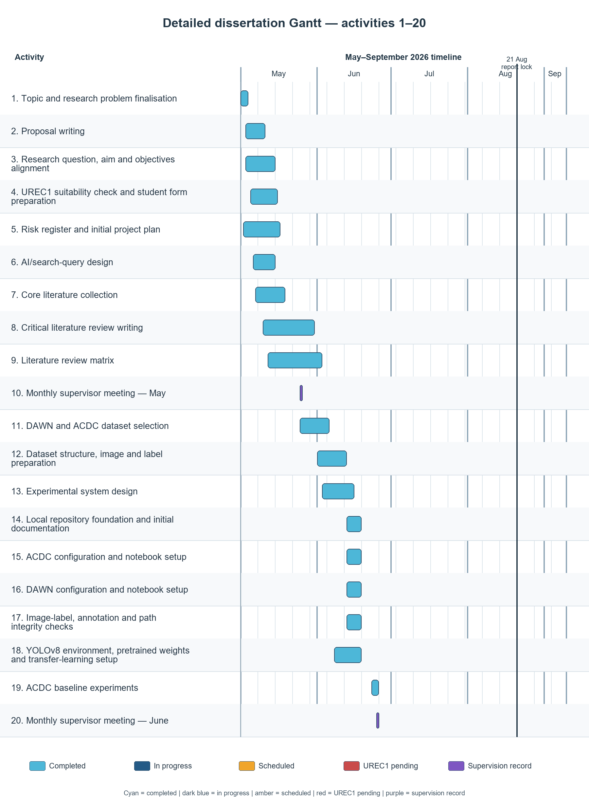
Figure I.1. Author's own status-coded Gantt for activities 1-20, derived from the verified project-plan workbook; formatting prepared with declared AI assistance.

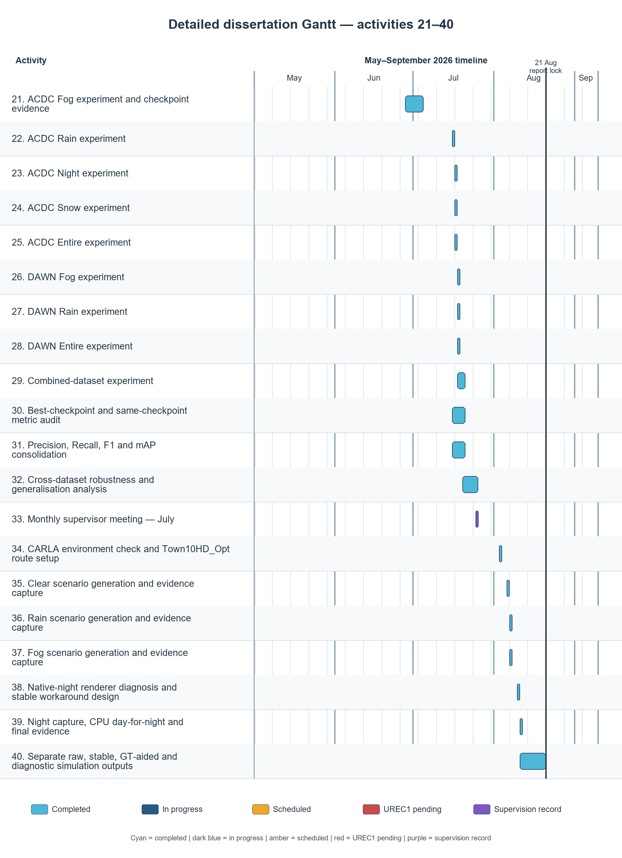
Figure I.2. Author's own status-coded Gantt for activities 21-40, derived from the verified project-plan workbook; formatting prepared with declared AI assistance.

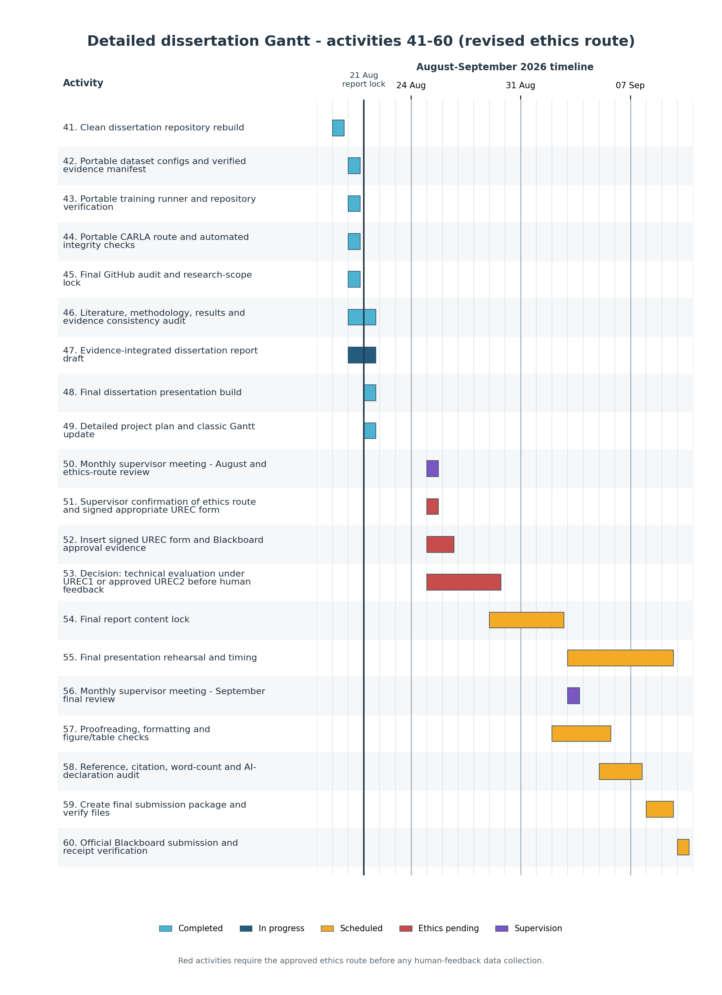
Figure I.3. Author's status-coded Gantt for activities 41-60, derived from the project-plan workbook; formatting prepared with declared AI assistance.

Appendix J - Supporting Evidence
This appendix contains low-level implementation controls, formal test status, supporting diagrams, deliberately selected successes and one matched historical failure panel. These artefacts remain subordinate to the validation-bound matrix.
Table J.1. Low-level implemented architecture and evidence controls.
ID | Component | Operation | Control or evidence
A1 | Configuration | Dataset YAML files define paths, eight class names and split membership. | Versioned YAML, fixed class order and portable paths.
A2 | Integrity and correction | Audits image-label pairing, identifiers and bounds; applies the DAWN remap to a separate copy. | Original and archived labels remain unchanged; correction evidence is explicit.
A3 | Training | Loads pretrained YOLOv8l and trains at 640 pixels for 100 epochs; corrected runs use seed 0 and deterministic mode. | Run directory preserves arguments, trajectory and best.pt.
A4 | Checkpoint and provenance | Locks best.pt after training and records SHA-256 identities. | A metric row remains attributable to one immutable checkpoint.
A5 | Validation | Loads one locked checkpoint and one target YAML per cell under the common Ultralytics protocol. | Seven cells are produced without mixing training rows.
A6 | Metrics | Retains P, R and both mAP measures from one result and derives F1 from the same unrounded P and R. | Prevents cross-row assembly and rounding drift.
A7 | Evidence | Writes tables, manifest entries, hashes and verification records. | Compact evidence is versioned; raw datasets, weights and large media are excluded.
A8 | CARLA diagnostic | CARLA 0.9.16 uses Town10HD_Opt, 640 x 360 RGB, 10 sensor FPS and a 20 tick per second world. | Simulation remains qualitative and outside the real-data matrix.
Table J.2. Formal verification cases and retained status at experimental evidence commit 1eb81b5.
ID | Test objective | Method or input | Acceptance criterion | Status
T01 | Configuration schema | Load nine historical YAML configurations and confirm one eight-class order. | Parser completes; names and splits are present. | Pass
T02 | Corrected DAWN label integrity | Run pairing, class-range and bound checks on the corrected copy. | No audited violation. | Pass
T03 | Fog semantic audit | Compare 78 corrected Fog validation images with Pascal VOC names. | Every image is covered. | Pass
T04 | Non-destructive correction | Compare targets and evidence paths with archived originals. | No original label is overwritten. | Pass
T05 | Corrected runner presets | Validate preset names, arguments and dry runs for four corrected runs. | All commands resolve. | Pass
T06 | Corrected outcomes | Verify four outcome rows and checkpoint metadata. | Fog, Rain, Entire and Combined are present. | Pass
T07 | Matrix completeness | Verify every model-to-validation pairing. | Exactly seven cells are present. | Pass
T08 | Same-row F1 | Recalculate 2PR/(P+R) from unrounded same-row values. | Stored values agree within tolerance. | Pass
T09 | Checkpoint lineage | Recompute SHA-256 for locked checkpoints. | Each digest matches metadata. | Pass
T10 | CARLA boundary | Verify route, condition labels and qualitative status. | No CARLA output enters the metric matrix. | Pass
T11 | Repository exclusion | Inspect version-control scope. | No raw data, weights, large video or private path is intentionally committed. | Pass
T12 | Python syntax | Compile maintained Python source. | No syntax error. | Pass
T13 | Cross-split duplication and scene grouping | Require byte, perceptual and scene-ID comparison. | A complete audit ledger is available. | Not established
T14 | Manifest-to-source reconciliation | Cross-check every manifest field against its source. | Every field is source-linked and recomputed. | Partial at 1eb81b5
T15 | YOLO coordinate validator | Confirm normalised coordinates and positive area. | All four values are valid. | Partial at 1eb81b5
Test-status note: “Not established” and “Partial” are disclosure outcomes, not passes. They remain visible until a later repository integrity patch is applied and independently re-verified.
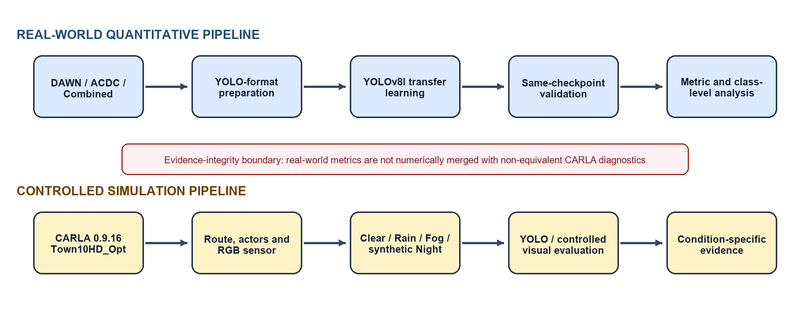
Figure J.1. High-level real-data training, validation and evidence architecture; moved from the word-counted core.
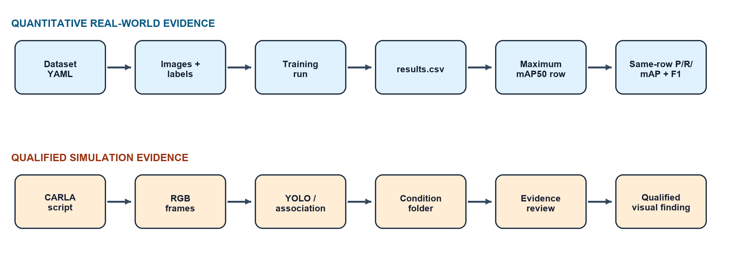
Figure J.2. Evidence-flow and construct-boundary diagram; moved from the word-counted core.
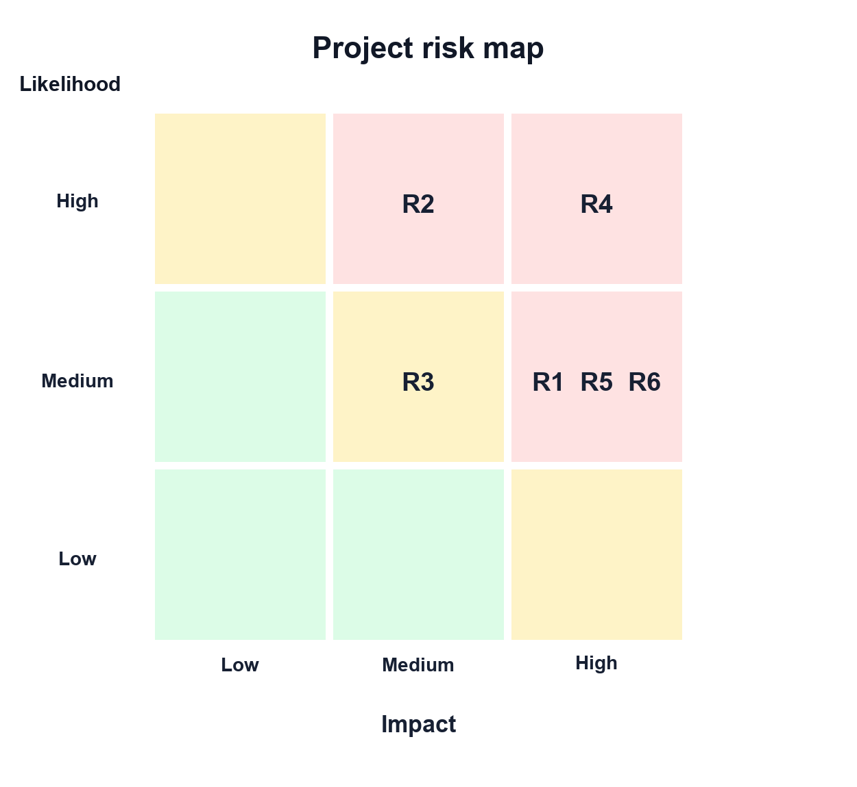
Figure J.3. Project risk map derived from Appendix G; moved from the word-counted core.
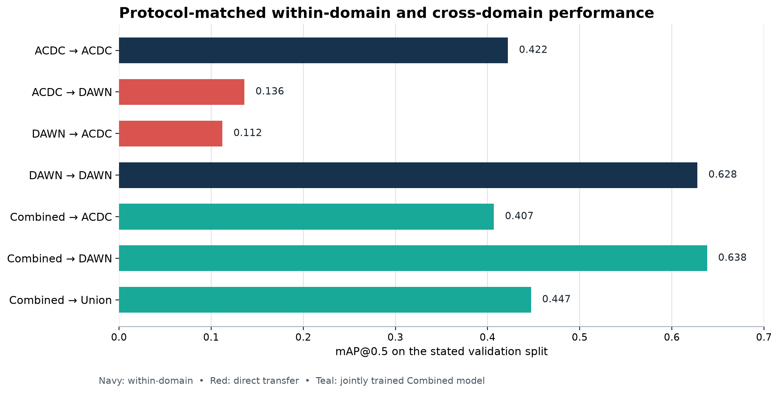
Figure J.4. Protocol-matched real-world validation overview; Table 4.1 remains authoritative.
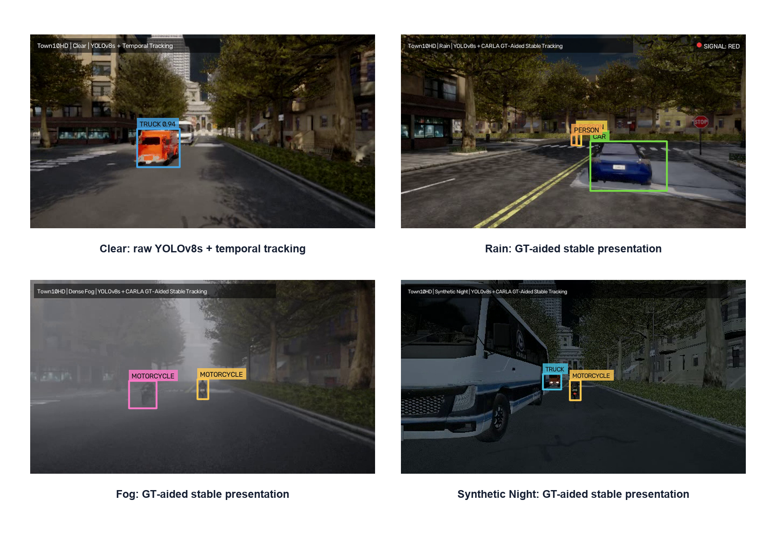
Figure J.5. CARLA Clear, Rain, Fog and synthetic Night diagnostic presentation. Outputs are non-equivalent and are not numerically compared with ACDC or DAWN.
Table J.3. ACDC Fog class-level validation evidence from the retained best.pt validation transcript (100 images, 640 instances).
Class | Images | Instances | P | R | mAP50 | mAP50-95
person | 36 | 62 | .681 | .452 | .491 | .238
rider | 10 | 11 | .793 | .273 | .464 | .218
car | 99 | 496 | .687 | .768 | .790 | .571
truck | 33 | 41 | .562 | .281 | .338 | .228
bus | 5 | 5 | 1.000 | .780 | .829 | .632
train | 3 | 3 | .335 | .667 | .665 | .409
motorcycle | 10 | 11 | .397 | .273 | .224 | .147
bicycle | 10 | 11 | .690 | .364 | .457 | .238
The transcript's aggregate rerun values were P 0.643, R 0.482, mAP@0.5 0.532 and mAP@0.5:0.95 0.335. The dissertation's canonical aggregate table instead uses the maximum-mAP@0.5 row of results.csv (0.5334 and 0.3361). The small difference is preserved transparently; class-level values are not merged into a synthetic canonical row.

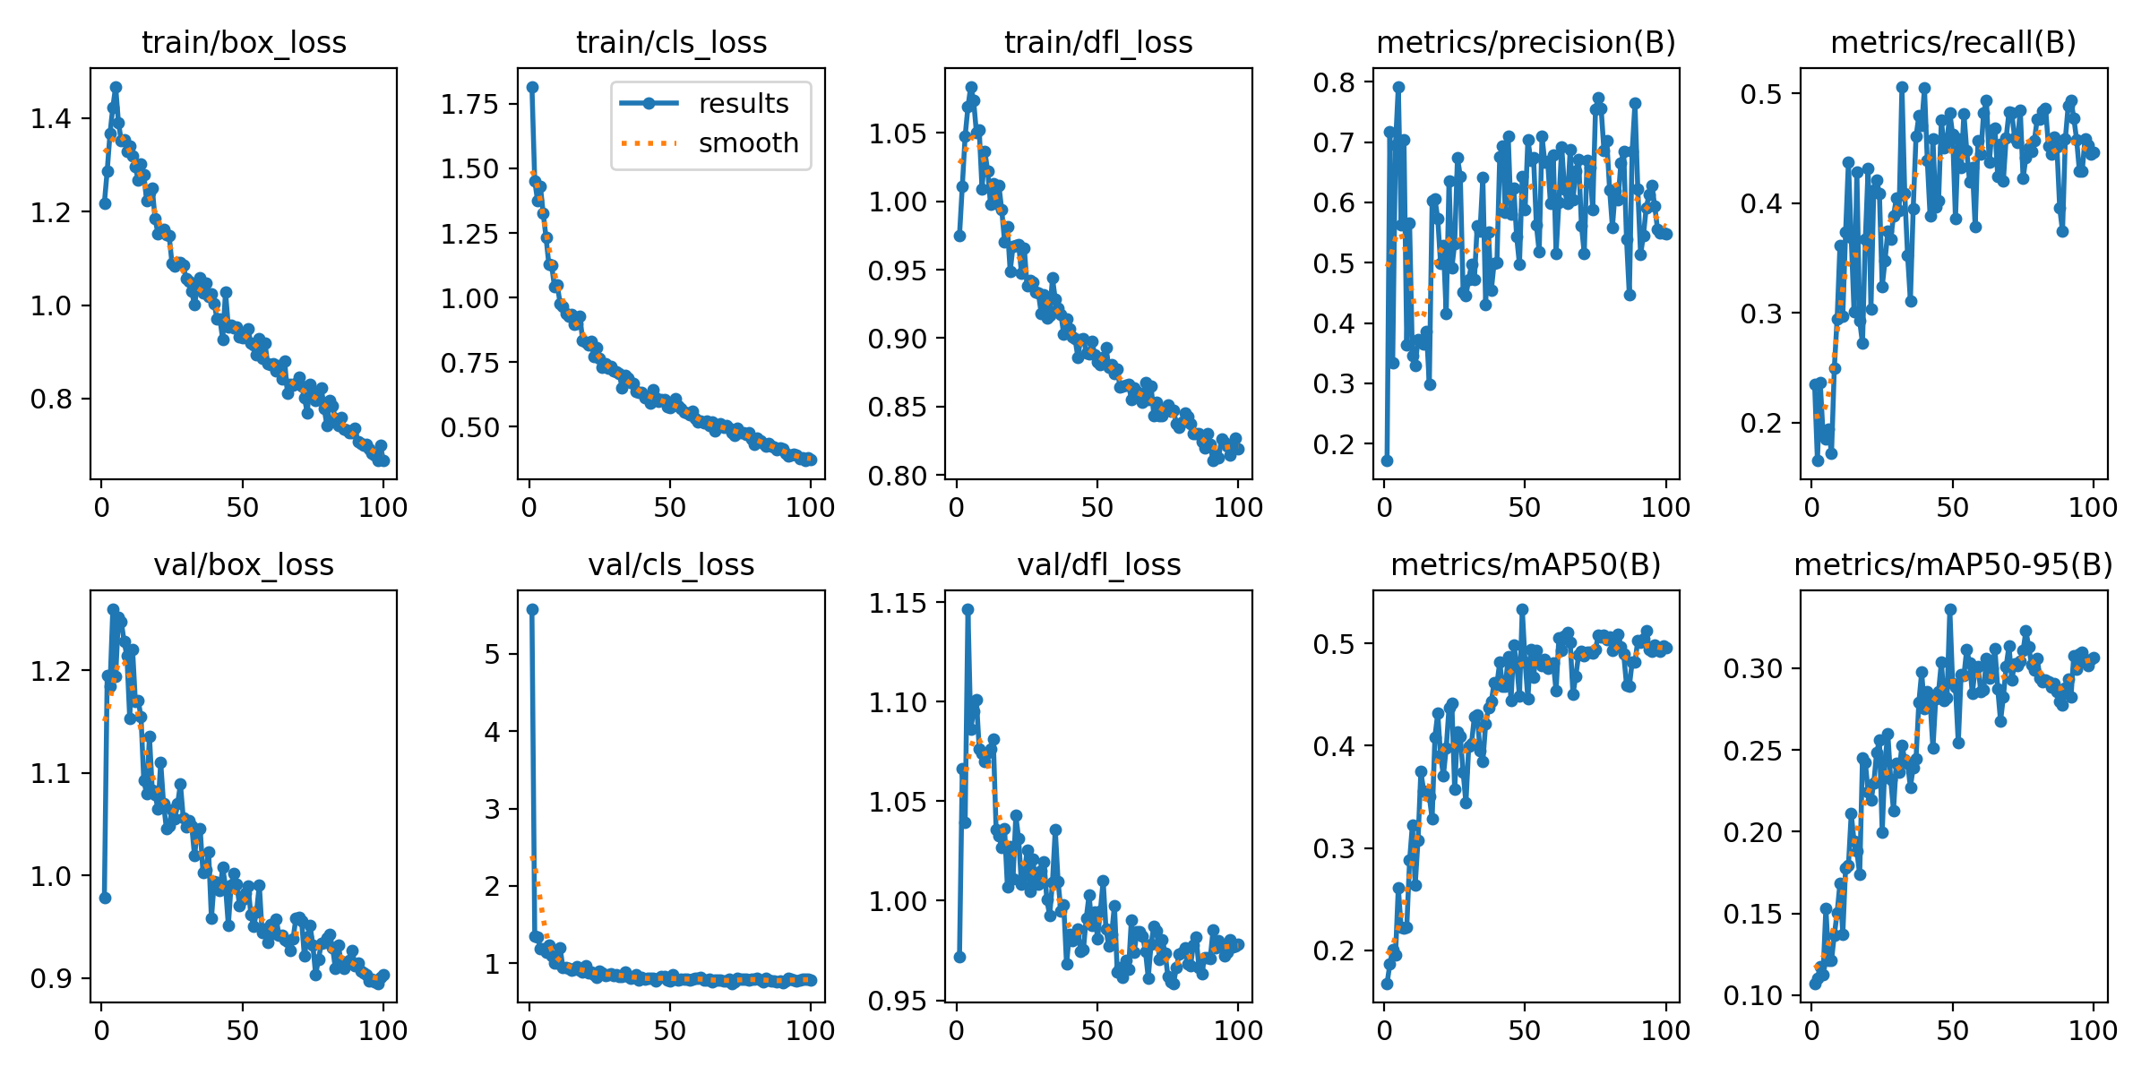
Figure J.6. ACDC Fog training and validation diagnostics retained with the experiment.

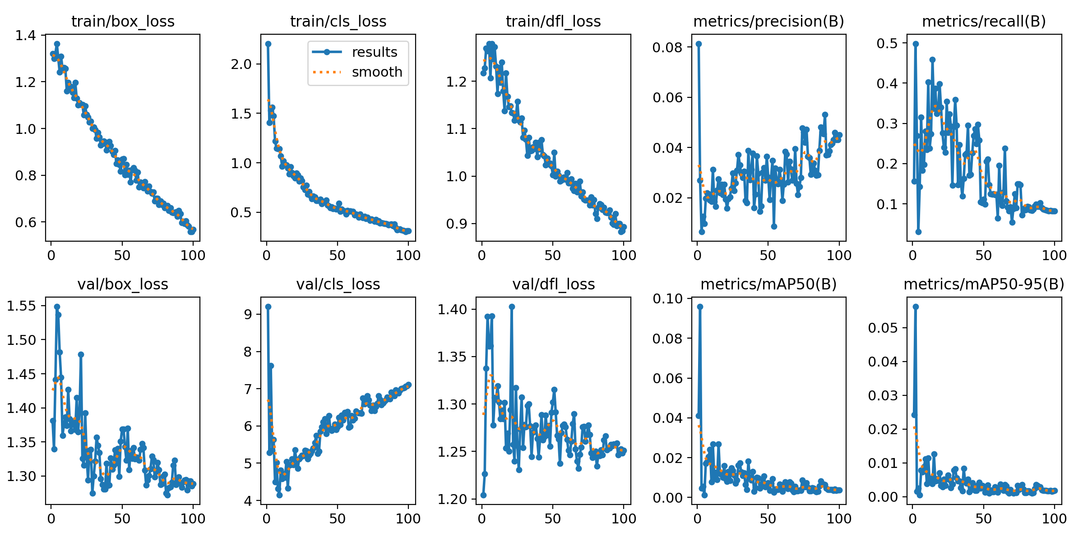
Figure J.7. Historical DAWN Fog diagnostic retained for provenance; superseded for reporting after the validation-label integrity correction.

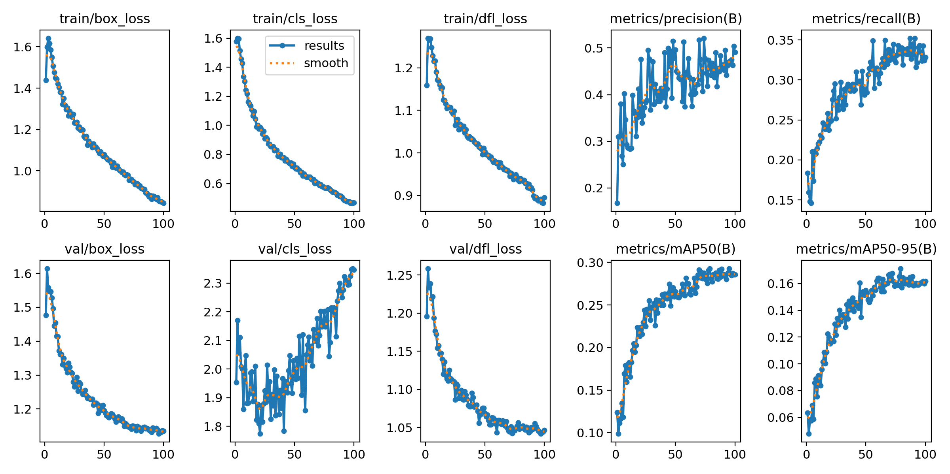
Figure J.8. Historical Combined diagnostic retained for provenance; superseded for reporting by the corrected Combined run and final matrix.

Table J.4. Locked CARLA route and capture parameters.
Parameter | Verified value
Simulator / map | CARLA 0.9.16 / Town10HD_Opt
Spawn / road / lane | 36 / 11 / 1
Spawn location | x 67.659744, y 69.822777, z 0.600000
Rotation | pitch 0.0, yaw 0.073273, roll 0.0
Camera | sensor.camera.rgb; x 1.5, y 0.0, z 2.4; FOV 90 degrees
Capture timing | 640 x 360; 10 sensor FPS; 20 world ticks per second
Night boundary | Calibrated CPU day-for-night transformation of genuine CARLA RGB frames
Automated repository test result: PASS for nine historical configurations, nine presets, one CARLA route, four corrected training outcomes, seven final validation cells and eleven corrected manifest rows. Additional checks confirmed same-result F1, checkpoint-hash lineage, Python compilation and dry-run execution paths without starting training.

J.1 Selected successful qualitative examples
The figures below were selected from the submission-ready inference outputs supplied for this audit. Candidate frames were first filtered to retain only detections with confidence at or above 0.79, then manually reviewed for visible agreement between each displayed box and its class label. No visually apparent false class assignment was found in the seven retained frames. This is a presentation-oriented selection of successful cases, not a random or representative sample.
The inference CSVs provide file, class ID and confidence records but not matched ground truth. Consequently, visual review cannot prove that every object was detected, and the absence of an obvious false box in these selected frames does not establish error-free performance. Aggregate Precision, Recall, F1 and mAP in Table 4.1 remain the performance evidence.
Table J.5. Provenance audit for the selected submission-ready qualitative outputs.
Configuration(s) | Submission-ready output | Selected file | Audit status
ACDC Entire | acdc_entire_test | GOPR0351_frame_000121_rgb_anon.jpg | Unique output
ACDC/DAWN Fog | acdc_fog_test + dawn_fog_test | GOPR0476_frame_001060_rgb_anon.jpg | 100/100 images identical; shown once
ACDC Night | acdc_night_test | GOPR0351_frame_000065_rgb_anon.jpg | Unique output
ACDC/DAWN Rain | acdc_rain_test + dawn_rain_test | GOPR0402_frame_000214_rgb_anon.jpg | 100/100 images identical; shown once
ACDC Snow | acdc_snow_test | GOPR0122_frame_000376_rgb_anon.jpg | Unique output
DAWN Entire | dawn_entire_test | rain_storm-732.jpg | Unique output
Combined | acdc+dawn_combined_test | mist-063.jpg | Unique output

J.1.1 ACDC Entire configuration
Four retained detections: one car, two persons and one rail vehicle represented by the configured train class; confidence 0.80-0.92.
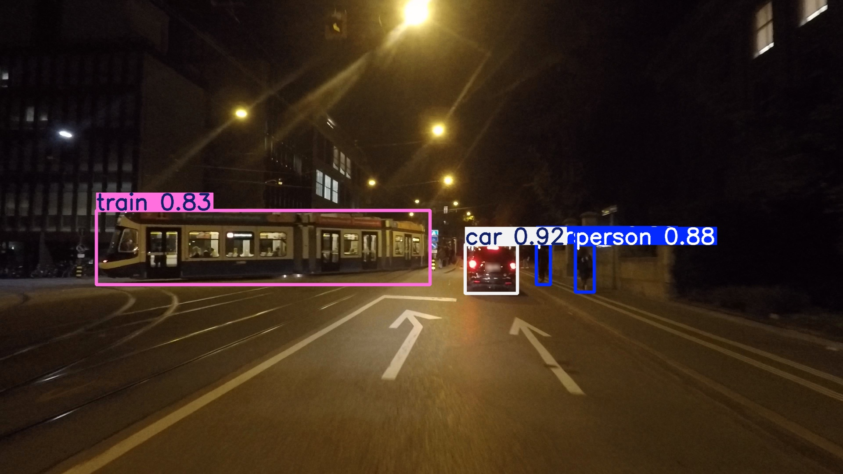
Figure J.9. Selected high-confidence example for ACDC Entire configuration; original boxes and confidence labels are unchanged.

J.1.2 Fog output shared by the duplicate ACDC/DAWN folders
Four car detections in dense fog; confidence 0.90-0.92. The identical DAWN-labelled folder is not shown again.
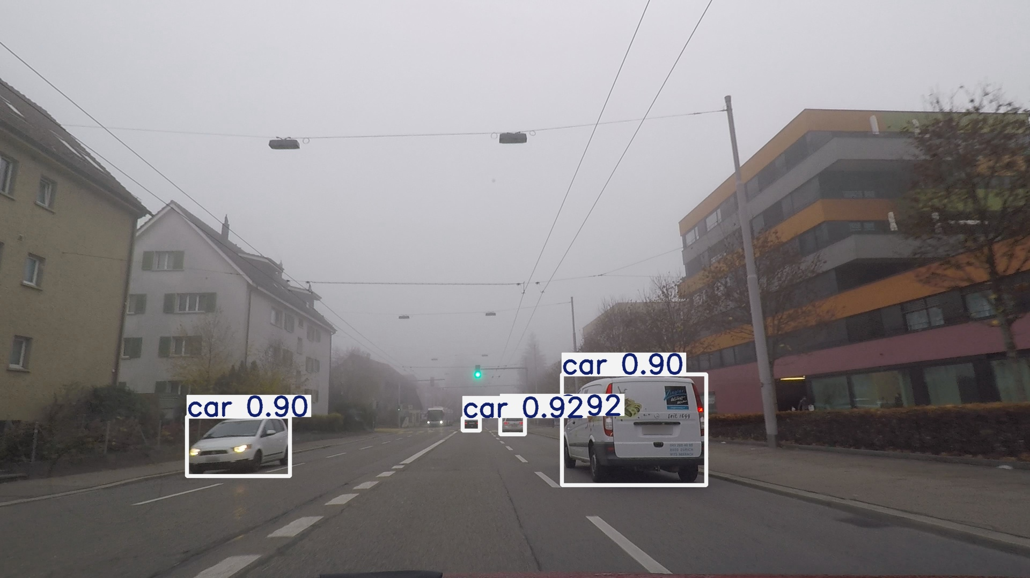
Figure J.10. Selected high-confidence example for Fog output shared by the duplicate ACDC/DAWN folders; original boxes and confidence labels are unchanged.

J.1.3 ACDC Night
Three car detections under low illumination; confidence 0.87-0.89.
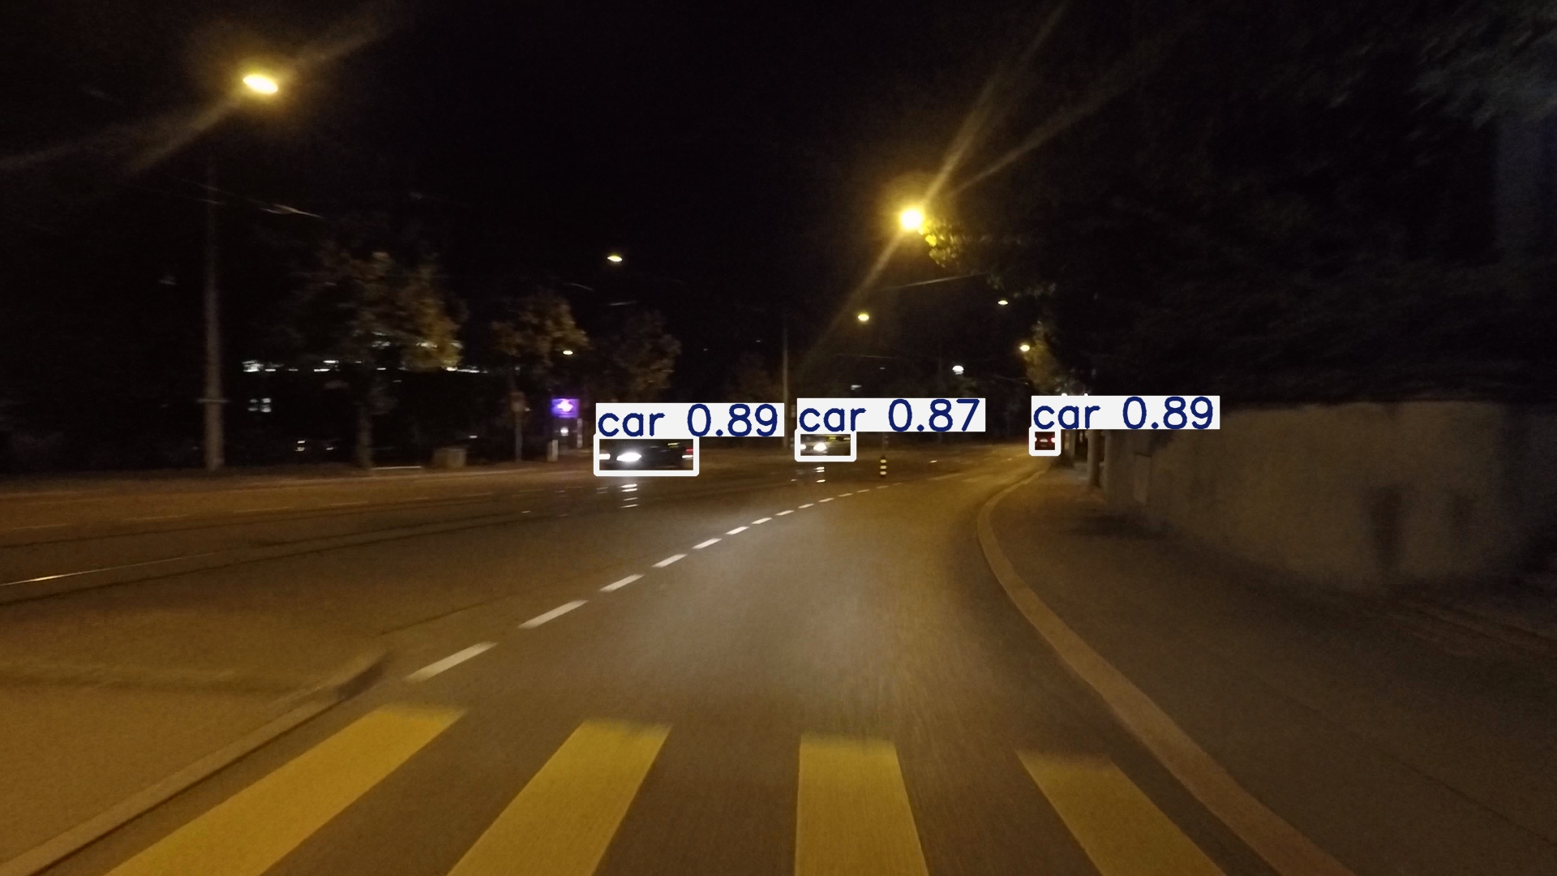
Figure J.11. Selected high-confidence example for ACDC Night; original boxes and confidence labels are unchanged.

J.1.4 Rain output shared by the duplicate ACDC/DAWN folders
Three clearly visible car detections in rain; confidence 0.91-0.96. The identical DAWN-labelled folder is not repeated.
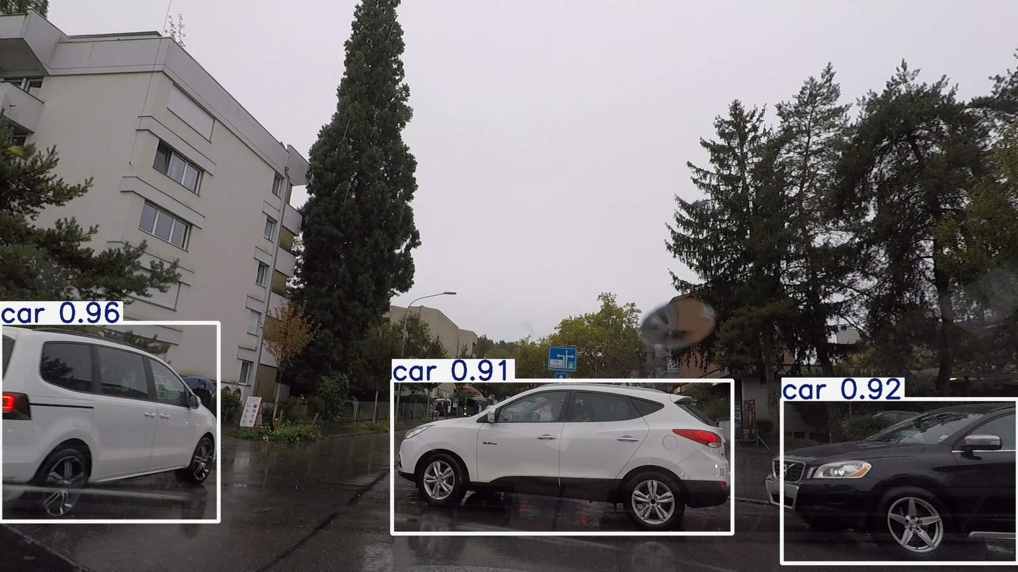
Figure J.12. Selected high-confidence example for Rain output shared by the duplicate ACDC/DAWN folders; original boxes and confidence labels are unchanged.

J.1.5 ACDC Snow
Three car detections on a snow-covered road; confidence 0.89-0.94.
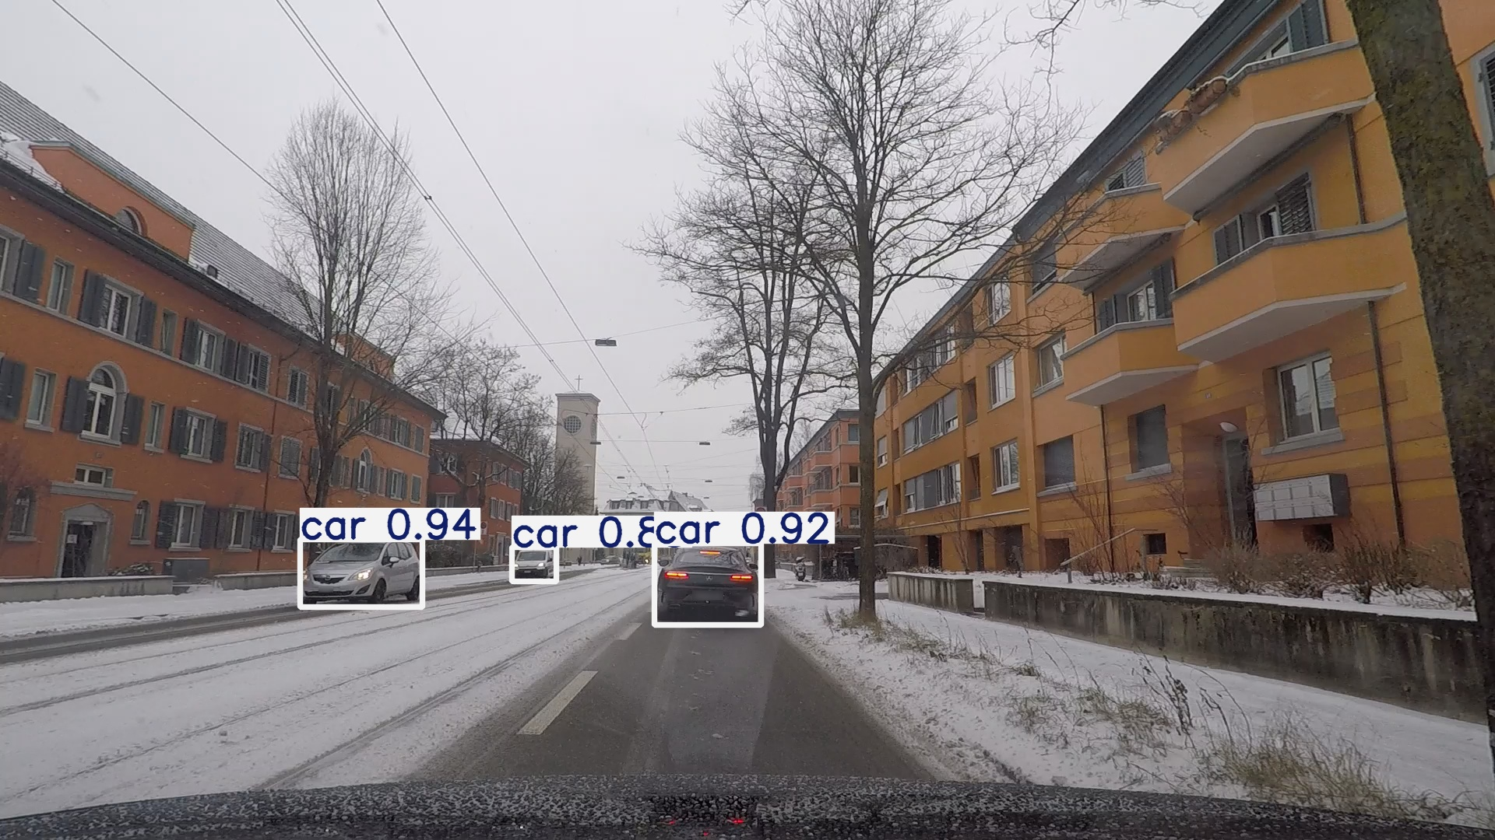
Figure J.13. Selected high-confidence example for ACDC Snow; original boxes and confidence labels are unchanged.

J.1.6 DAWN Entire configuration

Four car detections in heavy rain; confidence 0.84-0.99.
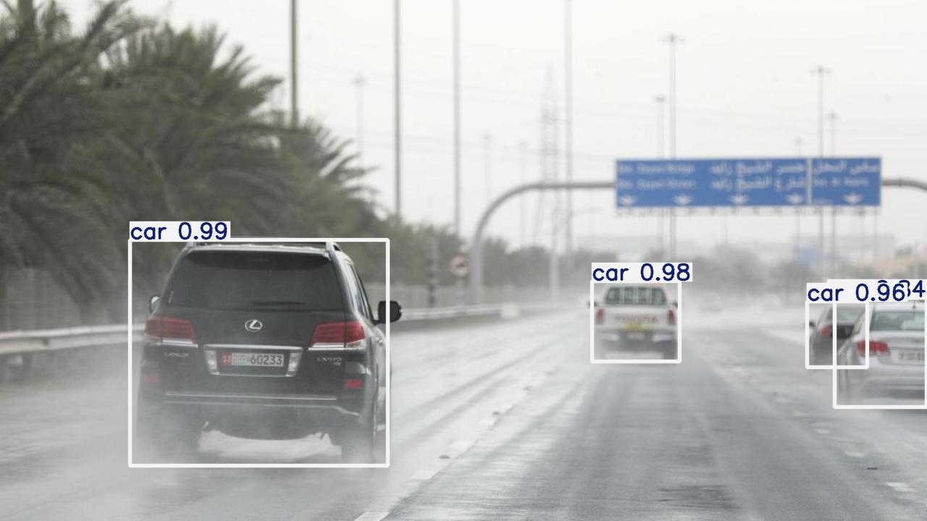
Figure J.14. Selected high-confidence example for DAWN Entire configuration; original boxes and confidence labels are unchanged.

J.1.7 Combined configuration
Six car detections in a dense urban mist scene; confidence 0.85-0.95.
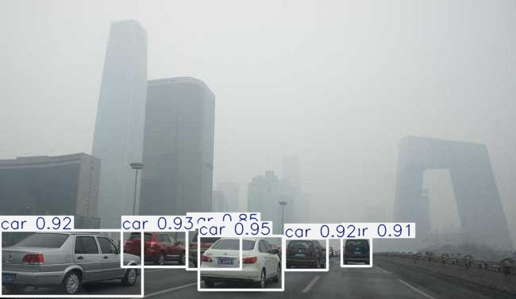
Figure J.15. Selected high-confidence example for Combined configuration; original boxes and confidence labels are unchanged.

J.2 Interpretation and evidential boundary
These figures demonstrate that the retained pipelines can produce convincing localisations under fog, night, rain, snow and mixed conditions. They are deliberately selected successes and must not be used to estimate detection frequency, compare weather difficulty or override the canonical metrics. Missed objects may remain outside the displayed boxes because the inference CSVs contain predictions rather than independently matched annotations.
The DAWN Fog and DAWN Rain visual directories are exact byte-for-byte copies of the corresponding ACDC Fog and ACDC Rain directories. Repeating those images under separate headings would create false visual independence; therefore each duplicated pool is shown once and the limitation is explicitly recorded in Table J.3.

J.3 Corrected DAWN training and cross-domain audit
The archived DAWN validation labels retained older numeric IDs. A separate corrected copy remapped 1→0 person, 2→7 bicycle, 3→2 car, 4→6 motorcycle, 6→4 bus and 8→3 truck. The source data and historical evidence were not modified. Image-label pairing, class range and box bounds passed; all 78 aligned Fog validation images were also checked against Pascal VOC object names.
Table J.6. Final corrected training outcomes (Ultralytics validation splits).
Experiment | Val images | P | R | F1 | mAP50 | mAP50-95
DAWN Fog | 78 | .7361 | .5093 | .6020 | .5539 | .3490
DAWN Rain | 42 | .9716 | .9864 | .9790 | .9916 | .8880
DAWN Entire | 120 | .8490 | .5784 | .6881 | .6279 | .4367
ACDC+DAWN Combined | 526 | .5816 | .4398 | .5008 | .4465 | .2712
DAWN Rain's near-saturated result is valid only for its small 42-image in-domain validation split; it does not establish universal rain robustness. The seven-cell matrix in Table 4.1 uses one protocol and three locked checkpoints. Their full SHA-256 hashes and row lineage are preserved in docs/CORRECTED_EVIDENCE_MANIFEST.csv at repository commit 1eb81b5 and pass the automated verifier.

J.4 Matched ACDC Fog failure evidence
The matched ACDC Fog validation batch supplies direct error evidence. Several labelled objects are absent from predictions, while crowded or overlapping vehicles produce incomplete or ambiguous localisation. Historical aggregate values were Precision 0.643, Recall 0.482 and F1 0.551. Lower Recall is consistent with missed objects, but the frame cannot prove that fog alone caused each error because distance, scale, overlap, class frequency and annotation policy are confounded.
Class support is strongly imbalanced: cars account for 496 of 640 instances. Bus AP@0.5 of 0.829 rests on five instances and train AP@0.5 of 0.665 on only three; neither is a stable class conclusion. The panel is historical condition-specific evidence, not a cell in the corrected seven-cell matrix. No matched final failure panel exists for every cell, so no visual frequency or complete error taxonomy is claimed.
Table J.7. Historical ACDC Fog class support and retained AP@0.5 evidence.
Class | Instances | Share | AP@0.5 | Interpretive boundary
Car | 496 | 77.5% | 0.790 | Dominant support; aggregate behaviour is car-weighted.
Person | 62 | 9.7% | Not retained | Retain exact AP only if the source record is recovered.
Truck | 41 | 6.4% | Not retained | Avoid inventing a class AP.
Rider | 11 | 1.7% | 0.464 | Rare; estimate is unstable.
Motorcycle | 11 | 1.7% | 0.224 | Lowest retained AP; rare and visually difficult.
Bicycle | 11 | 1.7% | 0.457 | Rare; estimate is unstable.
Bus | 5 | 0.8% | 0.829 | High point estimate with only five instances.
Train | 3 | 0.5% | 0.665 | Only three instances; not a reliable class conclusion.
Predictions |  | Ground-truth labels
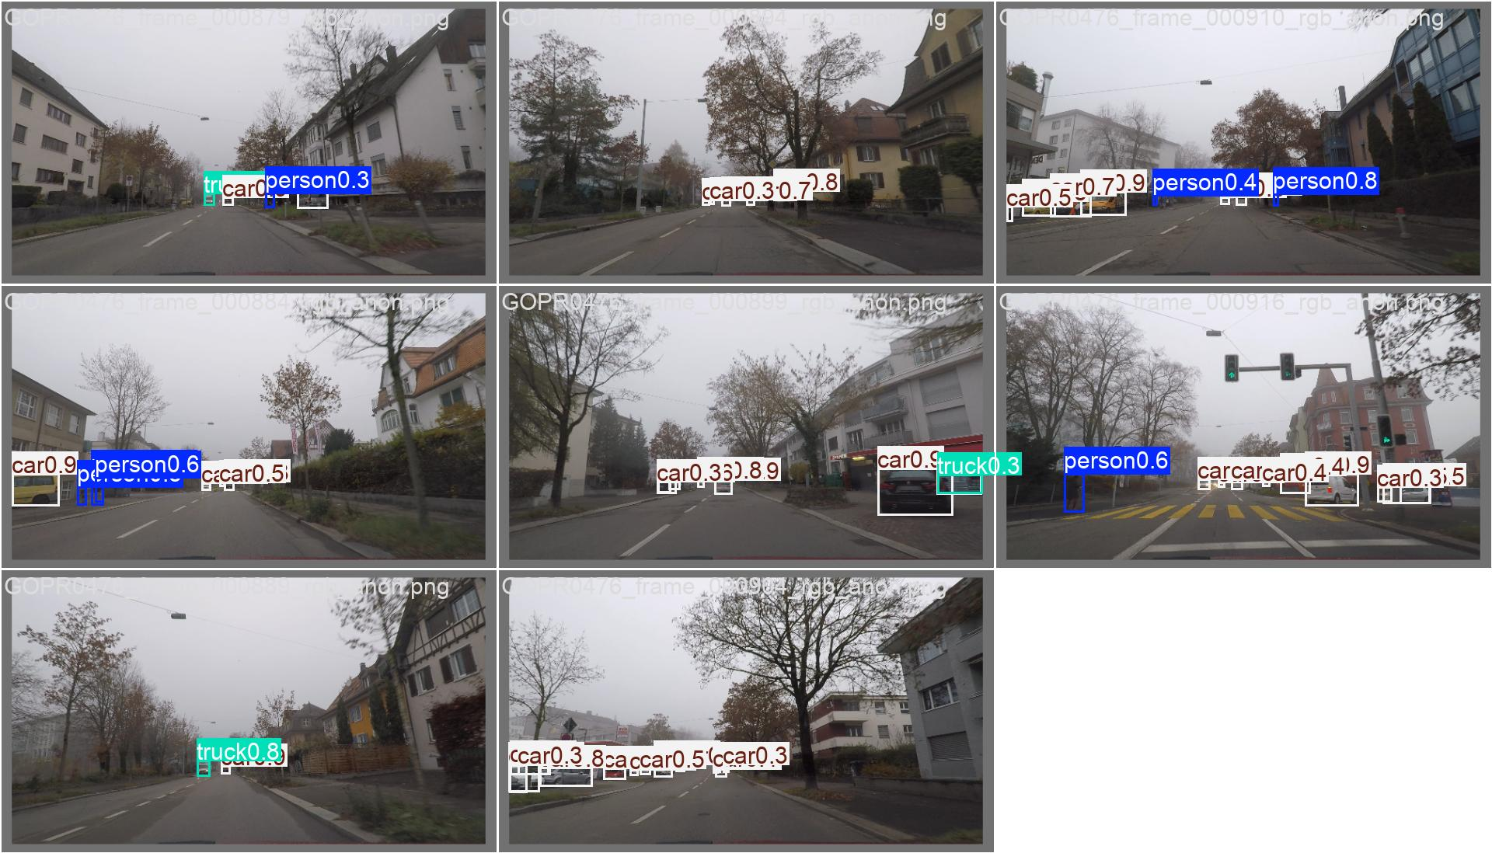 |  | 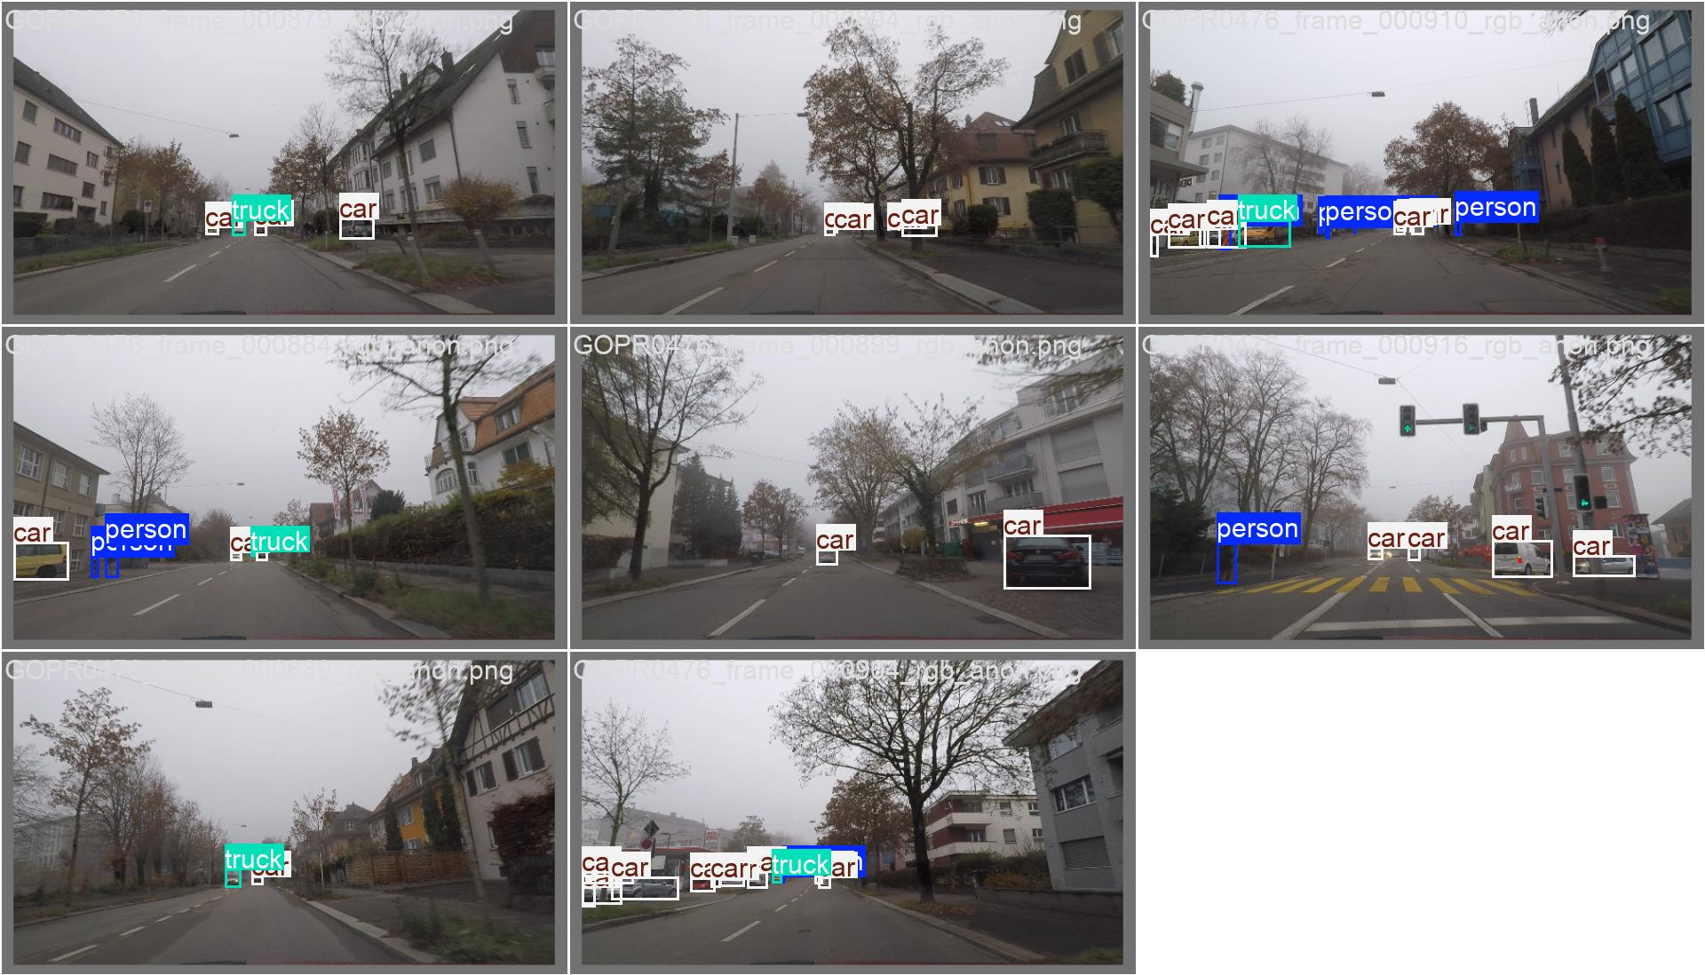
Figure J.16. Matched ACDC Fog validation batch 2: predictions (left) and corresponding ground-truth labels (right). Original Ultralytics overlays are retained; crowded label text reflects the source output. Historical evidence only, not a corrected-matrix cell.

