Calculator Using The Memento Design Pattern and Localization

In order to create the calculator a few requirements had to be made.
The calculator must had the ability to undo the calculations. In order to achieve that the memento design pattern will be used.

The calculator is a console based calculator. The calculator supports basic operations such as sum, subtraction, multiplication, and division. There are other additional operations that are supported such as undo, clear and exit.

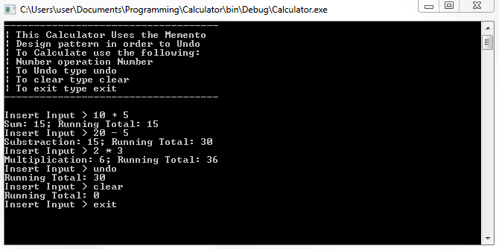
In addition, the calculator must support at least three languages, in this case, the languages selected include English, Spanish and French.

(Continue on the next page)
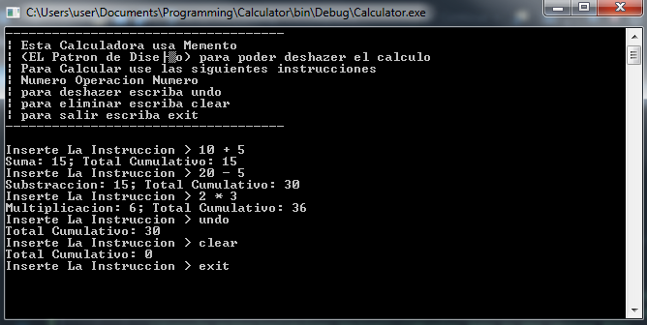

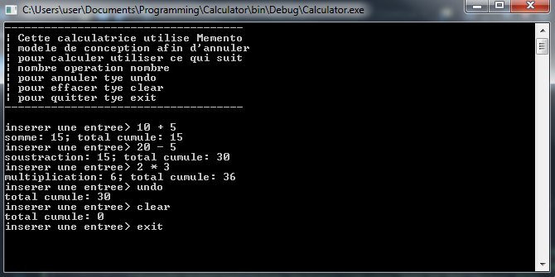

(Continue on the next page)

There are other additional features that the calculator supports, for example, avoids the division by zero, or undo when the stack is empty, and it allows for input validation and some degree of error correction.

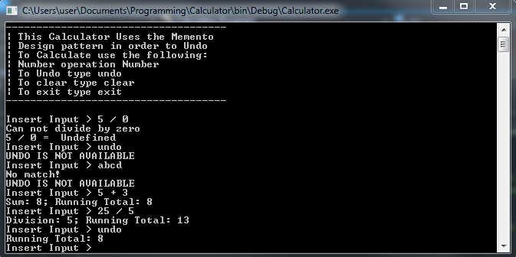

Cultural Competency Notes:

Part of the reason why this program was created was to explore cultural competency. In this case we wanted to create a program that would be useful in North America, Europe and Asia.

If we think of North America as Canada, Greenland, USA, Mexico, and the Caribbean, we will need to cover Spanish and french, since many countries in the Caribbean speak both Spanish and french. Also, historically French used to be used as an international language for diplomacy. Because of this fact, it might be a good idea to give support to the French language. In addition, there are countries in Asia that have a relatively large segment of the population that are familiar with Spanish, for example the Philippines, or Guam. The reason why is because many of those countries used to be Spanish colonies. English has been use for international commerce in the last 50 years in part because of the influence of the British Empire, and because of the economic influence of the USA.

There are however issues with this model, there are entire continents that are not been taken into account such as the African Continent, or central and south America.

