**RESUBMISSION – 4/9/2023**  
Explain what factors you took to enhance user experience.

1. In the interface, we gave all of the buttons the same color palette so that the user knows when they see that color, it means that there is a button.
2. We utilized a simple, clean design, so that there is no extra confusion on where to click and where to go.
3. The simple design allows the page to be fast loading, which increases the user experience.
4. All of the elements are consistent and engaging, which allows the user to visually see the structure of the page
5. The font is simple and large, allowing for readability.
6. Text is limited to labels to allow the user to not have to read paragraphs and sentences to know what is going on.

What challenges did you encounter when building the interface?

1. Picking a color scheme that was readable, but also unique was a bit of a challenge with this interface.
2. Figuring out how to structure the different pages and what to put on each page. Understanding the user’s experience helped with designing the page and understanding the overall workflow that a user might have.
3. One of the challenges was designing the interface to be intuitive and easy to use, while still being visually appealing.
4. Knowing what software to use and collaborate with online was another challenge.

**LOGIN PAGE**  
The Login page is the page that all employees will be redirected to if they are not logged in. They will use a username and password that are in the database to create a new account. New accounts are created on the register page (Not pictured). All employees will log in through this Login page and will not have access to any other pages without logging in.

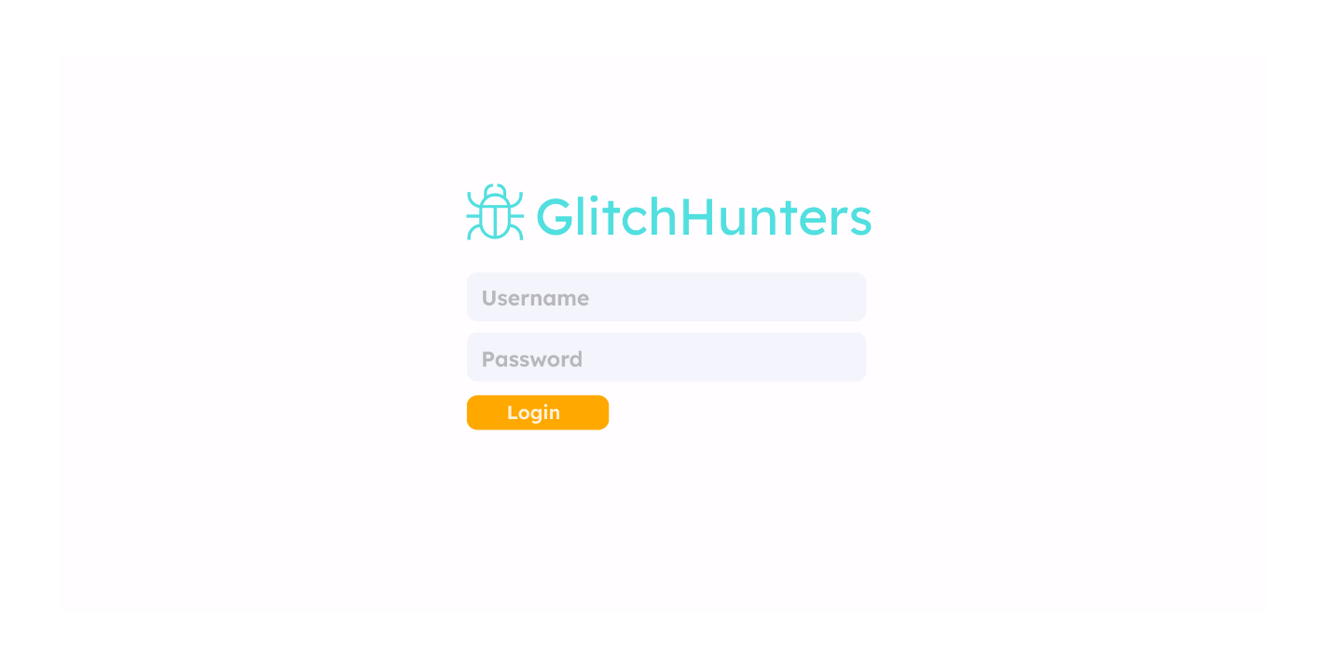

**DASHBOARD**  
After logging in, you will be logged into the dashboard, where you can see an overview of all the current projects. These projects can be accessed and edited by clicking on them, which allows you to view the project details. You can also use the orange “Create Project” button to add more projects.

When more projects are added they will continue to show up on this page. You can also access the tickets on the left hand menu.

**TICKETS**

Here an employee can view all the current tickets on the system, they click on them to reveal more information, such as what project it is a part of and a description of the ticket.

**TICKET DETAILS**If you click on a ticket, it will take you to a page where you can view the ticket information, such as who is assigned to the ticket, and the ticket description. This is a view of that:

**EDITING TICKETS**  
You can also edit each individual ticket, which allows you to make updates to the description and notes, as well as change the title, employee assigned to it, and the project

There are other views not shown as well, such as the project editing and project details pages, but viewing the ticket pages, you can get a good understanding of the overall visual appearance and flow of the system.