MySQL Complete Learning Roadmap

Basics to Advance with Live Demos & Exercises

For B.Tech / MCA Students

Course Overview
Duration: 10 Sessions (60 minutes each)
Level: Beginner to Advanced
Prerequisites: Basic programming knowledge
Tools Required: MySQL Server, MySQL CLI / Workbench

Table of Contents
- Session 1: MySQL Fundamentals & Setup
- Session 2: Single-Table CRUD Operations
- Session 3: Data Filtering & Sorting
- Session 4: Constraints & Data Integrity
- Session 5: Two-Table Joins (INNER & LEFT)
- Session 6: Advanced Joins & Three-Table Scenarios
- Session 7: Aggregation & Group Operations
- Session 8: Views, Functions & Stored Procedures
- Session 9: Transactions, Indexes & Performance
- Session 10: Mini-Project & Interview Prep

SESSION 1: MySQL Fundamentals & Setup

Learning Objectives
- Understand MySQL, RDBMS, and SQL concepts
- Install MySQL and connect to server
- Create first database and explore basic commands
- Understand relational database concepts

Content

Part 1: Concepts (15 minutes)
What is MySQL? - Relational Database Management System (RDBMS) - Open-source, free, widely used in web applications - Stores data in tables (structured format)
Key Terminology:
Term | Definition | Example
Database | Container for multiple tables | college_db
Table | Structured data (like spreadsheet) | students table
Row | One record | Student “Amit”
Column | Field/attribute | name, email, age
Schema | Table structure & relationships | Students→Courses relationship
RDBMS vs SQL: - SQL = Language (universal, works in all RDBMS) - MySQL = Software (specific implementation) - RDBMS = Category (includes Oracle, PostgreSQL, SQL Server)
Relational Database Concept:
college_db/
├── students table
│ ├── id (unique identifier)
│ ├── name
│ ├── email
│ └── city
├── courses table
│ ├── id
│ └── title
└── enrollments table (links students to courses)
├── student_id (foreign key)
├── course_id (foreign key)
└── enrollment_date

Part 2: Installation & Setup (20 minutes)
Step 1: Download MySQL - Windows: https://dev.mysql.com/downloads/mysql/ - Mac: Homebrew (brew install mysql) - Linux: sudo apt-get install mysql-server
Step 2: Start MySQL Server
# Windows (Command Prompt)
mysql --version
mysql -u root -p
# Mac/Linux
sudo systemctl start mysql
mysql -u root -p
Step 3: First Connection
-- Test connection
SELECT "Welcome to MySQL!" AS message;
-- See current date/time
SELECT NOW();
-- Check MySQL version
SELECT VERSION();
Tools You Can Use: 1. MySQL CLI (command line) 2. MySQL Workbench (GUI, recommended for beginners) 3. VS Code with MySQL extension
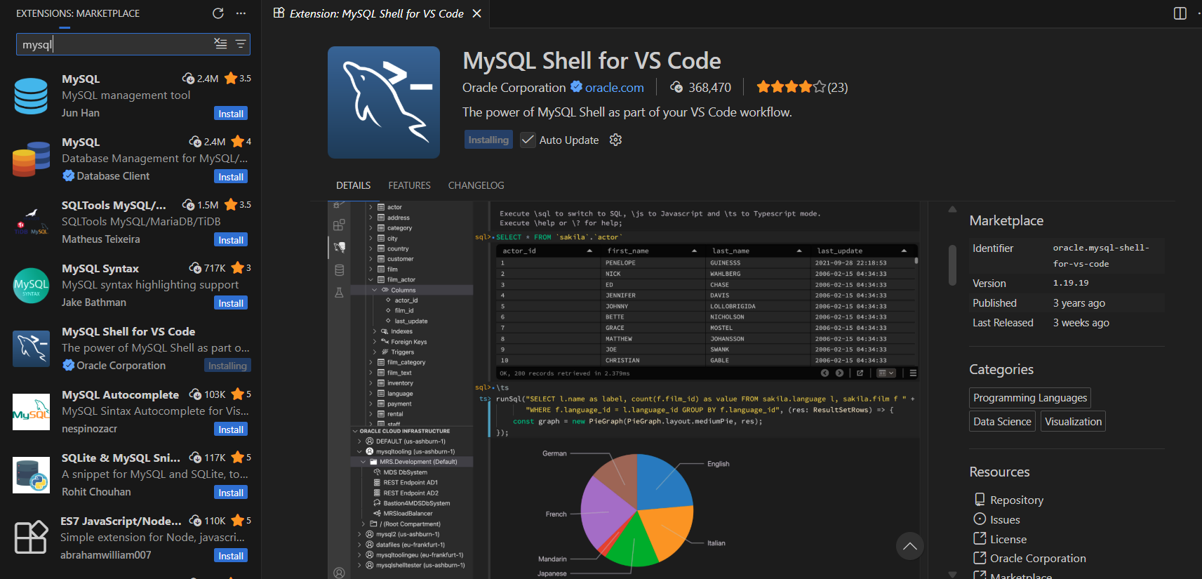
Introducing MySQL Shell for VS Code | mysql

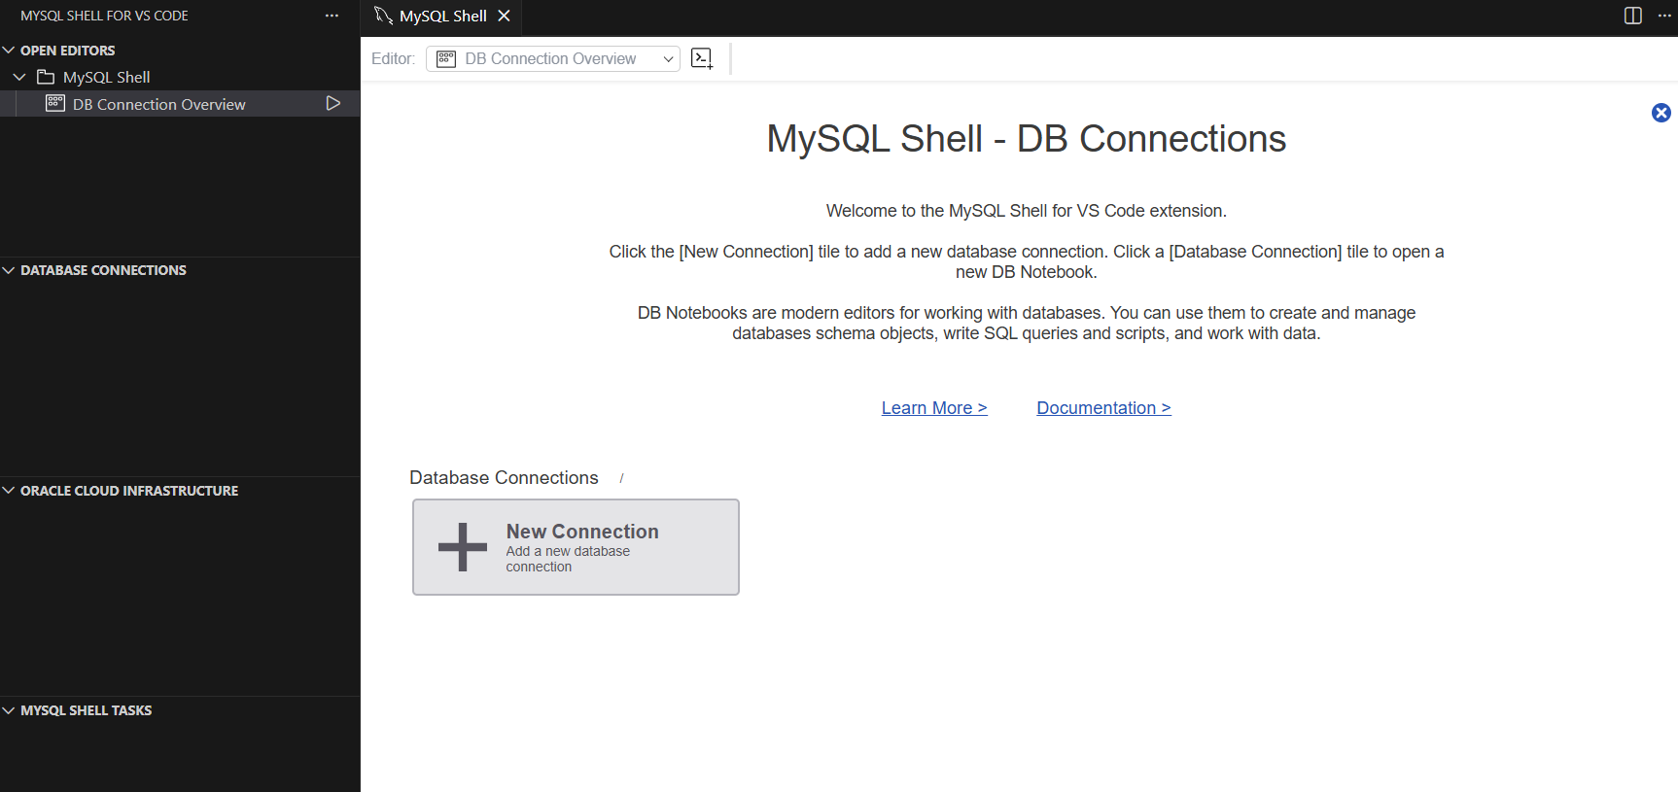

Part 3: Basic Commands (30 minutes - Demo & Hands-On)
Demo 1: Database Operations
-- List all databases
SHOW DATABASES;
-- Create new database
CREATE DATABASE college_db;
-- Switch to database
USE college_db;
-- Confirm current database
SELECT DATABASE();
-- View databases again
SHOW DATABASES;
-- Delete database (CAUTION!)
-- DROP DATABASE college_db;
Students Try: Create 2 databases: practice_db, test_db

Demo 2: Table Creation
-- Basic table structure
CREATE TABLE students (
id INT PRIMARY KEY AUTO_INCREMENT,
name VARCHAR(50) NOT NULL,
email VARCHAR(100),
age INT,
city VARCHAR(50),
created_at TIMESTAMP DEFAULT CURRENT_TIMESTAMP
);
-- View table structure
DESCRIBE students;
DESC students;
-- Show all tables
SHOW TABLES;
-- Delete table (if needed)
-- DROP TABLE students;
Key Components Explained:
Component | Purpose | Example
id INT | Integer column for student ID | 1, 2, 3…
PRIMARY KEY | Makes id unique identifier | No duplicates
AUTO_INCREMENT | Auto-assign 1, 2, 3… | Don’t insert manually
VARCHAR(50) | Text, max 50 characters | Names, emails
NOT NULL | Field is required | Name can’t be empty
DEFAULT CURRENT_TIMESTAMP | Auto-fill with current time | Audit trail
Students Try: Create table courses with columns: id, title, instructor, credits

Part 4: Sample Data Setup (20 minutes)
Demo 3: Insert Sample Data
-- Insert one row
INSERT INTO students (name, email, age, city)
VALUES ('Amit Kumar', 'amit@college.edu', 20, 'Delhi');
-- View data
SELECT * FROM students;
-- Insert multiple rows (faster)
INSERT INTO students (name, email, age, city)
VALUES
('Sara Singh', 'sara@college.edu', 21, 'Mumbai'),
('Ravi Patel', 'ravi@college.edu', 19, 'Chennai'),
('Priya Sharma', 'priya@college.edu', 22, 'Bengaluru'),
('Deepak Gupta', 'deepak@college.edu', 20, 'Hyderabad');
-- View all data
SELECT * FROM students;
Output:
id | name | email | age | city | created_at
---|----------------|--------------------|-----|-----------|--------------------
1 | Amit Kumar | amit@college.edu | 20 | Delhi | 2025-11-30 18:45:00
2 | Sara Singh | sara@college.edu | 21 | Mumbai | 2025-11-30 18:46:00
3 | Ravi Patel | ravi@college.edu | 19 | Chennai | 2025-11-30 18:46:00
4 | Priya Sharma | priya@college.edu | 22 | Bengaluru | 2025-11-30 18:46:00
5 | Deepak Gupta | deepak@college.edu | 20 | Hyderabad | 2025-11-30 18:46:00
Students Try: Insert 3 more students into courses table

Exercises
Exercise 1.1: Create and explore database
1. Create database: your_name_db
2. Create table: employees (id, name, department, salary)
3. Insert 5 employees
4. Display all employees
5. Show table structure with DESCRIBE
Exercise 1.2: Practice basic commands
1. Show all databases
2. Switch between databases
3. Show all tables in current database
4. Drop a test table
5. Create new table with proper constraints

Summary & Key Takeaways
✅ MySQL is a specific RDBMS using SQL language
✅ Relational databases store data in normalized tables with relationships
✅ Every table should have a PRIMARY KEY for unique identification
✅ Use meaningful column names and appropriate data types
✅ AUTO_INCREMENT saves manual ID management
✅ DEFAULT values are useful for audit fields (created_at, status)

SESSION 2: Single-Table CRUD Operations

Learning Objectives
- Master CRUD: Create, Read, Update, Delete
- Write effective SELECT queries with WHERE
- Update and delete data safely
- Understand transaction basics

Content

Part 1: INSERT (Create) - Deep Dive (20 minutes)
Demo 1: INSERT Variations
-- Insert with explicit columns
INSERT INTO students (id, name, email, age, city)
VALUES (6, 'Neha Verma', 'neha@college.edu', 21, 'Pune');
-- Insert without specifying columns (must match order)
INSERT INTO students
VALUES (7, 'Vikram Singh', 'vikram@college.edu', 20, 'Jaipur', NOW());
-- Insert multiple rows (efficient)
INSERT INTO students (name, email, age, city)
VALUES
('Anjali Desai', 'anjali@college.edu', 19, 'Ahmedabad'),
('Sanjay Nair', 'sanjay@college.edu', 22, 'Kochi');
-- View all students
SELECT * FROM students;
Best Practices: - Always specify column names (safe, readable) - Use AUTO_INCREMENT for ID (don’t insert manually) - Provide values for NOT NULL columns - Use NULL for optional columns you’re not filling
Common Error:
-- ERROR: Duplicate primary key
INSERT INTO students (id, name, email) VALUES (1, 'Test', 'test@test.com');
-- (id=1 already exists)
-- Solution: Let AUTO_INCREMENT handle id
INSERT INTO students (name, email) VALUES ('Test', 'test@test.com');
Students Try: Insert 5 new courses with different instructors

Part 2: SELECT (Read) - Query Mastery (25 minutes)
Demo 2: SELECT Variations
-- Get all columns, all rows
SELECT * FROM students;
-- Get specific columns
SELECT name, email FROM students;
-- With aliases
SELECT name AS student_name, email AS contact_email, age AS student_age
FROM students;
-- With expressions
SELECT name, age, (2025 - age) AS birth_year
FROM students;
-- Remove duplicates
SELECT DISTINCT city FROM students;
-- Result: Delhi, Mumbai, Chennai, Bengaluru, Hyderabad, Pune, Jaipur, Ahmedabad, Kochi
-- Count total rows
SELECT COUNT(*) as total_students FROM students;
Students Try:
1. Get only names and cities
2. Rename columns with AS
3. Calculate years until graduation (assuming 4-year program)
4. Find unique departments in courses table

Demo 3: WHERE Clause - Filtering
-- Simple condition
SELECT * FROM students WHERE age > 20;
SELECT * FROM students WHERE city = 'Delhi';
-- Multiple conditions (AND)
SELECT * FROM students
WHERE age > 20 AND city = 'Mumbai';
-- OR condition
SELECT * FROM students
WHERE city = 'Delhi' OR city = 'Mumbai';
-- IN operator (cleaner than multiple ORs)
SELECT * FROM students
WHERE city IN ('Delhi', 'Mumbai', 'Chennai');
-- BETWEEN
SELECT * FROM students
WHERE age BETWEEN 19 AND 21;
-- NOT
SELECT * FROM students
WHERE age NOT IN ('19', '20');
-- String pattern matching
SELECT * FROM students
WHERE name LIKE 'A%'; -- Names starting with A
SELECT * FROM students
WHERE email LIKE '%@college.edu'; -- College emails
LIKE Wildcards:
Pattern | Meaning | Example
A% | Starts with A | Amit, Anjali
%a | Ends with a | Priya, Neha
%i% | Contains i | Priya, Vikram
A_it | A, any char, it | Amit (4 chars total)
Students Try:
1. Find students age 20 or younger
2. Find students from Delhi, Mumbai, or Pune
3. Find names containing 'a' (any case)
4. Find students NOT from Bengaluru

Part 3: UPDATE (Modify) - With Safety (15 minutes)
Demo 4: UPDATE Operations
-- Update one student
UPDATE students
SET city = 'Bangalore'
WHERE name = 'Ravi Patel';
-- Update multiple columns
UPDATE students
SET city = 'Mumbai', age = 21
WHERE id = 3;
-- Update with calculation
UPDATE students
SET age = age + 1
WHERE id = 1;
-- View changes
SELECT * FROM students WHERE id = 1;
⚠️ CRITICAL: WHERE Clause
-- DANGEROUS: Updates ALL rows!
UPDATE students SET city = 'Unknown';
-- SAFE: Updates only specific rows
UPDATE students SET city = 'Unknown' WHERE age > 25;
-- Even safer: Use transaction (Session 9)
START TRANSACTION;
UPDATE students SET age = 21 WHERE id = 1;
-- Review changes
SELECT * FROM students WHERE id = 1;
-- If correct, COMMIT; else ROLLBACK;
COMMIT;
Best Practices: - Always use WHERE clause (except intentional bulk updates) - Test SELECT first to see which rows match - Use transactions for critical updates - Backup before bulk updates
Students Try:
1. Update Amit's age to 21
2. Update all Bengaluru students' city to "Bangalore"
3. Calculate: increase all students' age by 1
4. Test with SELECT first

Part 4: DELETE (Remove) - Carefully (15 minutes)
Demo 5: DELETE Operations
-- Delete one row
DELETE FROM students WHERE id = 9;
-- Delete multiple rows
DELETE FROM students WHERE age < 19;
-- View remaining rows
SELECT COUNT(*) FROM students;
-- Check which rows would be deleted (safe approach)
SELECT * FROM students WHERE age < 19;
-- Then DELETE those
⚠️ DELETE vs TRUNCATE vs DROP
Command | What happens | Recoverable? | Speed
DELETE FROM students WHERE ... | Removes rows | Yes (if backed up) | Slow
TRUNCATE TABLE students | Empties table, resets ID | Harder | Fast
DROP TABLE students | Removes table structure | Harder | Fast
-- DELETE: Safe, specific
DELETE FROM students WHERE id = 1;
-- TRUNCATE: Removes all rows but keeps structure
TRUNCATE TABLE students; -- AUTO_INCREMENT resets to 1
-- DROP: Removes entire table
DROP TABLE students;
Safe DELETE Strategy:
-- Step 1: Preview what you're deleting
SELECT * FROM students WHERE age < 18;
-- Step 2: Use transaction
START TRANSACTION;
DELETE FROM students WHERE age < 18;
-- Step 3: Review deletion count
SELECT COUNT(*) FROM students;
-- Step 4: Commit if correct
COMMIT;
-- Or ROLLBACK if wrong
Students Try:
1. Delete student with id=5
2. Safely delete students older than 23 (use transaction)
3. Use SELECT first to preview
4. Practice ROLLBACK

Exercises
Exercise 2.1: CRUD Mastery
1. Create courses table if not exists
2. Insert 8 courses with title, instructor, credits
3. Select courses taught by specific instructor
4. Update course credits
5. Delete a course (use transaction)
6. Display final state
Exercise 2.2: Data Integrity
1. Insert student with age -5 (should fail or check)
2. Insert duplicate id (should fail)
3. Try to delete non-existent record
4. Update with wrong column name
5. Document errors and how to fix

Summary
✅ INSERT: Add data (use AUTO_INCREMENT for IDs)
✅ SELECT: Read data (always use specific columns, not *)
✅ WHERE: Filter rows (test with SELECT first)
✅ UPDATE: Modify data (always use WHERE clause)
✅ DELETE: Remove data (use transactions for safety)
✅ TRANSACTIONS: COMMIT or ROLLBACK for multi-step operations

SESSION 3: Data Filtering & Sorting

Learning Objectives
- Master ORDER BY and LIMIT for pagination
- Understand NULL handling
- Use aggregate functions (COUNT, SUM, AVG, MIN, MAX)
- Combine filters for complex queries

Content

Part 1: ORDER BY (Sorting) (15 minutes)
Demo 1: Basic Sorting
-- Ascending (default)
SELECT name, age FROM students ORDER BY age;
-- Descending
SELECT name, age FROM students ORDER BY age DESC;
-- Sort by multiple columns
SELECT name, city, age FROM students
ORDER BY city ASC, age DESC;
-- Result: Alphabetical by city, then youngest first in each city
-- Sort by expression
SELECT name, age, (2025 - age) as birth_year
FROM students
ORDER BY birth_year DESC;
Real Scenarios:
-- Oldest students first
SELECT name, age FROM students ORDER BY age DESC LIMIT 5;
-- Students from each city (grouped by city)
SELECT name, city FROM students ORDER BY city, name;
-- Recently added students
SELECT name, created_at FROM students ORDER BY created_at DESC LIMIT 10;
Students Try:
1. List students alphabetically by name
2. Show oldest student first
3. Group cities together, then sort by age within each city
4. Show 3 youngest students

Part 2: LIMIT and OFFSET (Pagination) (15 minutes)
Demo 2: Pagination
-- Get first 5 students
SELECT * FROM students LIMIT 5;
-- Get next 5 (skip first 5)
SELECT * FROM students LIMIT 5 OFFSET 5;
-- or: SELECT * FROM students LIMIT 5, 5;
-- Pagination formula for page P, showing N rows per page
-- LIMIT N OFFSET (P-1)*N
-- Page 1: rows 1-5
SELECT * FROM students LIMIT 5 OFFSET 0;
-- Page 2: rows 6-10
SELECT * FROM students LIMIT 5 OFFSET 5;
-- Page 3: rows 11-15
SELECT * FROM students LIMIT 5 OFFSET 10;
-- Real example: Show 20 students per page, page 2
SELECT * FROM students ORDER BY id LIMIT 20 OFFSET 20;
Common Web App Pattern:
-- User clicks page 3, showing 10 students per page
SET @page = 3;
SET @per_page = 10;
SELECT * FROM students
ORDER BY name
LIMIT @per_page OFFSET (@page - 1) * @per_page;
Students Try:
1. Show first 3 students
2. Show students 4-6 (page 2 with 3 per page)
3. Paginate courses: 5 per page, get page 1, 2, 3
4. Calculate what page a specific student is on

Part 3: NULL Handling (10 minutes)
Demo 3: NULL Operations
-- Check for NULL (IS NULL, not = NULL)
SELECT * FROM students WHERE email IS NULL;
-- Check for NOT NULL
SELECT * FROM students WHERE email IS NOT NULL;
-- Count non-NULL emails
SELECT COUNT(email) FROM students; -- Only non-NULL
-- Count all rows
SELECT COUNT(*) FROM students; -- All rows including NULL
-- NULL in comparisons (always returns UNKNOWN/FALSE)
SELECT * FROM students WHERE email = NULL; -- Returns NOTHING
SELECT * FROM students WHERE email IS NULL; -- Correct way
-- NULL with COALESCE (provide default)
SELECT name, email, COALESCE(email, 'No email') as contact
FROM students;
-- Shows 'No email' when email is NULL
Real Examples:
-- Find students without email
SELECT name FROM students WHERE email IS NULL;
-- Find students with incomplete profiles
SELECT * FROM students
WHERE email IS NULL OR city IS NULL;
-- Replace NULL with default value for reporting
SELECT name, COALESCE(city, 'Not Specified') as city
FROM students;
Students Try:
1. Find students without email
2. Find students with both email and city
3. Use COALESCE to replace NULL city with 'Unknown'
4. Count students with and without email

Part 4: Aggregate Functions (20 minutes)
Demo 4: Aggregation
-- COUNT: Number of rows
SELECT COUNT(*) FROM students; -- All rows: 9
SELECT COUNT(email) FROM students; -- Non-NULL emails: 9
SELECT COUNT(DISTINCT city) FROM students; -- Unique cities: 9
-- SUM: Total of numeric column
SELECT SUM(age) FROM students; -- Total age: 187
-- AVG: Average
SELECT AVG(age) FROM students; -- Avg age: 20.78
-- MIN / MAX: Minimum and maximum
SELECT MIN(age) FROM students; -- Youngest: 19
SELECT MAX(age) FROM students; -- Oldest: 22
-- Combined
SELECT
COUNT(*) as total_students,
AVG(age) as avg_age,
MIN(age) as youngest,
MAX(age) as oldest
FROM students;
Real Scenarios:
-- Basic statistics
SELECT
COUNT(*) as total,
AVG(age) as average_age,
MIN(age) as minimum_age,
MAX(age) as maximum_age
FROM students;
-- Report
SELECT
COUNT(DISTINCT city) as cities,
COUNT(*) as total_students,
ROUND(AVG(age), 2) as avg_age
FROM students;
Students Try:
1. Count total students
2. Find average age
3. Find oldest and youngest students
4. Count how many cities are represented
5. Create a report with 5 statistics

Part 5: Complex Filtering (10 minutes)
Demo 5: Combining Filters
-- Age between 20-22, from specific cities, sorted by name
SELECT * FROM students
WHERE age BETWEEN 20 AND 22
AND city IN ('Delhi', 'Mumbai', 'Bengaluru')
ORDER BY name;
-- Recently added, not from Bengaluru
SELECT name, created_at FROM students
WHERE created_at > DATE_SUB(NOW(), INTERVAL 7 DAY)
AND city != 'Bengaluru'
ORDER BY created_at DESC;
-- Complex condition with parentheses
SELECT * FROM students
WHERE (age < 20 OR city = 'Delhi')
AND email IS NOT NULL
ORDER BY age;
Query Building Strategy:
1. Identify table
2. Add WHERE filters
3. Add ORDER BY
4. Add LIMIT if paginating
5. Test with SELECT first
Students Try:
1. Students age 20+, from non-metro cities, sorted by age desc
2. Students without email, added in last 30 days
3. Students from cities starting with 'B' or 'D'
4. Oldest 5 students in each city

Exercises
Exercise 3.1: Sorting & Pagination
1. List all students sorted by name
2. Show oldest 10 students
3. Paginate: 3 students per page, show pages 1, 2, 3
4. Sort by city, then by age within each city
Exercise 3.2: Aggregation Report
1. Total students
2. Average age
3. Count of students per city
4. Oldest and youngest student names
5. Email coverage (% with email)
Exercise 3.3: Complex Queries
1. Students age 19-21 from Delhi or Mumbai
2. Students without email (use IS NULL)
3. Recent signups (last 7 days)
4. Combine filters + sorting + limit

Summary
✅ ORDER BY: Sort ascending/descending, multiple columns
✅ LIMIT: Restrict row count; OFFSET for pagination
✅ NULL: Use IS NULL / IS NOT NULL, never =
✅ COUNT, SUM, AVG, MIN, MAX: Aggregate functions
✅ Combine: WHERE + ORDER BY + LIMIT for powerful queries

SESSION 4: Constraints & Data Integrity

Learning Objectives
- Understand constraints (PRIMARY KEY, FOREIGN KEY, UNIQUE, NOT NULL, CHECK, DEFAULT)
- Design relationships between tables
- Prevent bad data with constraints
- Practice schema design

Content (Full session structure)
[Continue with Sessions 5-10 following similar format…]

Key Topics:
- PRIMARY KEY & UNIQUE
- FOREIGN KEY relationships
- NOT NULL & CHECK constraints
- DEFAULT values
- Schema design best practices
- Real-world examples (students→courses, customers→orders)

SESSION 5: Two-Table Joins (INNER & LEFT)
[Full session with INNER JOIN, LEFT JOIN, practical examples]

SESSION 6: Advanced Joins & Three-Table Scenarios
[Self joins, RIGHT JOIN, CROSS JOIN, 3-table joins with real scenarios]

SESSION 7: Aggregation & Group Operations
[GROUP BY, HAVING, complex aggregations with multiple tables]

SESSION 8: Views, Functions & Stored Procedures
[CREATE VIEW, string/date functions, simple stored functions]

SESSION 9: Transactions, Indexes & Performance
[ACID, transactions, indexes, query optimization with EXPLAIN]

SESSION 10: Mini-Project & Interview Prep
Mini-Project Options:
- College ERP System
  - Students, courses, enrollment, marks
  - Queries: student transcript, course roster, top performers
- Library Management
  - Books, members, issue/return
  - Queries: overdue books, member history, popular books
- E-Commerce System
  - Customers, products, orders, payments
  - Queries: top customers, inventory status, revenue reports
- Examination Portal
  - Students, exams, questions, answers
  - Queries: student results, question statistics, result analysis
Interview Prep: - Walk through 30-40 questions from MySQL 101 Q&A - Map questions to sessions (joins in Session 5-6, etc.) - Live coding practice with real datasets

Recommended Teaching Notes

Each Session Should Include:
- Concept Introduction (15 min)
  - Whiteboard explanation
  - Real-world analogy
  - Visual diagram
- Live Demo (25 min)
  - Type queries in MySQL Workbench
  - Show before/after results
  - Explain each part
- Student Practice (30 min)
  - Guided exercises
  - Students follow along
  - Help troubleshoot
- Independent Practice (15 min)
  - Challenge exercises
  - Students work solo
  - Q&A at end
- Summary & Homework (5 min)
  - Key takeaways
  - Additional exercises for home
  - Preview next session

Recommended Lab Environment
For Classroom:
- MySQL Server (shared or local on each machine)
- MySQL Workbench (free GUI)
- Pre-loaded sample database (college_db)
- Cheat sheet with common queries
- Practice problems handout
Sample Database Script:
-- Run this in new MySQL Workbench session
CREATE DATABASE college_db;
USE college_db;
-- Students table
CREATE TABLE students (
id INT PRIMARY KEY AUTO_INCREMENT,
name VARCHAR(50) NOT NULL,
email VARCHAR(100),
age INT,
city VARCHAR(50),
created_at TIMESTAMP DEFAULT CURRENT_TIMESTAMP
);
-- Insert sample data
INSERT INTO students (name, email, age, city) VALUES
('Amit Kumar', 'amit@college.edu', 20, 'Delhi'),
('Sara Singh', 'sara@college.edu', 21, 'Mumbai'),
('Ravi Patel', 'ravi@college.edu', 19, 'Chennai'),
('Priya Sharma', 'priya@college.edu', 22, 'Bengaluru'),
('Deepak Gupta', 'deepak@college.edu', 20, 'Hyderabad');
-- Courses table
CREATE TABLE courses (
id INT PRIMARY KEY AUTO_INCREMENT,
title VARCHAR(100),
instructor VARCHAR(50),
credits INT
);
INSERT INTO courses (title, instructor, credits) VALUES
('Database Systems', 'Dr. Sharma', 4),
('Web Development', 'Prof. Patel', 3),
('Data Structures', 'Dr. Verma', 4),
('Python Programming', 'Mr. Singh', 3);

Assessment Methods
Formative Assessment (throughout course): - Live coding exercises - Q&A after each concept - Quick quizzes (5 min)
Summative Assessment (end of course): - Mini-project (40% weight) - Written exam (30% weight) - Interview Q&A (30% weight)

Resources for Students
Online References: - MySQL Official: https://dev.mysql.com/doc/ - W3Schools: https://www.w3schools.com/mysql/ - GeeksforGeeks: https://www.geeksforgeeks.org/sql/ - LeetCode: Database problems for practice
Practice Platforms: - HackerRank SQL challenges - LeetCode Database problems - CodeChef SQL problems

Next Steps After This Course
- Advanced Topics:
  - Window functions
  - Common Table Expressions (CTEs)
  - Recursive queries
  - Advanced indexing strategies
- Real-World Skills:
  - Database design & normalization
  - Replication & backup strategies
  - Performance tuning
  - Security & access control
- Integration:
  - Connect MySQL with Python/Java/PHP
  - Build web applications
  - API development with databases

End of Roadmap
Questions or Suggestions? This roadmap is flexible and can be adapted to your classroom pace and student needs.

