**Jenkins Configuration Compare tool**

**Prerequisites:**

1. Install python and pip.

2. Install Email-Ext plugin in jenkins for sending reports via email.

3. Before running the pipeline script store passwords in crendentials secret text for security purpose.

* Store GoldCopy Jenkins Instance password in GoldCopy_Password variable using credentials secret text and give credentials ID as GoldCopy_Password.
* Store Remote Jenkins Instance password in Remote_Password variable using credentials secret text and give credentials ID as Remote_Password.
* Store Remote Machine password in Remote_vm_Password variable using credentials secret text and give credentials ID as Remote_vm_Password.

First add the credentials in jenkins as shown in the below figure.

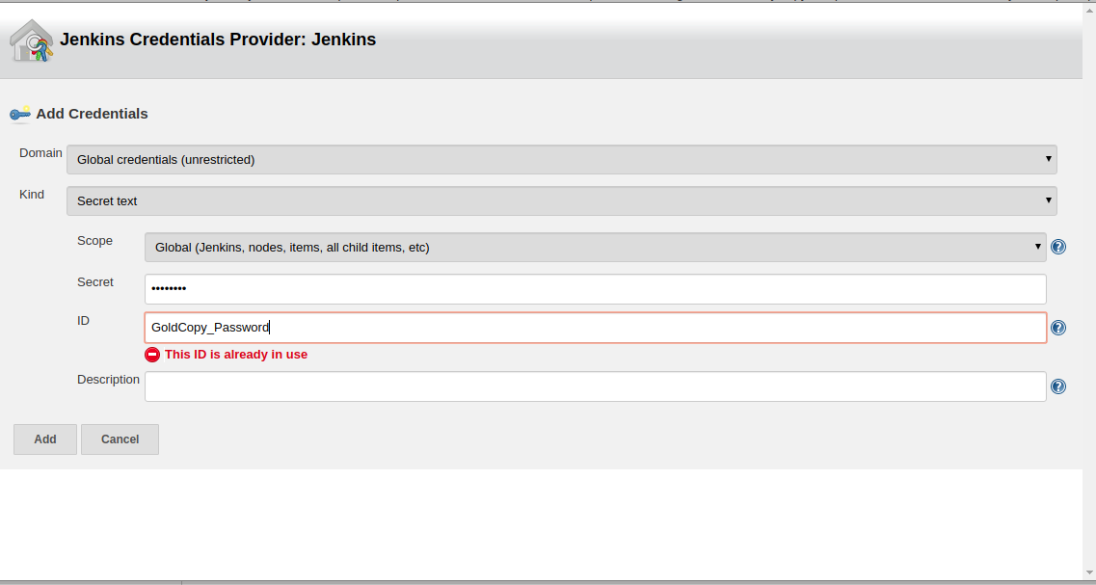

Once you add the credentials use withCredentials step in jenkins pipeline to store these secrets in variables as shown in the below figure.

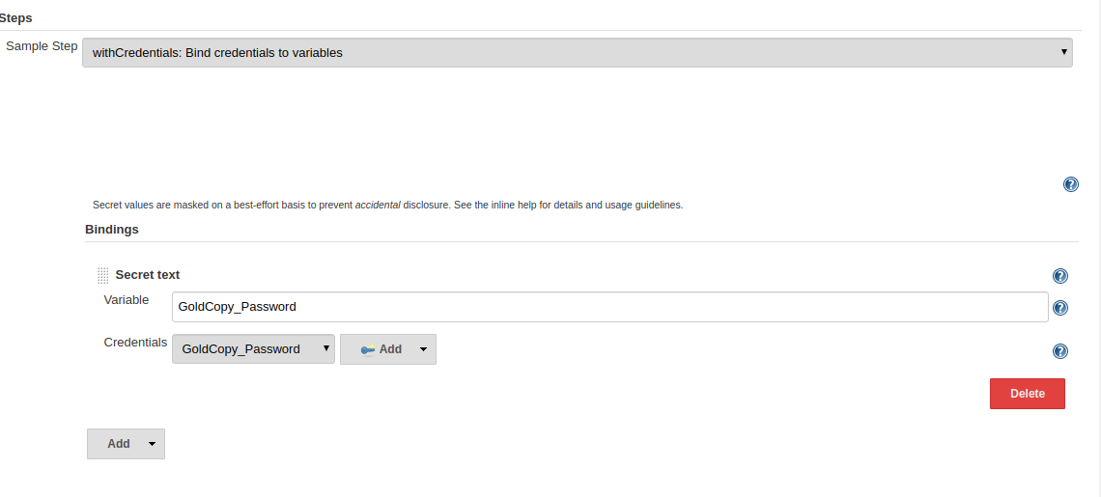

**Scripts:**

**1. plugin1.py:** This is the python script which matches the configuration of GoldCopy instance with remote instance.

**Features covered till now:**

* Matching plugins.
* Github Servers.
* Sonar Servers.
* Global Shared Libraries.
* Maven installations.
* Secrity option.

**2. plugin.csv:** This is a csv file generated from above script which contains the list of plugins and their versions of GoldCopy Jenkins instance. This file is used to match plugins of GoldCopy jenkins with Remote jenkins instance.

**3. Jenkinsfile:** This is the jenkins pipeline to run the python script and generate a report of tools which are matched and which are unmatched and also sends report via email.