"Overcoming Obstacles: Strategies for Women Accessible Mental Health Care in Underserved Communities of Survey"

Disha Varma

[dishavarma910@gmail.com](mailto:dishavarma910@gmail.com)

L J Institutes of Computer Applications, LJ University, Ahmedabad, Gujarat, India.

**Abstract-**Mental health problem are mode frequent in women than men. The aim of this research is to dissect the intricate dynamics of mental health concerning women, recognizing and addressing the nuanced challenges they confront. The research intends to unravel the complex interplay of Social and contextual factors and provide support and understanding mood of anxiety disorders are more common in women but they are affected by Schizophrenic Psychoses later in Life In India roughly 7.5% of women suffer from severe mental health conditions and nearly half of adult females are affected from a less serious mental health issue once in a Lifetime with this high Prevalence and sizable number of Young female Population, women's mental health is a huge concern. The solution to this Problem can be addressed through various measures mainstreaming a gender Perspectives in the mental health sector through educating women at all levels of society about the Possibilities of mental health interventions and the potential for a services and programs is central to the success of mental health program development.

**Keywords*-*** Gender, Mental health, Women, Human Rights, Trauma, Community, Depression, Violence, Anxiety, Mental health disorders.

**1. Introduction -**

Mental health is a fundamental aspect of overall well-being, influencing various dimensions of an individual's life. While mental health issues impact people across all genders, an emerging recognition underscores that women, in particular, encounter unique challenges deserving dedicated attention.[1] There are actual differences in the way women's brains are structured and “wired” and in the way they process information and react to events and stimuli.[2] Women differ in the way they communicate, deal in relationships, express their feelings, and react to stress.[4] This research paper endeavors to delve into the intricate landscape of mental health concerning women, aspiring to unravel the complexities surrounding prevalence, risk factors, and access to care.[4]

Historically, discussions surrounding mental health have often been generalized, with the specific nuances of women's mental well-being overlooked. [2] However, contemporary research increasingly recognizes the significance of understanding and addressing the unique mental health needs of women. [8] This research paper embarks on a journey to unravel the complexities that define and impact women's mental health, exploring the various factors that contribute to their psychological well-being. [4]

His research endeavors to contribute to the ongoing dialogue on mental health by providing a comprehensive analysis of the unique challenges faced by women.[12] By synthesizing empirical evidence, examining societal structures, and considering individual narratives, we aim to foster a deeper understanding of the factors influencing women's mental health.[8] Ultimately, this exploration seeks to inform and guide future interventions, policies, and research initiatives that address the specific mental health needs of women, paving the way for a more inclusive and equitable mental health landscape.[13]

Furthermore, the prevalence of mental health disorders varies among women of different ages, ethnicities, socioeconomic statuses, and cultural backgrounds.[11] Recognizing and addressing these diverse factors are essential for fostering a holistic approach to women's mental health that considers the individualized needs and experiences of each woman.[8]

As the mental health is an important matter in human

life and effects on individual life and society, the aim of

this research is studying the effective factors on mental

health such as depression, job stress and type of

personality physical activity in employees. Notice that

having some important and effective factor

simultaneously, having a suitable volume, wide various

geographical range and sampling from different places

of Iran are advantageous of this research

As the mental health is an important matter in human

life and effects on individual life and society, the aim of

this research is studying the effective factors on mental

health such as depression, job stress and type of

personality physical activity in employees. Notice that

having some important and effective factor

simultaneously, having a suitable volume, wide various

geographical range and sampling from different places

of Iran are advantageous of this research

As the mental health is an important matter in human life and effects on individual life and society, the aim of this research is studying the effective factors on mental health such as depression, job stress and type of personality physical activity in employees.[13] Notice that having some important and effective factor simultaneously, having a suitable volume, wide various geographical range and sampling from different places of Iran are advantageous of this research. Women’s mental health and inform efforts to promote gender equity, social justice, and holistic approaches to mental health care. [12, 8]

Among the factors that cause mental disorders are

psychological ones such as depression, stress [11], type

of personality [12] and physical inactivity [13]. Several

studies deal with the effect of stress and depression on

mental health.

Gigantesco

[14], for example, reported the

effect of stressful factors in job environments on mental

health. Results of studies on mental health and type of

personality show that there is a meaningful correlation

between type of personality and mental health [15] and

physical activity can effect positively on mental health

[16].

As the mental heal

Among the factors that cause mental disorders are psychological ones such as depression, stress , type of personality and physical inactivity.[15] Several studies deal with the effect of stress and depression on mental health. Gigantesco, for example, reported the effect of stressful factors in job environments on mental health.[10] Results of studies on mental health and type of personality show that there is a meaningful correlation between type of personality and mental health and physical activity can effect positively on mental health.[12] Moreover, women often face unique mental health challenges during key life transitions, including pregnancy, childbirth, menopause, and aging, underscoring the need for tailored interventions and support services.[16]

**2. Literature Review -**

Research suggests that women's mental health is seriously affected. Many women in our country are suffering from mental health or have to face mental health. There are many mental health problems such as Depression, Anxiety, Stress, Trauma, Suicide, Sociocultural Imbalances, etc.[15,11] All these problems women have and all these problems women have to face every day.

One of the most common mental health disorders someone might struggle with is depression. [22] Major depressive disorder accounts for a significant amount of disability worldwide. Depressive disorders account for more than 40% of disability in women. In men, they account for just under 30% of disability. [11] Anxiety among women is a common and significant mental health concern characterized by persistent feelings of worry, fear, and apprehension. It affects women of all ages, backgrounds, and life circumstances, and can profoundly impact their daily functioning, relationships, and overall well-being.[18] Stress for women encompasses a broad spectrum of psychological and emotional responses to the demands and pressures of everyday life.[16] It's an inevitable part of life, and women often encounter stressors related to various roles they play, including those within the family, workplace, community, and society at large.[11]

The overwhelming majority of individuals who are exposed to violent conflicts, civil wars, displacement from home, and natural disasters are women and children. About 20% of all women will experience rape or attempted rape at some point in their lifetime. [12] This may increase the risk of developing a mental health issue. PTSD (post-traumatic stress disorder) is a very common mental health disorder. Women are more likely to attempt suicide, even though men are more likely to die by suicide. [19] Females who reported having a higher physical manifestation of symptoms were more likely to attempt suicide again after their first attempt. [10] The societal pressure and expectations that women cope with regularly can increase the chances of developing mental health issues. This includes society’s greater valuing of women who are more physically attractive, empathetic and nurturing, and intelligent. [20, 25]

* 19% of women experience a common mental disorder, such as anxiety or depression, compared to 12% of men.[21]
* 53% of women with mental health problems have experienced abuse.[21]
* 29% of Black women, 24% of Asian women, and 29% of mixed-race women have a common mental disorder.[21]
* 10% of pregnant women and 13% of women who have just given birth experience a mental disorder, primarily depression.[21]
* Women between the ages of 16 and 24 are almost three times as likely (26%) to experience a common mental health issue as males of the same age (9%).[21]
* Women are twice as likely to be diagnosed with anxiety as men.[21]
* 25.7% of women and 9.7% of men aged 16 to 24 report having self-harmed at some point in their life.[21]
* 1 in 20 women experience premenstrual dysmorphic disorder (PMDD), a severe form of PMS.[21]

WHO estimates that the burden of mental health problems in India is 2443 disability-adjusted life years (DALYs) per 10000 population; the age-adjusted suicide rate per 100 000 population is 21.1. The economic loss due to mental health conditions, between (2012-2030), is estimated at USD 1.03 trillion. Every three hours, a woman becomes a victim of such violence.[26] Astonishingly, this equates to 148 incidents each day, impacting approximately 47,000 women enduring this gender-based violence. 26% of young women experience a Common Mental Disorder, such as anxiety or depression – almost three times more than young men. 1 in 7 young women (16-24) have PTSD (compared with 3.6% of young men).[21]

* **According to a 2022 report, women in India have the highest percentage of mental health disorders:**

In the latest study by Deb et al., 2022, 13.2 percent of students suffer from high, 46.9 percent moderate and 37.7 percent low levels of anxiety, while 27.5 percent suffer from high, 34.8 percent medium and 25.3 percent low levels of depression among 237 students from all over India.[18,21]

**TABLE: 1 Percentage of women’s mental health**

|  |  |
| --- | --- |
| **Women’s mental health** | **Percentage (%)** |
| Stress | 60% |
| Anxiety | 55% |
| Depression | 40% |
| Trauma | 30% |
| Social violence | 35.5% |
| Suicide | 15% |

* **Methodologies and approaches:**

|  |  |  |  |
| --- | --- | --- | --- |
| Paper. No | What did the author say? | Content | References |
| 13. | Depression and anxiety in women across the life span pose a significant burden to the Women themselves as well as to the public health system, and costs United States society tens of billions of dollars each year. | In this research paper Content is Depression,  Anxiety, Depression and anxiety in childhood and adolescence, Menstruation-pregnancy-,and Menopause-Related Depression and Anxiety, etc. | Robynn Zender, Ellen Olshansky. (October 2009). Women's Mental Health: Depression and Anxiety. |
| 43. | The effects of physical, emotional and, sexual violence by intimate partners on women’s mental health is borne out by the Findings of research in the past two decades. | In this research paper Content is Themes of severe emotional distress, The role of mental health services: supporting the victim or the abuser? Victim blaming, The domestic of the medical model, etc. | Cathy Humphreys. (March 2003). Mental Health and Domestic Violence: 'I call it Symptoms of Abuse'. |
| 15. | Violence against women is a prevalent problem around the world.  Women’s ability to live happy and productive lives. Violent acts against women include rape, incest, physical violence, and emotional abuse. | In this research paper  Content is Post-traumatic Stress Disorder, Impact of Intimate Partner Violence on Women’s Mental Health, Substance Abuse, etc. | Gunnur Karakurt, Douglas Smith & Jason. (May 2014).  Impact of Intimate Partner Violence on Women’s Mental Health. |
| 11. | This study on Depression, Anxiety and Stress among married women is relevant. Because it tries to comprehend the relationship between Depression, Anxiety and Stress among married women based on their age. The study was conducted to understand the influence of age on Depression, Anxiety and Stress among married women. | In this research paper  Content is Relevance of the study, Definition of key terms, Major findings, Limitations, Implications, Scope for the further study, etc. | Monisha. M., Sannet Thomas. (October 2020). THE STUDY ON DEPRESSION, ANXIETY AND STRESS AMONG MARRIED WOMEN. |
| 12. | Gender is a critical determinant of mental health and mental illness. The patterns of psychological distress and psychiatric disorder among women are different from those seen among men. Women have a higher mean level of internalizing disorders while men show a higher mean level of externalizing disorders. | In this research paper  Content is mental health and mental disorders, women’s mental health, Severe mental illness, Women- a life cycle of vulnerabilities, what need to be done, etc. | Savita Malhotra, Ruchita Shah. (July 2015). Women and mental health in India: An overview |
| 16. | Women were found to have a greater risk of a depressive episode following the life  event than men, and this difference was of a similar magnitude to other reports of gender  Differences in depression. Consistent with a role hypothesis, this greater risk was entirely Restricted to episodes that followed events involving children, housing or reproductive problems. | In this research paper  Content is Onset of depression, A direct test of the effect of role differences, Gender differences in roles, Other outcomes, etc. | Nazroo J, Edwards A. Brown G. (March 1997). Gender differences in the onset of depression following a shared life event: A study of couples. |
| 26. | Mental health problems or mental illness is an ongoing serious health issue. People in their conversation have started speaking and accepting about it. Mental illness does not see any hierarchy prevails in society, and it is evident that a person once in a lifetime suffers from mild to severe forms of mental illness. Therefore, private companies and public sector enterprises are devising ways to preserve their employees’ mental well‑being. | In this research paper  Content is mental health problems of women working in the unorganized sector, Financial support and sponsorship, Mental problems of working women, etc. | Priyanka Saikia, Pathak Abhijit. (January 2022). MENTAL HEALTH PROBLEMS OF WOMEN WORKING IN THE UNORGANIZED SECTOR. |
| 24. | Health decision-making for women in South Asia is still perceived and expected to be controlled by family members and male relatives. Even women who work and have independent incomes in the region may relinquish control over autonomous health decision-making in order to be accepted by society and preserve the traditional order. | In this research paper  Content is Sociodemographic and Health Characteristics of Women, Gender Gaps and Family Factors, Health Education and Health Behaviour, Nature of Employment, Violence and Safety, Quality of Healthcare Services and Traditional Healers, etc. | Sara Rizvi Jafree, Rubeena Zakar, Shaheda Anwar. (Aug 2020). Women’s Role in Decision-Making for Health care. |
| 10. | Violence against women, and more particularly male partner violence, is frequent. Although there are many studies on the consequences of violence on women's mental health, a number of aspects are still unclear. The impact of violence is seldom studied in the context of other risk factors of mental distress, psychological abuse is rarely considered, and older women are generally excluded from the sample. | In this research paper  Content is Current and past violence, Indicators of women’s health, Strategy of analysis, Frequency of violence, Relationships between violence and health indicators, Current violence, Past and current violence, Aim of the study, etc. | Patrizia Romito, Janet Molzan Turan, Margherita De Marchi. (April 2005). The impact of current and past interpersonal violence on women's mental health |
| 21. | Suicide is a global public health problem. Asia accounts for 60% of the world's suicides, so at least 60 million people are affected by suicide or attempted suicide in Asia each year. The burden of female suicidal behavior, in terms of total burden of morbidity and mortality combined, is more in women than in men.  More research on suicidal behavior in women particularly in developing countries is needed. | In this research paper  Content is Suicide rate of women, Sociodemographic Factors, Clinical risk factors, Sociocultural factors, Suicide prevention in women,  Protective factors, etc. | Lakshmi Vijayakumar. (September 2015). SUICIDE IN WOMEN. |

**3. The most Prevalent Mental Disorders among a women's: Depression, Anxiety, Stress and Trauma:**

**Depression**

Depression in women is a serious mental health condition characterized by persistent feelings of sadness, hopelessness, and worthlessness.[5] It affects women of all ages, backgrounds, and walks of life, and can have profound effects on their overall well-being and quality of life.[7] Depression in women can manifest in various ways, including changes in mood, sleep disturbances, appetite changes, fatigue, difficulty concentrating, and loss of interest in previously enjoyed activities.[11] Women may also experience physical symptoms such as headaches, digestive issues, and chronic pain alongside their emotional distress. Depression is a common mental health condition that can affect anyone. [13] Its a brain disorder that can cause a persistent feeling of sadness, emptiness, and loss of joy. It can also cause a loss of interest in activities and a low mood. [11] Depression is different from mood changes and feelings about everyday life. Depression results from a complex interaction of social, psychological and biological factors. [15] People who have lived through abuse, severe losses or other adverse events are more likely to develop depression. Problems at school and work can also result in depression. [5]

**Depression can have many causes, including:**

* Stress at work
* Relationship difficulties
* Pregnancy and birth
* A mix of events and factors[22]

**Anxiety**

Anxiety among women is a common and significant mental health concern characterized by persistent feelings of worry, fear, and apprehension. [16] It affects women of all ages, backgrounds, and life circumstances, and can profoundly impact their daily functioning, relationships, and overall well-being**.** Anxiety disorders can take various forms, including generalized anxiety disorder (GAD), panic disorder, social anxiety disorder, specific phobias, and obsessive-compulsive disorder (OCD).[11,15] Symptoms of anxiety can manifest physically, emotionally, and cognitively, leading to a range of distressing experiences such as rapid heartbeat, shortness of breath, trembling, sweating, muscle tension, restlessness, irritability, and difficulty concentrating.[17] Women are more likely than men to experience anxiety disorders, with factors such as biological differences, hormonal fluctuations, and socio-cultural expectations playing significant roles.[13] While experiencing occasional anxiety in response to stressful situations is a normal part of life, anxiety becomes problematic when it becomes chronic, excessive, and interferes with daily activities.[16] Anxiety can be mild or severe and can be experienced through thoughts, feelings, and physical sensations. It can be a normal reaction to stress, such as when faced with a difficult problem at work, before taking a test, or before making an important decision. [20] Anxiety is a natural reaction to stress that can manifest as a feeling of fear, dread, and uneasiness. It can also cause you to sweat, feel tense and restless, and have a rapid heartbeat. [14]

**Stress**

Stress for women encompasses a broad spectrum of psychological and emotional responses to the demands and pressures of everyday life.[20] It's an inevitable part of life, and women often encounter stressors related to various roles they play, including those within the family, workplace, community, and society at large.[25] Women may experience stress in different domains of their lives, such as managing household responsibilities, nurturing relationships, pursuing career aspirations, and balancing competing priorities.[22] Additionally, societal expectations, gender roles, and cultural norms can contribute to the experience of stress among women, imposing unrealistic standards and creating internal and external pressures to excel in multiple domains simultaneously.[30] Certain life transitions, such as marriage, pregnancy, childbirth, parenting, menopause, and caregiving for aging parents, can also be significant sources of stress for women.[17] These transitions often involve adjustments to roles, responsibilities, and expectations, which can contribute to feelings of uncertainty, vulnerability, and emotional upheaval.[18]

**In women, stress can be caused by a multitude of external and internal factors, such as:**

* Long hours
* High workloads
* Conflicts with colleagues or supervisors
* A lack of control over work tasks [12,15]

**Trauma**

Trauma is when we experience very stressful, frightening or distressing events that are difficult to cope with or out of our control. It could be one incident, or an ongoing event that happens over a long period of time. [15] Most of us will experience an event in our lives that could be considered traumatic. But we won't all be affected the same way. Trauma can happen at any age. [11] And it can affect us at any time, including a long time after the event has happened. The overwhelming majority of individuals who are exposed to violent conflicts, civil wars, displacement from home, and natural disasters are women and children. [16] About 20% of all women will experience rape or attempted rape at some point in their lifetime. This may increase the risk of developing a mental health issue. Women are exposed to higher levels of sexual violence and have higher rates of post-traumatic stress disorder (PTSD) associated with sexual violence. [20, 25] PTSD is a very common mental health disorder. When people think of PTSD, they often think of people exposed to combat violence. [7] While this is one factor, women are twice as likely to experience PTSD as men. PTSD in women can develop following domestic violence issues, sexual abuse, and other traumatic experiences. Women are also more likely to develop serious symptoms as a result of PTSD. [29]

**Symptoms of PTSD include:**

* Being easily startled
* Having trouble feeling emotions or feeling numb
* Avoiding things that remind them of the trauma
* Feeling depressed and anxious[51]

**Women are twice as likely as men to develop post-traumatic stress disorder (PTSD). Women who experience trauma are more likely to also experience:**

* Physical or sexual violence from an intimate partner
* Sexual abuse
* Depression
* Anxiety disorders [4,9]

## **4.** **WOMEN'S MENTAL HEALTH: THE FACTS (WORLD HEALTH ORGANIZATION REPORT, 2023):**

World Mental Health Day 2023 is an opportunity for people and communities to unite behind the theme “Mental health is a universal human right” to improve knowledge, raise awareness and drive actions that promote and protect everyone’s mental health as a universal human right. [18]

WHO estimates that the burden of mental health problems in India is 2443 disability-adjusted life years (DALYs) per 100 00 population; the age-adjusted suicide rate per 100 000 population is 21.1. The economic loss due to mental health conditions, between 2012-2030, is estimated at USD 1.03 trillion. [18]

The Mental Health Policy, 2014 upholds a participatory and rights-based approach for quality service provisions. The Mental Healthcare Act, 2017 provides the legal framework for providing services to protect, promote and fulfil the rights of people with mental illnesses. These are in line with the United Nations Convention on Rights of People with Disabilities (UNCRPD). [18]

**5.** **Mental health among young women and girls -**

Three quarters (75%) of mental health issues are established before the age of 24, and young women have emerged as the highest-risk group for mental ill health: [12]

* A quarter of young women (25.7%) have self-harmed – more than twice the rate for young men. There is evidence this could be higher and is growing.[22]
* 26% of young women experience a Common Mental Disorder, such as anxiety or depression – almost three times more than young men.
* 1 in 7 young women (16-24) have PTSD (compared with 3.6% of young men).[22]
* 72% of those in suicide counselling with NSPCC are girls
* Suicide is the third most common reason for girls to contact Child line, and the fifth most common for boys[22]

A study from the University of Manchester found that 73% of 10-19 year olds who identified as having self-harmed at least once were girls.[36] Experts have seen a “rapid” rise in self-harm among teenage girls, with reports of self-harm among 13-16 year old girls rising by 68% between 2011 and 2014.[14,22]

**6.**  **Mental health and abuse -**

There is clear evidence indicating that women’s mental health is linked to their experiences of violence and abuse. For example:

* 53% of women who have mental health problems have experienced abuse.[17]
* More than three quarters of women (78%) of women who have faced extensive physical and sexual violence – in both childhood and adulthood – have experienced life threatening trauma, and 16% have Post-Traumatic Stress Disorder (PTSD).[29]
* Over a third (36%) of women who have faced extensive physical and sexual violence in both childhood and adulthood have attempted suicide, and a fifth (22%) have self-harmed.[31,36]

**7. Analysis on the Current Survey-**

In this research paper, data was collected through a survey to understand people's preferences and experiences with different modes of working. The survey was conducted based on multiple factors like one's How to come overcome stress, which factors to use to overcome stress and many more that were considered during its development and implementation. These factors helped to ensure that the survey covered a comprehensive range of topics and provided valuable insights.

**8. Analysis on Survey -**

The survey questionnaire consisted of two sections of questions. The first section dealt with questions on personal information like name, age, gender, email, phone number, qualification. The second sections included questions about the How often do you feel stressed or overwhelmed, How satisfied are you with the mental health support provided in your workplace, Are there lifestyle changes you have made to support your mental well-being, Are you comfortable discussing your mental health with others, etc. questions ask to ours survey paper.

The figures [Figure 1] display data regarding people's current qualification status and their preferred mode of work. Most of people responded as this is directly related to their personal and professional lives, reflecting their current feelings and statuses. See this Figure 1 the highest Qualification come those aged is BCA students 17(21.3%), 12(15%) people is house wife, and than12th pass student is 3(3.8%), and Graduation students is 3(3.8%) etc. so we sought these Qualification people.

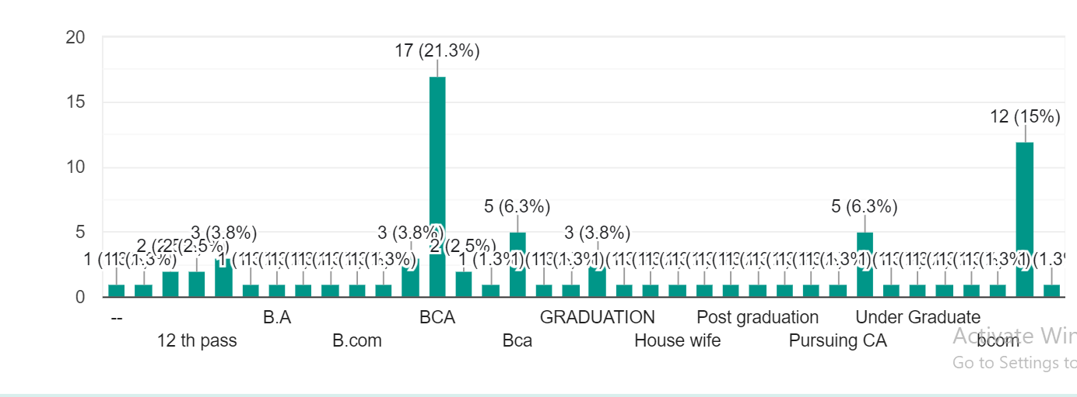

**Figure 1: Qualification of people**

The figures [Figure 2] display data regarding people's current Age. Under 18 age people is 5(6.3%). So there is huge response from the age group of 18-24. They know the impact on a woman's mental health. And 3(3.7%) people is aged between 25 and 34, 17(21.3%) people is aged between 35- 44, and 5(6.3%) people is aged between 45 to 55, and then while those 55 above aged have the lowest people 1(1.2%) [Figure 2].

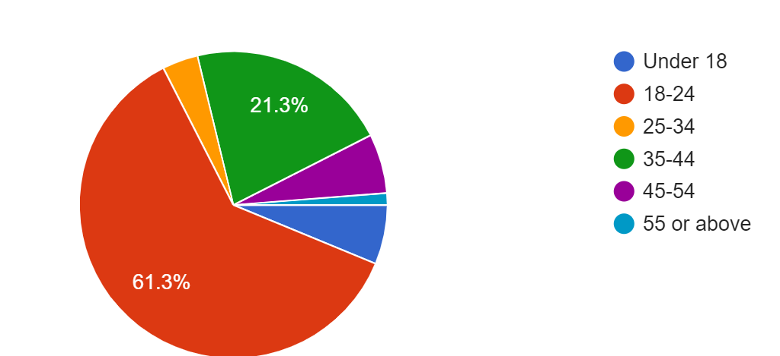

**Figure 2: How old are you?**

[Figure 3] displays the gender-wise breakdown of preference for Women's mental health. Most of the respondents found to be female. It may be most of the cases in India female peoples are more than males. Around 22(34.4%) of the males and 42(65.6%) of the females agreed for Women's Mental health, which definitely an indication that, people somewhere want to dedicate for their works and want to have comfortable life and to spare some of their valuable time for their families too.

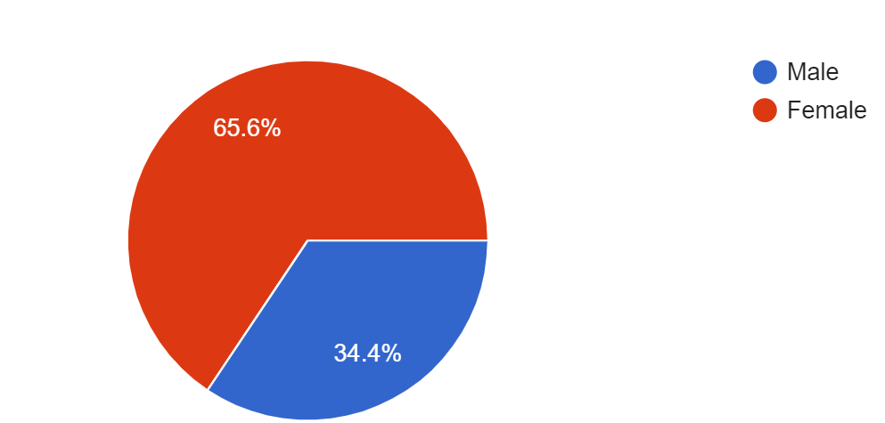

**Figure 3: Gender**

The figures [Figure 4] the results have been blended. 9(11.3%) of the people could not determine whether or not Are there areas in the mental health where you believe more education and awareness are needed?

Can enhance their properly-being or no longer. 71(88.8%) of the respondents answered that believe Are there areas in the mental health where you believe more education and awareness are needed? so that this response is positive.

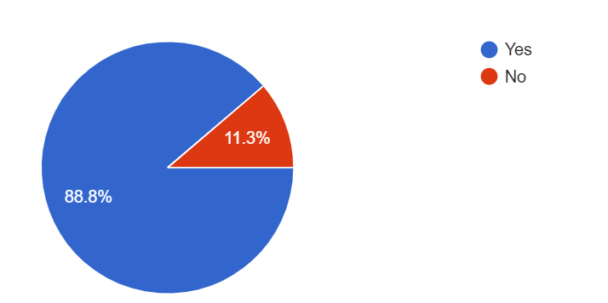

**Figure 4: Are there areas in the mental health where you believe more education and awareness are needed?**

[Figure 5] displays the how to stress can be removed. What doing more relieves stress, we have discovered that through our survey. What strategies and activities are helpful to overcome the problem of stress? So in our survey, 58(72.5%) higher people say that mental health problems are removed with a healthy lifestyle. And second higher people 53(66.3%) say that mental health problems are removed with a Mindfulness and Meditation. 49(61.3%) people say that mental health problems Regular Exercise are removed. And 45(56.3%) people say that Social Connections mental health problems are removed from. So these four problems help prevent mental health.

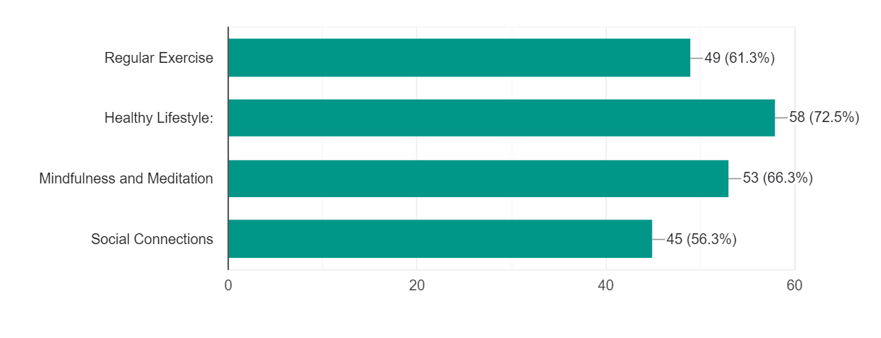

**Figure 5: What strategies or activities do your find helpful in preventing mental health issues? (Select all that apply)**

[Figure 6] displays the data how often do you feel stress or overwhelmed?

So most of people answer 34(42.5%) that Sometimes. 20(25%) people answer that Always. Those people always feel stress no.11 (13.8%) people answered that Never. 9(11.2%) of the people answer is that Rarely. we are rarely feel stressed. And 6(7.5%) people answer is that frequently. Those people often experience stress.

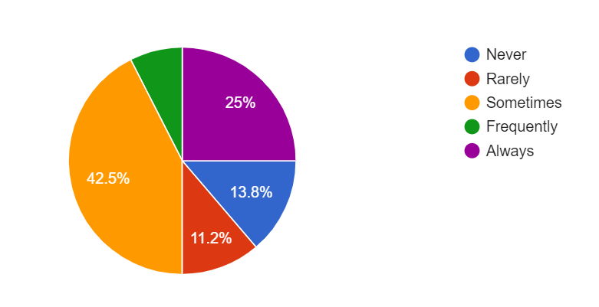

**Figure 6: How often do you feel stressed or overwhelmed?**

[Figure 7] displays the data show that 46(57.5%) people are not neutral about talking about their health with others. Most people are not neutral in talking about their health with others. 23(28.7%) answered that they are comfortable talking about their health with others. the second higher

People love to share and tell about their health with others. And 11(13.7%) people say that a it is uncomfortable to talk to people about their health.

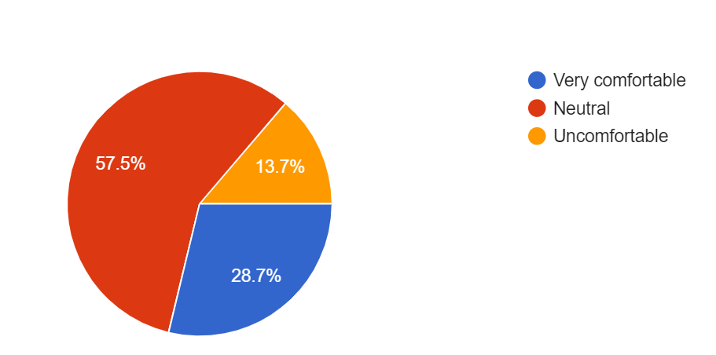

**Figure 7: Are you comfortable discussing your mental health with others?**

[Figure 8] displays the data shows how satisfied are you with the mental health support provided in your workplace? This figure shows what the opinions of the people are. Our survey found out how satisfied people are with the mental health support their workplace provides. So 49(61.3%) of people in our survey are satisfied with the mental health support provided at their workplace. 23(28.7%) people are neutral about mental health support provided to them at workplace. 8(10%) of people are dissatisfied with the mental health support provided in their workplace.

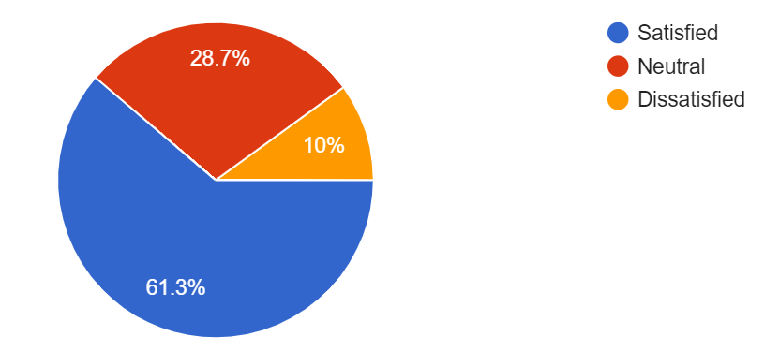

**Figure 8: How satisfied are you with the mental health support provided in your workplace?**

[Figure 9] displays the data shows there is sufficient awareness and understanding of women's mental health issues in the society. Can society understand women's mental health issues? And society has enough understanding and awareness about women's mental health. So in this survey of ours 34(42.5%) say most of the people No. Society does not have enough understanding and awareness about women's mental health. 34(42.5%) People say that society does not understand women's mental problems. 30(37.5%) answer that Yes, society is enough understanding and awareness about mental health of women. These people say they society can understand the mental problems of women's. 16(20%) people say that they are Unsure.

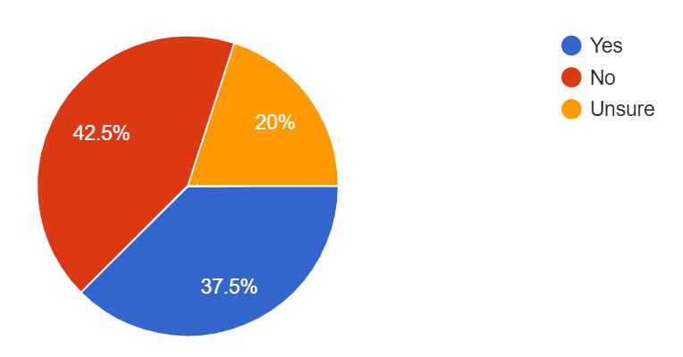

**Figure 9: Do you feel that there is enough awareness and understanding of women's mental health issues in society?**

[Figure 10] displays the data suggests that you have someday made lifestyle changes to support your mental well-being. So in our survey 70(87.5%) people answered yes. These people have made lifestyle changes to support their mental well-being. And 10(12.5%) have made no lifestyle changes to support their mental well-being.

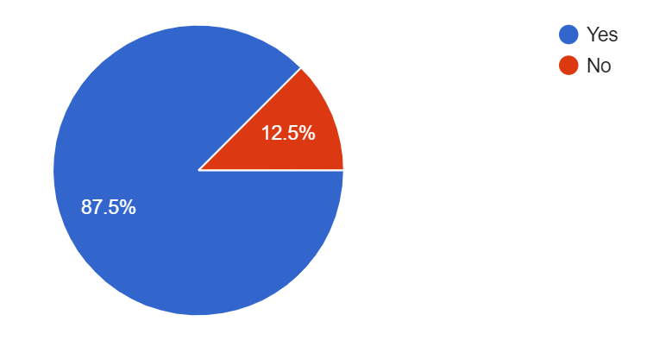

**Figure 10: Are there lifestyle changes you have made to support your mental well-being?**

[Figure 11] displays the data what factors contribute to women's mental well-being. What factors are used to overcome mental problems in women? We have discovered that through this survey. A lot of people said that Arab the abo means 53% people think that Supportive networks, Access to healthcare, Educational opportunities, Economic stability, that is all of the above, 63% of the people believe that all these factors contribute to the mental well-being of women 9% of the people believe that the supporting network contributes to the mental well-being of women in our community. 8(10%) believe that access to health care contributes to women's mental well-being. 6(7.5%) people say that Educational opportunities are beneficial to women's mental well-being. And 4(5%) believe that this factor contributes to the mental well-being of women in our community from the Economic stability.

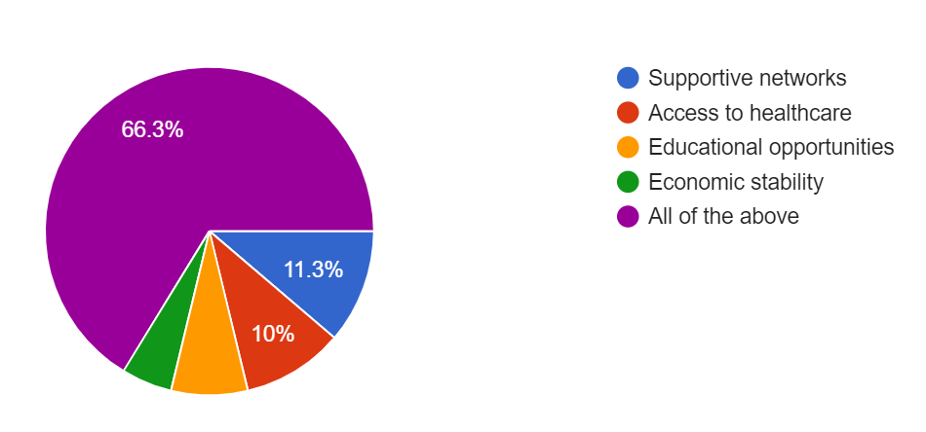

**Figure 11: In your opinion, what factors contribute to the mental well-being of women in your community?**

**9. Descriptive Statistics -**

According to the statistics done on the data collected through the survey has been shown in Table 1 and Table 2.

**Table 2**: **Percentage helpful in preventing mental health issues:**

|  |  |
| --- | --- |
| **Helpful in preventing mental health issues** | **Percentage** |
| Regular Exercise | 61.3% |
| Healthy Lifestyle | 71.5% |
| Mindfulness and Meditation | 66.3% |
| Social Connections | 56.3% |

[Table: 2] The survey collected data from individuals for helpful in preventing mental health issues. So in this table of ours Helpful in preventing mental health issues. So regular exercise is 61.3%. Regular Exercise is Helpful in preventing mental health issues. Healthy Lifestyle is 71.5%. Mindfulness and Meditation Percentage is 66.3%. And Social Connections Percentage is 56.3%. This data is from a survey we conducted to Helpful in preventing mental health issues.

**Table 3**: **Percentage feel stressed or overwhelmed:**

|  |  |
| --- | --- |
| **Feel stressed or overwhelmed** | **Percentage** |
| Never | 13.8% |
| Rarely | 11.2% |
| Sometimes | 42.5% |
| Frequently | 7.5% |
| Always | 25% |

[Table: 3]The survey collected data from individuals for feel stressed or overwhelmed. So in this table first of all Never 13.8% of people who experience stress. 11.2% people Feel stressed or overwhelmed rarely. 42.5% people Feel stressed or overwhelmed sometimes. 7.5% people Feel stressed or overwhelmed frequently. And 25% people Feel stressed or overwhelmed always. Our survey reveals that most of the people i.e. 42% feel stress at some time. This table shows when people feel stressed. We have collected this data through our survey.

**10. SUICIDE RATE OF WOMEN** Suicide is a global public health problem. Each year worldwide approximately one million individuals die by suicide, 10–20 million attempt suicide and 50–120 million are profoundly affected by the suicide or attempted suicide of a close relative or associate.[30] Asia accounts for 60 percent of the world's suicides, so at least 60 million people are affected by suicide or attempted suicide in Asia each year.[37] Suicide statistics was obtained from the mortality statistics of WHO's website and human development index (HDI), was used to categorize countries as low, medium, and high.[28] For roughly half of the countries (53.1%) and one-third of the population (27.3%) there were no data on suicide.[29] Country level suicide rates were aggregated to regional level by using a weighted average where the weights were proportional to the a population of each country in the aggregated group.

In a nationally representative survey in India, it was found that the overall age standardized suicide rates per 100,000 population at ages 15 years and elder were 26.3 for males and 17.5 for females.[39] The age standardized rates at all ages were 18.6 for males and 12.7 for females**.** Suicide rates tend to increase with age. [40] In 2000, the males rates for specific age category started at 1.4 (5–14 years) and gradually increased to 52.1 (75 years and older). The female rates for the different age groups are: 5–14 years - 0.4, 15–24 years - 4.8, 25–34 years - 6.2, 35–44 years - 7.8, 45–54 years - 9.7, 55–64 years - 10.6, 65–74 years - 12.3 and 75+ years - 15.9. This is suicide rate for women’s.[40,45]

In 2022, there were more than 48 thousand female deaths due to suicides in India. Some of the causes for suicides in the country were due to professional problems, abuse, violence, family problems, financial loss, sense of isolation and mental disorders.[39] Women are more likely to [**attempt suicide**](https://www.mcleanhospital.org/suicide-prevention), even though men are more likely to die by suicide.[40] Females who reported having a higher physical manifestation of symptoms were more likely to attempt suicide again after their first attempt.[42] It’s important to note that just because someone may not be successful in a suicide attempt does not mean that they will not continue to struggle with lifelong complications as a result. Suicide ranks as the number one cause of mortality in young girls between the ages 15 and 19 years globally. [40]

**11. What are symptoms of mental disorders in women?**

Mental health includes emotional, psychological, and social well-being. Mental disorders can affect women differently. [40] Some disorders are more common in women, such as depression, anxiety, and eating disorders. There are also certain disorders that are unique to women. [32] Women can develop most of the same mental disorders and conditions, but they may experience different symptoms. Some common symptoms include. This is a common symptoms for women’s mental health: [30]

* Persistent sadness or feelings of hopelessness
* Noticeable changes in mood, energy level, or appetite
* Difficulty sleeping or sleeping too much
* Appetite or weight changes
* Misuse of alcohol, drugs, or both
* Decreased energy or fatigue
* Excessive fear or worry
* Seeing or hearing things that are not there
* Extremely high and low moods
* Anger or irritability
* Social withdrawal
* Thoughts or behaviours that interfere with work, family, or social life
* Thoughts of death or suicide or suicide attempts[25]

# **12. Violence against women -**

Violence against women does not mean only physical violence. It is much broader and includes sexual, emotional, psychological and financial abuse. The National Plan targets two main types of violence against women – domestic and family violence, and sexual assault. [38] Violence against women is a pervasive and deeply troubling issue globally. Some common forms of violence against women include domestic violence, intimate partner violence, sexual assault, harassment, human trafficking, female genital mutilation, forced marriage, and honor killings.[40] These acts not only cause immediate physical and emotional harm but also have long-term consequences for women's health, well-being, and socio-economic empowerment.[37] Family violence is a broader term that refers to violence between family members, as well as violence between intimate partners. It involves the same sorts of behaviours as described for domestic violence. It's crucial to involve governments, civil society organizations, communities, and individuals in these efforts to create safer environments for women and ensure their fundamental human rights are protected. [42]

**Key facts (WHO):**

* Violence against women – particularly intimate partner violence and sexual violence – is a major public health problem and a violation of women's human rights.[20]
* Estimates published by WHO indicate that globally about 1 in 3 (30%) of women worldwide have been subjected to either physical and/or sexual intimate partner violence or non-partner sexual violence in their lifetime.[20]
* Most of this violence is intimate partner violence. Worldwide, almost one third (27%) of women aged 15-49 years who have been in a relationship report that they have been subjected to some form of physical and/or sexual violence by their intimate partner.[20]
* Violence can negatively affect women’s physical, mental, sexual, and reproductive health, and may increase the risk of acquiring HIV in some settings.[20]
* Violence against women is preventable. The health sector has an important role to play to provide comprehensive health care to women subjected to violence, and as an entry point for referring women to other support services they may need.[20]

**13.** **Mental Health Effects of Domestic Violence -**

Domestic violence is a serious issue that affects millions of people worldwide. It involves physical, emotional, and psychological abuse inflicted by one partner on another in an intimate relationship. [42] The trauma of domestic violence can have severe and long-lasting effects on mental health, which is often overlooked or minimized. Studies show that domestic violence can cause a range of mental health problems, including depression, anxiety, post-traumatic stress disorder (PTSD), and substance abuse. Victims of domestic violence are at a higher risk of developing mental health problems than those who have not experienced such abuse. [43]

Violence against women is a major public health and human rights issue in the world today. This study was conducted to assess the consequences of domestic violence on the mental health of women of reproductive age group. 42.8% of the women reported one or the other types of violence. [45] 34.9% of the women reported either physical or sexual violence ever in life. [43, 44] 29.1% of the women reported either physical or sexual violence in past 1 year (current violence). 12% of the women reported mental ill health. Women who had experienced domestic violence were more likely to report mental ill health status and suicidal tendencies as compared to women who had not experienced violence. [42]

A semi-structured interview schedule adapted from WHO multi-country study on women’s health and domestic violence was used in the study.[43] Around 70% of the women in the study population were in the age group of 20-24 and 25-29 years. Around one in three women (31.7%) were married for more than 10 years while 8.3% were married for less than 3 years.[48] Majority of the women (81.7%) were literate and 70.0% of the study population was educated up to middle level and above.[47]

**Other mental health issues that can arise from domestic violence include: [36]**

* Alcohol and drug abuse
* Phobias
* Panic disorders
* Physical inactivity
* Poor self-esteem
* Psychosomatic disorders
* Schizophrenia[36,50]

## **14. Future Research Direction-**

Archives of Women’s Mental Health, (AWMH) would like to contribute to a better understanding of women’s mental health from an interdisciplinary point of view, reflecting the whole field of women’s mental health. This includes psychological, social, and biological aspects of women’s mental health - their well-being, as well as the specificities of psychiatric and psychosomatic disorders in women. This also includes articles on sex- and gender differences in mental disorders and on specific risk factors for women’s mental health. So please submit respective studies from the fields of epidemiology, basic research, stress research, psycho-endocrinology, neuroimaging, neuropsychology, sociology, etc. Interdisciplinary studies are especially welcome. As the exchange of knowledge between psychiatrists and obstetrician-gynaecologists is one of the major aims of the journal, studies focusing on the interface between psychiatry/psychology on the one hand and gynaecology/obstetrics on the other hand are of special interest. We are also interested in training and education in women’s mental health, in mentoring for female mental health professionals, and - last not least - in policies for the prevention of mental illness in women. With our publications we want to assist clinicians, teachers, and researchers to incorporate knowledge of all aspects of women’s mental health into current and future clinical care, teaching, and research.

**15. Conclusion –**

The study indicates that mental health in India is attached with strong

social stigma against it. Most people are still unaware or ignorant about

the importance of mental wellbeing. Terms such as 'pagal', 'mental' and

'crazy' should not be thrown around casually. Awareness of mental

health in general and that women in particular, should be spread even in

the remote areas of India where there are people who still hold the

notions of spirits and demons when the explanation lies in

understanding of a mental illness.

The study indicates that mental health in India is attached with strong

social stigma against it. Most people are still unaware or ignorant about

the importance of mental wellbeing. Terms such as 'pagal', 'mental' and

'crazy' should not be thrown around casually. Awareness of mental

health in general and that women in particular, should be spread even in

the remote areas of India where there are people who still hold the

notions of spirits and demons when the explanation lies in

understanding of a mental illness.

The study indicates that mental health in India is attached with strong

social stigma against it. Most people are still unaware or ignorant about

the importance of mental wellbeing. Terms such as 'pagal', 'mental' and

'crazy' should not be thrown around casually. Awareness of mental

health in general and that women in particular, should be spread even in

the remote areas of India where there are people who still hold the

notions of spirits and demons when the explanation lies in

understanding of a mental illness.

Conclusion

The study indicates that mental health in India is attached with strong social stigma against it. Most people are still unaware or ignorant about the importance of mental wellbeing. Terms such as 'pagal', 'mental' and 'crazy' should not be thrown around casually. Awareness of mental health in general and that women in particular, should be spread even in the remote areas of India where there are people who still hold the notions of spirits and demons when the explanation lies in understanding of a mental illness. In conclusion, this research paper has shed light on various aspects of women's mental health, exploring the prevalence, risk factors, and impacts of mental health disorders on women's well-being. Through a comprehensive review of existing literature and empirical evidence, several key findings have emerged. Firstly, it is evident that women are disproportionately affected by mental health disorders, with higher rates of depression, anxiety, and trauma-related conditions compared to men. Factors such as hormonal fluctuations, societal expectations, and experiences of discrimination contribute to this disparity. In conclusion, improving women's mental health requires a multifaceted approach that addresses biological, psychological, social, and systemic factors. By fostering inclusive, supportive environments and advocating for gender equity, we can work towards enhancing the mental well-being of women and promoting a healthier, more equitable society.

**16. References-**

**1.** Indira Sharma, Abhishek Pathak. (July 2015). Women mental health in India.

**2.** Jayashri Kulkarni. (February 2008). WOMEN’S MENTAL HEALTH.

**3.** Mahin Delara. (January 2016). Social Determinants of Immigrant Women’s Mental Health.

**4.** Kay A Wilhelm. (June 2014). GENDER AND MENTAL HEALTH.

**5.** Febna Moorkath, Mysore Narasimha Vranda, Channaveerachari Naveenkumar. (July 1, 2019). WOMEN WITH MENTAL ILLNESS – AN OVERVIEW OF SOCIOCULTURAL FACTORS INFLUENCING FAMILY REJECTION AND SUBSEQUENT INSTITUTIONALIZATION IN INDIA.

**6.** Maki P.M. (March 2008). Menopause and anxiety: immediate and long-term effects.

**7.** Muntazir Maqbool, Neharshi Shrivastava and Manju Pandey. (November 2014). A COMPARATIVE STUDY OF MENTAL HEALTH OF WORKING WOMEN AND HOUSE WIFE.

**8.** Shahin Shooshtari, M. R. Abedi1, M. Bahrami, Rahele Samouei. (February 2018). Empowerment of women and mental health improvement with a Preventive approach.

**9.** Priyanka Saikia, Abhijit Patha. (January 2022). Mental health problems of women working in the unorganized sector.

**10.** Patrizia Romito, Janet Molzan Turan, Margherita De Marchi. (April 2005). The impact of current and past interpersonal violence on women's mental health.

**11.** Monisha. M., Sannet Thomas. (October 2020). THE STUDY ON DEPRESSION, ANXIETY AND STRESS AMONG MARRIED WOMEN.

**12.** Savita Malhotra, Ruchita Shah. (July 2015). Women and mental health in India: An overview.

**13.** Robynn Zender, Ellen Olshansky. (October 2009). Women's Mental Health: Depression and Anxiety.

**14.** Fatemeh ZareMobini1, Ashraf Kazemi and Ziba Farajzadegan. (March 2018). A COMPREHENSIVE MENTAL HEALTH CARE PROGRAM FOR WOMEN WITH POLYCYSTIC OVARY SYNDROME: PROTOCOL FOR A MIXED MENTHODS STUDY.

**15.** Inger Sandanger, Jan F. Nygård, Tom Sørensen. (16 September 2003). Is women’s mental health more susceptible than men’s to the influence of surrounding stress?

**16.** Nazroo J, Edwards A. Brown G. (March 1997). Gender differences in the onset of depression following a shared life event: A study of couples.

**17.** Kamlesh Kumari Sharma, Manju Vatsa, Mani Kalaivan. (July 2019). Mental health effects of domestic violence against women in Delhi: A community-based study.

**18.** WHO <https://www.who.int/health-topics/mental-health#tab=tab_1>

**19.** <https://www.nimh.nih.gov/health/statistics/mental-illness#:~:text=Prevalence%20of%20Any%20Mental%20Illness%20(AMI)>, Figure%201%20shows&text=The%20prevalence%20of%20AMI%20was,50%20and%20older%20(15.0%25).

**20.** <https://www.who.int/news-room/fact-sheets/detail/violence-against> women#:~:text=Estimates%20published%20by%20WHO%20indicate,violence%20is%20intimate%20partner%20violence.

**21.** Lakshmi Vijayakumar. (September 2015). SUICIDE IN WOMEN.

**22.** WOMEN’S MENTAL HEALTH,<https://iris.who.int/bitstream/handle/10665/66539/WHO_MSD_MDP_00.1.pdf>

**23.** Shahin Shooshtari, M. R. Abedi, M. Bahrami, Rahele Samouei. (February 2018). EMPOWERMENT OF WOMEN AND MENTAL HEALTH IMPROVEMENT WITH A PREVENTIVE APPROACH.

**24.** Sara Rizvi Jafree, Rubeena Zakar, Shaheda Anwar. (Aug 2020). Women’s Role in Decision-Making for Health care.

**25.** <https://my.clevelandclinic.org/health/diseases/22295-mental-health-disorders>

**26.** Priyanka Saikia, Pathak Abhijit. (January 2022). MENTAL HEALTH PROBLEMS OF WOMEN WORKING IN THE UNORGANIZED SECTOR.

**27.** Mary Ellsberg. (October 2008). Intimate partner violence and women's physical and mental health in the WHO multi-country study on women's health and domestic violence: an observational study.

**28.** Krim K. Lacey, Regina Parnell, Sasha R. Drummond-Lewis, Maxine Wood and Karen Powell Sears. (December 2022). Physical Intimate Partner Violence, Childhood Physical Abuse and Mental Health of U.S. Caribbean Women: The Interrelationship of Social, Contextual, and Migratory Influences

**29**. Gabriel Rodriguez, Jorge Acebes Sánchez, Sonia García Merino, Maria Garrido-Muñoz, Cecilia Blanco-García, Ignacio Diez-Vega. (December 2022). PHYSICAL ACTIVITY AND MENTAL HEALTH IN UNDERGRADUATE STUDENTS.

**30**. Yogesh Jogsan. (July 2019). MENTAL HEALTH AND DEPRESSION AMONG WORKING AND NON- WORKING WOMEN.

**31**. Dr.S.Brindha Suresh. (February 2020). MENTAL HEALTH PROBLEMS OF WORKING WOMEN IN INDIAN CONTEXT.

**32**. Ilona S. Federenko and Pathik D. Wadhwa. (07 November 2014). Women's Mental Health during Pregnancy Influences Fetal and Infant Developmental and Health Outcomes.

**33**. Venkatashiva Reddy.B, Arti Gupta, Ayush Lohiya, Pradip Kharya. (February 2013). Mental Health Issues and Challenges in India: A Review.

**34**. Aida Mehrad. (April 2017). RELATIONSHIP BETWEEN STRESS, PHYSICAL EXERCISE, AND MENTAL HEALTH AMONG ATHLETES.

**35**. <https://www.mcleanhospital.org/essential/why-we-need-pay-attention-womens-mental-health>

Why We Need To Pay Attention to Women’s Mental Health.

**36.** <https://www.agendaalliance.org/our-work/projects-and-campaigns/womens-mental-health-facts/#:~:text=Mental%20ill%20health%20among%20young%20women%20and,in%20suicide%20counselling%20with%20NSPCC%20are%20girls>.

**37**. Anant Kumar, S Haque Nizamie, Naveen Srivastava. (August 2013). Violence against Women and Mental Health.

**38**. Vibha Sharma. (February 2021). Violence Against Women: Psychological Issues and Interventions.

**39**. [https://www.agendaalliance.org/our-work/projects-and-campaigns/womens-mental-health-facts/#:~:text=*,3.6%25%20of%20young%20men](https://www.agendaalliance.org/our-work/projects-and-campaigns/womens-mental-health-facts/#:~:text=*,3.6%25%20of%20young%20men).

**40**. Pernilla Garmy, Agneta Berg, Eva Clausson. (October 2015). A qualitative study exploring adolescents' experiences with a school-based mental health program.

**41**. Alexander M. Clark, Bailey J. Sousa. (June 2018). The Mental Health of People Doing Qualitative Research: Getting Serious About Risks and Remedies.

**42**. Kylee Trevillion, Siân Oram, Gene Feder, Louise Michele Howard Obe. (December 2012). Experiences of Domestic Violence and Mental Disorders: A Systematic Review and Meta-Analysis.

**43**. Cathy Humphreys. (March 2003). Mental Health and Domestic Violence: 'I call it Symptoms of Abuse'.

**44**. Dixit Sanjay, AK Puranik, Girjesh Gupta, Bhupendrakumar Rohit. (January 2013). A study of the nature and causes of domestic violence among the attendees of a domestic violence counseling center of a tertiary level hospital of a city of central India.

**45**. Dian Pitaloka Priasmoro. (May 2016). Understanding Mental Disorders in Women in the Workplace to Mitigate Deleterious Effects.

**46**. Mehdi Mokhtari, Somayeh Farhang Dehghan, Mehdi Asghari. (Jun 2013). Epidemiology of mental health problems in female students: A questionnaire survey.

**47**. <https://www.sciencedirect.com/topics/medicine-and-dentistry/womens-mental-health> Women’s mental health

**48**. “Archives of Women's Mental Health”

Publishing model. (Book)

**49.** [**https://www.liptemberfoundation.org.au/2023-womens-mental-health-research**](https://www.liptemberfoundation.org.au/2023-womens-mental-health-research)

(2023 Women's Mental Health Research).

**50**. Diksha Sapkota, Sailesh Bhattarai, Dharanidhar Baral and Paras K. Pokharel. (April 2016). Domestic violence and its associatedfactors among married women of a villagedevelopment committee of rural India.

**51**. <https://link.springer.com/journal/737/aims-and-scope>

Women mental health in India

Indira Sharma, Abhishek Pathak

Women mental health in India

Indira Sharma, Abhishek Pathak

Women mental health in India

Indira Sharma, Abhishek Patha