- Complete Architecture:

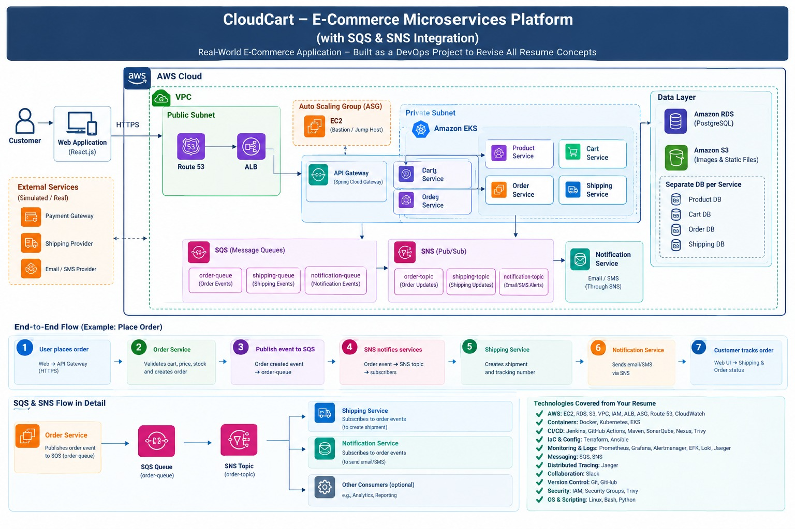
- User Flow:
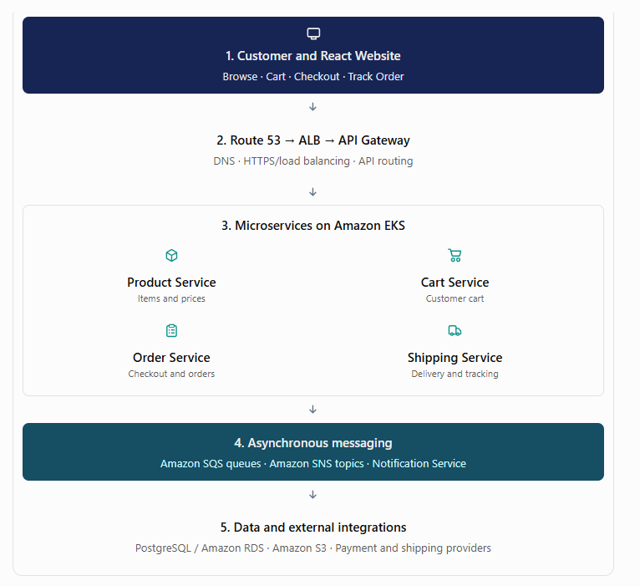
- Techonlogy & AWS DevOps Usage:
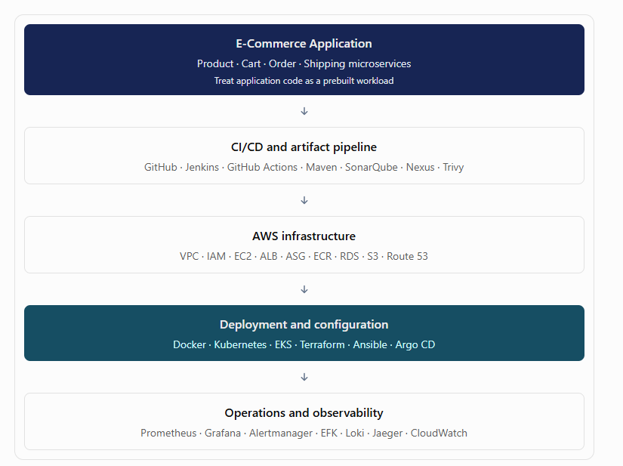

- Complete flow:

Stage 1 — Customer opens the website
User action: Opens shop.example.com.
Request flow: Browser → Route 53 → Application Load Balancer → frontend/API entry point.
Technologies used:
Route 53 resolves the domain to the application endpoint.
HTTPS/TLS protects traffic.
ALB distributes supported HTTP/HTTPS traffic to configured targets.
React renders the website.
S3 can store product images and static assets; CloudFront can deliver them efficiently.

Stage 2 — Customer browses products

User action: Views products and opens a product's details.
Request flow: React → API Gateway → Product Service → Product database.
Technologies used:
Spring Cloud Gateway routes the API request.
Product Service returns item details, prices and availability.
PostgreSQL stores product records; Amazon RDS can host the production database.
EKS runs the containerized service.
Docker packages the application.

Stage 3 — Customer adds products to the cart
User action: Adds two headphones to the cart.
Request flow: React → API Gateway → Cart Service → Cart database.
Technologies used:
Cart Service stores the user's cart and quantities.
Cart Service calls Product Service when it needs product information.
Each service owns its data; one service should not directly query another service's tables.
Redis is optional for fast cart access.

Stage 4 — Customer checks out

User action: Enters a delivery address and clicks Place Order.
Request flow: API Gateway → Order Service → Cart/Product/Inventory capabilities → Payment integration.
Technologies used:
Order Service validates prices, quantities and stock.
Inventory logic prevents overselling through safe stock reservation.
Payment Service communicates with a payment provider.
Order status progresses through states such as PENDING, CONFIRMED or FAILED.

Stage 5 — SQS and SNS process order events:
