Practical(Q2)
Name: Hamsini.ch
Rollno: 2520030016
Section: 8
Title: File Copying Using Linux System Calls and System Call Tracing Using strace
Aim: To develop a C program that uses the Linux system calls open(), read(), write(), and close() to copy the contents of one file to another.
Also, to use the strace utility to trace the system calls generated by the command:
cat sample.txt
and analyse the sequence of system calls and identify the kernel services involved.
Objective:
- To understand file handling using Linux system calls.
- To learn how open() opens a file.
- To learn how read() reads data from a file.
- To learn how write() writes data to another file.
- To learn how close() closes an opened file.
- To understand the transition between user space and kernel space.
- To use strace for tracing system calls.
- To identify the kernel services involved in executing cat sample.txt.
Theory:
Linux provides system calls that allow user programs to request services from the kernel.
For file operations, the important system calls are:
1. open()
The open() system call opens a file and returns a file descriptor.
Example:
int fd = open("source.txt", O_RDONLY);
Here, O_RDONLY opens the file in read-only mode.

2. read()
The read() system call reads data from an opened file into a buffer.
read(fd, buffer, sizeof(buffer));
It returns the number of bytes actually read.

3. write()
The write() system call writes data from a buffer to a file.
write(fd, buffer, bytes);

4. close()
The close() system call closes the file descriptor after the file operation is completed.
close(fd);

User Space and Kernel Space
Linux divides execution into two important areas:
User Space
This is where normal applications such as our C program and the cat command execute.
Kernel Space
This is where the Linux kernel manages:
- Files
- Memory
- Processes
- Hardware
- Input/output operations
- File systems
When a C program calls open(), read(), write(), or close(), control transitions from user space to kernel space.
Control Flow
User Program
|
| open()
↓
Kernel
|
| File System
↓
Disk / Storage
|
↓
Kernel
|
↓
User Program
For example:
C Program
↓
open()
↓
Kernel
↓
File System
↓
Source File
↓
Kernel
↓
C Program
The same process occurs for read(), write(), and close().

Algorithm:
- Start the program.
- Open the source file using open() in read-only mode.
- Open/create the destination file using open().
- Read data from the source file using read().
- Write the data to the destination file using write().
- Repeat the read and write operations until the complete file is copied.
- Close the source file using close().
- Close the destination file using close().
- Display a success message.
- Stop.

System Calls Used:
System Call | Purpose
open() | Opens or creates a file
read() | Reads data from a file
write() | Writes data to a file
close() | Closes a file descriptor

C Program:
#include <stdio.h>
#include <stdlib.h>
#include <fcntl.h>
#include <unistd.h>
int main()
{
int source, destination;
char buffer[1024];
ssize_t bytesRead;
// Open source file for reading
source = open("source.txt", O_RDONLY);
if (source == -1)
{
perror("Error opening source file");
return 1;
}
// Open destination file for writing
// Create it if it does not exist
// Give read and write permissions to the owner
destination = open("destination.txt",
O_WRONLY | O_CREAT | O_TRUNC,
0644);
if (destination == -1)
{
perror("Error opening destination file");
close(source);
return 1;
}
// Read and write until the complete file is copied
while ((bytesRead = read(source, buffer, sizeof(buffer))) > 0)
{
if (write(destination, buffer, bytesRead) != bytesRead)
{
perror("Error writing to destination file");
close(source);
close(destination);
return 1;
}
}if (bytesRead == -1)
{
perror("Error reading source file");
}
else{
printf("File copied successfully.\n");
}
// Close both files
close(source);
close(destination);
return 0;
}
OUTPUT:
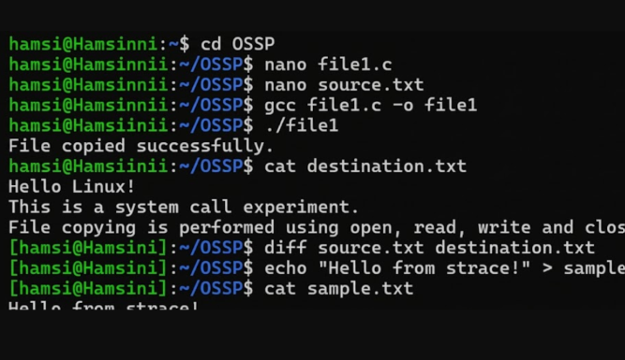

Part 2: strace System Call Tracing
Aim: To trace all system calls generated by the command:
cat sample.txt
using the strace utility and analyze the kernel services involved.

What is strace?
strace is a Linux debugging and diagnostic utility used to monitor the system calls made by a process.
For example:
strace cat sample.txt
This shows the system calls made by the cat command.

Important System Calls in cat sample.txt
When you execute:
cat sample.txt
the exact output varies depending on your Ubuntu version, libraries, architecture, and environment. However, the important file-related sequence is typically similar to:
execve(".../cat", ...)
openat(..., "sample.txt", O_RDONLY)
read(..., ...)
write(1, ...)
read(..., ...)
close(...)
exit_group(0)
You may also see many additional calls related to program startup and shared libraries.

Sequence of Important System Calls:
1. execve()
execve(...)
The shell starts the cat program using execve().
Kernel service: Process/program execution.

2. openat()
openat(..., "sample.txt", O_RDONLY)
cat asks the kernel to open sample.txt.
The kernel checks the file and returns a file descriptor.
Kernel service: File-system access.
On modern Linux systems, cat commonly uses openat() rather than the older open() system call.

3. read()
read(fd, "Hello Linux!\n", ...)
The cat program requests the kernel to read the contents of sample.txt.
Kernel service: File input / storage access.

4. write()
write(1, "Hello Linux!\n", ...)
File descriptor 1 represents standard output, normally the terminal.
The kernel writes the contents to the terminal.
Kernel service: Output/I/O.

5. close()
close(fd)
After reading the file, cat closes the file descriptor.
Kernel service: File descriptor/resource management.

6. exit_group()
exit_group(0)
The process terminates successfully.
Kernel service: Process termination.

Simplified strace Flow:
Shell
|
| execve()
↓
cat program
|
| openat()
↓
Kernel
|
| Opens sample.txt
↓
File System
|
| read()
↓
Kernel
|
| write()
↓
Terminal
|
| close()
↓
Kernel
|
| exit_group()
↓
Process terminates

Observation:
- The C program successfully copied the contents of source.txt to destination.txt.
- open() was used to open the source and destination files.
- read() was used to read data from the source file.
- write() was used to write data to the destination file.
- close() was used to release the file descriptors.
- The strace utility successfully displayed the system calls generated by cat sample.txt.
- The cat command uses kernel services for opening, reading, writing, and closing files.
- System calls provide the interface between user-space applications and the Linux kernel.

Result:
The C program was successfully implemented using the open(), read(), write(), and close() system calls to copy a file.
The strace utility was also successfully used to trace the system calls generated by cat sample.txt. The experiment demonstrated how user-space programs request file and process-related services from the Linux kernel through system calls.

