PRACTICAL – 04
Name: B. Likhitha
Roll No: 2520030580
Sec: 8

PART 1: PROCESS SYNCHRONIZATION USING wait() AND waitpid()

Aim
To write a C program where a parent process creates multiple child processes and synchronizes their completion using wait() and waitpid(), and compare the behavior of both functions.

Theory
The fork() system call creates a new child process. The wait() system call makes the parent wait for any child process to terminate. The waitpid() system call allows the parent to wait for a specific child process using its PID.
Both functions are used for process synchronization and for collecting the termination status of child processes.

C Code
#include <stdio.h> #include <stdlib.h> #include <unistd.h> #include <sys/wait.h>

int main()
{
pid_t child1, child2, child3; int status;
child1 = fork(); if (child1 == 0)
{
printf("Child 1: PID = %d\n", getpid()); sleep(2);
printf("Child 1 completed.\n"); exit(10);
}
child2 = fork(); if (child2 == 0)
{
printf("Child 2: PID = %d\n", getpid()); sleep(1);

printf("Child 2 completed.\n"); exit(20);
}
child3 = fork(); if (child3 == 0)
{
printf("Child 3: PID = %d\n", getpid()); sleep(3);
printf("Child 3 completed.\n"); exit(30);
}

printf("Parent: PID = %d\n", getpid());

/* wait() waits for any child */ pid_t finished = wait(&status);

printf("wait(): Child PID %d terminated with status %d\n", finished, WEXITSTATUS(status));

/* waitpid() waits for a specific child */ waitpid(child1, &status, 0);

printf("waitpid(): Child PID %d terminated with status %d\n", child1, WEXITSTATUS(status));

waitpid(child3, &status, 0);

printf("waitpid(): Child PID %d terminated with status %d\n", child3, WEXITSTATUS(status));

printf("Parent process completed.\n");

return 0;
}

Compile
gcc process_sync.c -o process_sync

Run
./process_sync

Flow Chart

START
↓
Create Parent Process
↓
Create Multiple Child Processes
↓
Children Execute Their Tasks
↓
Children Terminate
↓
Parent Calls wait()
↓
Waits for Any Child
↓
Parent Calls waitpid()
↓
Waits for Specific Child
↓
Parent Completes
↓
STOP

Sample Output
Parent: PID = 4500 Child 1: PID = 4501
Child 2: PID = 4502
Child 3: PID = 4503
Child 2 completed.
wait(): Child PID 4502 terminated with status 20 Child 1 completed.
waitpid(): Child PID 4501 terminated with status 10 Child 3 completed.
waitpid(): Child PID 4503 terminated with status 30 Parent process completed.

Observation

Function | Behavior
wait() | Waits for any child process
waitpid() | Waits for a specific child process
Control | Less control
PID Selection | Not specified
Usage | Useful when any child can be waited for

OUTPUT:

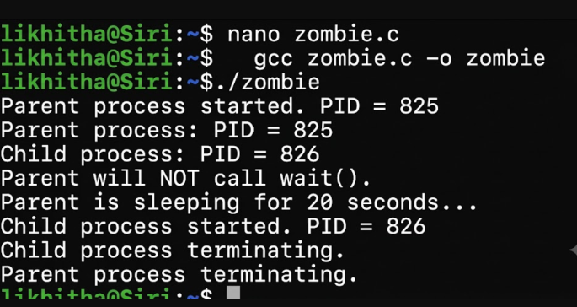
Result
The parent successfully created multiple child processes and synchronized their execution using wait() and waitpid(). It was observed that wait() waits for any child, whereas waitpid() waits for a specific child.

PART 2: ZOMBIE PROCESS CREATION AND ELIMINATION

Aim
To create a scenario where a child process becomes a zombie process, investigate it using the process table, and modify the program to eliminate the zombie using proper synchronization techniques.

Theory
A zombie process is a child process that has completed execution, but its parent has not collected its termination status using wait() or waitpid().
The zombie remains in the process table until the parent collects its exit status. The ps command can be used to observe the process state.
A zombie process can be eliminated by using wait() or waitpid() in the parent process.

C Code
#include <stdio.h> #include <stdlib.h> #include <unistd.h> #include <sys/wait.h>

int main()
{
pid_t pid; int status;

pid = fork();

if (pid < 0)
{
printf("Fork failed.\n"); return 1;
}

if (pid == 0)
{
printf("Child: PID = %d\n", getpid()); printf("Child terminating...\n"); exit(0);
}
else
{
printf("Parent: PID = %d\n", getpid());

printf("Child has terminated. Parent now waits...\n"); waitpid(pid, &status, 0);
printf("Parent collected child status.\n"); printf("Child terminated with status %d\n",
WEXITSTATUS(status));
}

return 0;
}

Compile
gcc zombie.c -o zombie

Run
./zombie

Flow Chart
START
↓
Parent Creates Child
↓
Child Executes
↓
Child Terminates
↓

Parent Does Not Collect Status
↓
Child Becomes Zombie
↓
Check Process Table Using ps
↓
Use waitpid() in Parent
↓
Collect Child Exit Status
↓
Zombie Removed
↓
STOP

Sample Output
Parent: PID = 5000 Child: PID = 5001
Child terminating...
Child has terminated. Parent now waits... Parent collected child status.
Child terminated with status 0

Observation
- The child process terminates before the parent collects its status.
- Without wait() or waitpid(), the child becomes a zombie.
- The ps -l command can be used to identify the zombie state.
- waitpid() collects the child's termination status and removes the zombie entry.
- Proper synchronization prevents accumulation of zombie processes.

OUTPUT:

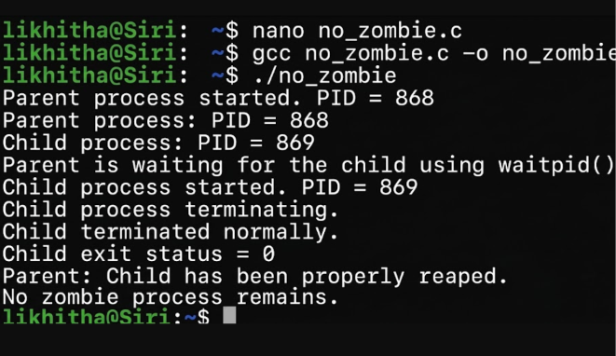
Result
A zombie process was successfully demonstrated and investigated using the process table. The zombie process was eliminated by using waitpid() for proper synchronization between the parent and child processes.

