**Shine shuttle website design phase**

**_________________________________________________________________________________**

Contents

Project Abstract: 3

Introduction: 3

Aim and objective: 3

Marvel Design: 3

Design is mentioned below: 4

The User experience design principle are explained below: 7

➢ Visibility of system status: 7

➢ Match between System and the real world: 8

➢ User Control and Freedom: 9

➢ Consistency and Standard: 10

➢ Error Prevention: 11

➢ Recognition rather than recall: 11

➢ Flexibility and Efficiency of use: 12

➢ Aesthetic and minimalist design: 12

➢ Help users recognize, diagnose, and recover from errors: 12

➢ Help and Documentation: 12

Conclusion: 13

# Project Abstract:

This document explains the prototype model for the “Cab Service Management System” using Marvel Application. Car travel agencies need an effective management platform for handling their respective transportation services.

The proposed cab service management system is a website which can handle a variety of activity of a typical car agency. In the case of cab services, this sort of system stands out as safe and reliable in the travel business.

This project aims at offering the best car services to the clients in need. The best thing about this website is that it provides direct and easy booking. This makes the overall car service work reliable.

# Introduction:

Transport facility is a matter of headache for those people who do not have any personal transport. On occasions like Wedding, Vacation, house shifting, and tour and many other situations they feel the necessity of a vehicle to sort out the problems. So, if it is possible to design or develop a website for availing transport whenever and wherever possible, then it will be beneficial for the transport provider. Nowadays, by some click only, we can get whatever you want at home. We already know about online shopping, e-banking, etc. Similarly, Car booking is the online facility to book cars online within few clicks only. Some people cannot afford to have a car, for those people this system becomes very helpful. This system includes three cars, as per the customer order and comfort, it places the order and the driver will pick up the customer at their assigned location within the given time.

# Aim and objective:

Specific goals are-

• To produce a website that allows the customer to register and reserve a car online and to travel from the airport to the city or city to the airport.

• To ease customer’s tasks whenever they need to book a car.

# Marvel Design:

As we said above, we created our mock prototype in Marvel Application. The Marvel app is an app that allows you to design an interactive prototype of your application. This is an effective way to apply your imagination and build your app. As a concern of design principles, we are going to explain heuristic law for the user interface design of our project (Mutlu, 2014).

## Design is mentioned below:

Fig. 1(a) Registration page Fig. 1(b) Log-in page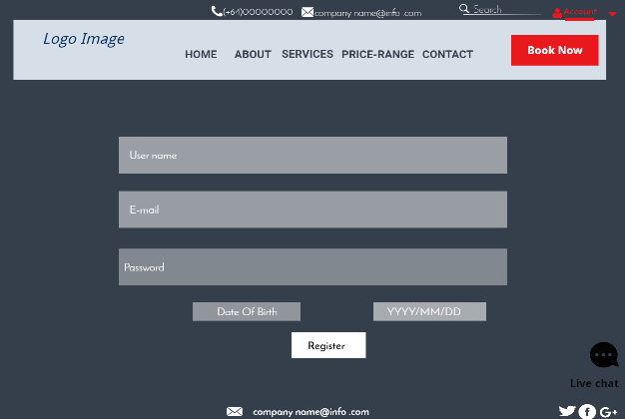 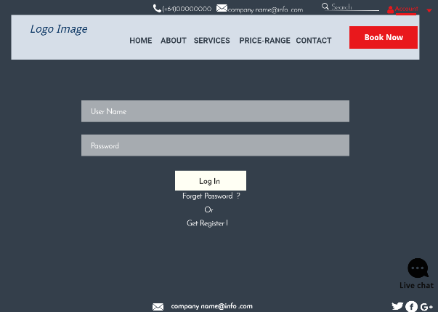

Fig. 1(c) Home page Fig. 1(d) About page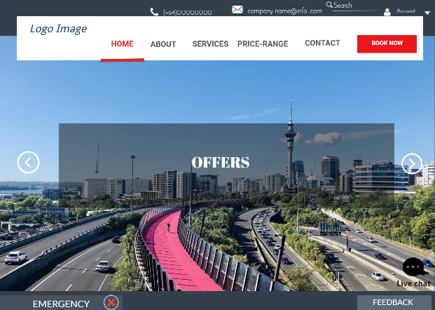 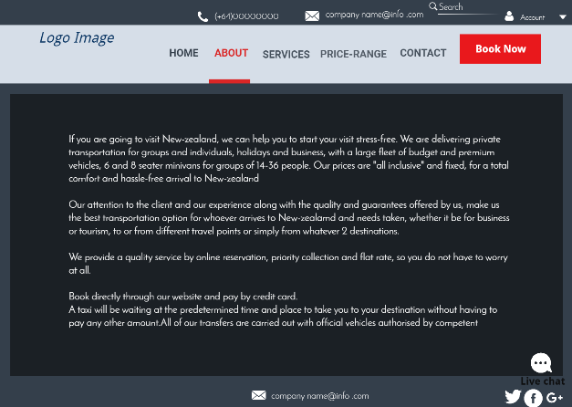

Fig. 1(e) Service page Fig. 1(f) Contact page

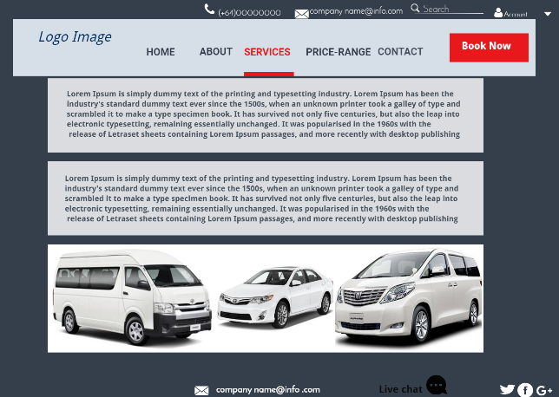 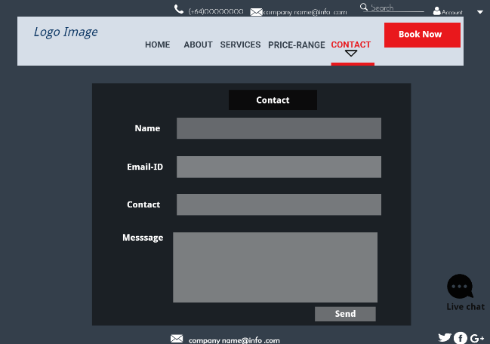

Fig. 1(g) Contact Page &FAQ’S option Fig. 1(h) FAQ’s page

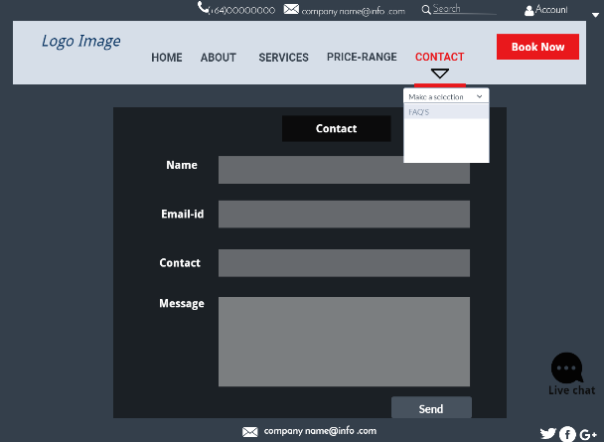 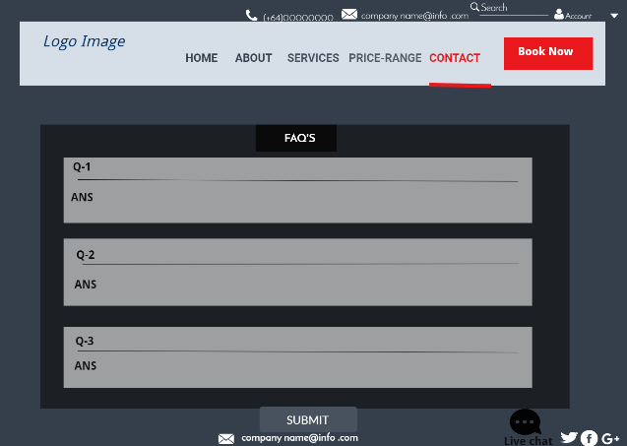

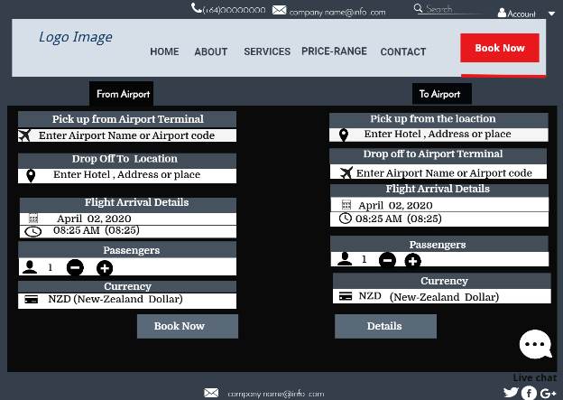 Fig. 1(i) Online Booking page Fig.1(j) Booking details page

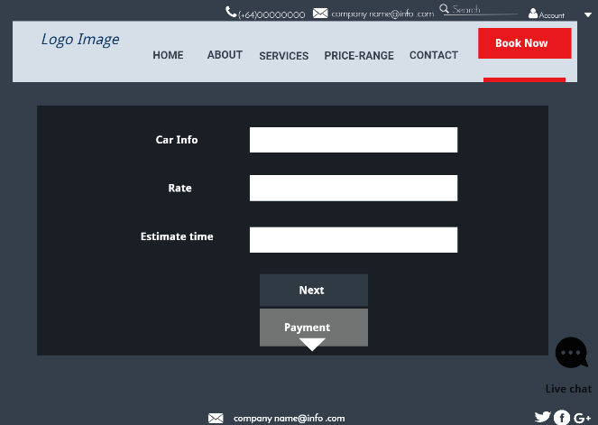

Fig. 1(k) Payment page Fig. 1(l) User account page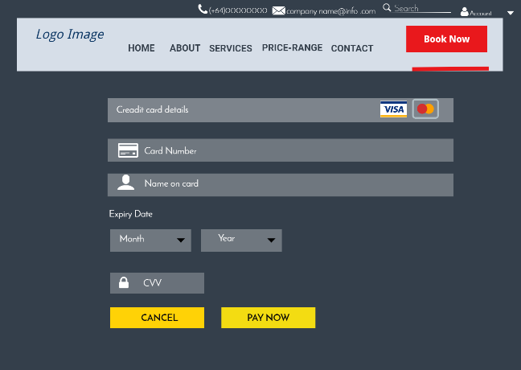 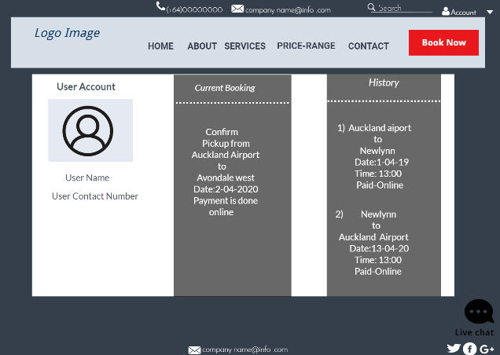

Fig. 1(m) Price -Range page Fig. 1(n) Terms and condition page

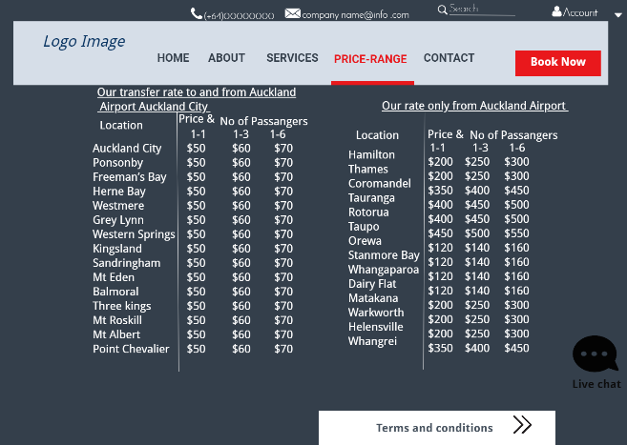 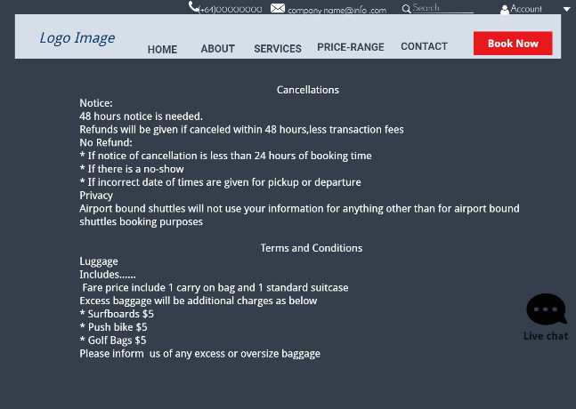

Fig. 1(o) Emergency option Fig. 1(p) Login & Registeration option

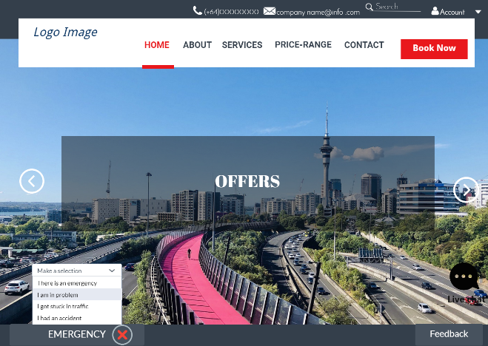 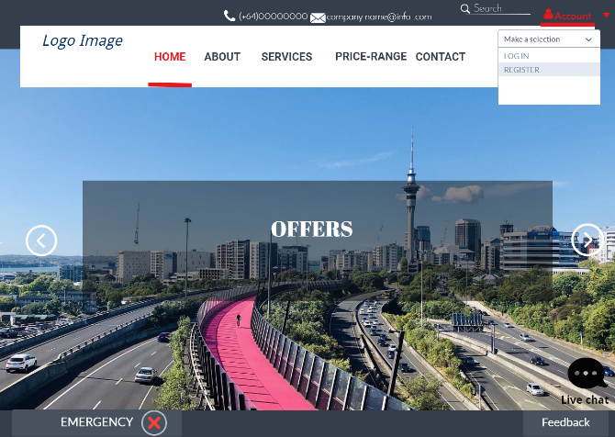

Fig. 1(q) Feedback page

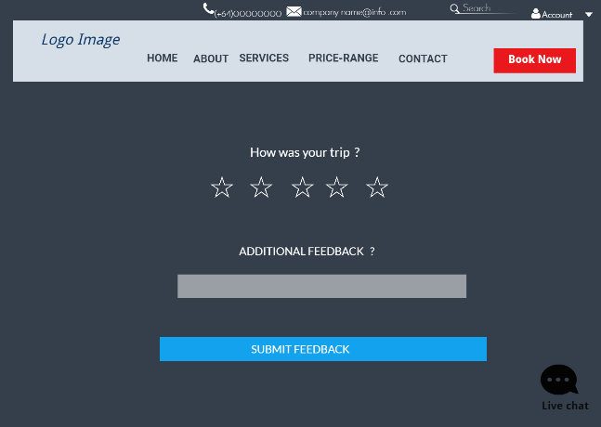

# The User experience design principle are explained below:

## Visibility of system status:

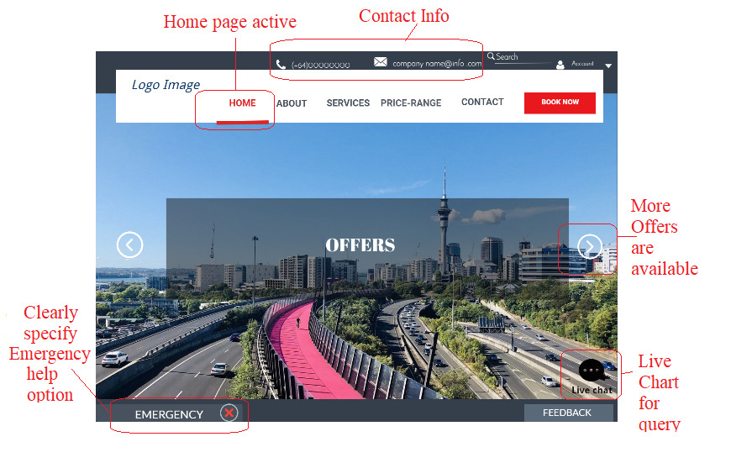

Fig. 2(a)

Above Fig. 2(a) shows the user is always informed by their actions and activities. We can see the communication transparency in live chat and feedback form. Arrows show more options for offers. An emergency button is a specified help option strictly.

## Match between System and the real world:

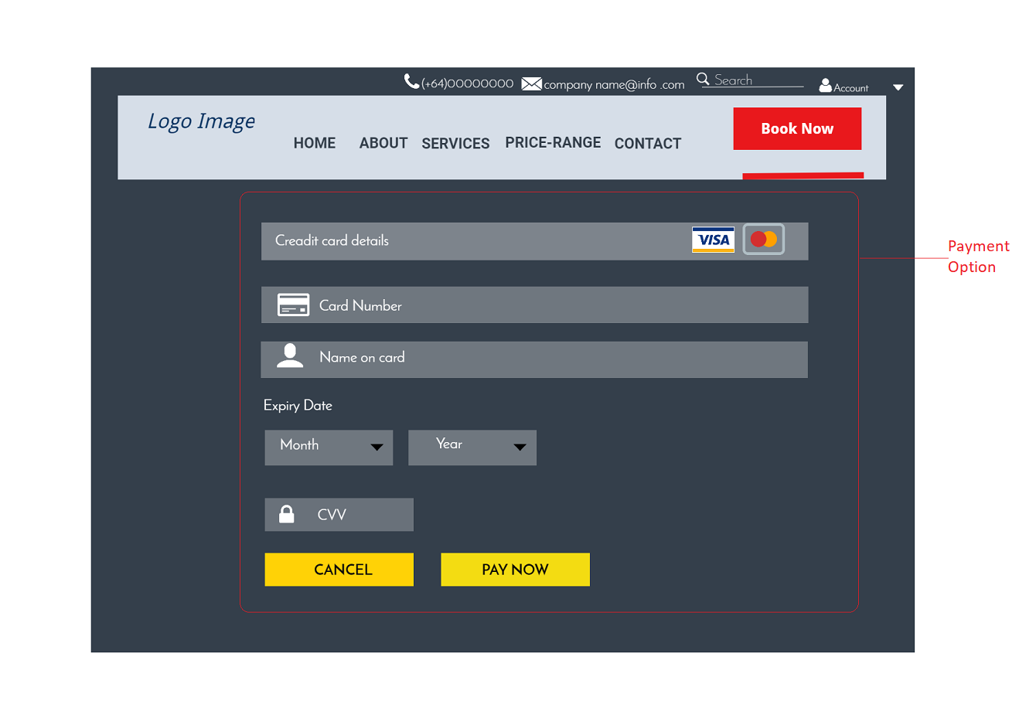

Fig. 2(b)

In Fig. 2(b) we can see a payment option. After seeing the information, we can book the cab according to our requirements at any time and place. According to the time and place we have pay for the ride. All the details we must fill in the application. We can estimate our payment by price-range page provided by the application. This option is directly connected to the payment gateway which is the best example of a matching system and real word. Also, in Fig. 2(a) the live chat and emergency button are a good example of this principle.

## User Control and Freedom:

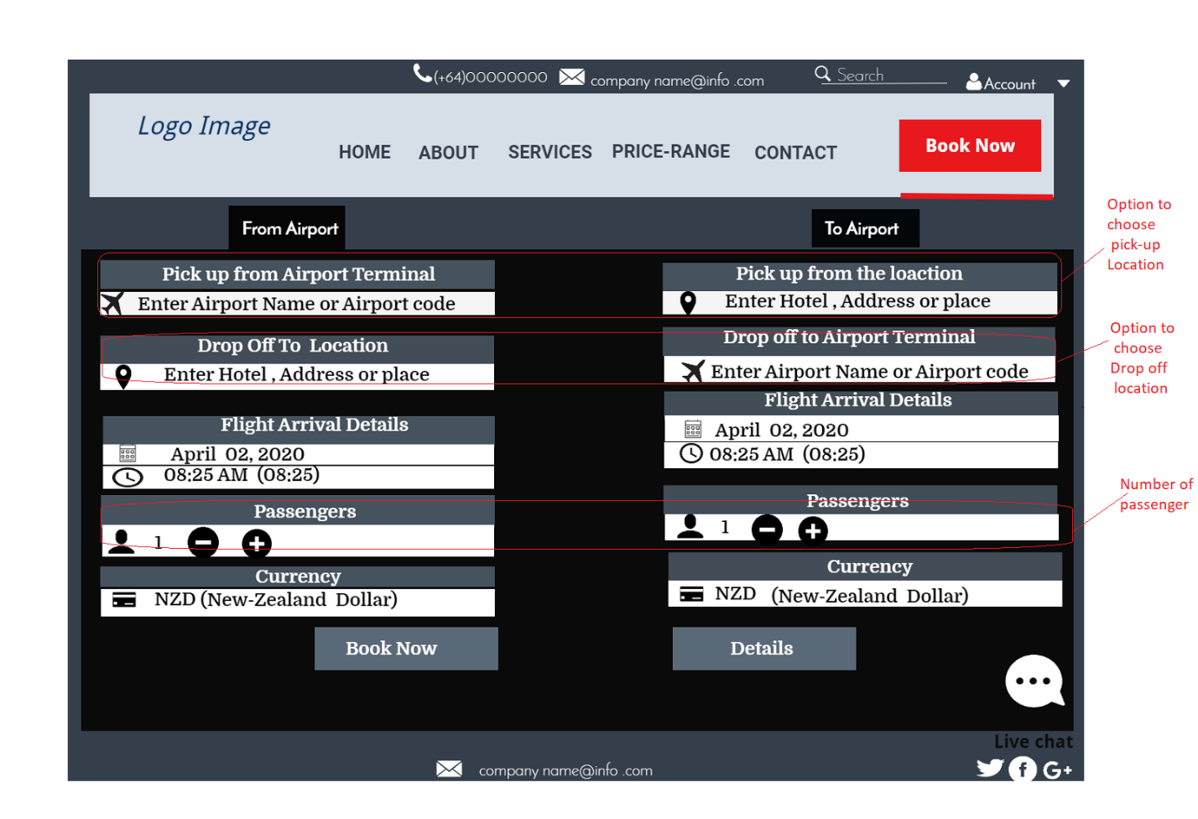

Fig. 2(c)

Fig. 2(c) describes user has the freedom and control to choose pick-up and drop-off location option, choose a count of passenger option, time and payment option which is shown in Fig. 2(b) already.

## Consistency and Standard:

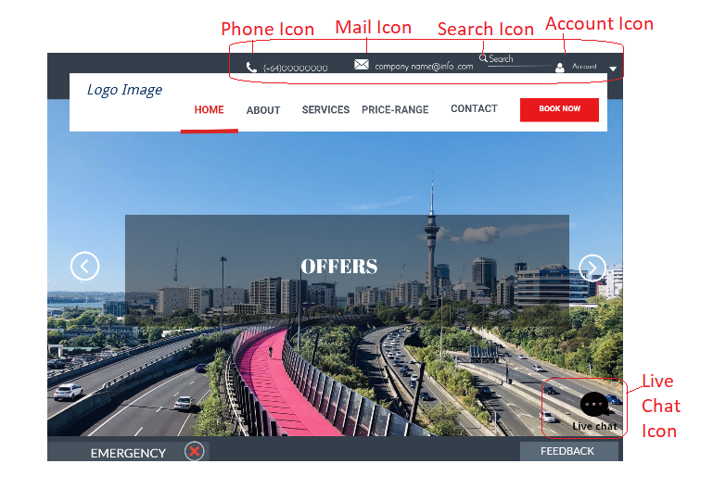

Fig. 2(d)

Inside Fig. 2(d) explains that consistent and standard icons are placed to make an easy way for new and inexperienced people.

## Error Prevention:

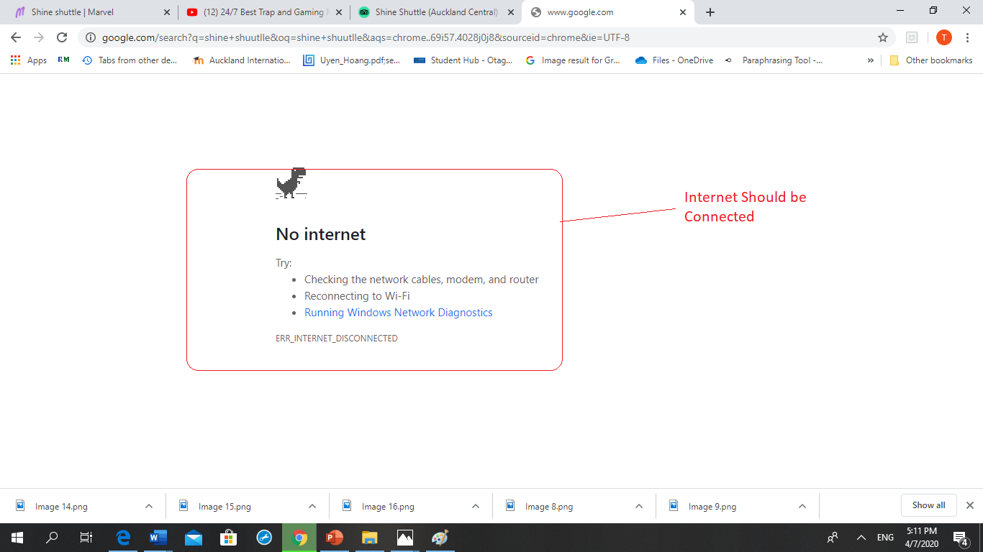

Fig. 2(e)

Fig. 2(e) displays the error prevention principle. In above clearly shows an error message so that the user can easily fix it.

## Recognition rather than recall:

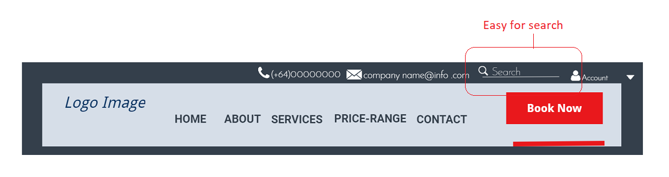

Fig. 2(f)

Fig. 2(f) gives the best option for recognition rather than recall. The Search option is the easiest way to search for a trip. Also, Fig. 2(d) Shows the live chat option which is another example of this principle.

## Flexibility and Efficiency of use:

Fig. 2(a), 2(b), 2(c), 2(d) and 2(f) explicitly exhibits the flexibility and efficiency of the website. The Search option, Emergency option, live chat, payment options, booking form, feedback form and, so on.

## Aesthetic and minimalist design:

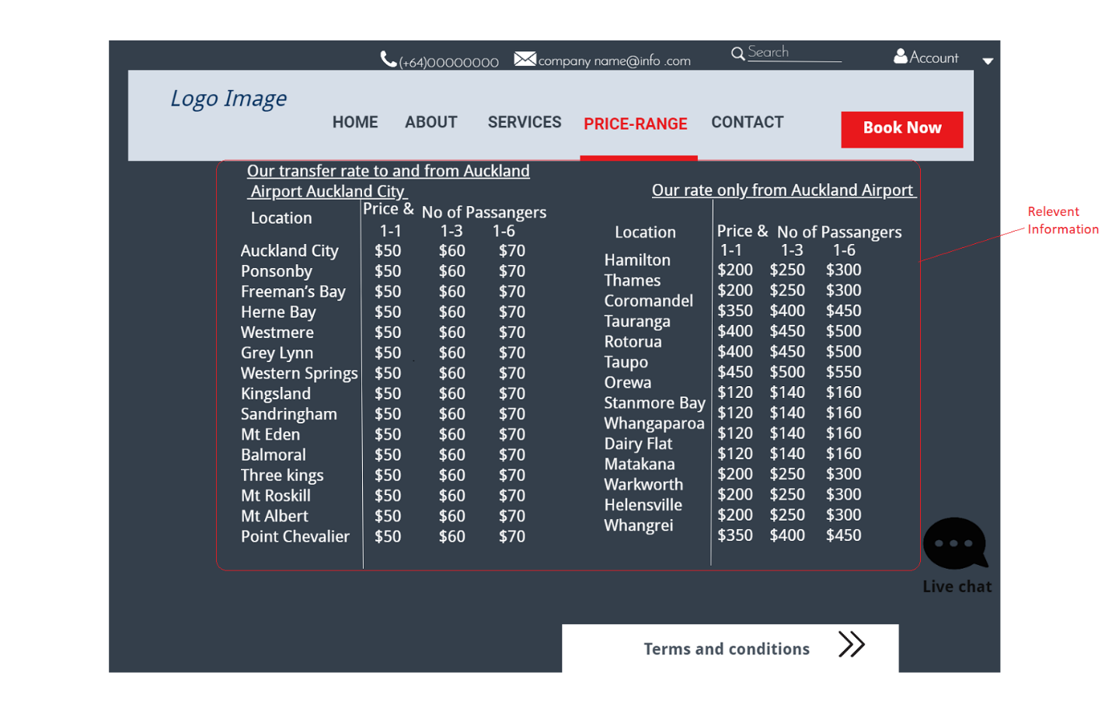

Fig. 2(g)

Fig. 2(g) present important information for the user. Also, there is a Terms and conditions option that will also provide relevant information.

## Help users recognize, diagnose, and recover from errors:

We can see in Fig. 2(e) error recognition. An error message is displayed on a screen so that the user can diagnose and recover from the error.

## Help and Documentation:

Fig. 2(d) shows the assistant option. Users can get a quick answer to their questions by using live chat. And, in Fig. 2(f) search option is extremely helpful to explore the options (Jakob Nielsen, 1994).

# Conclusion:

Transport business has emerged with new goodies compared to the experience where every activity concerning transportation business is limited to a physical location only. Even though the physical location has not been eradicated; the nature of functions and how these functions are achieved has been reshaped by the power of the internet. Nowadays, customers can reserve cars online as per their own time and place. The website for an online car booking system has offered an advantage to both customers to efficiently and effectively manage the trip or ride as their own schedule’ need at the click of a button.

# References:

Jakob Nielsen. (1994, April 24). *10 Usability Heuristics for User Interface Design*. Retrieved from https://www.nngroup.com/articles/ten-usability-heuristics/: https://www.nngroup.com/articles/ten-usability-heuristics/

Mutlu, M. (2014, November 4). *Marvel*. Retrieved from https://marvelapp.com/: https://marvelapp.com/