**MODELING AND KEY TECHNOLOGIES OF DATA DRIVEN SMART CITY SYSTEM**

**SEMINAR REPORT SUBMITTED**

**TO**

**AWH ENGINEERING COLLEGE**

**KUTTIKKATTOOR, KOZHIKODE**

### IN PARTIAL FULFILMENT

**OF THE REQUIREMENTS FOR THE AWARD OF THE DEGREE**

**OF**

# Master Of Computer Applications

**BY**

**VARNA VINOD**



### DEPARTMENT OF COMPUTER APPLICATIONS AWH ENGINEERING COLLEGE KUTTIKKATTOOR,

**KOZHIKODE**

**FEBRUARY 2024**



**AWH ENGINEERING COLLEGE**

KOZHIKODE

#### **CERTIFICATE**

*This is to certify that this thesis entitled* ***“MODELING AND KEY TECHNOLOGIES OF DATA DRIVEN SMART CITY SYSTEM”*** *submitted herewith is an authentic record of the Seminar work done by* ***VARNA VINOD (AWH22MCA-2045)*** *under our guidance in partial fulfillment of the requirements for the award of* ***Master of Computer Applications*** *from APJ Abdul Kalam Technological University during the academic year 2024.*

Head of the department Seminar Co-ordinator

#### Mrs. Sruti SudevanMs. Prajina.K

Assistant Professor Assistant Professor

Dept. of Computer Applications Dept. of Computer Applications

### ACKNOWLEDGEMENT

I express my sincere gratitude to our beloved principal **Dr.Sabeena M V** for providing me an opportunity with the required facilities for doing this project. I express my hearty thanks to **Mrs. Sruti Sudevan**, Head of the department of Computer Application, **Ms. Prajina.K,** Assistant Professor for her guidance. I am thankful to all other staff of the MCA department for their encouragement, timely guidance, valuable suggestions and inspiring ideas given throughout this seminar. I am grateful to my friends for the way they have cooperated, expected me to achieve success and have always stirred my ambition to do the best. Above all, I am grateful to the almighty, who has showered His blessings on me throughout my life and throughout the seminar.

**VARNA VINOD**

**ABSTRACT**

The smart city management center, using advanced data-driven technology, is widely adopted to address various challenges in data management for smart cities. It effectively addresses issues related to data acquisition, gathering, storage, processing, and application. Currently, building a smart city operation and management center encounters challenges like incomplete top-level design theory, limited software and hardware integration capability, inefficient data collection and aggregation, and a lack of intelligence in data analysis and application. This paper suggests a top-level design model for a smart city called 'two-dimension, three-layer, and six-goal.' It includes principles for a smart city operational pattern and emphasizes three key technologies: integrating infrastructure, collecting multidimensional data and intelligent data analysis. The paper highlights issues in building smart city centers, like incomplete design plans and difficulties in connecting software and hardware. It emphasizes the importance of organizing the large amount of data generated in smart cities and suggests using technology like integrated Information and Communication Technology infrastructure and data analysis to improve city functioning.

**CONTENTS**

PAGENO

1. INTRODUCTION 1

2. SELF DRIVING VEHICLES 2

2.1 The emergence of self-driving cars 3

2.2 Testing self-driving cars 4

2.3 Challenges of self-driving cars 6

2.4 Incidents 8

2.5 Regulations 10

3. TRUST IN SDVs 11

3.1 Trust in SDVs from the perspectives of stakeholders 12

3.2 Trust in SDVs from the perspectives of Cities, Governors,

Policymakers, Legislators and Organisations 13

3.3 Trust regarding Technological Aspects 14

3.4 Trust from Manufactures' Perspective 15

3.5 Trust from the perspective of Users 17

3.6 Trust from the perspective of Pedestrians 18

3.7 Trust from the perspective of other Traffic Participants 19

4. VERIFICATION OF TRUST 21

5. ETHICAL ASPECTS OF TRUST IN SDVs 23

6. ADVANTAGES OF SDVs 25

7. CHALLENGES OF SDVs 27

8. FUTURE OF SDVs 28

9. CONCLUSION 30

10. BIBLIOGRAPHY 31

### INTRODUCTION

Modern cities have transformed from simple two-dimensional spaces to complex environments that integrate physics, human society, and information networks. The data generated by smart city operations is a valuable asset, but its effectiveness relies on organized systems. Middleware tools act as a crucial link between data collection infrastructure and smart city applications, utilizing integrated Information and Communication Technology (ICT) infrastructure for functions like data storage, analysis, modeling, visualization, and decision support. This not only facilitates information sharing among government departments but also empowers the public to enhance city operations through innovative data applications.

Smart city operation and management centers play a key role in orchestrating the relationship between urban elements and data-driven applications. The rapid growth of smart cities, however, has brought challenges such as business system interconnection, data sharing mechanisms, and the processing of massive data. These challenges hinder the advancement of urban intelligence but also offer opportunities for key technologies and engineering practices in data-driven smart city systems. This paper explores these complexities by reviewing related research, addressing weaknesses, proposing a top-level design model for a data-driven smart city, and introducing pivotal technologies for smart city operation and management centers. Through a case study, it illustrates the application of the proposed model and technologies, concluding with insights and suggestions for future research.

### 2. FEATURES OF SMART CITY OPERATION AND MANAGEMENT CENTER

From the smart city practices of Cisco and IBM from 2008 to 2018 , the smart city operation and management center is regarded as the ‘‘brain’’ or ‘‘engine’’ of a smart city. The common points of smart city operation and management center can be summarized as follows:

* It has numerous computers and workstations.
* It provides city managers, data analysts, police dispatchers, etc., with large screens for data visualization.
* It can transfer raw data collected from sensors, historical databases, existing applications, and other sources throughout the city into useful conclusions.

To improve the timeliness and intelligence level of spatial big data processing, it proposes to integrate artificial intelligence with spatiotemporal big data to form three highly intelligent systems namely, earth observation brain, smart city brain, and smartphone brain, at the macro, and micro scales of earth space respectively, to realize data-driven perception, cognition and action processes. Among them, the smart city brain is a kind of city operation and management service system, which collects real-time urban data through various IoT sensors automatically and in real time using intelligent methods such as artificial intelligence and data mining, and processes mass and complicated calculations by a cloud computing center to realize the city’s perception, cognitive and controlled feedback, and provide various intelligent services for the city.

Rio de Janeiro was one of the first cities to put in practice of a smart city operation and management The center integrates data from more than 30 government departments, integrates social crowdsourcing data and shares data and information with the public security department’s integrated Command and Control Center. Its integration platform is based on open standards and rules and adopts a service-oriented architecture (SOA), which facilitates the integration of data from various government department systems and social crowd-sourcing data, and provides flexible services to other applications. It integrates monitoring sensors, video surveillance cameras, and urban services including electricity, water, and gas supply, for the 24/7 monitoring of the city. Multi-source data are connected, integrated, and associated on a geographic information platform, and the real-time monitoring data and analysis results are presented on screen to improve the ability of real-time analysis and decision-making. The core of the Smart Copenhagen project is to fuse and analyze cross-sectoral data and then display the data on dashboards in real time to give city managers insight and control. To monitor and control the

CCTV networks for better safety and crime prevention, Glasgow built a smart operation center, a city technology platform that collects data from over 200 streams to understand how the city works . Recent construction projects called ‘‘city brains’’ are similar to the smart city operation and management center in nature. For example, the city brain in Pudong District of Shanghai based on a smart city operation and management center, integrates 431 systems from 109 departments, 3.08 million intelligent water meters, nearly 40000 sensors, and mass data and can automatically identify problems, respond rapidly through comprehensive data analysis, and display passenger flow, a traffic congestion index, garbage disposal and other urban operational data in real time. The city brain in Jiaxing is supported by a big data center and brings together 203 classes of more than 80 million pieces of data from 37 government departments. It forms several city operation sign indicators on the basis of abundant basic data, regarding the population, legal persons, organizations and geographic entities, and dynamic data, regarding the human flow, logistics, information flow, to reflect the health status of the city from the aspects of production, consumption, transportation and public services and provide the basis for precise urban governance and scientifically based decision making.

The city brain in Beijing takes the city dashboard as the core, collects real-time monitoring data, operational event data, and data of physical indicators of the city, and visually displays information regarding the industry dimension, offers dynamic spatial geographic data, and supports decision-making analysis through data visualization. The first city brain project implemented in Kuala Lumpur, the core of which is different types of sensors and artificial intelligence running on cloud infrastructure, mainly aims at improving management efficiency in traffic. From the above discussion, the common features of a smart city operation and management center are summarized as follows:

* Relying on a large number of sensors, cameras, and other sensing devices deployed in the city to collect multidimensional data, and integrating both government data and social data.
* Taking centralized data storage and data analysis as the core to carry out the integrated application of infrastructure .
* Visualizing data with large screen
* Assisting urban governance and scientifically based decision-making through data analysis

### 3. HIERARCHICAL STRUCTURE OF A SMART CITY OPERATION AND MANAGEMENT CENTER

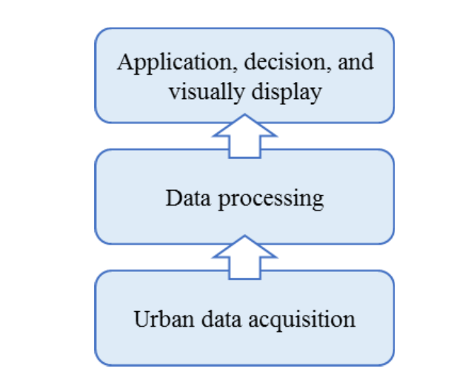 The existing studies mainly consider smart city operation and management centers from the perspective of data-driven architecture and undertake a hierarchical design (Fig. 1). The common features are as follows:

Figure 1. The hierarchical structure of a data-driven smart city operation

and management center

* First, solve the problem of data acquisition, collect urban data through the information infrastructure, gather and store data to build a data resource system .
* Second, solve the problem of data processing , integrate the information systems in the city, realize data sharing, fuse and analyze the data from different sources. Further reveal patterns, rules, and knowledge by building models and identifying the internal relations among the data.
* Then, solve the data application problem , execute the decision through specific applications, and visually display the data processing results in an interactive way

**3.EXISTING WEAKNESSES OF SMART CITY OPERATION AND MANAGEMENT CENTERS**

Various failed initiatives, such as New Songdo in South Korea and Masdar in the U, show that smart city operation and management centers are not completely mature and perfect. From the literature and practices, the following problems currently exist in smart city operation and management centers.

**3.1 Incomplete top-level theory**

From the perspective of design content, the existing smart city operation and management centers pay more attention to the design of technical architecture than to the design of management mechanisms and operational patterns. The lack of appropriate management mechanism and operational pattern design leads to chaos in the function executing of smart city operation and management centers, which directly affects the daily operation of a smart city. From the perspective of architecture, the existing literature states that smart cities at the application level are still composed of single-purpose, vertical ‘‘siloed’’ solutions. Analysis says more than 60 smart city applications in 33 cities and shows that smart city applications are designed as isolated tools in most cases, without considering how the various systems in the city cooperate, and without promoting the development of a broader urban ecosystem.

In conclusion, the top-level design of the whole smart city should be strengthened, and the connection and interoperation between the operation and management center and different applications should be considered in general. Moreover, the design of management mechanisms and operational patterns should be emphasized, and the cooperation between government departments should be considered. Government data, enterprise data, and the actual needs of citizens should be combined to improve the efficiency of urban governance in a data-driven way.

**3.2 Incomplete integration ability of hardware and software**

The current implementation model for the integration of a smart city has several shortcomings , such as focusing on the provision of various city services, rather than

hard infrastructure. Smart services are driven without any integrated system thus smart city initiatives can hardly be sustained .

The top-level design of a smart city operation and management center needs to solve the problem of data collection and access. Unified standard data interfaces should be established to access multi-source data. Through the construction of a unified data acquisition, analysis, and processing platform, information resources can be widely shared, highly integrated, comprehensively utilized, and integrated into a big data resource pool. The top-level design also needs to include the design of a data storage structure, the construction of an infrastructure platform based on cloud architecture, the realization of computing resource sharing and dynamic adjustment on demand based on cloud computing technology, and the cloud management of software and hardware resources. In addition, due to the sensitivity of urban data, the security of infrastructure should be a key consideration.

**3.3 Inefficient data collection and computing**

With the rapid development of smart city applications, the collected data have gradually expanded from simple sensor data to massive heterogeneous data from multiple sources. For example, unmanned aerial vehicles (UAVs) have been increasingly used in many smart city scenarios, such as air pollution monitoring , criminal tracking, firefighting , traffic support , goods delivery , and real-time urban data crowdsourcing .

It is necessary to ensure the effective storage of all kinds of structured, unstructured, and semi-structured data . With the rapid development of artificial intelligence technology and the rapid growth of computing power, meaningful and irreplaceable value can be extracted from massive heterogeneous data (especially video data), and the way of urban management can be changed through data acquisition and cognition, decision-making, and optimization, search and mining, prediction, intervention, and other steps, which increase the requirements for the collection and computing power of unstructured data such as video.

**3.4 Unintelligent data analysis and application**

In the previous construction of smart city operation and management centers, great attention was paid to data aggregation and visual presentation, but the process of ‘‘data-information-knowledge-wisdom’’ was usually ignored. Citizens, enterprises, and governments should be the creators, contributors, users, and evaluators of data and knowledge in a smart city . Data collected by terminal devices in a smart city need to be converted into information and knowledge to provide more satisfactory applications. Therefore, it is necessary to extract empirical features based on current data, statistical rules, and expert experience, build big data analysis models for various business topics, form algorithms and scenarios, and improve the efficiency of data analysis, simulation and decision-making.

**3.** **THE TOP-LEVEL DESIGN MODELING AND OPERATIONAL PATTERN OF A SMART CITY**

**4.1 Methods**

The concept of ‘‘top-level design’’ has mainly followed the principle of ‘‘decomposition from the top to the bottom with stepwise refinement’’ . It has gradually become an effective method for the comprehensive design of complex application systems. The top-level design method emphasizes the integrity of complex engineering, pays attention to the close combination of design and actual needs, and considers all levels and elements as a whole from the overall perspective to achieve the overall goal of the system.

A smart city is a comprehensive complex, giant system with complex elements, diverse applications, interaction, and constant evolution. Therefore, the top-level design of a smart city oriented to a complex giant system should be carried out with the thinking of systems engineering. Moreover, a smart city is a ‘‘system of systems’’, rather than direct and simple combination of subsystems. Therefore, for the top-level design, the relationship description and constraint analysis between subsystems are more important than the design of the subsystems themselves. All layers and all elements of the system should be considered from an overall perspective, with concept consistency, function coordination, structure unification, resource sharing, and component standardization. In the worldwide practice of smart cities, Chinese cities and European cities are typically top-down oriented. The literature review and problem analyses in Section II reveal the importance of the top-level design of a smart city. To improve top-level design theory, we establish a conceptual framework for a better approach to smart cities. This study is undertaken through 3 phases:

* From the aspect of top-level model design, inspiration about the data architecture and key domains of smart city is obtained from the literature.
* The study moves on to model design, and composes the operational pattern of a smart city for sustainability.
* This framework is employed in a real city, Longgang District of Shenzhen, to observe the practical effect. The selection of Longgang as a case of study is based upon the city’s unique characteristics.

#### **4.2 Analysis of conceptual framework of smart city**

**4.2.1 Data-driven architecture model of smart city**

There are a variety of research views on smart city architecture models, such as designs focused on IoT , designs based on SOA architecture , and designs from the ecosystem perspective .

In recent years, scholars have gradually paid attention to the importance of data-centric technology for smart cities, and increasing number of studies define smart city architecture from the perspective of data . For example, Pan et al. propose a framework based on trace mining and divide the framework for smart cities into three layers: data sensing, data mining, and applications . Zheng et al. propose a technical framework of urban computing, which is divided into four levels: urban perception and data capture, data management, data analysis, and service provision. Liu and Peng propose a four-layer architecture of perception layer, transmission layer, processing layer, and application layer . Rong et al. propose a smart city architecture from the perspective of data with six layers, including data acquisition, data transmission, data vitalization and storage, support services, domain services, and smart applications . Gaur et al. propose a four-layer smart city architecture, including data collection, data processing, data integration and reasoning, and applications . (Table 1)

In this study, we propose a data-driven architecture of a smart city based on the above studies. We divide the framework into three layers: smart infrastructure, smart brain, and smart application. The smart infrastructure layer contains sensors for data acquisition, networks for data transmission, and related software and hardware for data storage. Since data collection and storage are becoming easier, while the management and analysis of data has become a more important challenge, it is unnecessary to emphasize data acquisition, transmission, and storage by layering separately. The smart brain layer mainly focuses on data management, processing, and integration, which can be realized by the smart city operation and management center . The smart application layer provides specific solutions for different domains in a smart city.

**4.2.1 Key domains of smart city**

According to the literature review, researchers classify smart city services into different domains (Table 2). Giffinger et al. categorize smart city service into 6 parts: smart economy, smart people, smart government, smart environment, smart mobility, and smart living. On this basis, Chourabi et al. define governance, people, economy, infrastructure, and environment as the key elements of smart cities . Neirotti et al. propose seven elements of a smart city, which are natural resources and energy, transportation and mobility, building, life, government, economy, and people. Gil-Garcia et al. list the core components of the physical environment, society, and government in a smart city, including the natural environment, ecological sustainability, infrastructure, economy, urban governance, and public services . There are also some key domains revealed in the standards for smart city evaluation indicators, for example, economy, governance, public services (education, health, etc.), infrastructure (telecommunication, data, etc.), environment, and network safety.

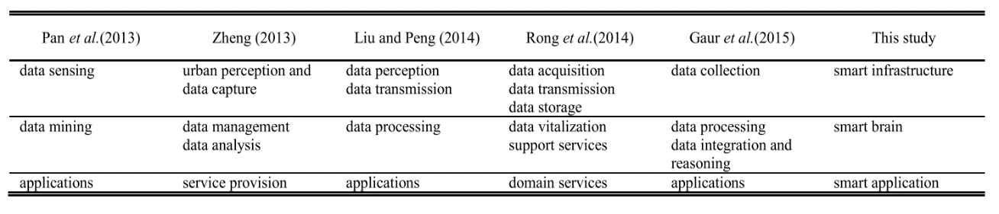

Table 1. Data-driven architecture models for smart cities.

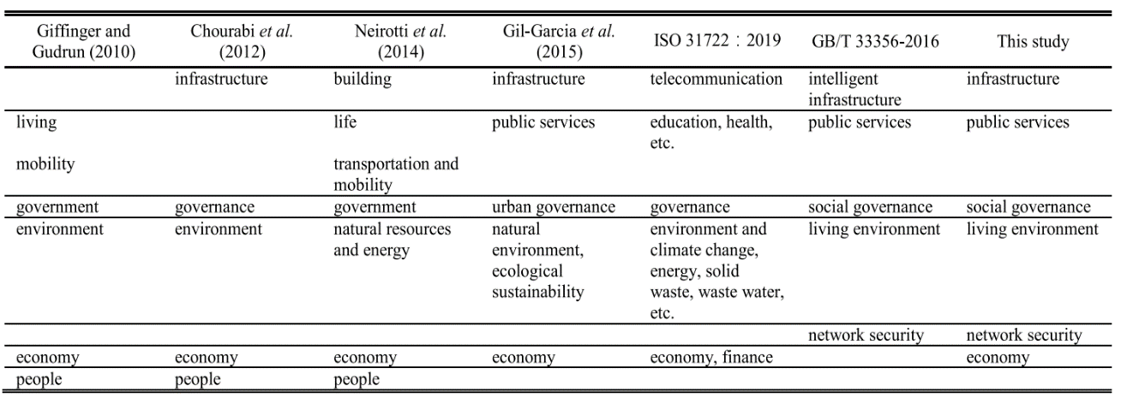

Table 2. Key domains of smart city.

list the core components of the physical environment, society, and government in a smart city, including the natural environment, ecological sustainability, infrastructure, economy, urban governance, and public services . There are also some key domains revealed in the standards for smart city evaluation indicators, for example, economy, governance, public services (education, health, etc.), infrastructure (telecommunication, data, etc.), environment, and network safety.

**4.2.1 Design principles**

Technology and system are two interrelated key components of a smart city . Technology needs institutional adaption. A narrow focus on the technology and infrastructure of smart cities has been made at the expense of involving different stakeholders and public participation in an inclusive urbanization . However, immense investment in technology cannot deliver a desired smart city system, and smart city development should incorporate particular social dynamics into the system in order to be successful . The interactions between the social and the technological dimensions of smart cities incorporate institutional collaboration and instrumental value, to achieve successful technological innovation.

A smart city is not a stand-alone system. Clearly, the existence of specified rules and regulations for all the stakeholders to comply with can support more synergistic implementations and prevent redundancy. For the above reasons, the top-level design of smart cities in this study is not only a technical issue but also an institutional issue. It is necessary to focus on the integration and sharing of resources and the restructuring of the pattern of interests.

**4.3 A top-level design model of a smart city**

Considering the above, we propose a data-driven ‘‘two-dimension, three-layer, and six-goal’’ top-level design model for a smart city, applying big data to improve urban governance ability. To make the smart city run efficiently and in an orderly manner, we propose six principles of a smart city operational pattern. The above model covers from policy making to construction and implementation, from information infrastructure to management mechanisms, and from data fusion application to operational patterns, to guide the practice of smart cities, as shown in Fig. 2.

* + 1. **Two dimensions**

To ensure the connection and interoperation between urban data and applications, as well as the cooperation between government departments, enterprises, and citizens, the top level design of a smart city should be coordinated from two dimensions, namely, technology implementation and policy mechanisms.

* Technical implementation: The design from the perspective of technical implementation focuses on breaking the technical barriers and organically combines the bottom-up business design and the top-down information design according to an ‘‘end-network cloud’’ architecture to realize technology integration, data integration, and business integration across different domains, regions, systems, departments, and businesses.
* Policy mechanism: The design from the perspective of the policy mechanism mainly solves the lack of coordination between systems, including overall coordination, innovation of management mechanisms, and improvement in investment and financing mechanisms.
  + 1. **Three layers**

The three layers of the hierarchical structure for building a smart city from bottom to top are smart infrastructure, smart brain, and smart application. The hierarchical structural design considers the constituent elements of smart cities and the relationships among elements from a systematic perspective. Through top-down design and bottom-up matching, the development roadmap of a smart city is established, including task planning, key projects, and implementation schemes.

* Smart infrastructure: It integrates software and hardware to build information infrastructure as the hub for city-level massive data sharing and exchange, and provides a smart city with basic resources such as computing, storage, security, and sharing and exchange capacity.
* Smart brain: Taking the construction of an integrated smart city operation and management center as the core, multidimensional urban data collection is realized through an urban grid, dynamic visual AI system, UAVs, and other means, and centralized data aggregation is realized by using a spatiotemporal information cloud platform.
* Smart application: Urban data fusion optimization and intelligent modeling analysis are promoted to meet the business requirements of smart cities. Intelligent applications, such as automated approval without manual intervention, integrated mobile government service collaboration with multi-source applications, automatic matching of enterprise service information, city form intelligent surveillance, massive video high-precision search, and other intelligent applications, are provided.

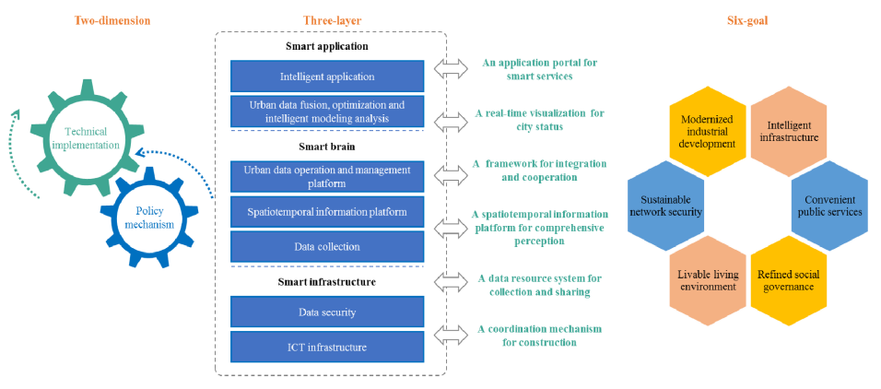

* + 1. **Six goals**

Closely combined with the strategic objectives of urban development, the information system construction needs and the business requirements of various service subjects in a smart city are analyzed. The demand analysis of a smart city service subject focuses on the government, enterprises, and the public, and determines the construction content of a smart city by solving the actual demand of the service subject. The demand analysis of a smart city follows the process from analyzing the needs of service subjects to developing products and then to meeting the phased needs of users. Based on Maslow’s hierarchy of needs theory, this process is divided into three levels, including basic application needs, developmental application needs, and personalized application needs. Taking the actual needs of urban and rural residents as the core, centering on the process of urban evolution and guided by the concept of sustainable development, we propose six core objectives of smart city: intelligent infrastructure, convenient public services, refined social governance, livable living environment, sustainable network security, and modernized industrial development

* Intelligent infrastructure: Through the construction of broadband, an integrated, safe, and ubiquitous next-generation information infrastructure in smart city, and the intelligent retrofit of public infrastructures such as electric power, gas, transportation, water, and logistics, the deep integration of industrialization and informatization can be realized, and the operation and management of smart city can be precise, assimilated and integrated.
* Convenient public services: In the fields of education and culture, medical and health care, labor and employment, social security, environmental protection, transportation, disaster prevention and mitigation, and other public services, information service systems covering urban and rural residents are built, making it more convenient, timely and efficient for the public to obtain basic public services.
* Refined social governance: The informatization system in the fields of municipal administration, population management, traffic management, public safety, emergency management, social credit, market supervision, inspection and quarantine, food and medicine safety, drinking water safety, and other social management fields are built. The digital urban management information system, urban geospatial information system, building database, and other resources are realized. The digitization and accuracy of urban management can be greatly improved, as can the government’s administrative efficiency and urban management level.
* Livable living environment: Through the construction of a smart city, an intelligent monitoring system of water, atmosphere, noise, soil, and natural vegetation environment and online prevention is strengthened, the control of pollutant emission and energy consumption is enhanced, the living environment quality of residents is improved, and the improvement in the urban living environment is promoted.
* Sustainable network security: A sound urban network security guarantee system and management system is established, the security of the basic network and the control of key information system are ensured, the security of important information resources is ensured, and the information of citizens, enterprises, and the government is effectively protected.
* Modernized industrial development: The industrial structure is optimized through upgrading the information industry, promoting the development of manufacturing and service industries by information technology, and fostering new industries to enhance the overall industrial efficiency and competitiveness.
  1. **Operational pattern**

The operational pattern is very important for the orderly and sustainable development of a smart city. The main objectives of the operational pattern can be summarized as

* Enabling the integration of the distributed services and resources in a combined synergistic way
* Improving public services
* Real-time monitoring the city in intuitive ways,
* Increasing the sustainability of a smart city.

Through the long-term practice in smart city planning and construction and based on the ‘‘two-dimension, three-layer and six-goal’’ smart city top-level design model, we propose six principles of a smart city operational pattern to guide the construction and operation of a smart city, including one coordination mechanism for construction, one center for data collection, one map for comprehensive perception, one platform for integration and linkage, one screen for the overall situation, and one application portal for smart life. This provides an effective guarantee for the implementation of a smart city top-level design.

* A coordination mechanism for construction: Adhering to overall planning and coordination, a leading group is established for smart city construction, with the main leaders of the city (or urban area) as the group leader and the main leaders of various departments as the group members, to form a strong government coordination and promotion mechanism. To avoid data isolation, management must be standardized through unified planning, standards, construction, management, operation, and maintenance.
* A data resource system for collection and sharing: The E-government public infrastructure should be built as a whole, with the smart city operation and management center as the core. Data can be collected in all fields relying on various business systems and perception devices, forming basic databases for aspects such as population, enterprises, macro-economy, and geographic information, as well as various subject databases, to realize the aggregation and sharing of data.
* A spatiotemporal information platform for comprehensive perception: Two-dimensional maps, three dimensional models, aerial images, and other basic spatial data are integrated to build a spatiotemporal information platform. Based on the spatiotemporal information platform, different personalized and refined demands of real-time electronic map service can be met on the same base map. This platform can also promote the visualization, refinement, and precision governance of urban management.
* A framework for integration and cooperation: A data sharing and exchange platform, spatiotemporal information platform, and data analysis platform are essential platforms in a smart city operation and management center, supporting its role of the ‘‘hub’’ in a smart city. All application systems are extended on this architecture based on a unified standard data interface.
* A real-time visualization of city status: Through the smart city operation and management center, the city operation status can be visualized in real time. In daily urban management, the multidimensional macro situation of the economy, public security, living environment, people’s livelihood, and government affairs is collectively displayed on a large screen. According to the perception data, the status quo of various fields is analyzed, problems are summarized, and suggestions are automatically generated. When dealing with emergency events, real-time video monitoring is used to sense the situation. Through big data analysis, the situation data model is automatically generated, which provides a strong guarantee for scientific decision-making and accurate policy implementation.
* An application portal for smart services: Online service applications are provided so that people and enterprises can handle affairs anytime and anywhere. Different services are integrated into the same portal to facilitate user access.

**5. KEY TECHNOLOGIES OF A SMART CITY OPERATION AND MANAGEMENT CENTER**

To solve the existing problems , we focus on three key technologies to improve the smart city operation and management center, each of which solves one problem. These key technologies include the following:

* A new-generation ICT infrastructure for smart cities
* Urban data perception, multidimensional collection and technical fusion for fine management
* Intelligent analysis and service technology for urban data. The technologies are shown in Fig. 3.

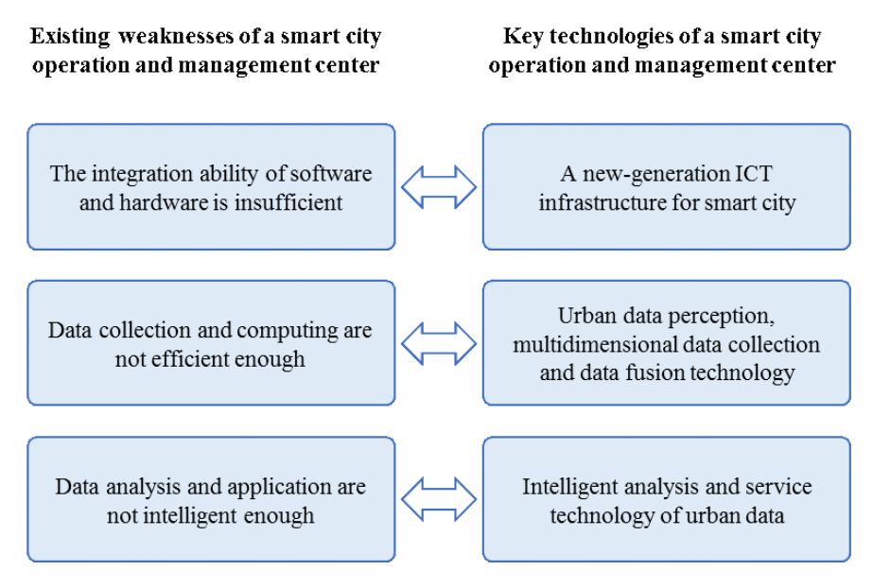

Figure 3. Key technologies of a smart city operation and management center

**5.1 New generation ICT infrastructure**

Aiming at the problems of the long network deployment cycle, low network bandwidth utilization, difficult system integration, difficult fault positioning and maintenance, and high network security threats in the construction of a smart city operation and management center, an urban data platform integration technology is necessary. The new-generation ICT infrastructure for a smart city integrates a high-performance server, hybrid cloud, network security situation awareness system, and urban data platform. It realizes a hybrid cloud architecture (dedicated cloud & private cloud) and a network security situation awareness system based on big data analysis technology, provides an intensive and integrated platform architecture for the smart city, and builds an integrated security system for the application, data, host, and network of the city, as shown in Fig. 4.

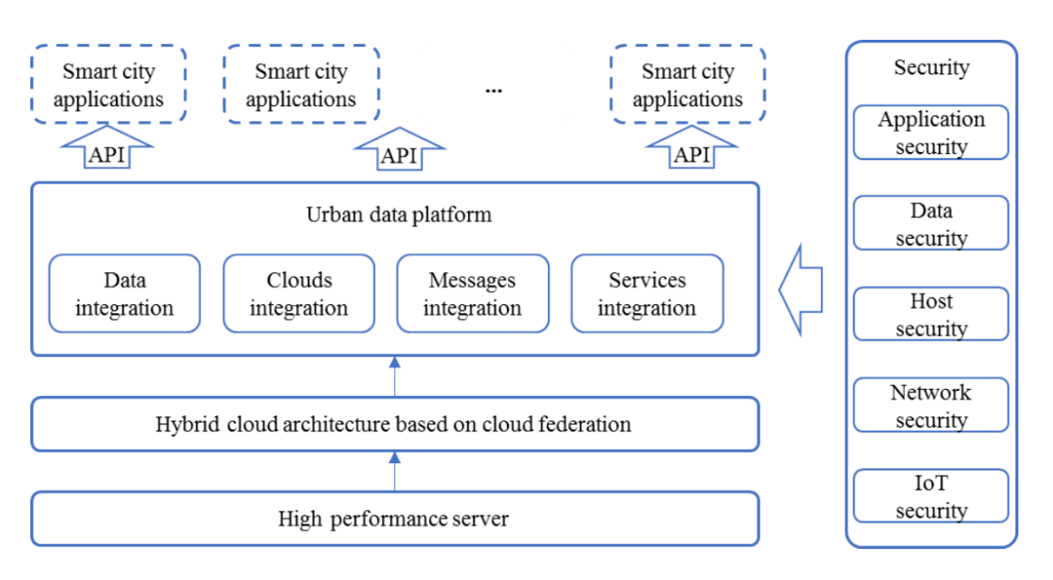

Figure 4. The framework of a new-generation ICT infrastructure for a smart city.

**5.1.1 Hardware and software integration technology**

To address the problem of the weak integration ability of software and hardware in the construction of a smart city operation and management center, the integration technology of an urban data platform is developed. The urban data platform faces different independent software vendor (ISV) services through a unified API northbound interface. The urban data platform uses Spark, Hadoop, MPPdb, Storm, and other open source technologies to parallel access and process PB level massive structured and unstructured data. It can process text, graphics, images, video, and other types of data, and use memory computing to process real-time messages and real-time data. The urban data platform is based on open source technology and has enhanced function, performance, and security, which meets the requirements of large-scale business. To facilitate flexible expansion, it can run on the cluster of large-scale parallel computing, meeting the requirements of parallel graphics processing and model calculation

**5.1.2 High performance graphic computing server**

To address the problems associated with a large amount of data processing, low CPU performance, and insufficient utilization of cloud resources in the smart city, a high-performance graphics computing server should be applied in the smart city operation and management center. This can satisfy the requirements of large-scale data fusion and high collaboration in business in the smart city operation and management center and provide a chip-level data encryption and decryption acceleration engine.

**5.1.3 Hybrid cloud**

This technology addresses the disadvantages of the traditional hybrid cloud platform with calling public cloud services through API, such as the insufficient amount of public cloud services provided by the hybrid cloud and the inability to directly deliver advanced services. By using cloud federation authentication and user mapping, private cloud and dedicated cloud can be combined into a federation system. Through elastic expansion, cross-cloud disaster recovery, network collaboration, hierarchical deployment, and other cross-cloud linkage capabilities, this can achieve full-service access, and effectively ensure that users can safely and quickly obtain Internet of things, edge computing, blockchain, software development, and other cutting-edge technologies. Moreover, it uses a unified architecture to provide consistent functional components, service capabilities, operation mode, and interface style to ensure a consistent user experience and management mechanisms.

**5.1.4 Integrated application of urban data platform**

To address the problems of information system segmentation among government departments, the low efficiency of resource scheduling and data transmission between different big data platforms, and the redundancy of data storage in a smart city, an urban data platform should be applied in the smart city operation and management center. Using a high-performance resource scheduler, based on historical data, machine learning is carried out to estimate the number of resources and execution time needed to improve the efficiency of system resource scheduling. An information hub, data hub, and application hub are constructed to effectively coordinate API, data, and messages across regions and departments without breaking the organizational security boundary.

**5.1.5 Network security awareness technology**

To solve the problem of encryption attack the network, data, and other core systems and key information infrastructure of the smart city operation and management center face, a network security situation awareness system should be applied in the smart city operation and management center. Combined with an AI detection algorithm, multidimensional massive data association analysis can be carried out, various security threats can be found in real time, and the attack behavior of the whole APT attack chain can be restored. This system can collect and store multiple types of network information data to find threats, block threats, collect evidence, trace the source, respond and deal with threats, forming a closed loop of the whole process surrounding threat events.

**5.2 Urban data perception**

In the current practice of smart city operation and management centers, due to the limited ability to collect urban high-altitude data, blind areas of urban management often exist. In addition, the emergence of various kinds of urban video data poses brings challenges for quick and intelligent video processing. Targeting the problems of incomplete data perception, low data collection efficiency, and unsystematic data aggregation, a spatiotemporal information cloud platform should be constructed in the smart city operation and management center. Through the efficient collection, processing, analysis, and identification of urban high-altitude image, urban video data, and spatiotemporal information data, combined with UAV aerial photography and other technologies, the visualization, refinement, and accuracy of urban management can be promoted.

* Second level video data acquisition and intelligent analysis of massive data based on edge computing: To address the problems of algorithm accuracy and computability in big data massive image processing, a large-scale application system of ‘‘end to cloud’’ dynamic visual AI should be applied in the smart city operation and management center. By deploying edge intelligent chips in urban video capture devices, core algorithm training and optimization technology combined with the traditional computer vision algorithm and deep neural network can be achieved. This technology includes the following:

1) end-to-end model algorithm training and optimization, end-to-end localization training, and the design of a face detection and feature extraction model integrating the traditional computer vision algorithm and face image processing algorithm based on deep learning,

2) image feature evaluation and measurement calculation

3) large-scale feature search and analysis.

* Key technology and the application of a normalization acquisition system of urban high altitude image data: To address the problems of the long update cycle, high acquisition cost, and different format standards of high-altitude satellite image and aerial survey image data in a smart city, an automatic acquisition system of UAV panoramic urban high-altitude image data should be applied in the smart city operation and management center. This system uses a UAV control program to automate and standardize the acquisition process, improve the data accuracy, reduce the cost and improve the update frequency. To address the problem of the projection distortion of urban high-altitude panoramic images, an image mosaic fusion technology based on a real projection skeleton should be applied in the smart city operation and management center. Panoramic images with their structure frame collected from a high altitude are stitched and fused by adding the projection skeleton as a reference point, which makes the images more valuable.
* Key technologies and applications of a spatiotemporal information cloud platform supporting multidimensional data fusion and aggregation: To address the demand of multidimensional data fusion and aggregation in urban governance, a spatiotemporal information cloud platform supporting multidimensional data fusion and aggregation should be applied in the smart city operation and management center. Through the forwarding control of hierarchical services, the hierarchical control of data can be realized. This improves the loading efficiency of massive spatial data, provides accurate and diversified online spatiotemporal map services, improves the visualization effect of highly intensive data, and improves the maintenance efficiency of

platform resources, so multidimensional urban data can be displayed more efficiently and intuitively.

**5.3 Intelligent analysis and service technology of urban data**

The demands of the rapid examination and approval of enterprise services and other urban government affairs in smart cities are rapidly increasing. To meet these demands, intelligent analysis and services of urban data through thematic data modeling and analysis technology, automatic matching technology of urban industrial information, an intelligent examination and approval model without human intervention and integrated mobile government collaboration technology should be realized.

**5.3.1 Intelligent approval system**

To address the problems of low efficiency, long cycle, and low intelligence of government approval, an intelligent approval system without human intervention is proposed. It has a multi-layer automatic comparison architecture for intelligent approval, which realizes the unified management of the underlying data comparison target and the multi-source heterogeneous data of the comparison source, automatic comparison execution, standardized task management, and user interaction in the whole process of intelligent approval. It uses the spot check and tracing algorithm for warning to prevent possible problems and risks in the process of comparison. When the spot check rule is triggered, the spot check and tracing algorithm in the system automatically run and check the approved items. This system can make government approval standardized, procedural, and complete, greatly improves the processing speed of approval items for enterprises and residents and effectively prevent the possible problems and risks in the process. This system is shown in Fig. 5.

**5.3.2 AUTOMATIC MATCHING METHOD**

To address the problem that enterprise demand cannot match industrial policy accurately and intelligently, an automatic matching method and a system of enterprise service information based on semantics are proposed. The semantic relationship of matching conditions and enterprise management information is refined and established. Through machine learning training on massive data, semantic-based government policy deconstruction and intelligent policy matching can be realized.

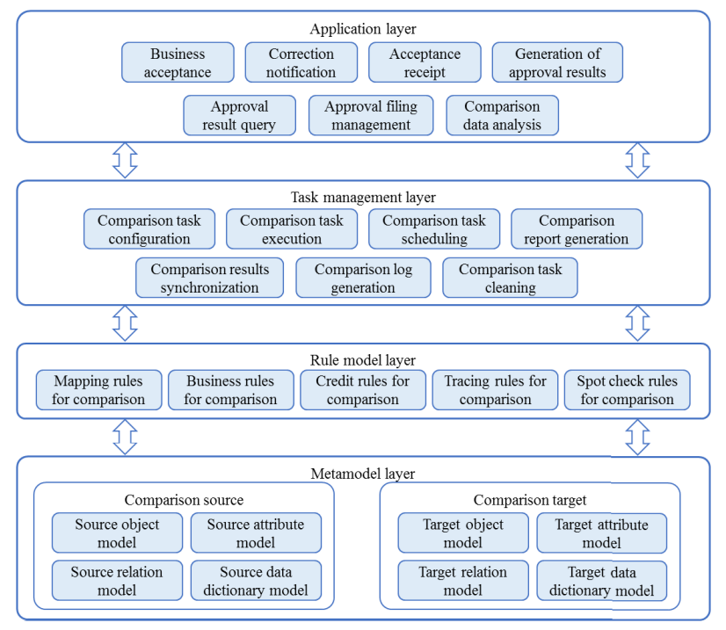

Figure 5. framework of an intelligent approval system without human intervention

### 5. PRACTICAL CASE OF SMART CITY OPERATION

### MANAGEMENT CENTER

### 5.1 Characterization of the case

### 

No two cities are the same. Smart city challenges vary by city and region due to a variety of factors, including the local urban characteristics, social needs, economy, governmental structures, culture, technological settings, and geographical contexts . In smart city policy making, the focus should be on the significant diversity of the cities, considering the needs and challenges, and formulating policies according to local conditions. However, identifying the common features of cities and carrying out practice in representative cities helps form experiences that can be referenced and replicated. In this study, we employ the smart city top-level design model proposed and the key technologies to observe the effect in practice. The selection of Longgang District of Shenzhen as a case of study is based upon the city’s unique characteristics.

1) Fundamental conditions: Shenzhen is one of the fastest-growing experimental cities in China, ranked as the top smart city in China by Deloitte. It has become the first ‘‘gigaband city’’ proposed in China. As a district of Shenzhen, Longgang District has a good network foundation and urban data accumulation, which can provide strong support for the construction of the smart city.

2) Late-mover advantage: Longgang District is a newly planned area. Construction from scratch is conducive to the implementation of the top-level design concept and can prevent the interference of other factors. There is a minimal intelligent software and hardware foundation in the district, so the integration technology can be applied from the early stage of construction. These advantages can improve the scientificity of the observation of the implementation effect.

3) Complex urban governance needs: Longgang District covers an area of 388.21 km2 , most of which was rural decades ago. However, it has gathered more than one million large and small enterprises and approximately 5 million people, forging a world-class hi-tech cluster. In this context, Longgang District has a great demand for urban governance, including but not limited to urban safety, environmental management, and illegal building management. For the large number of enterprises in Longgang District, the government needs to provide high-quality and efficient smart services, including business start-up services, business license renewal, project approval, and policy matching.

Considering the above characteristics, Longgang is suitable as an implementation case for this study and can provide a replicable experience for similar cities with one or more of the above characteristics. This experience can be referenced and replicated in large cities, developed cities, new urban areas, industrial agglomeration cities, or cities seeking more refined urban governance.

**5.2 Applied effect of the case**

Longgang District applied the top-level design model of a smart city proposed in this paper in compiling ‘‘The Master Plan of Smart City in Longgang District’’, and the six principles of a smart city operational pattern proposed in this study were applied to guide the construction and operation of the smart city. According to the master plan, the smart city has already been built and put into use. The construction framework of Longgang smart city takes the smart city operation and management center as the core, including three essential platforms: a big data management platform, a spatiotemporal information platform, and a network security awareness platform. Longgang District has established a unified data interface standard. All smart applications are strictly required to be extended on this architecture.

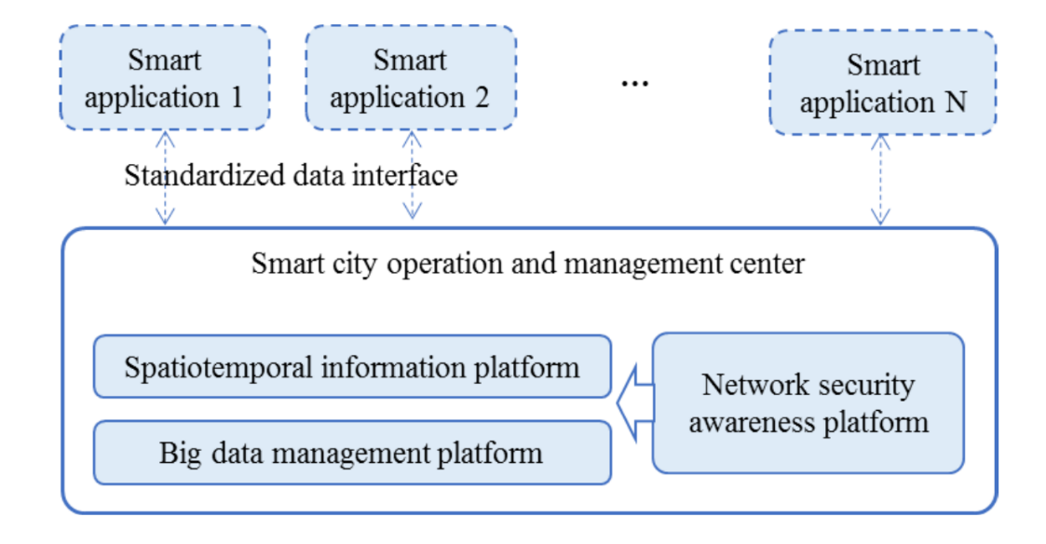

Figure 6. Construction framework of Longgang smart city

Based on the smart city operation and management center, Longgang District has realized the aggregation of data on the big data management platform and real-time visual monitoring of the city operation status through the spatiotemporal information platform. The smooth operation of various application systems provides solid support for Longgang District to realize fine and efficient management. At present, it has integrated more than 100 government information systems on government affairs, police affairs, fire control, safety supervision, education, medical treatment, etc.

### 6.ADVANTAGES OF NEW TOP LEVEL MODEL

### Comprehensive Coverage through Two Dimensions:

### The model considers two crucial dimensions - technology implementation and policy mechanisms. This dual focus ensures a holistic approach that addresses both the technical aspects and the regulatory and policy frameworks required for smart city development. It helps in avoiding siloed implementations and promotes a more integrated and synergistic approach.

### Guiding Operational Pattern:

### The model proposes six principles for a smart city operational pattern. These principles, including coordination mechanisms, data collection systems, spatial-temporal information platforms, integration frameworks, real-time visualization, and application portals, provide a clear and practical guide for the construction and operation of a smart city. This ensures that the implementation aligns with the top-level design, promoting consistency and efficiency.

### Clear Six Goals for Smart City Development:

### The model defines six core goals for smart city development, encompassing intelligent infrastructure, convenient public services, refined social governance, a livable living environment, sustainable network security, and modernized industrial development. This clarity in objectives helps in aligning the efforts of various stakeholders towards common goals, fostering a shared vision for smart city development.

### Structured Three-Layer Design:

### The three-layer structure (smart infrastructure, smart brain, and smart application) provides a systematic and organized approach to building a smart city. This design ensures that essential elements such as information infrastructure, data processing capabilities, and application functionalities are well-coordinated and integrated, contributing to the efficiency of the overall system.

9. CONCLUSION

In conclusion, this study addresses critical challenges in smart city operation and management centers and proposes innovative solutions. Key contributions include a thorough problem analysis, the introduction of a novel 'two-dimension, three-layer, and six-goal' top-level design model, and the application of this model in a real city, exemplified by Longgang District. The practical case demonstrates positive outcomes, offering valuable insights for large cities, developed areas, and those aspiring to refine urban governance. Lessons learned emphasize focusing on city characteristics, prioritizing management mechanisms, and combining government, enterprise, and citizen needs for efficient data-driven urban governance. Future research directions involve assessing the long-term success of implemented smart city centers and exploring theoretical methodologies and technologies for continued advancements.

### 10. BIBLIOGRAPHY

**Websites**

[1] [*https://en.wikipedia.org/wiki/Smart_city*](https://en.wikipedia.org/wiki/Smart_city)

[2][*https://journalofbigdata.springeropen.com/articles/10.1186/s40537-019-0221-4*](https://journalofbigdata.springeropen.com/articles/10.1186/s40537-019-0221-4)

[3] [*https://www.mdpi.com/2624-6511/5/2/25*](https://www.mdpi.com/2624-6511/5/2/25)

[4] [*https://www.sciencedirect.com/science/article/pii/S266618882100006X*](https://www.sciencedirect.com/science/article/pii/S266618882100006X)

[5][*https://dl.acm.org/doi/10.1145/3289100.3289123*](https://dl.acm.org/doi/10.1145/3289100.3289123)

**Books**

[1] *Y. Pan, Y. Tian, X. Liu, D. Gu, and G. Hua, ‘‘Urban big data and the development of city intelligence,’’ Engineering, vol. 2, no. 2, pp. 171–178, Jun. 2016.*

[2] *V. Moustaka, A. Vakali, and L. G. Anthopoulos, ‘‘A systematic review for smart city data analytics,’’ ACM Comput. Surveys, vol. 51, no. 2, pp. 1–4, 2018.*

[3] *A. Luque-Ayala and S. Marvin, ‘‘The maintenance of urban circulation: An operational logic of infrastructural control,’’ Environ. Planning D, Soc. Space, vol. 34, no. 2, pp. 191–208, Apr. 2016.*

[4]  *S. Dustdar, S. Nastic, and O. Scekic, ‘‘A novel vision of cyberhuman smart city,’’ in Proc. 4th IEEE Workshop Hot Topics Web Syst. Technol. (HotWeb), Washington, DC, USA, Oct. 2016*

[5] *J. Sadowski and R. Bendor, ‘‘Selling smartness: Corporate narratives and the smart city as a sociotechnical imaginary,’’ Sci., Technol., Hum. Values, vol. 44, no. 3, pp. 540–563, May 2019.*